pySVG Tutorial

Introduction
pySVG is a library that allows you to “code” svg as well as to load and store svg files.
It is not meant to be a design or conversion tool but rather one that allows you to visualize computed data.

Working with pySVG is relatively straight forward. You (still) need some knowledge on what values the appropriate svg elements need. Validation of input parameters is not yet implemented. Apart of this inconvenience handling pySVG should be a a piece of cake. Note that parameters that are numbers normally can be given either as ints or strings. Should both work fine.

Download/Installation/Support

Download
You can find the current distribution using the cheeseshop:
http://pypi.python.org/pypi?%3Aaction=search&term=pysvg&submit=search

Alternatively you can find the code in Google Code:
http://sourceforge.net/projects/generateds/

As third alternative you may want to look for information on pySVGs homepage:
http://codeboje.de/pySVG

Installation
Apart of an appropriate Python itself (pySVG was created using a 2.5.x environment) you should not need anything. Just run the setup.py tool OR simply include the modules in your PYTHONPATH.

General remarks about the library
pySVG comes with three main directories:
- pysvg
- tests
- doc
The tests directory contains all modules that I have written to test one functionality or another, as well as some experiments. It also includes the sourcecode of this tutorial. Any resources needed for the tests should be in the subfolder “sourceimages”. Any output created by the code should be found in “testoutput”.
The doc folder contains this tutorial as well as the html created for the api.
Pysvg itself finally is the package where you find the pysvg library. You will find modules that are named after the chapters found in http://www.w3.org/TR/SVG/index.html.
For example all elements that are described in the chapter “Shapes” should be in a module named shape. Apart of that there are some Builder modules that should eventually facilitate the creation and manipulation of svg (all with the extension “Builder”) as well as some core modules that are not directly linked to the svg specification like “core.py”, “parser.py” etc. These provide functionality and abstraction layers.

Support
There is currently no mailing list or forum. Please contact me directly at:
kmansour”youknowthesignthatshouldbehere”DOTwebDOTde

License

Tutorial
The examples used in the tutorial can be found in the class “pySVGTutorial”. There each example is part of a whole chain of examples. The numbering of the examples corresponds to the chapters in this tutorial. Each example will create an output file in the “testoutput”directory with its name and again the number.

Getting started - Text
Lets start with the typical "hello world" which I have already packed into a method.

def HelloWorld1():
s = svg()
t = text("Hello World", 0, 100)
s.addElement(t)
print s.getXML()
s.save('./testoutput/1_HelloWorld1.svg')

Each svg document is actually just an xml document with a svg element as root. You can then add anything you want to it.
The steps as a summary:
- Create a svg document.
- Create a text element with the text "Hello World" at position x=0, y=100.
- Add the text to the svg document.
- Save the document as “1_HelloWorld1.svg”

As you can see the svg element has a method save which can be used to store your created xml. Actually ALL elements have that method for convenience although only with svg as root you will have any output that can be used by other programs.
Run the script and open the saved document it with your svg capable browser or imageviewer.
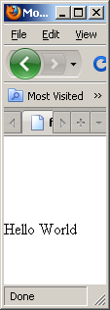

Now let’s do some more stuff with the styling. The class styleBuilder will provide you with many methods for fonts, filling, stroke and so on. (Note that this class might change over time while the core classes are rather stable now)

def HelloWorld2():
s = svg()
myStyle = StyleBuilder()
myStyle.setFontFamily(fontfamily="Verdana")
myStyle.setFontSize('5em') #no need for the keywords all the time
myStyle.setFilling("blue")
t1 = text("Hello World", 0, 100)
t1.set_style(myStyle.getStyle())
s.addElement(t1)
print s.getXML()
s.save('./testoutput/2_HelloWorld2.svg')

Just create the style, set the font and filling. Rest stays the same. Run the program and you should get some result like:
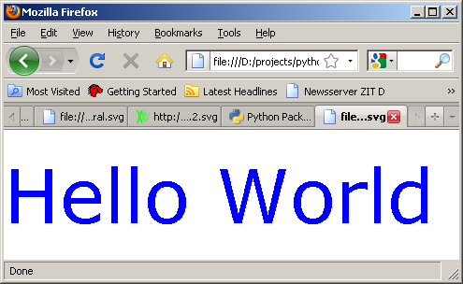

If you want to experiment a bit, take a look at the function TextFeatures in pySVGTutorial.py. Fontsize, -style, -weight etc. should all not be a problem and have easy set-methods in the StyleBuilder. Alternatively you can also set the style directly as a string. Here are some results:
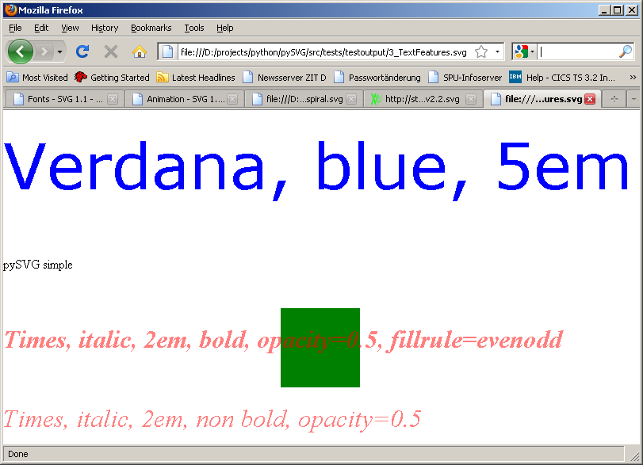

Basic Shapes
Including shapes is as easy as it is to produce text. Beware and keep in mind that pySVG will not check what you set as values in the appropriate classes. You can set an x-coordinate of “3” just as well as one of “myPLACE”. pySVG will not verify that what you do makes sense.
Since svg is a bit nasty when it comes to defaults, you can have a look at the ShapeBuilder class. It provides you with some defaults and some extra parameters that I think are needed often.
In order to draw a line you would normally do something like:
s = svg("test")
myStyle = StyleBuilder()
myStyle.setStrokeWidth(2)
myStyle.setStroke('black')
l = line(0, 0, 300, 300)
l.set_style(myStyle.getStyle())
s.addElement(l)
s.save('./testoutput/5_Line.svg')

With the ShapeBuilder class however it is far shorter:
oh = ShapeBuilder()
s.addElement(oh.createLine(10, 0, 300, 300, strokewidth=2, stroke="blue"))
s.save('./testoutput/5_Line.svg')

Some parameters are often needed and so I tried to include them (with defaults) in the ShapeBuilder. Feel free to mail me if you think something useful is missing.
Now let us simply paste the code for common shapes here. I think you will get the idea fast.
def Shapes():
oh = ShapeBuilder()
s = svg("test")

s.addElement(oh.createRect(0, 0, 400, 200, 12, 12, strokewidth=2, stroke='navy'))
s.addElement(oh.createRect(100, 50, 200, 100, strokewidth=2, stroke='navy', fill='yellow'))
s.addElement(oh.createCircle(700, 500, 50, strokewidth=5, stroke='red'))
s.addElement(oh.createCircle(810, 500, 50, strokewidth=5, stroke='yellow', fill='#AAAAAA'))
s.addElement(oh.createEllipse(600, 50, 50, 30, strokewidth=5, stroke='red'))
s.addElement(oh.createEllipse(700, 50, 50, 30, strokewidth=5, stroke='yellow', fill='#00AABB'))
s.addElement(oh.createLine(0, 0, 300, 300, strokewidth=2, stroke="black"))
s.save('./testoutput/4_Shapes.svg')
The result:
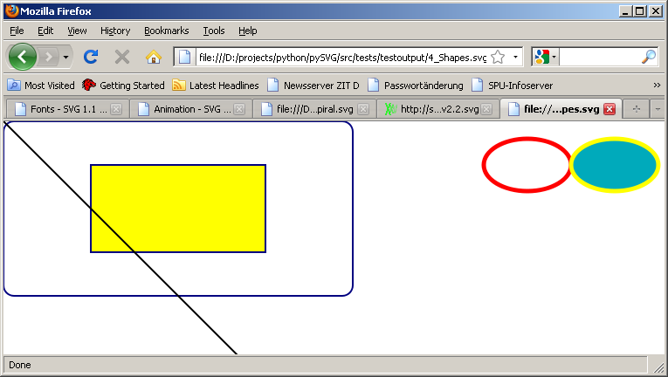

Complex Shapes
Complex shapes are done using polylines, polygons and paths. Now these (for now) are still the ugliest folks in the lib. For example if you have a polyline you must specify ALL points as a string. Something like:
pl=oh.createPolyline(points="50,375 150,375”,strokewidth=10, stroke='blue')

This is rather ugly especially when you have many points. The ShapeBuilder has a function that allows you to convert a list of points (tuples) into that format. You can use that for polylines or for polygons for example like here:
pointsAsTuples=[(350,75),(379,161),(469,161),(397,215),(423,301)] pg=oh.createPolygon(points=oh.convertTupleArrayToPoints(pointsAsTuples),strokewidth=10, stroke='blue', fill='red')

pySVG also supports paths now but it doesn’t yet optimize them. If for example you have several moveto commands you can normally append the coordinates and skip the command repetitions. In pySVG you must append each move separately and it will create slightly bigger svg files.

Here are some examples for paths:
path.appendMoveToPath(190, 520, False)
path.appendCubicCurveToPath('+0', '+0', 30, 30, -60, 30, True)
path.appendCloseCurve()
path.appendQuadraticCurveToPath(0, 30, 30, 0)
See the function ComplexShapes and some results below
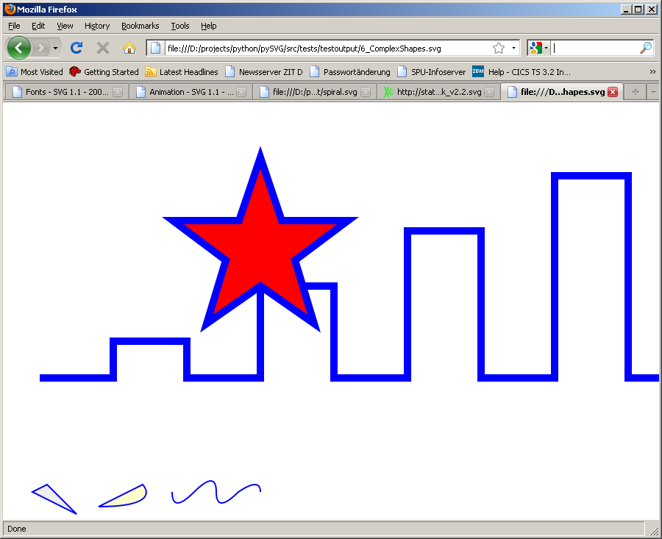

Grouping
Sometimes you want to apply certain styles to many elements. And changes in that style also should have an effect on all appropriate elements. For that svg has a group element that you of course can also use in pySVG:
def Grouping():
oh = ShapeBuilder()
s = svg()
myStyle = StyleBuilder()
myStyle.setStrokeWidth(2)
myStyle.setStroke("green")

group = g()
group.set_style(myStyle.getStyle())
group.addElement(line(300, 300, 600, 600))
group.addElement(circle(500, 500, 50))
s.addElement(group)

group = g()
group.set_style(myStyle.getStyle())
style_dict = {"stroke":"#000000", "fill":"none" , "stroke-width":"49" , "stroke-opacity":"0.027276"}
p = path(pathData="M 300 100 A 1,1 0 0 1 802,800")
p.set_style(StyleBuilder(style_dict).getStyle())
p2 = path(pathData="M 100 300 A 1,1 0 0 1 802,800")
p2.set_style(StyleBuilder(style_dict).getStyle())
group.addElement(p)
group.addElement(p2)
s.addElement(group)
print s.getXML()
s.save('./testoutput/7_Grouping.svg')
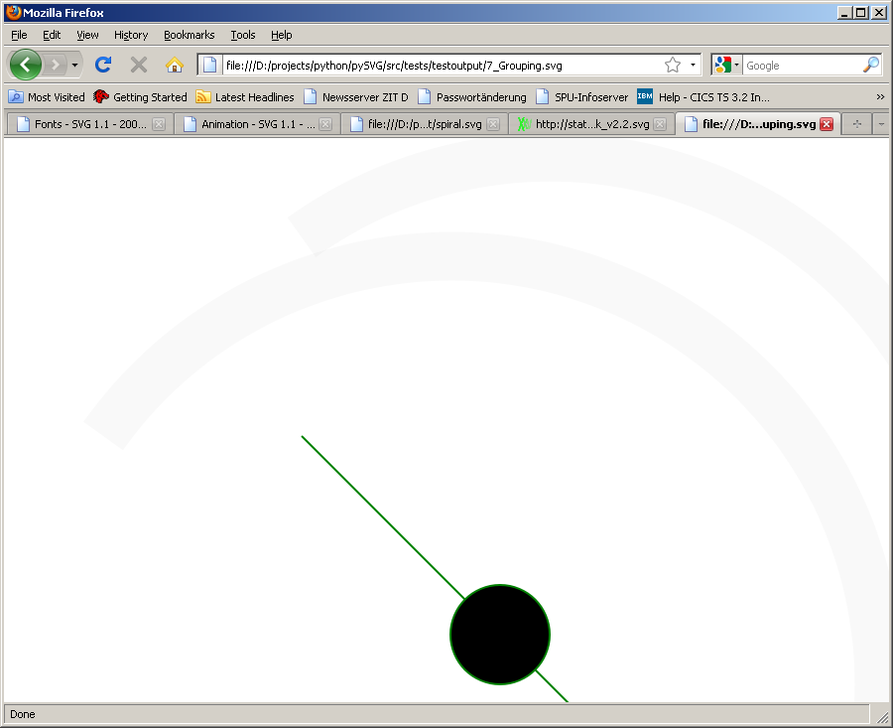
We create two arcs here (p and p2) which are part of the same group thus sharing the same style (no filling, strokewidth of 49 ..)
We also created a line and a circle, set them in another group and thus they share the same style with a green stroke of width 2px.

Gradients
There can be linear and radial gradients. Since they don’t differ much I only mention the linear one. Here is the code.
def LinearGradient():
mySVG = svg("test")
d = defs()

lg = linearGradient()
lg.set_id("orange_red")
s = stop(offset="0%")
s.set_stop_color('rgb(255,255,0)')
s.set_stop_opacity(1)
lg.addElement(s)
s = stop(offset="100%")
s.set_stop_color('rgb(255,0,0)')
s.set_stop_opacity(1)
lg.addElement(s)
d.addElement(lg)

oh = ShapeBuilder()
e = oh.createEllipse(cx="200", cy="190", rx="85", ry="55", fill="url(#orange_red)")

mySVG.addElement(d)
mySVG.addElement(e)
print mySVG.getXML()
mySVG.save('./testoutput/8_LinearGradient.svg')

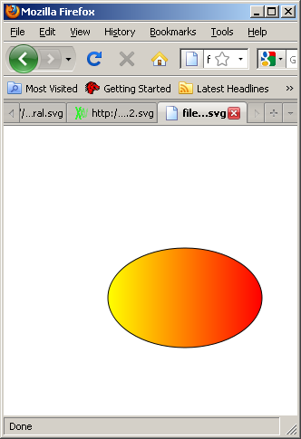
If you know how a gradient is defined in svg you should be able to deduce how to create one in pySVG. Notice that I have used a definition (defs element) where I defined the gradient and applied that gradient (using the fill attribute) to an ellipse.
This works well if you have exactly ONE place in your code where you create ALL the definitions and add them to one defs element.
Theoretically it is possible now to create two or more defs and add them to an svg element. The results are not defined. Be careful when you use defs. In one of the next versions of pySVG I will include some routines to handle this problem.

Images
Images are just as simple as shapes or text.
def Image():
s = svg()
i = image(x=80, y=25, width=88, height=31)
i.set_xlink_href('http://img0.gmodules.com/ig/images/googlemail.gif')
s.addElement(i)
i = image(x=80, y=125, width=88, height=31)
i.set_xlink_href('../sourceimages/images.jpg')
s.addElement(i)
s.save('./testoutput/10_Image.svg')

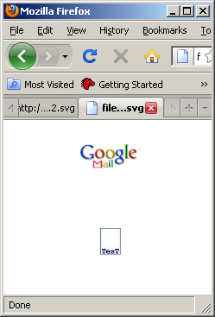

What is missing?
Better support for definitions and use elements.

