Angular Tour of Heroes Demonstration

Starting up the Angular App:
This is very easy.

ng new angular-tour-of-heroes
cd angular-tour-of-heroes
ng serve --open
Then from the output trace you can watch to see which address it’s being hosted at. For me, it’s localhost:4200 and you can access the sample page from the browser.
This sample page we see is called the APPLICATION SHELL and it’s being controlled by an AppComponent
Components are the building-blocks of angular apps. They display data, listen for inputs, and react to inputs. The implementation of the shell component is split up into three files:

1. app.component.ts— the component class code, written in TypeScript.
2. app.component.html— the component template, written in HTML.
3. app.component.css— the component's private CSS styles.
Let’s change the title header on the page to “Tour of Heroes”. Notice how in app.component.html it has <h1>{{title}}</h1> in the html? It gets that value from the class title property in app.component.ts ! Let’s edit it there.
We end up with this:
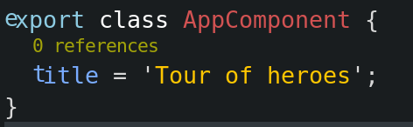

Very simple, now we need no additional edits. If we recompile the page we’ll see the title was changed!

Updating Styles Across the Application:
Most applications have a consistent styling. For this, we have styles.css which is just normal css. We’re going to put the following in there:
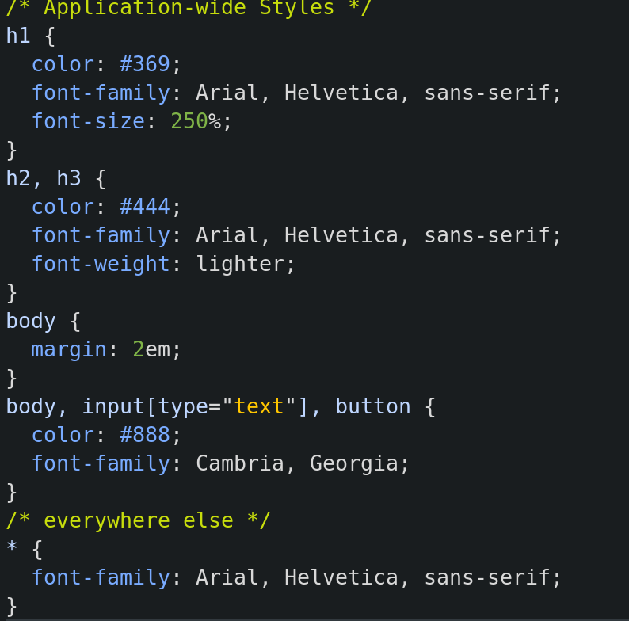
Save and reload. The changes are subtle, but you should be able to see them. By now we’ve started a sample-application, learned that components display information, changed something in an html template without touching the HTML, and applied styling across our application.

A New Component:
Let’s create a component called “heroes” where people can view and edit heroes.

From the command line generate a new component:
ng generate component heroes
Now we’ve got our new component in ../src/app/heroes !

Let’s open up the typescript component heroes.component.ts:

- selector— the component's CSS element selector
- templateUrl— the location of the component's template file.
- styleUrls— the location of the component's private CSS styles.

So selector will be used in html templates when we want to embed our component. The template and styleurls just tell angular where to find our component from the root folder, leave these untouched for the most part but be aware of what they are/do.
NgOnInit() { } is a lifecycle hook. Any code in here will execute as soon as the component is loaded for the first time. There are many lifecycle hooks you can use (example, on destruction!)
Make sure you ALWAYS exporta component class that way you can load it in places like AppModule. We do that here:
Let’s add a property now to our typescript in the component., We’ll call them ‘WindStorm’ (dodging trademarks).
hero = 'Windstorm';

So far so good. Now in heroes.component.html (our template for this component!) I want to display this hero’s name, so I’ll add…
<p>
{{hero}}
</p>

Great! Now we need to SHOW THE VIEW. I’ll add it to our original app.component.html using tags that are the name of our SELECTOR (see above)

<app-heroes></app-heroes>

Save and reload after our app html template looks like:
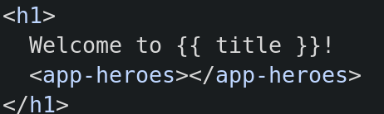

And…..


It works!

Object-Oriented:
Now, typescript is object-oriented and a real hero is obviously more than just a name as a string, so let’s make a Hero class!
This class won’t belong to the heroes component, but rather be something global so we’ll leave it in the main app in src/app/ as hero.ts

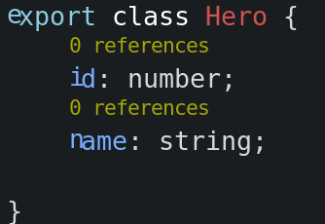

Now let’s actually use this new class. Return to the heroes component typescript heroes.component.ts, and let’s import and use it!
Import with:
import { Hero } from '../hero';

-…at the top with the rest of the imports.
And now let’s refactor where we created Windstorm above to make it as a hero object:
export class HeroesComponent implements OnInit { hero: Hero = { id: 1, name: 'Windstorm' };

Here’s what it looks like:
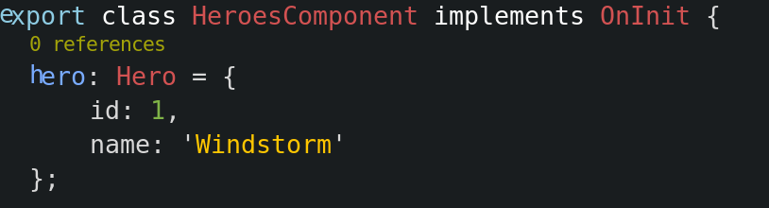

We’re almost there! Now we’ve just got to SHOW our new refactored object in our component template. This will belong to the heroes component template. LET’S ADD THE BINDING
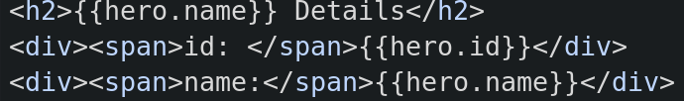

Pipes in the HTML Template:
Now, a hero’s name should be uppercase if we’re going to have it big like that. We can force a string into uppercase in the template as we use it!

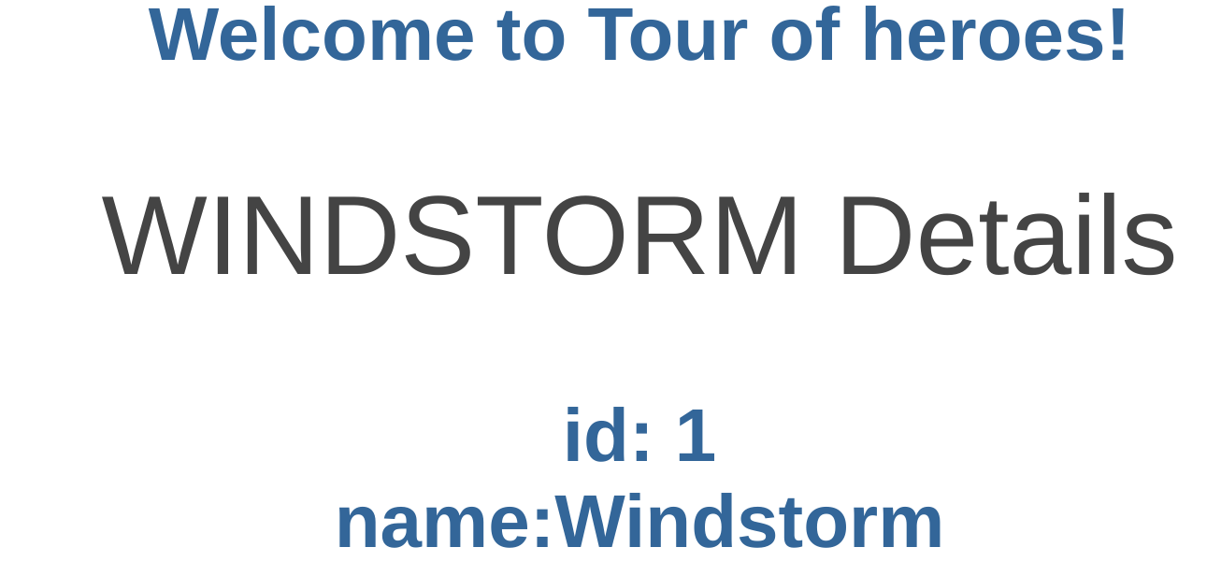

Look at what we have now, excellent. There are lots of premade pipes for dates, currency, etc.

Editing a Hero:
A user should be able to “edit” a hero name as an <input> textbox. To accomplish this we’re going to need a TWO-WAY-BINDING.

Bindings are done through templates, so we’re going to refactor our hero template:
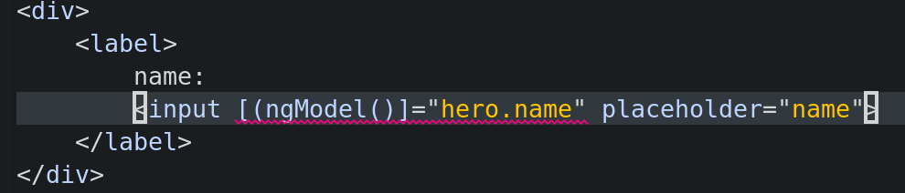

There we go – although something is wrong. We’re missing something….

Adding a module:
We want to add the forms module. Even though it’s built-in, it’s not imported by-default. Open app.module.ts to add it. First we import it with:
import { FormsModule } from '@angular/forms';

Then we’re going to add it to our list of imports like:
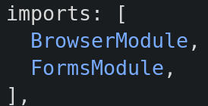

And just like that it works! We have our working <input> form that actively and realtime adjusts the value from the typescript single-binded to the part in the template.

Let’s add the import for our HeroesComponent in app.module.ts for good measure. You can use relative-pathing here:

import { HeroesComponent } from './heroes/heroes.component';

Oh… wait! Look! Angular added it for us! This is because we MUST import a component somewhere in order to use it.

Displaying a List:

You can be clever about your bindings and display lists in lots of ways. Normally we’d import data from something (maybe an API?!) but for now let’s keep things really simple and mock up a list of fake heroes. We’ll put these in a totally separate typescript file in the root app component, src/app/mock-heroes.ts

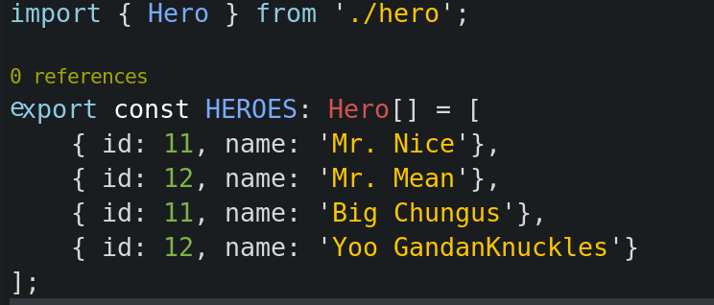

This is really simple in typescript (making an array of custom objects). First we’ll import hero from Hero.ts using the relative path.
Then we’ll export a constant array called HEROES of type Hero[]
It’s elements can be named as key-value pairs even though it’s declaring Hero objects! It looks like dictionaries, but we’re getting Hero objects back. Cool.

I want to use this now in my Heroes component, so let’s go over to heroes.component.ts

First let’s import that typescript file we created. We want the const list HEROES from it so we’ll do:

import { HEROES } from '../mock-heroes';

Next we’ll just create a variable that’s equal to HEROES in our OnInit() for this component, so that something is exposed for the templates to use!
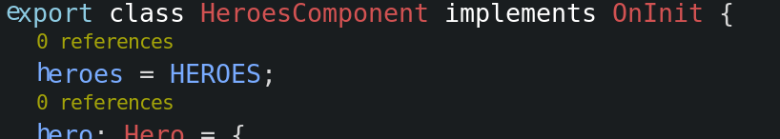

Easy stuff so far. Now we’re going to need to use it IN A TEMPLATE using a for-loop through the power of NGFOR.

*ngFor

You know how you can create list items with the <li></li> tags in HTML> You can do these across a for-loop of an array here!
Let’s make an unordered list and do exactly that using *ngFor (for-loop logic in templates!)

First we’ll make it for our single hero (windstorm):
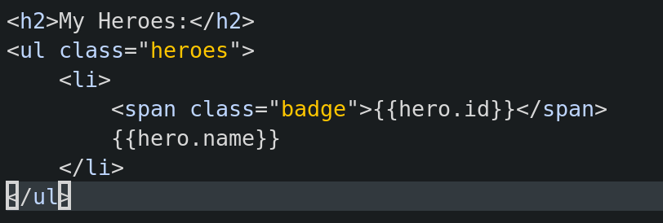

Now instead of doing this, let’s change the list so that it loops over our list HEROES and prints hero.id and hero.name for EACH hero!

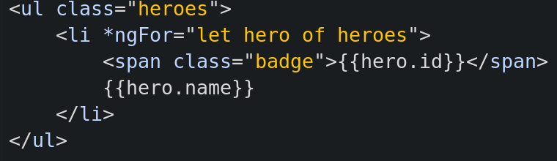

That’s awesome. We give it a string that resembles a typical for-loop and it repeats the list over and over again, only “hero” changes each time. The result is that it loops over our list and prints out all of our heroes in the format we wanted!
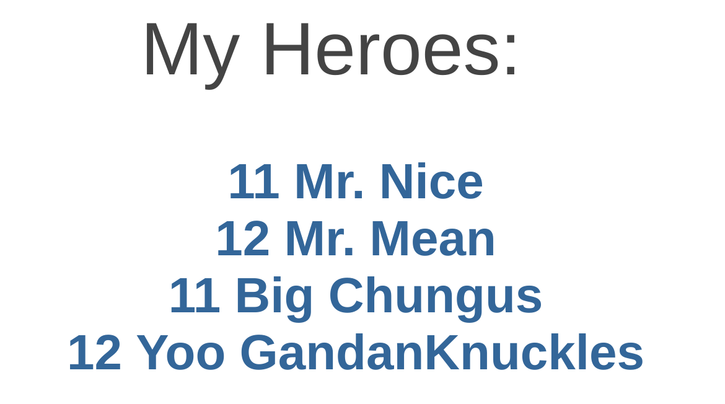

(forgive my creativity, I could only think of memes)

Styling our Hero Component:
In the beginning we had a generic stylesheet for the whole app. Well, now we can make one for Heroes but encapsulate it in a separate component!

I’ll opt NOT to do this…. But if I wanted to I’d just link the private stylesheet in the component like this:

@Component({ selector: 'app-heroes', templateUrl: './heroes.component.html', styleUrls: ['./heroes.component.css'] })

