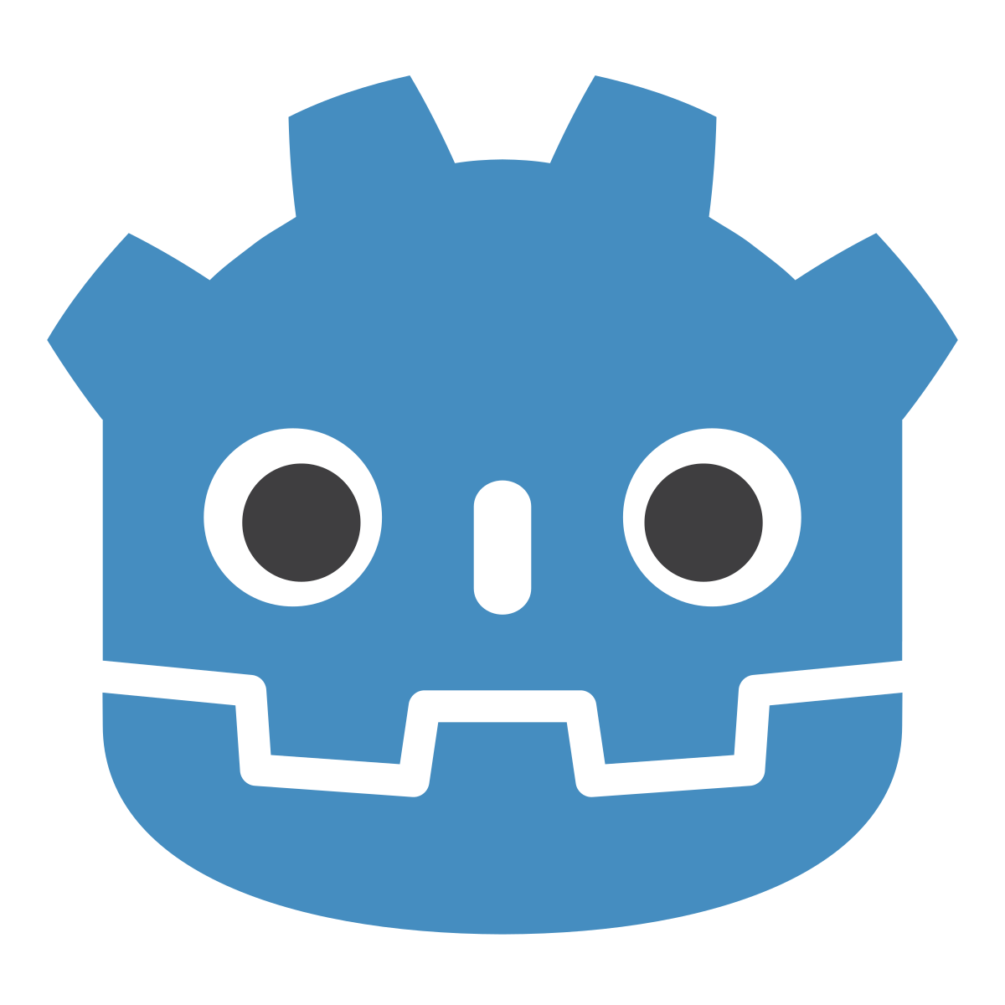
Learning Godot (3D)
By Mike Papili

Personal Github Link:
https://github.com/mpapili/Learning-Godot.git

First we’re setting up our Godot project, just create a new one in a blank folder – nothing special.

Table of Contents
Learning Godot (3D) 1
Creating a Root Node 2
Creating our 3D Plane: 3
Adding our Camera: 4
Adding a Cube: 5
Scripting our Cube: 6
Exporting to Android: 7
Blender 3D models to Godot 8

Creating a Root Node

Next we need to create a Root Node – nodes are everything in Godot (apparently). In your blank project, create a 3D Root Node Scene

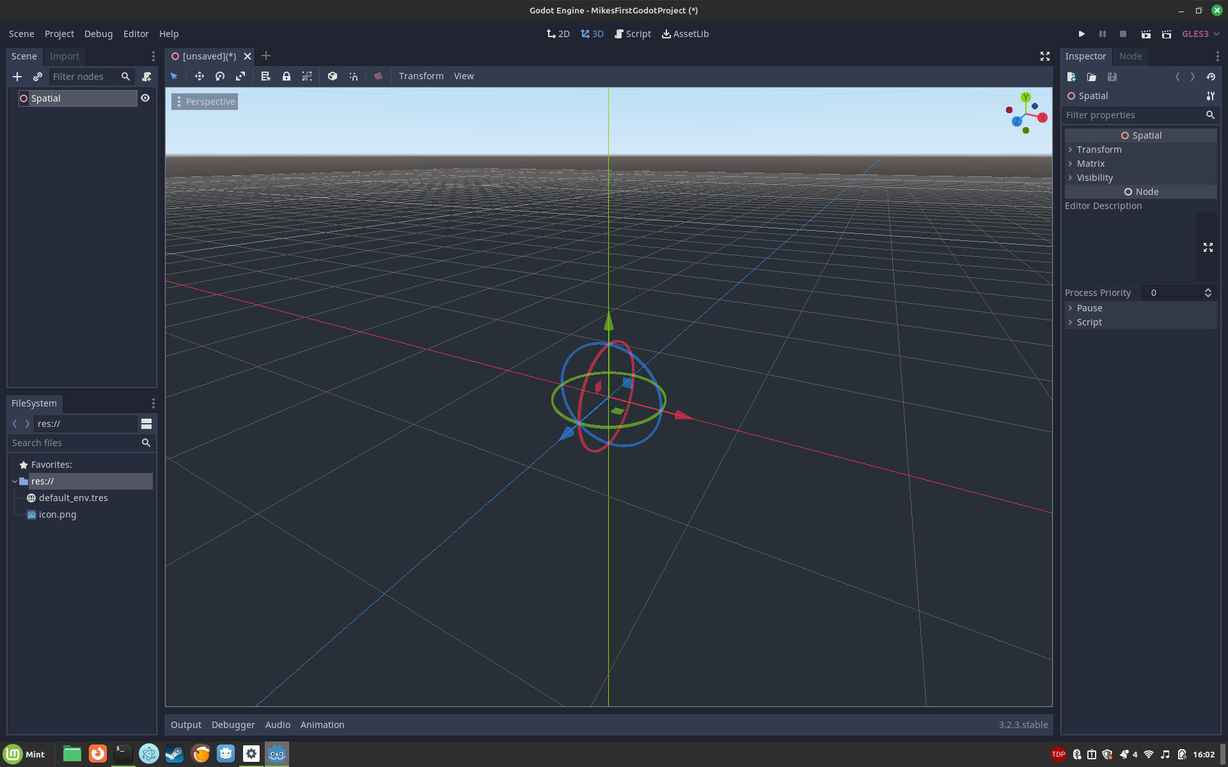
It looks like we just have a wireframe of a thing? Selecting it doesn’t show us much but offers that it’s a Spacial Node… hmmm?

Creating our 3D Plane:

First click on the “+” button in the scene section:
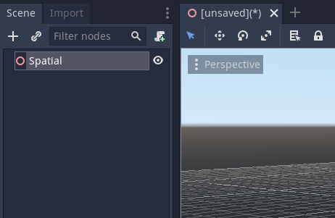

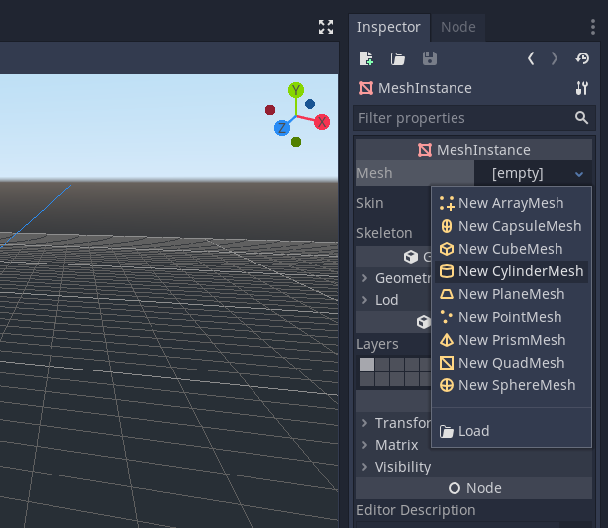

Right click on the spatial-node and click to add a child node. From here, let’s find a “MeshInstance” node and add it.

On the right-hand side there is a “properties” section for your selected object. You can here select the TYPE of mesh:

Scale it up by pressing “R” to enter scale mode and then stretching it however you’d prefer.

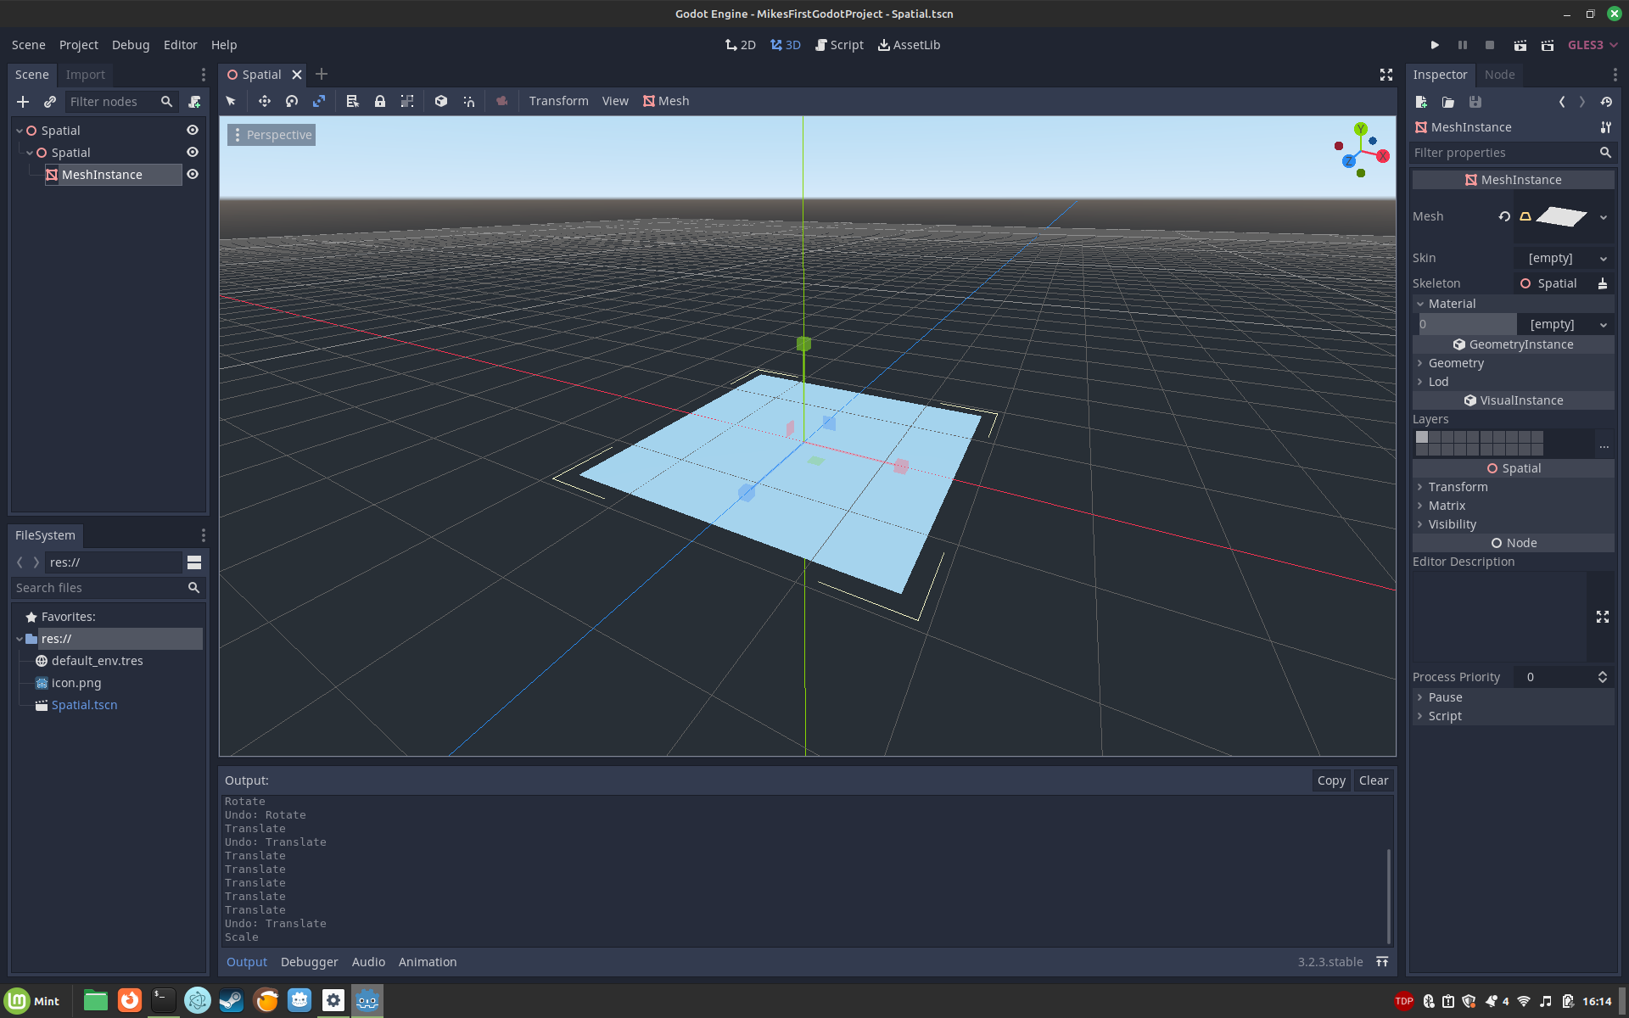

Adding our Camera:

Add the camera as another node (make sure that it’s a child of the spatial node still!)

Then adjust it using E (rotate mode) and S (scale mode) and W (move mode).

I’ve also added a “Directional Light” and aimed it at the plane.

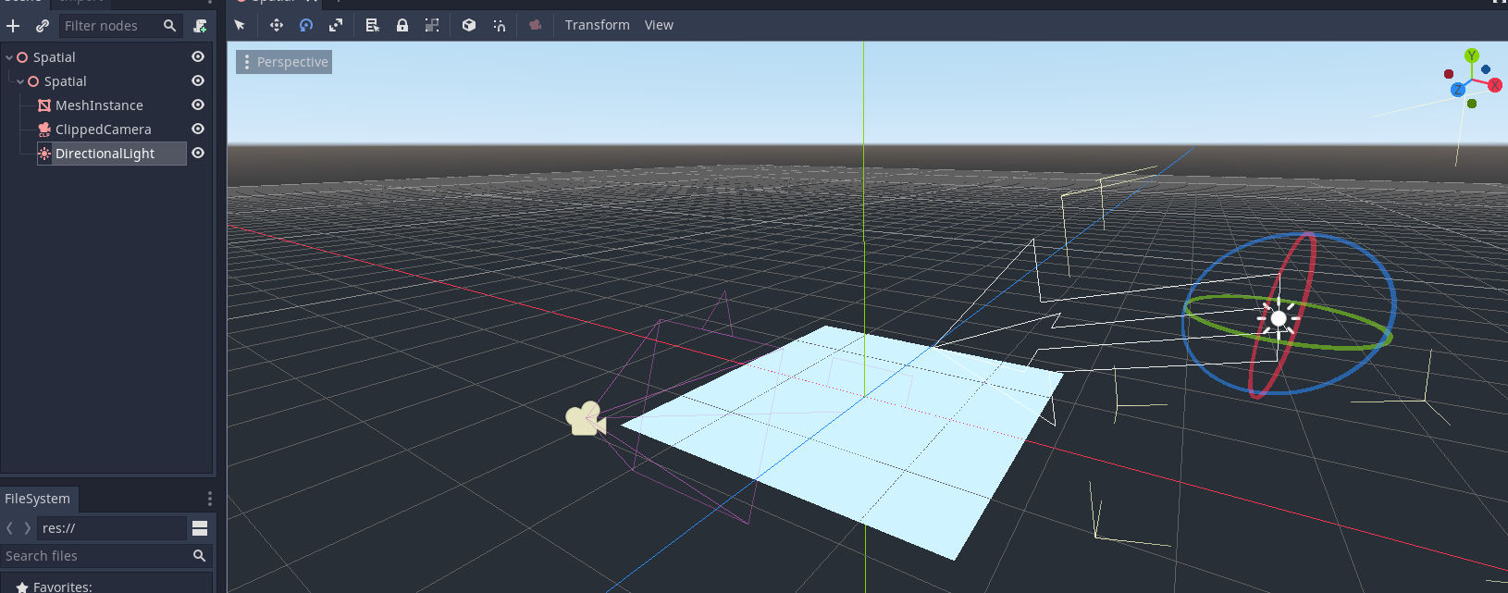

Adding a Cube:

Adding a cube is mostly review of what we’ve done so far.. Ready?

Add another node UNDER THE SPATIAL ROOT NODE. This should be a MeshInstance object, then in the properties of the new MeshInstance object make it a new CubeMesh:

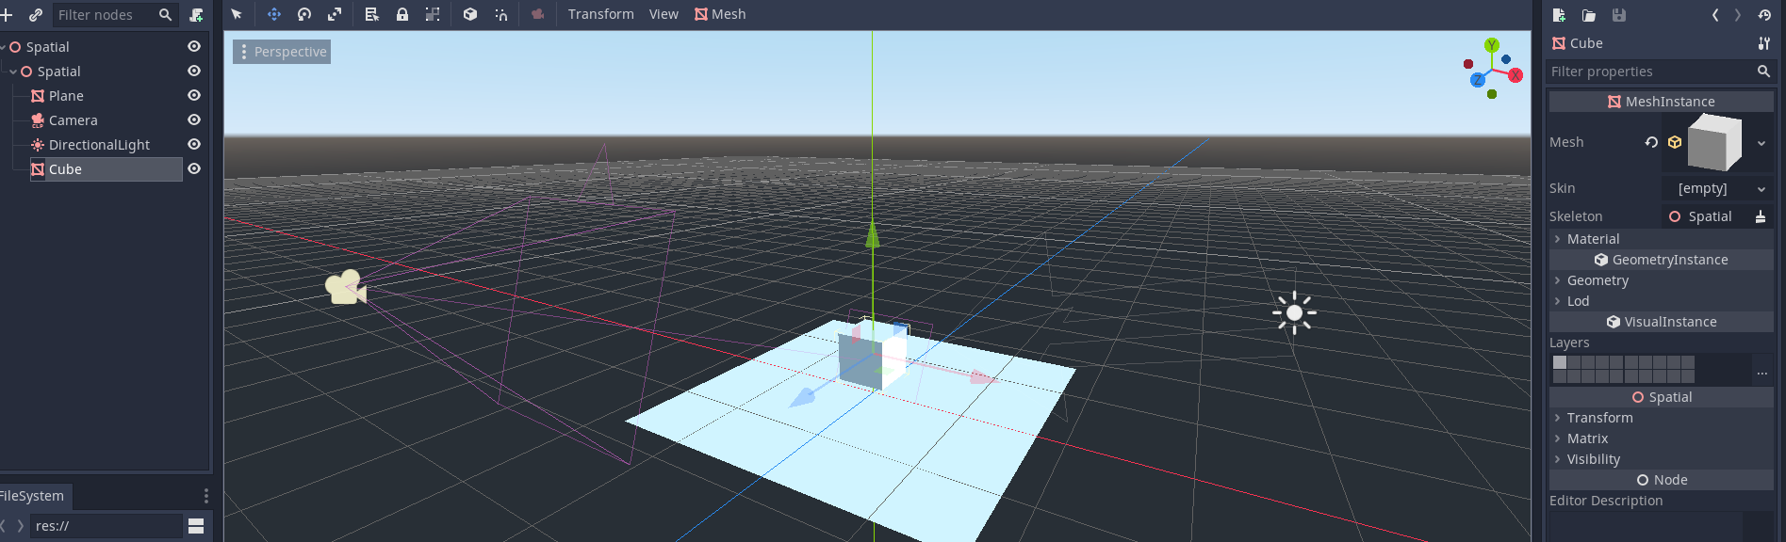

Then size it however you want.

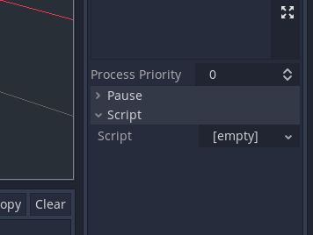
Scripting our Cube:

Now that we have a cube sitting on a plane, we need to make it DO something; ideally something that the player tells it to do. This is usually at the bottom of the “properties” tab when you’ve selected your object:

Create your new script and add the following:

func _process(delta):
var input_vector = Vector3.ZERO
if Input.is_action_pressed('ui_right'):
input_vector.x += 1
if Input.is_action_pressed('ui_left'):
input_vector.x -= 1
if Input.is_action_pressed('ui_down'):
input_vector.z += 1
if Input.is_action_pressed('ui_up'):
input_vector.z -= 1

input_vector = input_vector.normalized() * delta * 5
translate(input_vector)

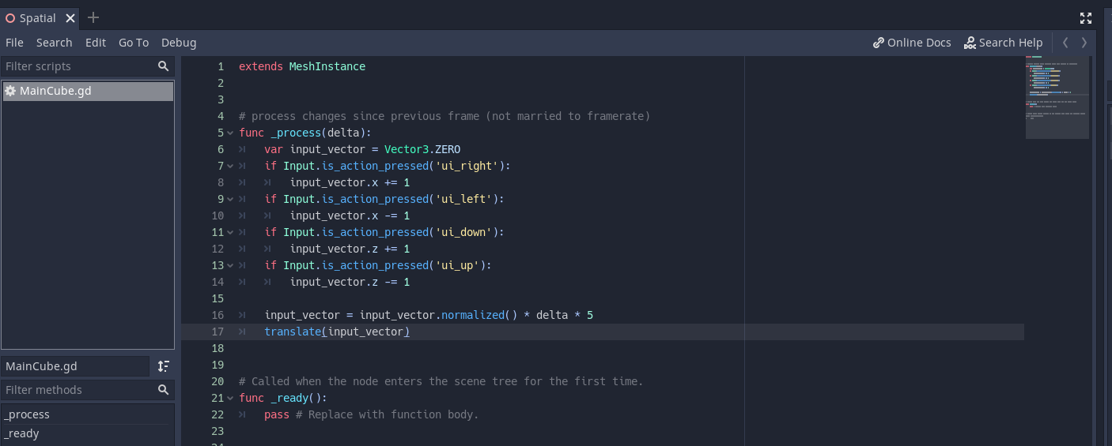

Exporting to Android:

On Debian I needed to install android adb and openjdk. Then in the editor settings I needed to set the Android settings for the jarsigner and the key and the adb executable so that Godot knew where to find them.

Make sure you also set your key’s username (alias, in the keygen command) and the password.

The command I used to generate my keyfile was:

keytool -genkey -v -keystore my-release-key.keystore -alias alias_name -keyalg RSA -keysize 2048 -validity 10000

After that it’s just project → export

And nice! I’ve got an APK that works ON MY PHONE . Would be nice if it did.. you know.. anything though.

Blender 3D models to Godot

Make your model in Blender then delete any premade camera/light objects. Do joins where possible.

Now export as .glb (some other file formats work, but this one apparently keeps textures).

Now copy this glb file into your project’s folder somewhere that you can find it.

