Pluralsight ReactJS

https://app.pluralsight.com/player?course=react-js-getting-started&author=samer-buna&name=80d0eca3-47cd-4461-a875-7b1c078659dd&clip=0&mode=live

Sandbox: jscomplete.com/playground

We’re going to learn some very basic react concepts/code. We’ll learn JSX and event handlers, data, and API’s, react hooks, communicating between components, and making a local environment in react.

No prior knowledge of React is needed, but you should be somewhat comfortable in Javascript (Objects, arrays, Variables, functions, classes, loops, conditions, etc…) - I’m going to try and dive in anyways.

React’s 3 Concepts:

1. Components – they’re like functions (sometimes they literally are just functions). You can reuse these as needed.
- input: Props, state
- output: UI
- <Component />

2. Reactive Updates – if an input changes, the UI it represents has to change as well. With react we don’t have to manage this, react will react

3. Virtual Views in memory – generates HTML using Javascript (Javascript will generate the HTML!?)

Component types – Functional Components and Class Components bost exist. The props is like a list of attributes going into a function; a state goes into a class. Props are not muteable.

JSX is not HTML:

class Hello extends React.Component {
render() {

return (
<div className=”container”>
<h1> Getting Started </h1>
</div>
);
);
}
}
ReactDOM.render(<Hello />, mountNode);

See that? We actually write the markup (JSX) in the return.

Creating a simple react component!

Let’s make a counter that can count up one by one. Head over to https://jscomplete.com/playground to get going.

Also – it’s hugely recommended to install the “React Devtools” extension for your browsers. Open your devtools and you’ll see additional information if you’re on a page that’s powered by react. You can interact with EVERYTHING in there. If you find a component responsible for something, you can change values in ELEMENTS.

Start at:

jsdrops.com/rgs1.1

Here’s what we’re starting with:

function Hello() {
return <div>Hello React!</div>;
}

ReactDOM.render(
<Hello />,
document.getElementById('mountNode'),
);

The ReactDOM library can render things for us. This element needs to exist (in here we just use mountNode).

Our Playground has JSX – it will be executed by the JSX extension and compiled into something the browser can understand. Babel is this javascript compiler. These are all wrapping “React.create” functions in actual javascript – let’s stick to JSX going forward.

Let’s change out component to Button

function Button() {
return <button>Hello React! I am mike</button>;
}

ReactDOM.render(
<Button />,
document.getElementById('mountNode'),
);

Note – components need to be uppercase.

React Hooks:

So we’ve got a stateless counter. This is neat, but we need it to have a state so we can increase this button counter each time. We need a useState()

Want to display a VALUE in JSX? Just use curly-braces! (thing f-strings in python!)

Here’s an example of us making a button that, when clicked, will log a random number to the console:

function logRandom() {
// random test function
console.log(Math.random());
}

function Button() {
// get our state (counter) and a setter() (setCounter())
const [counter, setCounter] = useState(0); // 0 is initial state value
return <button onClick={logRandom}>{counter}</button>;
}

ReactDOM.render(
<Button />,
document.getElementById('mountNode'),
);

Here’s the same one, but using ARROW FUNCTIONS instead:

function Button() {
// get our state (counter) and a setter() (setCounter())
const [counter, setCounter] = useState(0); // 0 is initial state value
return <button onClick={() => console.log(Math.random())}>{counter}</button>;
}

Arrow functions are cool quick and easy ways to insert logic into JSX without having to have defined a full function ahead of time. We’re not invoking the function here but rather defining it and passing it to onClick() .

So let’s use setcounter() instead!

function Button() {
// get our state (counter) and a setter() (setCounter())
const [counter, setCounter] = useState(0); // 0 is initial state value
return <button onClick={() => setCounter(counter+1)}>{counter}</button>;
}

ReactDOM.render(
<Button />,
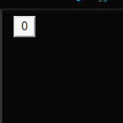
document.getElementById('mountNode'),
);

This useState(0); is a hook. React is automatically updating the browser for us. There were no transactions done. This was pretty cool actually. I can click the button and steadily increment it.

Challenge: Start counter on 5 and double it with every click (this was easy).

Improving the code:

function Button() {
const [counter, setCounter] = useState(0);
const handleClick = () => setCounter(counter+1)
return (
<button onClick={handleClick}>{counter}</button>
)
}

Now let’s say we want a very simple “Display” component which will display our number and to wrap these both in a nice App() component which will be what’s actually called in ReactDOM.render(). How will it have access to the Counter() object? Well let’s move that over to the parent component (App()).

All components have props passed in, usually we just call this arg “props”. This will be a KEY VALUE PAIR of everything passed in. Props can hold functions as well which we’ll do right now!

function Button(props) {
const handleClick = () => setCounter(counter+1)
return (
<button onClick={props.onClickFunction}>+1</button>
)
}

function Display(props) {
return (
<div>{props.message}</div>
)
}

// Main App Component (organization!)
function App() {
// let's use props to flow this data to our button!
const [counter, setCounter] = useState(0);
const incrementCounter = () => setCounter(counter+1);

// pass the "counter" to Display Component
// pass the "IncrementCounter" function to Button component
return (
<div>
<Button onClickFunction={incrementCounter}/>
<Display message={counter}/>
</div>
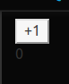
)
}

ReactDOM.render(
<React.Fragment>
<App />
</React.Fragment>,
document.getElementById('mountNode'),
);

It works perfectly! Wrapping things up in a parent component (App()) worked out very well for us here. The code is super organized and the functions are all nice and short and simple.

Components are reusable, let’s see that.

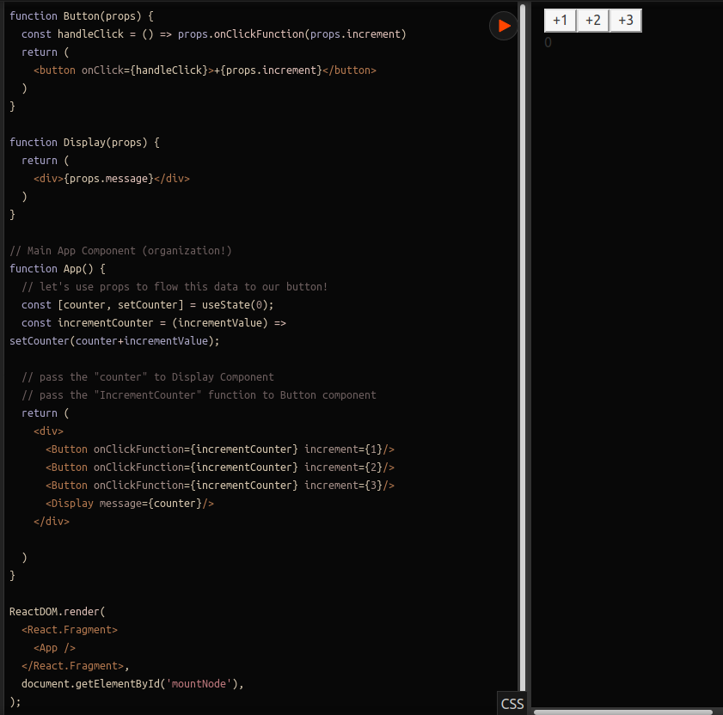
Here we’ve modified the code so that a second argument is handed into props called “increment” which will both display the number on the button and change how much the number is increased by. We changed this effortlessly.

Tree Reconciliation in Action:
https://jscomplete.com/playground/rgs1.7

document.getElementById('mountNode').innerHTML = `
<div>
Hello HTML
<input />
</div>
`;

The above is how you might render a few things in HTML. Try it out.

Now, we’re going to sacrifice some clarity for some react powered things:

ReactDOM.render(
React.createElement(
'div',
null,
'Hello React',
React.createElement('input', null),
React.createElement('pre', null, (new Date).toLocaleTimeString()),
),
document.getElementById('mountNode2'),
);

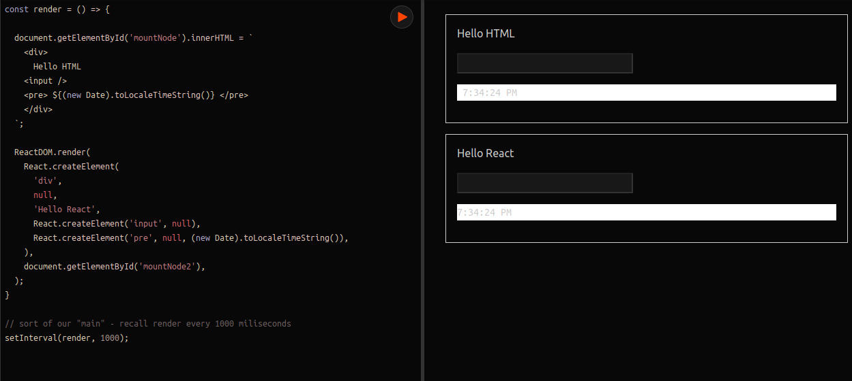
I miss the HTML already. That’s ugly, but let’s make it refresh constantly by wrapping both of these in our “render() constant arrow function”

Check it out now – we actually can type in the react version but NOT the HTML version. React is intelligent enough to only regenerate the CHANGED elements, HTML is stupid and will regenerate EVERYTHING EVERY TIME. Really cool, hope it’s worth this weird syntax. The react way removes a big layer of complexity of deciding “should I or should I not regenerate an element?!”

Summary:
A react application is a set of components. The DOM library let’s us render objects intelligently. We can write components using the react javascript api and JSX. This special react syntax is called JSX.
Props are the first object argument into components which is usually called “props”.
A component gets re-rendered when its state changes.

ReactDOM.render takes a compnent and a DOM node.

React events (onClick, onSubmit…)

Class components are coming up, for now we’re using functional components.

Modern Javascript:

Modern javascript is a very different language than it used to be. This won’t be close to complete, but it’ll be good.

Variables and Block Scopes:
https://jscomplete.com/playground/scopes

Kind of like tags, BLOCK SCOPES are super important. They’re created with a pair of curly braces.
{{{}}} // this is valid JS

Block scopes are slightly different than function scopes. In a block scope, you can access variables outside of that scope afterwards.

for (var i = 1; i <= 10; i++) {
// Block Scope
}

I can access this “I” everywhere. This is because we use the var keyword to declare it. If we want something to only exist in its block scope we’ll use the let keyword.

for (let i = 1; i <= 10; i++) {
// Block Scope
print(i);
}

Slight difference, but now we aren’t carrying all these temp variables around with us!

You can also nest block scopes. As long as you use the LET or CONST keywords, they will all take care of encapsulating their scopes.

Const means that there is a constant reference to it, but they are muteable. Scalar values like strings or integers cannot be changed because they’re changed by reference. You can, however, change values in an array because all const gaurantees is that you’re looking at the same array. The array itself can change though.

const answer1 = 42;
// BIG PROGRAM
answer1; // still holds 42

It’s usually better to use const for all of your variables unless you use temp variables (ex: index in array) in which case you’d use let. We probably won’t be using var often.

Arrow and Regular Functions:

We use arrow functions more-often. It’s got shorter syntax and cares less about “who” calls it, meaning you can kind of pass it around. The this keyword is always constant to where it’s called in a regular function, but in an ARROW FUNCTION it closes over the value of this for wherever it was defined meaning that you can pass it around! Nice. This is a big benefit for listeners.

const Y = () => {
print("hello world");
}

Y()

Easy right?

Objects and Literals:
https://jscomplete.com/playground/object-literals

There’s a few ways to make an object in javascript. The object literal syntax is suuuper simple – think python dataclasses:

const obj = {
key: value
key: value
...
}

So here’s an example:

const mystery = 'answer';
const InverseOfPI = 1 / Math.PI;

const obj = {
p1: 10,
p2: 20,
f1() {},
f2: () => {},
[mystery]: 42,
InverseOfPI, // you can just type existing variables ONCE to reuse their name+value!
};

These things all add up to keep the code short and easy to read.

Destructuring:
https://jscomplete.com/playground/destructuring

You can EXTRACT PROPERTIES outside of an object:

Instead of:
// const PI = Math.PI;
// const E = Math.E;
// const SQRT2 = Math.SQRT2;

We can use:
const {PI, E, SQRT2} = Math;

Now we have “PI”, “E”, “SQRT2” !!

This can kind of be used like keyword args! Watch this:

const circle = {
label: 'circleX',
radius: 2,
};

// precision has a default of “2” and is optional because of “={}”
const circleArea = ({radius}, {precision = 2} = {}) =>
(PI * radius * radius).toFixed(precision);

console.log(
circleArea(circle, { precision: 5 }) // outputs 12.56637
);

CircleArea becomes an arrow function extracting arg names, radius from the first object passed in (so circle.radius if you pass in a circle) and then precision as a key-value pair. Then it does the stuff.

It’s shorter and simpler. You can also set a DEFAULT value like we do here (2) and then later we call it with “5” which overrides that 2.

You can make an argument optional by using the = {} addition.

Destructuring works for arrays to. You can even skip values:

const [first, second,, forth] = [10, 20, 30, 40];

This becomes powerful when you want to pop items off of an array by using rest-spread . These are those “…” operators we keep seeing in modern javascript.

const [first, ...restOfItems] = [1, 2, 3, 4, 5];
print(first) // 1
print(restOfItems) // 2,3,4,5

This is powerful for splitting an array. You can also use this for properties of an object! Let’s destructure an existing object to clone the object with rest-spread.

const data = {
temp1: '001',
temp2: '002',
firstName: 'John',
lastName: 'Doe',
};

const {temp1, temp2, ...person} = data;

const newArray = [...restOfItems];

const newObject = {
...person
}

String Literals:

Backtick characters are called template strings. They can be used as an HTML template and you can insert any javascript inside the ${} brackets.

Javascript objects:

Javascript is an OOP language – so there’s classes, extensions, and more.

Here’s an example of making a basic class with an atrribute and a method:

class Person {
constructor(name) {
this.name = name;
}
greet() {
console.log('Hello ${this.name}!');
}
}

Pretty simple right? Honestly cleaner than a lot of other programming languages I’ve been using. Now what good would this be if I couldn’t extend it?! What’s an extension of a PERSON? How about a STUDENT?

class Person {
constructor(name) {
this.name = name;
}
greet() {
print(`Hello ${this.name}!`);
}
}

class Student extends Person {
constructor(name, level) {
super(name); // take name from person
this.level = level; // this is passed in
}
// override greet
greet() {
print(`Hello ${this.name} from ${this.level}`);
}
}

const o1 = new Person("Max");
o1.greet()
const o2 = new Student("Tina", "1st grade");
o2.greet();

Really simple, right? Every student is also a Person. We instantiate objects from classes with the new keyword.

You can use arrow-methods to override methods for certain objects after the fact:

const o3 = new Student("Mary", "2nd Grade");
o3.greet = () => {print("i am special")}
o3.greet()

Simple!

Promises:

Promises are a way to do this asynchronously. These might deliver data at a LATER point in the program.

A good example is the FETCH object (something used to hit API endpoints!”). Watch how we hit

const fetchData = () => {
fetch('https://api.github.com').then(resp => {
// .json() is a promise so we need a "then" method
resp.json().then(data => {
print(data)
})
})
}

fetchData();

And it works! Neat! But I’m not really thrilled about it. If onl there was a better way to do things using asynchronous promises…?? THERE IS.

Use the async syntax while making the function for the promise object and AWAIT on the promises within there. Watch:

const fetchData = async () => {
// waits for fetch
const resp = await fetch('https://api.github.com');

// waits for resp then waits for json()
const data = await resp.json();

// prints!
print(data);
}

Wow this is so much cleaner! Never using the old promise types again (I wonder if this is available in Angular for Typescript??).

Let’s build a simple github card decoder! That’s right, we’re actually going to be making react stuff now.

We’re going to be using Class Components for this. It’s possible that functional state-components will be used in the future; you should be comfortable with both (and we’ll use both in the later apps). This is going to be fun.

React Class Component:

Here we’re going to make a basic component for our title.

We usually start with what makes sense for us. It’s nice to blueprint, but sometimes you’ve just got to get started. Let’s start with just something – like a title class. We’re going to be using a list of cards, each card representing a github user.

Let’s use a class for a component. Let’s start out simple:

class App extends React.Component {}

See that EXTENDS keyword? We know what this is now – it’s basically inheritance. Every react class needs a render function. Instead of receiving props, the class will get a state and it will “just work” believe it or not.
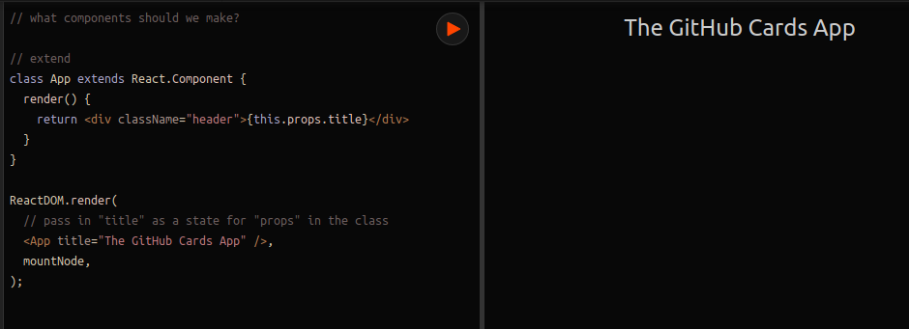

Do you see that? We don’t really pass props in anywhere however everything passed in the tags (example: title=”The Github Cards App”) is available in a key-value store called “props” in “this” which is an attribute of the class. Cool.

Let’s make a “Card” component for our cards that just has some dummy-texxt at first and then just like before, we’ll make a WRAPPER CONTAINER for all of this called “App”.

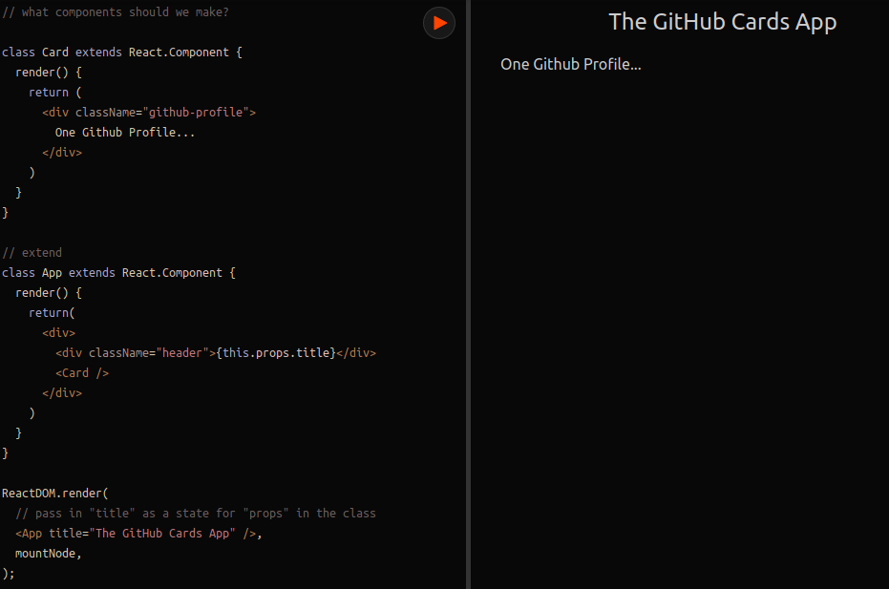

Hey I kinda get it. This is cool. Look how simple it all comes together in the App component which wraps the other components.

Now let’s add some markup. This course isn’t on HTML in any way, so we’re just kinda gonna toss it all in there without discussing it much.

class Card extends React.Component {
render() {
return (
<div className="github-profile">
<img src="https://placehold.it/75" />
<div className="info">
<div className="name">Name here...</div>
<div className="company">Company here...</div>
</div>
</div>
)
}
}

It’s useful to assign classnames to absolutely everything for later when you’re styling it up with CSS.

Styling React Components without a Global Stylesheet:
https://jscomplete.com/playground/rgs2.2

We can style react components without a global CSS stylesheet. You probably don’t even need class names if you end up doing styling this way. We’re going to use the “style” attribute and use an object literal inside of jsx syntax (this ends up looking like double curlys {{ }}).
Let’s take a look at this.

<div className="github-profile" style={{ magrin: '1rem' }}>
<img src="https://placehold.it/75" />
<div className="info" style={{display:'inline-block', marginLeft: 10}}>
<div className="name">Name here...</div>
<div className="company">Company here...</div>
</div>
</div>
);

This feels like using in-line styles which a lot of people don’t like; but it’s javascript – we can use conditional styles this way, we can put LOGIC into our stylings through javascript styles. We have total control this way.
For CSS global files; you should probably use these for things that you want to be styled everywhere.
There are many options for using javascript to style your components.

Working With Data in ReactJS:
https://jsdrops.com/rgs2.3

So now we’ve got a test data query and a const for testData once we’re done with that.

Let’s manage the state of the application in CardList for now and we’ll write this as a function.

const CardList = (props) => (
<div>
<Card />
</div>
);

Now let’s put some real data in there – we’re using out TESTDATA constant object.

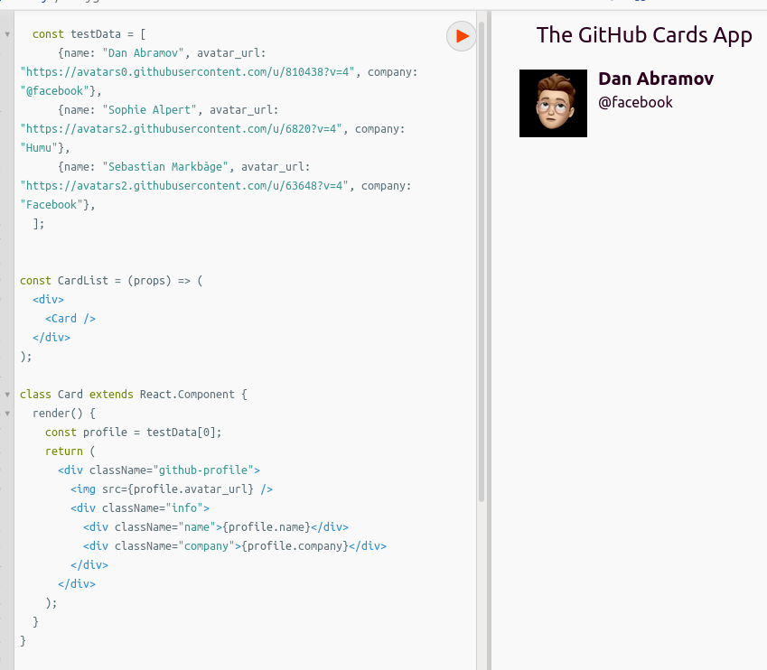
So right now we’re just faking it, making a constant data and rendering a singe card component using TestData[0] as profile – but look how easy that was! Can you guess what’s coming next? Let’s make it reusable. All cards right now will fetch the first user’s information. Let’s make the card component get its data through its props.

We can use the spread operator to spread out the props from our key-value pair object and it will show up simply as PROPS. Watch. Let’s loop over our list of objects with .map()

const CardList = (props) => (
<div>
{testData.map(profile => <Card {...profile}/>)}
</div>
);

Look at this! Handled in a single line. We use “map” on our iterable object and say basically “for each” profile => <Card {...profile}/>
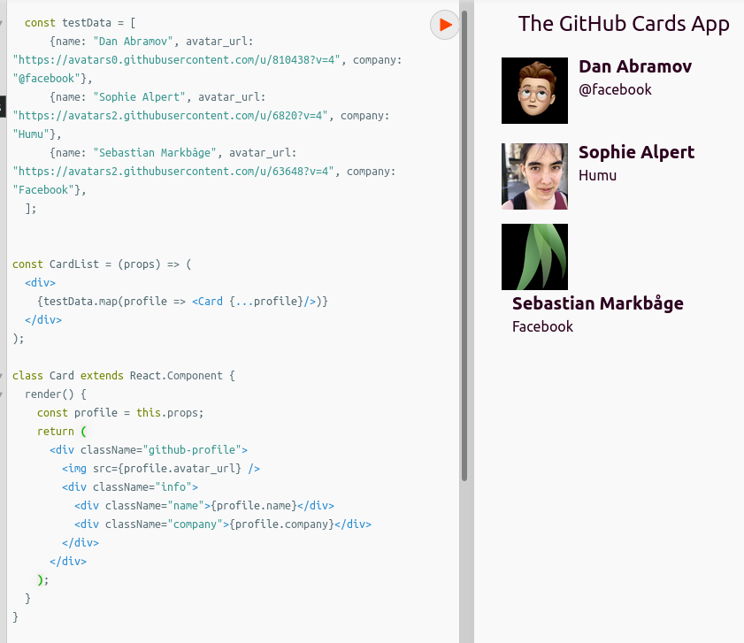

Awesome! Let’s move onwards.

Initialize and Read the State Object:
https://jscomplete.com/playground/rgs2.4

What I really want to do now is to make a new component which will take an input from the user. So first we’re going to have to make a simple new component which will represent our FORM (html magic).
Here’s what that will look like:

class Form extends React.Component {
render () {
<form action="">
<input type="text" placeholder="Github Username"/>
<button>Add Card</button>
</form>
}
}

Nice. Simple enough (even if it doesn’t do anything yet) – we’ve got to render it though.

We could put this anywhere really, but conceptually we want to put this up in the App() component. Works great so far. The app component will now be responsible for getting data from the Form component to the Cards components.

Let’s add a prop names profiles which will pass our testData in rather than just leaving it as sojme big global. This will set us up for when we dynamically get our data. So in our App component let’s add the attribute to CardList to add profiles to props.

<CardList profiles={testData}/>

Now over in our CardList component let’s stop using the global and start using what was passed in as a prop:

<div>
{props.profiles.map(profile => <Card {...profile}/>)}
</div>

Great! Test it out and… everything works perfectly. Now we want to trigger changes when the profiles object changes.

We can manage the state of the profiles in the CardList itself. So how will we do this? We’ll be using the constructor method for the App component and call the super() method to use the generic props logic from React.Component (which it extends).

class App extends React.Component {

constructor(props) {
super(props);
this.state = {
profiles: testData,
}
}

render() {
return (
<div>
<div className="header">{this.props.title}</div>
<Form />
<CardList profiles={this.state.profiles}/>
</div>
);
}
}

Look at that! Our app component now has a state stored in “this” – and it’s initialized as testData at first, but now that we pass the APP STATE in instead of TestData as a prop to our CardsList it will change when changed (reacting). Super. Everything still works, but we’re set up so that if the “profiles” object in the App Component’s State changes, all child components will REACT accordingly (get it?).

Taking in User Input:
https://jscomplete.com/playground/rgs2.5

Alright it’s time to make this somewhat interactive.

We’re going to trigger the “lookup” on the onSubmit event in the input tags on the Form component.

We can get REFERECES to our elements (fancy internal react ID’s).

Here’s what we’ve got to start with:

class Form extends React.Component {

// create ref object
userNameInput = React.createRef();
handleSubmit = (event) => {
print("submit was clicked!");
print(`usernameinput is ${this.userNameInput.current.value}`)
event.preventDefault(); // prevent page from refreshing
};
render() {
return (
<form action="" onSubmit={this.handleSubmit}>
<input type="text" placeholder="GitHub username"
ref={this.userNameInput}/>
<button>Add card</button>
</form>
);
}
}

Let’s show some controlled components instead though. This, instead of using a ref, will create something attached to a state in our Form app that we can control… but we can’t type in the field anymore because React is controlling it. This is why we need an onChange event!

<form action="" onSubmit={this.handleSubmit}>
<input type="text" placeholder="GitHub username"
value = {this.state.userName}
onChange = {event=>this.setState( { userName: event.target.value} )}/>
<button>Add card</button>
</form>

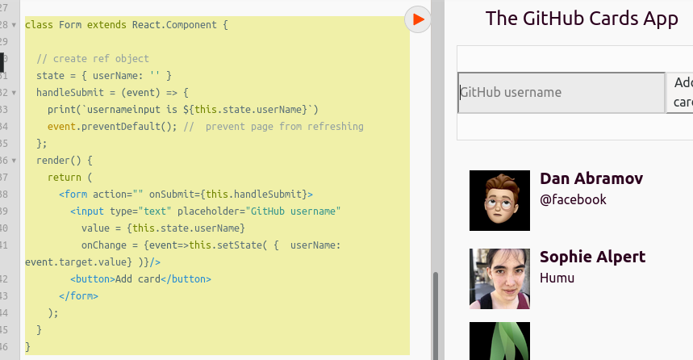
This is what we need to do to have a controlled component.

React is aware of these changes in State – we don’t have to worry about reloads or similar, this is handling this all through states just like anything else. When it comes to states, React will React.

This method is valuable if you need to provide some form of feedback as the user is typing.

Using and API in React with Axios:
https://jscomplete.com/playground/rgs2.6

Axios is a simple library to use and is included in the React library. We’re going to do a simple get request in a template string (backticks) so we can insert the javascript variable we need.

We’ll need to insert Async into our func declaration and await in the request as this returns a PROMISE object we’ll want to wait for. This should hava a “data” object that’s pased and ready for us. Now all we have to do is get this “data” to our list of profiles. Form right now can’t change the state of its parent :(
If the APP COMPONENT passes a function reference to the FORM COMPONENT, we can call it from there and change things from app!

Holy crap it works!

Here is the entire app:
// gaearon, sophiebits, sebmarkbage, bvaughn
const testData = [
{name: "Dan Abramov", avatar_url: "https://avatars0.githubusercontent.com/u/810438?v=4", company: "@facebook"},
{name: "Sophie Alpert", avatar_url: "https://avatars2.githubusercontent.com/u/6820?v=4", company: "Humu"},
{name: "Sebastian Markbåge", avatar_url: "https://avatars2.githubusercontent.com/u/63648?v=4", company: "Facebook"},
];

const CardList = (props) => (
<div>
{props.profiles.map(profile => <Card {...profile}/>)}
</div>
);

class Card extends React.Component {
render() {
const profile = this.props;
return (
<div className="github-profile">
<img src={profile.avatar_url} />
<div className="info">
<div className="name">{profile.name}</div>
<div className="company">{profile.company}</div>
</div>
</div>
);
}
}

class Form extends React.Component {
state = { userName: '' };
handleSubmit = async (event) => {
print("handling")
event.preventDefault();
const resp = await axios.get(`https://api.github.com/users/${this.state.userName}`)
print("got a response")
this.props.onSubmit(resp.data);
this.setState({userName: ''}) // reset text box on submit
};
render() {
return (
<form onSubmit={this.handleSubmit}>
<input
type="text"
value={this.state.userName}
onChange={event => this.setState({ userName: event.target.value })}
placeholder="GitHub username"
required
/>
<button>Add card</button>
</form>
);
}
}

class App extends React.Component {
state = {
profiles: testData,
};
// pass to form so we can define profile data
addNewProfile = (profileData) => {
this.setState(prevState => ({
// basically an "append"!
profiles: [...prevState.profiles, profileData]
}))
}
render() {
return (
<div>
<div className="header">{this.props.title}</div>
<Form onSubmit={this.addNewProfile}/>
<CardList profiles={this.state.profiles} />
</div>
);
}
}

ReactDOM.render(
<App title="The GitHub Cards App" />,
mountNode,
);

I think I get it. This makes a good deal of sense.

There is another important improvement that we need. React is giving us warnings about key props. Whenever you do this, react will give you a warning that you need to give an identity to certain elements. You can pass a key property that is unique to prevent this issue.
In cards list we can add:
key={profile.id}

And we’ll be good to go.

Something important we need is some sense of ERROR HANDLING. But we will get to that later, it is a more advanced issue apparently…

A component should not entirely have all of this responsibility. Ideally you should have an AGENT module that handles all of your axios communication between API’s (example github).

Final code is in:
https://jscomplete.com/playground/rgs2.7

