React (but with Typescript!)
https://www.youtube.com/watch?v=F2JCjVSZlG0

This tutoial was based on one made for “freecodecamp” - the goal will be to build a “quiz” app. Very simple, looks to be only one or two components. All built with React + Typescript.

Setting up the project:

We’re going to bootstrap to set up with create-react-app but with an extra arugment this time in order to use typescript from the start.

First we’ll want to upgrade node. Typescript bootstrapping starts at version 10. we’ll need node’s package manager, “n”

npm install -g n

Update node to the latest stable branch with:

n stable

Now:

npx create-react-app my-app –template typescript

Let this go and set it up. CD into the newly created directory and use “npm start” and it should launch your browser with the demo page. Awesome, ready to go.

Let’s clean up a bit. We won’t need:
- App.test.tsx
- setupTests.ts
- serviceworker.ts
- logo.svg
- index.css

Then go through and remove all of our imports for things that no longer exist.

We’re going to be styling through STYLE COMPONENTS.

Styled Components:

We’re going to need Styled Components AS WELL AS the types for styled components (we are using typescript, after all!)

npm i styled-components @types/styled-components

Start our app up to make sure nothing is broken yet.

function App() {
return <div className='App'>Quiz</div>;
}

export default App;

Above is what our app currently looks like:

Now I’m wanting to use a nice background for our static image. To stay organized let’s make an “images” file under our source directory:

mkdir images

And I‘m going to toss a random beach-looking image in there from google, so that’ll go in images/beach.jpeg.

I also want to use a 700-weight Catamaran Font. This can be found and explored on Google Fonts.

Now we are going to be using a great open API to practice – the OPEN TRIVIA API – this will be able to provide trivia questions and answers via http requests. Awesome.

https://opentdb.com/api_config.php

You build and get your URL to use! Check this out, for example:

https://opentdb.com/api.php?amount=10&difficulty=medium&type=multiple

There’s our “backend” - so now nothing left to do but to actually build the thing out. We’re all set up and ready to go!

The Logic:

Let’s get organized – create a new folder called “components” and a file inside of it called “QuestionCard.tsx”

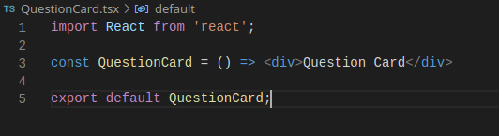
We’ll set this up as a skeleton to start with – it’s a functional component (arrow function) returning a single div with some text and then exporting itself. Easy enough.

Now let’s make two files inside of our src folder.
- API.ts
- utils.ts

These should be self-explanatory. One will be reusable utils, the API will contain logic for fetching the quesitons.

Let’s make our way over to App.tsx and convert what we have to an arrow function (optional!)

So first of all here’s what my App.tsx layout looks like:
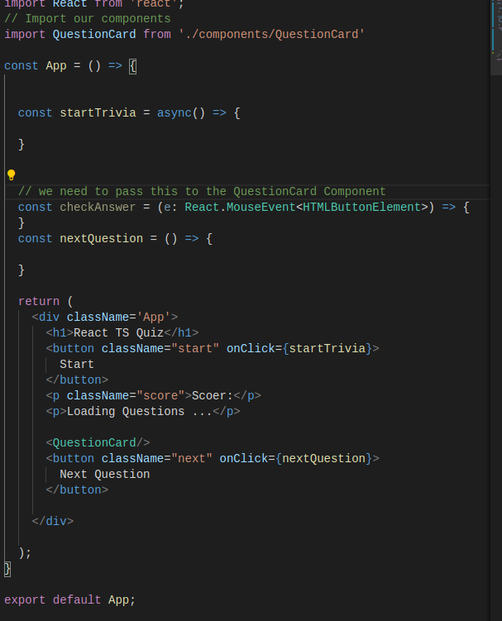
Notice nothing crazy yet besides needing to explicitly type the event argument to our checkAnswer function (a typescript special).

Now our one custom component so far is the QuestionCard – this is where things get interesting compared to JS as we’re going to have to define our props object rather than take in an ANY type.

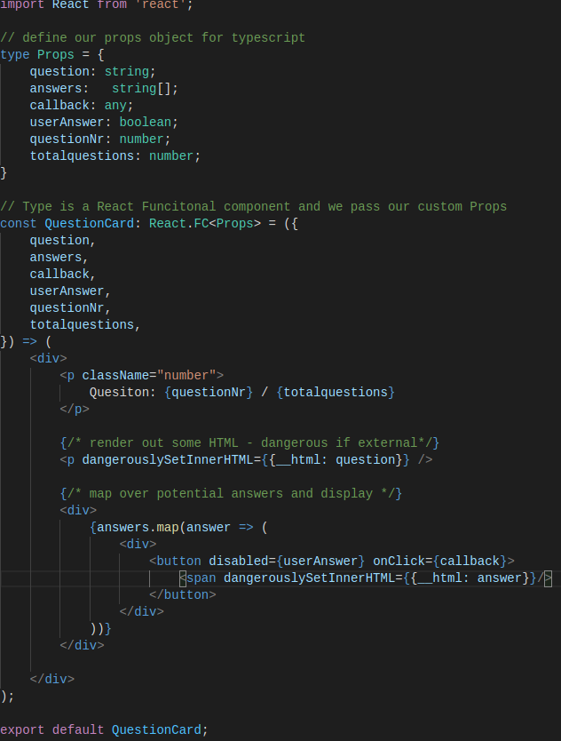
Notice here we define our props as a totally separate type and then we have to pass it in, re-declaring all of the attributes this type will have when we accept it as an argument. Also note we have to declare that QusetionCard is hard-typed as a Functional Component (React.FC).

We’ve got some simple logic and are rendering some html which will belong to our “answer” objects with dangerouslySetInnerHTML (never use this if this can come from something external!).

Now it’s time to pass these props where we’re using our QuesitonCard component, back over in App.tsx.

States:

Before we do this, let’s make some states. ReactTS and hooks let us use smaller states.

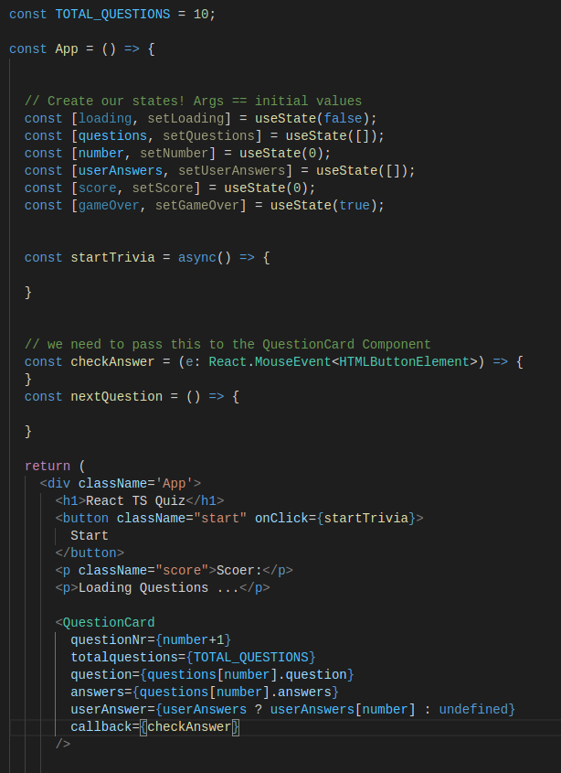
Here we’ve set up our states to be used later and now we’re passing in the relevant args to QuestionCard. But wait, we don’t have “question” or “answers” defined yet. Soon to come.

The API Utils:

29 minutes and 30 seconds in.

