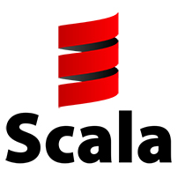
Tour of Scala

Tour:
https://docs.scala-lang.org/tour/tour-of-scala.html

Intro:
Scala is an attempt to combine object-oriented and functional programming into a high-level language. It should be easy to use and it compiles down to and runs in JVM’s. This language is supposed to be completely compatible with Java and should have very high-performance. It’s goal is to combine common programming patterns in a precise and type-safe way. Let’s see.

Installing Scala:

Currently on Bhodi Linux, Scala was out and available in the universe repos for a simple:

sudo apt install scala

No issues there. Let’s get right to it.

Hello World:

Hello world is a tad more-confusing than in other languages.

object HelloWorld {
def main(args:Array[String]): Unit = {
println(“Hello, World!”)
}
}

So… a lot going on for a very simple program. We make a HelloWorld object which we want to expose to our Scala compiler, Scalac (more on that in a moment). This object has a method which accepts an array of strings as an argument, and returns a Unit (I think? let’s keep going). Afterwards it finally gets to something relatable and prints “Hello World”.

To compile this we run from the command line:

scalac hello_world.scala # (what I named the program)

Scala programs end in the “scala” extension traditionally.
If we look in our current directory we have two new files. “HelloWorld.class” and HelloWorld$.class”. I’m not sure what this is yet, but if they are in our $PATH and we run “scala HelloWorld” from the command line, we get….

“hello, world!”

NOTE: for the beginning of this tour, I’m mostly going to be working in an INTERACTIVE SCALA SHELL (just run scala from the command-line).

Expressions:
Expressions work like any other languages. They’re computables and can be applied to numbers or strings.

scala> 1+1
res0: Int = 2

scala> "hello" + "world"
res1: String = helloworld

Simple-enough, that’s the norm.

Values:
NOT TO BE CONFUSED WITH VARIABLES – values are static objects that cannot be reassigned. You declare them with the “val” keyword:

scala> val x = 1 + 1
scala> println(x)
2

Notice that these values are constants and CANNOT be changed:

scala> x = 3
<console>:12: error: reassignment to val
x = 3

Types of values are inferred (like python, or Go’s := operator) BUT you can explicitly state the type using a colon as well:

scala> val x: Int = 1 + 1
scala> println(x)
2

Variables:
Variables are a lot like values, only they can be changed after they are declared. The difference is the keyword used in declaring them, which is “var” now”.

scala> var x: Int = 1+1
scala> println(x)
2

Variables in Scala can be reassigned, unlike values which act as constants.

scala> x = 5
x: Int = 5

Blocks:

You can use blocks which will return the LAST-RETURNED-VALUE in the block. Let’s use a BLOCK in the PRINTLN function:

scala> println( {
| val x = 1 + 1
| x - 2
| x + 5
| x * 2
| })
4

(note, the pipes are added by the interpreter, in reality it looks like):

println( { val x = 1 + 1
x – 2
x + 5
x * 2
})

Notice that all of the other returns are ignored except for the last one. We used this example for Println, but blocks can be used absolutely anywhere in Scala.

Functions:

Functions accept arguments and either do or return something.

Functions do tasks which are quick and repeatable and we can make and use later. Here’s an example of one of those in-action:

// create out function “addOne” which accepts an integer, and returns one-greater
scala> val addOne = (y: Int) => y + 1
scala> print(addOne(5))
6

We have a VALUE (makes more sense for these, why keep changing variables of cuntions?) that’s equal to a very simple function we can call over and over again to improve readability.

Methods:

Methods look and act a lot like functions, but there’s a few differences.
Method syntax is def <method-name>(var1: type, var2: type,…): returntype = FUNC

scala> def double(num: Int): Int = num * 2
scala> double(5)
res7: Int = 10

Here I declare my method “double” method and call it, passing it the arg “5”.

As with any other language, Scala can be multi-line:

def getSquareString(input: Double): String = {
val square = input * input
square.toString // casting?!
}
scala> getSquareString(2)
res8: String = 4.0
Very cool. Also notice how easy type-casting is in Scala. This is a pretty neat language so far, but we’ve only really seen the basics.
Scala DOES have a return keyword, but it’s rarely used. Just have it be the return of the last line in your BLOCK.

Classes:

You can define custom classes with the “class” keyword” followed by its name and constructor parameters.

scala> class Greeter(prefix: String, suffix: String) {
def greet(name: String): Unit =
println(prefix + name + suffix)
}
defined class Greeter
scala> my_greeter.gree("scala dev!")
Hello, scala dev!!

What’s “Unit” ? It’s like “void” as a return-type in other functions. This means this Unit DOES something but does not RETURN something. Printing DOES something but does not RETURN anything. Get it?
Seems simple-enough. The syntax isn’t bad at all, constructors are exactly like args are passed into a function/method definition and inside of the block are all of its functions/methods.

Case Classes:

Scala also has a special type of classes call “case classes”. These are immutable and compared by-value. They are the same as classes, only you can get equivilancy when comparing them if their values are the same.

scala> case class Point(x: Int, y: Int)
defined class Point

scala> val firstpoint = Point(1,2)
firstpoint: Point = Point(1,2)

scala> val secondpoint = Point(1,2)
secondpoint: Point = Point(1,2)

scala> val thirdpoint = Point(2,3)
thirdpoint: Point = Point(2,3)

And now let’s compare them with a conditional, which, by the way, uses the exact same syntax as Go and C# and the sorts:

scala> if (firstpoint == secondpoint) {
| println("yeah")
| }
yeah

Simple enough. The exact same as classes only you can compare by values even though they aren’t the same object…. And speaking of objects…

Objects:

Objects are single instances of their own definitions. Remember how in Go you could create anonymous structs? Well you can do that here in Scala as well!

Here I don’t need a class for my “IdFactory”, an object that’ll generate fresh ID’s, I just need one single instance. I can do that with the Object keyword!

scala> object IdFactory {
| private var counter = 0
| def create(): Int = {
| counter += 1
| counter
| }
| }
and tada…
scala> println(IdFactory.create())
1
scala> println(IdFactory.create())
2
scala> println(IdFactory.create())
3

So, don’t be in a habit of defining classes when you really just need a single object.

Traits:

Traits are another class-esque thing. It serves as kind of a blueprint for classes and objects to come. Let’s watch them in-action:

scala> trait Greeter {
| def greet(name: String): Unit =
| println("Hello" + name + "!")
| }

Alright so we’ve defined our Greeter. Now we can’t really do much with this, you can’t make objects from them… BUT we can make classes from them. Let’s make two, one being a default greeter, and one being a custom greeter!

First up, the default greeter:

scala> class DefaultGreeter extends Greeter
scala> val greeter = new DefaultGreeter()
scala> greeter.greet("steve")
Hellosteve!

Next up, a custom one where we override a value or method of our TRAIT.c

scala> class CustomGreeter(prefix: String, postfix: String) extends Greeter {
| override def greet(name: String): Unit = {
| println(prefix + name + postfix)
| }
| }

Pretty cool. We’ve extended DefaultGreeter to use multiple traits and have a different method, even though we kept the same Trait.

Main:

The Main Method needs to be defined within an object (Main as well) which will run as soon as your program runs. It works like the main method of other languages.

object Main {
def main(args:Array[String]): Unit =
println("Hello, Scala Dev!")
}

Here, “args” is an array of strings, meaning the commandline args that can possibly be passed into this program when it’s run.

We compile using:

scalac main_test.scala

And now I can run it with:

$ scala Main
Hello, Scala Dev!

Very cool. Now going forward, we will be able to write these examples into scripts instead of just through a Scala interactive session.

Scala Type Hierarchy:

Scala types have a hierarchy and it’s fairly simple to get how it works:
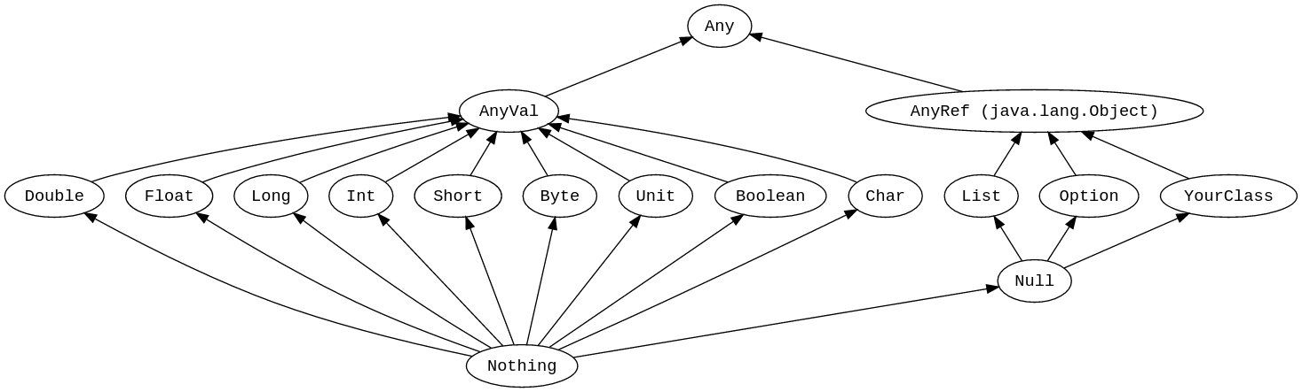
Anything UNDER a value can be used in place of that value.

Have a list of type ANY? You can fill it with an Int, Byte, Short, etc…

Have a variable of type Int ? You can fill it with a “Nothing” type!

Type Casting:

Value Types can be cast very easily type-casted:

def typecast(): Unit =
{
/* example of typecasting in Scala
*/
val x: Long = 12345678
val y: Float = x
println(x)
println(y)
print(x.toString)
}

Simply make a new variable hard-typed to the type you want it to become. Some even have values like “int.toString”

Nothing and Null:

Nothing is the bottom type on the Scala Type Hierarchy. No object has type Nothing. To assign or use “Nothing” you use “None” (kind of like in Python).

