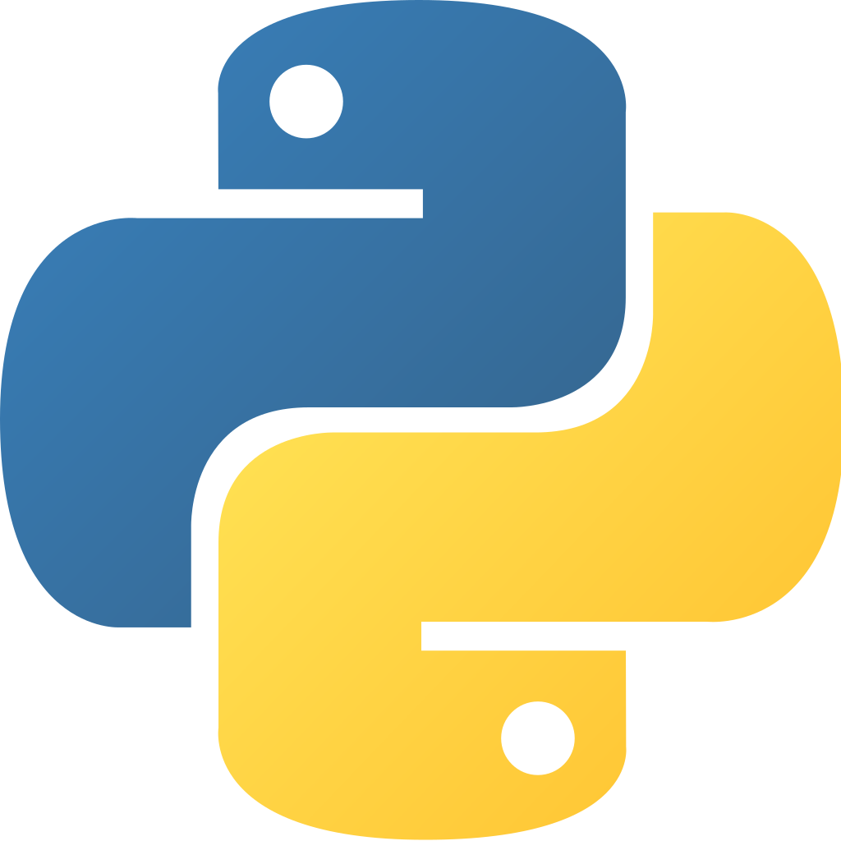
Python

Introduction:
First we’ll learn data types, functions, classes, and some python-only features. We’ll be working on a console application that we turn into a web application at the very end.
Python is simple, beautiful, and powerful. It’s also cross-platform and will work on most major operating systems. You can use python to automate just about anything – even artificial intelligence. Basic general programming knowledge is appreciated. Even if you know python, the course is very useful and recommended. In the end, you’ll see how simple it is AND how amazing it is.

Why is python so great?
Python can do A LOT of things. Did you want to automate some boring tasks like parsing csv files? Easy!
Complex scientific computaiton? Sure.
Cross-platform desktop applications for every opterating systems? Python.
Android? Python.
Website backends? Python+Django!
Want an app that recognizes pictures and categorizes them? Machine learning.
Python+PyQ work to make cross-platform web applications.
Python is also very very simple to write! Python uses whitespace as syntax so it forces you to write readable code which is very nice. Python uses indentation!
PEP8 is a coding principle that decides how you have to write your code to be readable. Be sure to check this out and learn about integrating it into git hooks!

Python 2 vs Python 3:
Which version should you use? The eternal debate. Forums are full of people fighting about either, but in reality, just use python 3 (oh?).
Python3 adoption did not go as smoothly as they had hoped (2.7 mainly). 2.7.13 is not ancient, it’s December 2016. Python2 will reach EOL in 2020!
Python 3 adds new features and tricks. It was released in december of 2008 and it’s still not fuly-adopted – there’s not many differences except for some syntax.
Python 2 treated print as a STATEMENT python3 treated it as a function.
print “hello world” vs print(“hello world”)
This course will be using python 3.6! Most of the course will work fine with python2.7 though. Let’s learn 3.3.

Installing Python:
Install from a package manager for linux and install from python.org if you’re using windows.
Also install ‘sudo apt-get install idle3’ this is important and doesn’t necessarily ship with linux distros that already have python on them.

Getting Started:
Now we’ve got the interpreter tool in our terminal. You have access to the entire python programming here (this is different than compiled languages). Think of this as a ‘python console’ for your developer tools. Now we can test small bits of functions in the interpreter!
The drackback is that every python program we run NEEDS a python command (the shebang).
Towards the end of this course you’ll learn to package your application “like a .exe” so you can run it on any operating system.
You should run idle3 as your python ide. Do open it simply search your machine for it – this is the official python ide (supposedly). It’s the same as if you type python in your terminal – the advantage is that you get highlighting and code-completion, but all at a pretty basic level…
We’ll be using idle3 for the beginning of the course just to get familiar with the basics.

Pycham:
Later on we’ll need to use some more-advanced python tools (sadly). This is one of the industry favorites and there is a FREE community edition! Any text editor will work just fine. For the purpose of this course we’ll be using pycharm. I’m going to stick with spyder, however.
Once you download, install, and start it create a new project and make sure that “Pure Python” is selected (for now).
Pycharm has virtual environments (EXTREMELY powerful) which are an amazing part of python – we will learn about them in the future of this course.
Now without further ado – let’s get coding.

Types Statements and Other Goodies:
We’re going to see some python code now – we’re going to look at the built-in data types, flow-control statements, loops, lists, and dictionaries (resembles json) and some try/except as well. We will touch on other datatypes as well!
By rhe end of this module you will be able to learn the rest of the data types by yourself. In the end you’ll see it’s not as much something you’d need to stress about nearly as much as other programming languages.

Types in Python:
With most programming languages you’ll need to declare a variable TYPE. With python it’s not-necessary to declare a type anywhere! Python also does not have as many types as C# or Java. There are certain advantages and disadvantages to this approach.
Many argue that dynamically-typed languages (python) speed up development, but it becomes difficult when you’re dealing with so-many of your own custom types. Not declaring types up-ahead can lead to many subtle bugs.
TYPE HINTING – relatively new, added in python3.5

def add_numbers(a: int, b: int) → int:
return a + b

Wow that’s pretty cool! It’s a way of showing interpreters that before you enter the function you must take in ints as args!

Integers and Floats:
Integers are numbers.
Floats are decimal numbers. Very easy.
# integer
answer = 42
# float
pi = 3.14159
# don’t worry about conversion!
answer + pi = 45.14159
float(answer) == 42.0 # true

Strings:
Ascii text in python2 and unicode text in python3 (REMEMBER THIS).
There is NO difference between:
‘Hello World’
“Hello World”
“””Hello World”””
“””Hello
World”””
Defining strings is super simple. They support a TON of methods including:
- capitalized()
- relplace(‘replace me’, ‘replaced’)
- isalpha()
  - is it alphabetical
- isdigit()
  - is my string able to be converted into an int?
- .split(“,”)
  - split by commas
String format is a powerful string function.

name - “PythonBo”
machine = “HAL”
“Nice to meet you {0}. I am {1}”.format(name, machine) #FINALLY

You write your whole string statement and then {0} will be the first arg {1} will be the second arg and so-on and so-on forever! Format is insanely powerful, you need to start using it for this.

String interproplation is also pretty useful:
# notice the ‘u’ and the ‘f’ before the string change it!
u”this is a unicode string”
# ‘f’ before the string lets you use variables IN the double quotes
f”Nice to meet you {name}. I am {machine}”

Boolean and None:
Booleans are a True or False value. Just type the name and assign it True or False. It’s used with flags with if-statements. Common for “has this been completed yet?”

python_course = True
java_course = False
# you can convert true or false to ints
int(python_course) == 1

None variables are variables that you’ve defined but given no value to (great if you don’t know what type it will be later!

# we want to create the variable but are not sure for later
aliens_found = None

If-Statements:
== is an equality-check.
‘is’ checks if they’re pointing at the same value in memory!

number = 5
if number == 5:
print(“number is 5”)
else:
print(“number is NOT 5”)

Any number that has any value (that’s not an empty string) is TRUE!

“string” == True
number = 5
number == True

Many times you’ll find that you don’t care about the value JUST that it’s defined. You don’t need to do “is not empty” or “is not zero” - you can just say if number
This removes the need to do things like “is null” “is empty” etc etc

python_course = True
if python_course: # this will return True and execute the block

# Nonetypes are FALSE
aliens_found = None
if aliens_found:
print(“this will not execute”)

To do the opposite of comparing you can use if not

if not aliens_found:
print(“this will also not execute”)

You can also check for multiple if-conditions using ‘and’ and ‘or’ (words, not symbols!)

number = 3
python_course = True
if number == 3 and python_course:
print(“this executes”)
if number == 17 or python_course:
print(“this executes too!”)

Ternary if statements are an awesome way to, instead of using a full if-statement, having a value be equal to something depending on the outcome of a conditional!

a = 1
b = 2
answerString = “bigger” if a > b else “smaller”

Lists:
Holding multiple objects under one variable. Kind of similar to an array in a lot of ways.

To define a list you write a variable name and assign it empty square-brackets.

student_names = []

You can also start it with some names in it:

student_names = [‘mike’, ‘sal’]

In order to access it you use an integer-value INDEX. Starting at 0:

student_names[0] == ‘mike’
student_names[1] == ‘sal’

You can also work in-reverse:

student_names[-1] == ‘sal’
student_names[-2] == ‘mike’

You can also add elements as the function goes onward:

student_names.append(‘aaron’)
student_names[2] == ‘aaron’

Want to see if something is IN the list?

# False
“marta” in student_names
# True
“sal” in student_names

Want to see how many elements are in the list?

len(student_list) # returns 3

We can also add other types to the list and it’s legal!

student_list.append(5) # add an integer to a list of strings is fine

Want to delete an element from the list? Also easy:

del student_names[1]
# shifts list to the left, indexes on the right will get moved to the left

List slicing is also nice!

student_names[1:] # skips first element of list
student_names[1:-1] # ignores first AND last element in list!
student_names[2:] # skip first two elements o flist

The true power of lists in python comes through list comprehension which will come later.

Loops:
Say we want to go through our list one-by-one element by element. This is where loops are extremely-helpful. We repeat a block of code for every element.
For-loops and while-loops are the two main loops in python.

# for loop that prints the name of every student in the list
for name in student_names:
print(“STudent name is {0}”.format(name))

If you see for-loops in other languages they define a starting point and an ending point (how many iterations to perform). Python is different – it works like a FOR EACH in other languages (think, ruby).
What if you DO want numbers? That’s where RANGE comes in!

# for-loop using ‘range’
x = 0
for index in range(10):
x += 10
print(“the value of X is {0}”.format(x))

This will execute 10 times! You can also do sets:

# range(5, 10) == [5, 6, 7, 8, 9]

Want to increase by a special increment?

range(5, 10, 2) == [5, 7, 9]

Range is surprisingly useful for how simple it is!

Break and Continue:

In some cases we just don’t want the for-loop to keep going until it reaches the very end, so we’re iterating over the list, seeing if it’s there, then breaking out once we found it? That’s where ‘break’ is helpful!

student_names = [‘mike’, ‘sal’, ‘aaron’, ‘terry’, ‘kyle’, ‘ace’]
for name in student_names:
if name == “terry”:
print(“Found him!” + name)
break

The above for-loop will break when it hits ‘terry’ and will not bother iterating with ‘kyle’ or ‘ace’ in this example!

What about every element in the list EXCEPT for ‘kyle’ for some reason? We can SKIP one using ‘continue’!

student_names = [‘mike’, ‘sal’, ‘aaron’, ‘terry’, ‘kyle’, ‘ace’]
for name in student_names:
if name == “kyle”:
print(“Found him!” + name)
continue
print(“this executes for everyone BUT kyle”)

Get it? Continue is a quick and easy skipper that let’s you stay in the loop!

While Loops:
These also have break and continue, and are a lot like for-loops:

x = 0
while x < 10:
print(“count is {0}”.format(x))
x += 1

The above example will keep looping until X is equal to 10! Be careful, you can create infinite loops! Sometimes you want this!

while True:
# keep doing something
if “something happens”:
break

Dictionaries
Kind of like built-in jsons. Key-value-pairs in sort of a list way.

student = {
“name”: “Mark”,
“student_id”: 15163,
“feedback”: None
}

We can just add any type we want. Keys can have entire lists or dictionaries as values! (nested dictionaries). Again, almost exactly the same concept for jsons, but just specifically made for python.
You can expand this dictionary at any time. It’s VERY easy to convert them into a json and visa-versa. Hugely recommended for web-development.
You can also have a list of dictionaries:

studentList = [
student1 = {...},
student2 = {…},
etc etc
]

But how do we access the data? In order to get the value, pass the KEY as if you would an index!

student[‘name’] = ‘Mike’

What if there’s a chance ‘name’ won’t be set? You can do:

# if there’s no last-name it will return “Unknown”
student.get(“last_name”, “Unknown”)

Want to get all of the keys in the dictionary? Use the keys() method!

student.keys() #return keys
student.values() #return values

Del works here too:

del student[‘name’] #destroys the key-value pair

Exceptions in python:

Exceptions mean that an error has been encountered and your program does not know how to deal with it. Basically “python screaming for help” and usually crashing out.
We can account and gracefully handle them!

student = {
“name”: “Mark”,
“student_id”: 15163,
“feedback”: None
}
print(student[‘last_name’]) # there is no last_name key, it will fail

So we can handdle this using:

try:
student[‘last_name’]
except KeyError:
print(“error finding last name”)
print(“program makes it here no matter what!”)

Try and keep it short and simple – these blocks should not be huge and detailed, keep as few lines as-possible in try/except blocks.

The above example only checks for KeyErrors. Let’s try a typeError!

x = 5
y = “caterpillar”
try:
z = x + y
except TypeError:
print(“error with type!”)
print(“we make it here”)

You can also chain exceptions together!

x = 5
y = “caterpillar”
try:
z = x + y
except TypeError:
print(“error with type!”)
except:
print(“something ELSE went wrong”)
print(“we make it here”)

You can add a generic exception handler too that prints out your unknown error! You can cache your errors as variables!

x = 5
y = “caterpillar”
try:
z = x + y
except TypeError as typerr:
print(“error with type! {0}”.format(typerr))
except Exception as exception:
print(“unknown error {0}”.format(exception))
print(“we make it here”)

You can also have “finally” handlers after exception blocks that always execute, but they’re outside the scope of this course. When should you use exception handling? You can just use it to “dodge” errors – but you should always prepare for them if you feel like a certain piece of code can fail (ESPECIALLY with user-input or reading files/jsons etc)

Other Data Types:
- complex
  - denotes complex numbers
- long
  - in python2, long integer
- bytes and bytearray
  - sequence of numbers
- tuple
  - immutable lists – cannot change their values
- set
  - identical to lists BUT only can have unique objects!
    - no replicates allowed
      - set([1, 2, 2, 3, 4, 4, 5]) == [1, 2, 3, 4, 5]

Object Summary:
Everything we use from now-on will use objects and data-types. These are the building-blocks – armed with this knowledge you should be able to continue to the rest of the course where we start writing our application.

Functions, Files, Yield, and Lambda:
Module overview.
We’re going to start working on building blocks.
Paremeters, methods (functions), and working on a larger app!

What app are we going to make?
We’re going to make a student manager! Many schools have this with a powerful excel manager, but we can do it all in a web application! It’s going to be PyStudentManager.
We’re going to enter student details.
We’re going to make it easy to expand.
It will be a console app that we’ll eventually convert into a web app! We’ll learn this as we go throughout the course!

Functions:
Functions are any reusable code that is made into a block that you can use over and over again. One function should do one thing. It should not go off and do unrelated things. If one function does many things you should split it down further and further! Be as-modular as-possible!!!

students = []
def get_students_titlecase():
students_titlecase = []
for student in students:
students_titlecase = student.title()
return students_titlecase

student_list = get_students_titlecase()

Our list will be the result of the function! We pass in a function parameter/argument at the time that we’re calling it. Many times you’ll be calling a function from another function!!

def add_student(name):
students.append(name)
add_student(“Mark”)

Functions are used for reducing code-repition. If you’re ever repeating yourself, MAKE A FUNCTION no matter what.

When we get to unit tests – functions make way more sense than just unit testing a giant function of code. You MUST use them to be successful in python.

Function Arguments:
Adding arguments to functions involve us declaring variable names in the function-header. Then we can re-use these variables to the function. These variables are “scoped” only to the inside of our function. You cannot access them from ‘main’ or from within other functions.
More-often than not your function will need external data. Rather than making it global (BAD. Headaches. Do not do this) we can simply pass the data around to whoever needs to use it!
You must match the number of arguments.

def add_student(name, student_id):
students.append(name)
add_student(“mark”, 123)

Awesome! Now what about OPTIONAL arguments? How can we set default arguments? We just set it equal to something just in-case!

def add_student(name, student_id=332):
students.append(name)
add_student(“mark”)

This will make it so that if we don’t pass in a second student_id argument, the default-value of mark’s student_id will be 332. We can still pass in an argument that will override the default!

def add_student(name, student_id=332):
student = {“name”: name, “student_id”: student_id }
students.append(name)

# you can label your arguments and that’s fine! Useful for modules
add_student(name=“mark”, student_id=15)

Variable Number of Arguments:

How do we pass in multiple arugments to something like ‘print’? It can take ANY number of arguments! How do they handle it? MULTIPLE ARGUMENTS

def var_args(name, *args):
print(name)
print(args)
# pass any number of args now!
var_args(“Mark”, “Loves python”, None, “Hello”, 5, True)

The above will allow you to put in any number of arguments and handle them in your function! This is very-useful, but it’s still a list and you’ll probablyyy end up sifting through a list. Wouldn’t it be nice if we could have any number of args and each has a name?

Keyword Arguments:
This will take in a variable amount of args but as a DICTIONARY instead oa list!

def var_args(name, **kwargs):
print(name)
print(kwargs[‘description’], kwargs[‘feedback’])
# pass variable args as a dictionary instead of a list
var_args(“Mark”, description=”loves python”, feedback=None, pluralsight=True)

You probably won’t use this a lot – but when you reach the point where you DO need it you’ll be extremely grateful that python let’s you handle a variable number of arguments to it.

Adding Students to our App:
We want to allow a user to add students instead of just do it programatically. We should use a built-in python input function! Let’s add some inputs:

student_name = input(“please enter a name: ”)
student_id = input(“please enter an id: “
add_sutdent(student_name, student_id)
print students

Check it out! We’ve got a function that creates students and a way for the user to input data!

HOMEWORK: Find a way to ask the user if they want to add a user or not. Keep going as long as they say “yes” but exit if they say “no”.

At this time our program looks like this:

#! /usr/bin/python

students = []

def get_students_titlecase():
students_titlecase = []
for student in students:
students_titlecase = student['name'].title()
return students_titlecase

def print_students_titlecase():
students_titlecase = get_students_titlecase()
print(students_titlecase)

def add_Student(name, student_id=322):
student = { 'name': name, 'student_id':student_id }
students.append(student)

student_list = get_students_titlecase()

student_name =input("Enter student name: ")
student_id = input("Enter student ID: ")
add_Student(student_name, student_id)

print_students_titlecase()

Nested Fucntions:
Here comes a pretty easy one. You can “nest” a function inside of another function! This is very-useful if you ever have a need to do that.
Sometimes you’ll need to repeat something within a function so you’ll need another fucntion. Instead of poluting the rest of your code with extra functions, why not just put the function within the scope of the only function that’ll use it??

def get_students():
students = [‘mark’, ‘james’]
# no need for variables as we can access variables from get_students’ scope
def get_students_titlecase():
students_titlecase = []
for student in students:
students_titlecase.append(student.title())
return student_titlecase
student_titlecase_names = get_students_titlecase()
print(students_titlecase_names)

Opening, Reading, and Writing Files:
Now we’re losing all of our data everyime. Wouldn’t it be nice if we could save our data somehow using files? Let’s add some functions to our program!
Note that it’s a good idea to wrap any file manipulation in a ‘try-except’ as they are error-prone.

def save_file(student):
try:
f = open(“students.txt”, “a”) # ‘a’ for append
f.write(student + “\n”)
f.close()
except Exception:
print(“could not save file”)

And now here’s one for reading the functions. Be sure to close your files – many operating systems won’t let two files be opened and accessed at the same time, so be sure to close as you move-along. This is just going to save names to a file as a list of strings. Saving a dictionary is a little more-involved and uses the pickle python module.

def read_file():
try:
f = open(“students.txt”, “r”)
for student in f.readlines():
add_student(student)
f.close()
except Exception:
print(“could not read file)

Now let’s integreate these functions into our code! The first thing a user wants to see is the current list. Let’s do:

read_file()
print_students_titlecase()

Then after the user is done making changes, at the end, let’s just do:

save_file(students)

If we run our program without the file existing our error-handling will catch it BUT we can go on and add a student. It then saves. Run it again, and we no longer have the error (the file is ther) and it shows us the student we created last time! Keep doing it over and over again, and watch!
Hmm… it only prints the most-recent student?

Lambda Functions:
A fancy name for something that’s very easy. All they are is ANONYMOUS FUNCTUONS. They don’t have a name and are very short and CAN take arguments!

Suppose we want to double an argument:

def double(x):
return x * 2

### is the same as…..
double = lambda x: x * 2

They’re amazing and interchangable. They save you some space and time.

They’re useful in HIGHER ORDER FUNCTIONS which take functions as their arguments (think decorators) or if your variables are simple enough that their name describes what they are and there’s no point taking up space in a drawn-out loop or function!

Try out a few in your interpreter!

Now we’re at the end of our functions module. We know the building-blocks of python at this point. So we know about functions and perks like named-arguments, variable numebrs of arguments, lambdas, generators and yield!
We have our app functioning to a certain extent at this point. It’s time for us to learn a bit about the power of object oriented programming. See when it’s a good idea to use classes and when it’s a bad idea.
We’ll also go over modules and packages for python.

Object Oriented Programming and Classes:
Taking a look at one of the stronger parts of python and we’ll look at when to use them and when not to.
We’ll also learn how to use python in a MODULAR way. In the end we’ll have a refactored app that’ll use classes instead of just functions.

Classes:
Some languages REQUIRE code written in a class. Python doesn’t require it but you can. They are a very important part on object oriented design. Use a class keyword for this.
A class is a logical grouping of functions and data.
Functions are called methods.

Let’s take a ‘student’ as an example. We want to have ‘getter’ functions that doesn’t need to be tons and tons of variables that keep recalculating. Here we should definitely treat Student as an object instead of a massive dictionary.

Classes allow you to write more-readable and more maintainable code! Dictionaries get very difficult to handle across large code. Classes and modules make this a lot easier by keeping everything about OBJECT in that object’s class!!!

You can make multiple instances (multiple students!)

A class is just a BLUEPRINT for a building block and the instances are those actual building blocks! They follow the same RULES but can be totally different and don’t depend on each other!

Classes support methods.

mark = Student(“Mark”)
james = Student(“James”)
jessica = Student(“Jessica”)
mark != james != jessica

With classes we can use something called SPECIAL METHODS (only available in classes). One of them is called a CONSTRUCTOR METHOD which is called everytime we create our object (__init__) which is a great way to require parameters (so you can’t create a student without the student having a name!

There will be a video on special classes later.

Definining a Class:
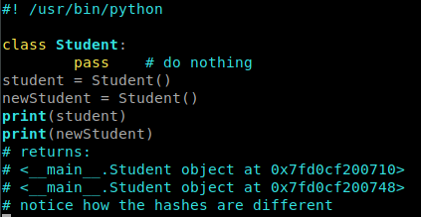
Now if you just create a plant class and try and print out an object you’ll just get a class definition explanation and a hash. This hash is different for every instance of your object and can be used to determine if something is different.

Adding Methods to our class:
Adding methods is as easy as just defining methods within the block that defines the class. Not a problem at all.
Be sure to add ‘self’ as the first argument (will be explained later). Here we make a method that will add a student dict to our ‘students’ list!!
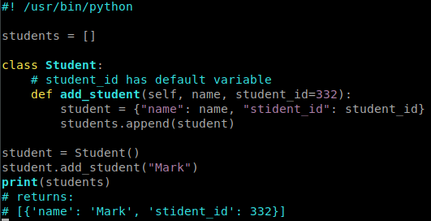
But wouldn’t it be nice if we didn’t have to do all of this after the fact? We can assign names and id’s upon creation with the special method CONSTRUCTORS!

Constructors:
A special method in python classes that’s executed everytime you create a new instance of a class. In the background this gets called. It’s provided by default, but we can create our own and override it!

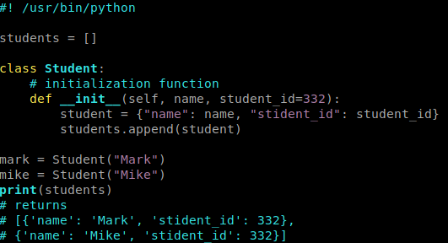
Now we’re just doing all the extra work upon creation which is perfect for what we’re doing BUT those returns are still pretty ugly. We can override another special method called __str__ for this!

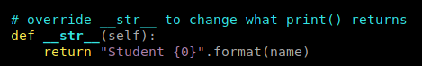

There we go, much easier that way.

Class and Instance Attributes:
This is data that can be found in your class and can be accessed from all of the methods inside of your class!
In our example we’re still relying on a list of student dictionaries for our information. This is not ideal.
Want some data to be the same across all instances? Use CLASS ATTRIBUTES which all ‘students’ will have. They’re static. They’re not like Instance Attributes. Just put them outside any of the method bodies but inside of your class body.

Inheritence and Polymorphism:
Sounds complex but hang in there.
When you have two classes defined you can kind of tie them together. Let’s go right into a demo for this.
Say you want a similar kind of student but don’t want to repeat all of the similar methods/attributes from a regular student?
Copy/pasting code is never a good idea. Let’s inherit the behavior we want!

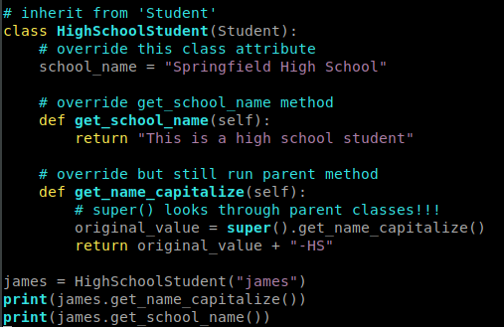

Pay attention to the “super()” function here that accesses and still runs the exact method from the parent class!
Our code is becoming a bit big for a single file. Let’s see how we can separate our code across many python MODULES.

Breaking the app into modules:
Right now we have our app in one giant file. Let’s chop it up into many module files!
main.py → will be the file that does all of the ‘doing’ - it should be fairly short. We need to make it away of HighSchoolStudent to create:

from hs_student import * # not always a good idea to use ‘*’ though
james = HighSchoolStudent(“james”)
print(james.get_name_capitalize())

using modules we can take advantage of OTHER PEOPLES functions and objects in this way as well.
Very quickly you will start using python’s packages.
You will start looking into python standard library modules. These are very powerful and include things like subprocess, os, datetime, pytz… all of which are extremely common.

Comments:
Comments are easy in python. You just add a pound sign. Pep8 rules are:

# space for one comment
print(‘lalala’) # comment after code has two spaces

Multi-line comments:
Good code has functions that are very well-commented. Multi-line comments at the beginning of your functions that explain your params is a great idea: Use Triple-double-quotes for this:

def add_student(name, student_id=332):
“””
Adds student to student list
:param name: string – student name
:param student_id: integer – optional student id
“””
student = “Mark”

See how easy that was? Now everyone knows what your function does and how to use it!

Classes/Functions Summary:
We learned how to write classes
We learned about overriding special methods
We learned about the power of child/parent classes and INHERITENCE (important!)
The instructor encourages using classes over functions whenever possible.

Python – Let’s build a Web App:
We’ll be using FLASK to build a web app and learn about PYPY and PIP
Python has tons of packages. Django is by-far the most-popular (NASA uses it). Flask and Django try and solve the same problem but with a different minimal approach. Learning Flask before learning django is recommended as you can take that knowledge over into django.

Let’s make a python file.

First let’s install flask with:

sudo pip install Flask

The website where you can explore all of these open python packages is pypy – be sure to explore it when looking for new python packages to install.

Easy right?

Now let’s do a Flask example:

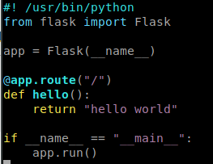

This code on the side, as small as it is, is technically a full website. If you run it from console it’ll tell you what address and port your site is at. Open it in a web browser and it will return “Hello world”, how cool is that?

Making Our App a Web App:
Since this is not a flask course there will be lots of flask code that we don’t need to focus on right now.
Let’s do a small crash-course on web-development.
When you open a web-browser to a url it expects a response from the webserver. Flask is providing this response. This can be a text response, to json, to an entire HTML page.
“Get” is a web request asking for data.
“POST” is a web request submitting data (like a form)
Our students page will handle both GET and POST so we have to include that in our @app.route (flask stuff you’ll see).
It is a bad idea to store our variables and data into our computer/server’s RAM – this is where a database should be used, but that isn’t done in this course (much better in django).
You WILL need to learn some html to use this properly.
Flask, much like django, can do some python iteration and stuff in HTML:

{% for student in students %}
student.student_id<br>
{% endfor %}

Bam, that’s some nice HTML isn’t it? We need to get better at this.

How Much Code did we share?
How much did we import in making our web app?
We imported the student class. Our web app functioned perfectly by passing it instances of classes. Instrance-attributes of classes become DICTIONARY KEYS when used in web-apps. This is an advanced topic but be aware that it’s happening like this.
You can pass many console application classes and just use them in flask/django. Python is extremely flexible this way.

What to take away from this lesson:
You shouldn’t walk away from this thinking you can do flask code. You should focus on how reusable python code is and how powerful modular code can be. Making our web application (we didn’t do the example) took so little code because we had already defined our student object earlier and just imported the class!
This is the power of python and something you MUST take advantage of.

Python Tips and Tricks:
In this module we will work with virtual environments
How we can debug an application using pycharm
Creating executable (.exe) files.
Create insallation wizards.

Virtual Environments:
Amazing power of python. This lets you set up independent python environemnts while you work on your python application.
Imagine your web-app uses python2.7 and django 1.8 LTS – however the machine has django 1.11 insatalled on your machine (you can only have one!)
You can create two isolated python environments! You can install whatever packages you want indepdnent of each other in these virtual environments (we have seen this in our work environment!).
It is VERY COMMON to have many virtual environments set up on your machines. They each have their own packages and don’t care about the other ones AT ALL.

To start using a virtual environment you must install it with pip

pip install virtualenv

From then-on the virtualenv command will be globally available.

virtualenv <env_name>
# example
virtualenv pluralsightProject
# specify python version
virtualenv –python=/usr/bin/python pluralsightProject

You can keep all of your virtual environments in one folder because you load them! You can store all of your venv’s in one folder (common)

Activating your virtual environment:
Now it’s time to activate it! When we created it it made a directory. Just use “source” on the “activate” file within this directory!

source home/user/pythonstuff/venvs/pluralsight/bin/active

And bam we’re good to go!
If successful your terminal should be prefaced with your virtual environment name! Keep in mind, pip installs will only go to your virtual environment :)

To leave it simply use deactivate:

deactivate

Pycharm has these built-in settings.

Pycharm Debugging and debugging:
Debugging is extremely useful. Break-points are used to pause the execution of the program and allow you to inspect your environment and variables etc.

Say we bring up the py-student-manager web app. I want to inspect and see if this new-student is created correctly. In pycharm just click next to the line number to add a red “break point” dot. Run pycharm in debug mode to observe what your code is doing at this time of execution!

Create an Executable File from our python program:
Shipping python can be challenging. The user won’t have your interpreter, your modules, your files, your pip installs, and everything.
What if we package our interpreter and our file AND the other packages? Enter pyinstaller

Pyinstaller is cross-platform and will compile all of your code into one piece! Let’s create a .exe binary file that can be used on any windows PC.
NOTE → pyinstaller does not yet support python 3.6! The latest supported version is python 3.5, however the dev-level version on their github has this 3.6 support.
Install using pip:

pip install pyinstaller

Now let’s navigate to where our python code path is.

pyinstaller main.py

Ignore most of the DLL warnings, they will be fine. Pyinstaller will take care of those for you.

Now there is:
build
dist
main.spec

Enter the dist folder and you’ll see a lot of files generated. “Main.exe” will be in here! Let’s execute it -
dist/main.exe

It works! That’s incredible! It didn’t need to look at any other files at all in order to do it. Isn’t that amazing? We still have a mess of all these files that are required though… How can we package EVERYTHING into one .exe file? With a switch!

Delete the scraps and run:

pyinstaller –onefile main.py

Now go back to your ‘dist’ directory and notice that you’re finally in MAIN.EXE!!! That’s great!
You might notice it’s large – this is because a lot of packages and interpreters need to be packaged in there.
It’s worth it to read up on the pyinstaller documentation because you can add an icon, change the name, require elevated privs, etc etc….

Normally you’ll want a setup wizard though – let’s make one!

Creating a Setup Wizard:
Let’s make a setup wizard so that a user can have many other files in their application instead of just the executable method using pyinstaller.
Let’s get the tool we need.
It’s a windows-only application at the moment called Inno Setup
When you run it you have two options. Use the built-in script wizard. It’s very self-explainitory. Let’s name it, make version info, add publishers, website info, etc etc….
Now let’s select where we want our application to be installed.
Now select the application main.exe file that we created in the last section.
Now add a bunch of additional files and folders you want in there.

Select which languages to include.
Give it instructions about the name of the “setup.exe” file and the output folder. Let’s call it pystudentmanager-setup.exe.
Try running the python script – pretty awesome huh? You can add your own license file too! (“do you accept?” kind of stuff)

Course Conclusion:
Congrats. You’re done. By now it’s easy to see that python is simple but incredibly powerful. You can do web development, computations, applications, and everything and ALL code is reusable.
Go celebrate and explore some more-powerful python libraries. Feel free to reach the instructor “pythonbo” and follow him on twitter.
Good luck and have fun.

