
Asyncio Notes:

Running things asynconously are not things being DONE in parellel. You’re AWARE of them in parallel but you’re not running them in-parallel.

If you’re jogging and your shoe is untied, do you have to finish your run before tying your shoe? Of course not. You can tie your shoe and run concurrently. Maybe a bad example… let’s think of a better one.

You’re opening a website with 30 components to it. Well, one of the components is buggy and the server isn’t feeding it to you. If this is handled SYNCHRONOUSLY then all 29 others will be hung up on that component. If it’s handled ASYNCHRONOUSLY then the 29 others will load no-problem, and the only thing missing will be your one bad component.

The idea is not to speed up your code with parallel processing, but rather to replace all the “waiting” times with other work.

If I had:
os.system(‘sleep 30’)
doWork()

Why should I have to wait 30 seconds before doWork() assuming doWork is not dependent on the outcome of the sleep?

LETS JUMP RIGHT INTO AN EXAMPLE:

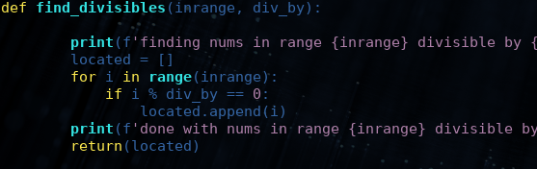
So here we’ve set up a very simple method, it’s going to find multiples in a certain range of our div_by number. Nothing special. Let’s suppose we call it three times in a row in our main like:

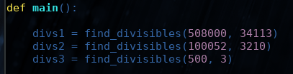

Now what’s the obvious issue? During the computation of divs1, divs2, and divs3 we’re going to be waiting. Divs3 doesn’t care about the output of divs1 and divs2, yet it still needs to wait on them! We don’t like this at all! What if div1 hangs? For what reason should the user still be waiting on divs2 and divs3?

We don’t want threading or multiprocessing as that adds a whole lot of extras we might not be interested in, but right now this is a SYNCHRONOUS program and we’re suffering the consequences for it.

So let’s start up by changing our method to a COROUTINE:

import asyncio

instead of:
def find_divisibles():
we’ll have:
async def find_divisibles()

Now down in main, we need to INITIALIZE our event loop and then run it:

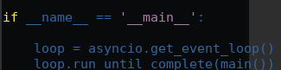

run_until_complete is one of the man run examples!
Then add loop.close() at the end for good measure.

So now, we’re still synchronous :( - let’s change our divs1, divs2, and divs3 from method calls to CREATE_TASKs !

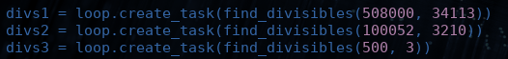
So it’s runnable at this stage, but we have a few issues. We don’t wait for our coroutine to finish! We obviously do want the results eventually. That’s where `await` comes in!

So now it runs (yay) but it’s still synchronous (boo) because the thing that’s doing the work is not being `awaited`. Let’s add something that’s going to be the thing that takes time.



Perfect. Now the more multiples of 50000 one passes, the longer it will take with an AWAIT code. Because of this, we should see our smallest (third) set finish first and our largest(first) set divs1 finish last, proving asynchonousness.

Now let’s cache our responses and finally here’s the whole code:

#! /usr/bin/python3.6
import asyncio

async def find_divisibles(inrange, div_by):

print(f'finding nums in range {inrange} divisible by {div_by}')
located = []
for i in range(inrange):
if i % div_by == 0:
located.append(i)
if i % 50000 == 0:
await asyncio.sleep(0.0001)
print(f'done with nums in range {inrange} divisible by {div_by}')
return(located)

async def main():

divs1 = loop.create_task(find_divisibles(508000, 34113))
divs2 = loop.create_task(find_divisibles(100052, 3210))
divs3 = loop.create_task(find_divisibles(500, 3))

await asyncio.wait( [divs1, divs2, divs3] )

# now divs1-3 are all the return objects of the coroutines
return(divs1, divs2, divs3)

#print(divs1,'\n\n', divs2, '\n\n', divs3, '\n\n' )

if __name__ == '__main__':

loop = asyncio.get_event_loop()
divs1, divs2, divs3 = loop.run_until_complete(main())
loop.close()
print(divs1.result())
~

