Machine Learning A-Z
https://www.udemy.com/machinelearning/learn/v4/t/quiz/284364

Data Preprocessing:
Preparing your data is NECESSARY for your data to work properly. There is no chance it will work. It’s the boring part before the trip, but when everything is well-prepared and you’re ready to go, the results will be amazing.
This part is NOT FUN – instructor assures us, but it’s necessary to move forward.
We will do this with both R and Python.

Getting the Datasets for the Course:
This course is MASSIVE – over 35 hours of content. All of the datasets are on their separate pagtes.

www.superdatascience.com/machine-learning/

You’ll see all of the datasets per-lesson available for download. We’re going to start with the ones under part1, the datapreprocessing datasets as well as the template-folder!
→ a nice way to store the datasets

We’ll download both of these and I’m going to extract them into the git working area I’ve made for them.
As we go through the course we’ll populate the folders with their datasets.
I’m going to manage my directories a little differently than he does.

We’re not taking all of the datasets at once in-case we need to update something, perhaps and also it keeps you from tripping up as you’ll keep getting the data step-by-step (sure)

Data Preprocessing Dataset:
This dataset is a comparison of countries, ages, salaries, and purchased (yes/no). It’s a standard csv file (like most of the one’s we’re dealing with). To open and view it in libreoffice calc, use “system” instead of “unicode”
This is a very small dataset. Only 10 rows it seems.

INDEPENDENT VARIABLES – the first three columns are the independent variables.
DEPENDENT VARIABLE – the last column. It DEPENDS on the independent variables.

Eventually, we will use independent variables to predict dependent variables. We cannot do it on this data the way it is currently.

Importing the Libraries (python):
This tutorial will be done in python and R. We’re going to start off with PYTHON. Just a few inputs and the library will do the job for you (you know modules by now…)

First up numpy:
import numpy as np

We’re going to be using numpy arrays here – it has mathematical tools that work much better than regular python lists/arrays.

Next up matplotlib
import matplotlib.pyplot as plt

We’ll be using this to make useful charts to visualize our data (more-important than you think!)

And finally pandas
import pandas as pd

Pandas is used for importing and managing datasets (managing the csv files!)

Install these with pip as-needed

Importing the Libraries R:
For R, you don’t need to import libraries, but you’re going to have to select the libraries by default. Later we will need them, and will be shown how to install them.

Importing the Datasets in Python:
I’ve installed Rstudio and all of the python modules. Time to import the datasets. Let’s make sure we’re in the working-directory for the data we want.

NOTE – tkinter broke on pandas install so I needed:
sudo pacman -S tk

This runs fine. We’ve imported the dataset. Note that indexes start at 0 (in R they start at 1)
We need to separate the FEATURES from the DEPENDENT VARIABLES (X vs Y)

# importing the dataset
dataset = pd.read_csv('Data.csv')

Great now we’re going to use the iloc() method of our dataset to get the values we want. Here, like most python arrays, colon (:) is the full length of the array and we can do math on it. So if we want ALL of the rows and ALL BUT THE LAST column we’d do:

X = dataset.iloc[:, :-1].values # everything but last column

Which is exactly what I’m going to do.
Works perfectly! Print it out to see something similar to what we had opening the csv.

y = dataset.iloc[:, 3]

All of the rows, just the last column. Note that we use a lowercase y as there’s only one column!

Here’s what the code looks like when we’re done:
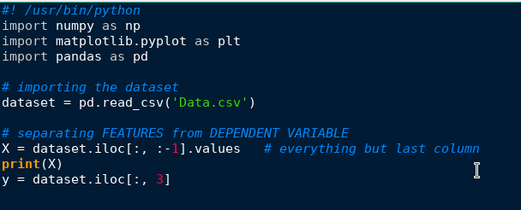

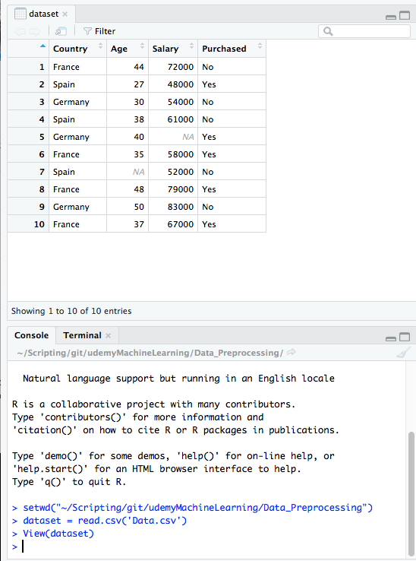
Importing Datasets in R:
This is actually much much easier in R for some reason. Navigate R over to the working directory and set your working directory. This is easy in the R-studio explorer.

Dataset = read.csv(‘Data.csv’)

And that’s it! That’s all we need to do. Execute the code and view the dataset.

View(dataset)

This brings up the dataset in a nice explorer window and it looks just like the csv, of course. These indexes start at 1 you should notice! The thing you should notice though is that everything we do is going to happen more-naturally through R than python.

How to use this dataset object will make sense as we move forward.

By the way, if you write and save an R-script you execute it with:

Rscript myScript.R

Handling “Missing” Data in Python:
This happens quite a lot in real life so it’s important that we know the trick to handle this when it happens.
We can see that there’s two bits of missing data:
Spain has no age data
Germany has no salary datasets
We could remove the line, but then we weaken our dataset. So how do we do this?
WE REPLACE IT WITH THE MEAN OF ALL THE VALUES IN ITS COLUMN.

Why? Because this won’t harm whatever machine learning is done. Something that strays zero from the mean will have no impact on any machine learning about to happen.
There are fast ways to do this in both Python and in R.

The library we’re going to use is scitkit-learn’s preprocessing library!

from sklearn.preprocessing import Imputer

sklearn = scikit-learn. Amazing libraries for machine-learniyng models. We’re importing the Imputer class which will let us take care of that missing data!

from sklearn.preprocessing import Imputer
imputer = Imputer(missing_values=’NaN’, strategy = ‘mean’, axis=0)

Why NaN as a string? Because if we look at our X we can see that missing values show up as ‘NaN’ strings! You might one day use ‘’ or None.
We’ll be using the mean strategy as decided above, so we’ll set strategy=’mean’
Axis = 0 set as default

Now let’s use the imputer on our Independent Variables!

imputer = imputer.fit(X[:, 1:3])
# use all rows and columns 1 and 2 (1:3 because upper-limit is excluded)

And let’s replace the missing data with the data from our imputer

X[:, 1:3] = imputer.transform
print(X)

And voila. We’ve got it – it looks like our Independent Variables for the missing columns were set to the mean of the data! Looks like it’s the right value (you can check on your own, this is a small dataset)

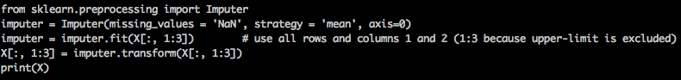
Not bad at all – just like that our missing data has been filled.
You can look at the other strategies (median and mode!)

Handling Missing Data in R:
This is going to be very similar only we’re going to have to handle the two datasets separately.

To access columns we give it $HEADER like:

> dataset$Age
[1] 44 27 30 38 40 35 NA 48 50 37

We’re going to use an ifelse() in R (if else!) This gets tricky as it’s going to be more exposure to R syntax than any preprocessing. Thankfully for us, mean() is a built-in function.

> dataset$Age = ifelse(is.na(dataset$Age),
+ ave(dataset$Age, FUN = function(x) mean(x, na.rm = TRUE)),
+ dataset$Age)

Okay….. let’s break down what happened.

LINE1:
“if dataset$Age (the cell for data for age) is blank
LINE2:
THEN dataset$age becomes the average of all the dataset$age
LINE3:
ELSE just leave it as it is

You’d do the same with dataset$Salary

Huh…. R is going to be a bit tougher than I thought.

Categorical Data Python:
We’re going to learn how to ENCODE CATEGORICAL DATA

Take a look at our dataset. We have two categorical variables:
Country (france, spain, germany)
Purchased (yes, no)

Machine learning models are MATH equations… it doesn’t really make sense to throw string-values at them, right?
We need to ENCODE the categorical variables.

# encode categorical data (strings)
from sklearn.preprocessing import LabelEncoder
labelencoder_X = LabelEncoder()
X[:, 0] = labelencoder_X.fit_transform(X[:, 0]) # all rows, column 0
print(X)

This is really simple so far. Printing X now shows us that 0, 1, 2 have replaced the country categories.

BUT THERE IS A BIG PROBLEM. There are three categories. France is not two-greater than Germany, that’s nonsense and silly to say. This would work for small, medium large, but we’re going to have to solve this for countries with DUMMY ENCODING

Dummy Encoding:
We’re going to ADD three columns as 0,1 booleans!
For example, one column will simply be is_france. If it’s 0, it’s not france. If it’s 1, it is france. Every row gets this column no matter what! Get it? Just adding a boolean variable.

So here’s what we end up with:

# encode categorical data (strings)
from sklearn.preprocessing import LabelEncoder, OneHotEncoder
labelencoder_X = LabelEncoder()
X[:, 0] = labelencoder_X.fit_transform(X[:, 0]) # all rows, column 0
onehotencoder = OneHotEncoder(categorical_features = [0])
X = onehotencoder.fit_transform(X).toarray()
print(X)

And it works! I have three extra columns for each country with a 0,1 boolean value!

This has to be performed AFTER a labelencoder is used – it cannot (in the current version) be used on string data, however the deprecation notes suggest that this feature is coming soon.

Now for the purchased column we’re going to need to change that as well, however it’s only 0,1 and you could say that the range in-between counts as how close something is to being “Yes” (1) so let’s label-encode our dependent variable as well!

labelencoder_Y = LabelEncoder()
y = labelencoder_Y.fit_transform(y)
print(y)

Perfect! Now we’ve encoded dummy-variables for independent variables and simple label encoding for our dependent variables! Our X and Y are ready to go!

Data Encoding in R:

> dataset$Country = factor(dataset$Country,
+ levels = c('France', 'Spain', 'Germany'),
+ labels = c(1,2,3))

Simple enough – this one is a little easier to understand. We map countries to integers (levels to labels)
Now let’s do it for our depdenent variable (purchased)

> dataset$Purchased = factor(dataset$Purchased,
+ levels = c('Yes', 'No'),
+ labels = c(1,0))

And finally view the dataset with print() or View() on dataset and you can see that it perfectly matches what we’d done in python. Nice.

UPDATE NOTE:
For the sake of the tutorials, a module was deprecated.

Replace:
from sklearn.cross_validation import train_test_split
by
from sklearn.model_selection import train_test_split

Going forward. Got it?

Splitting the Train/Test Data in Python:
We need to split our full dataset into two parts. The TRAINING data (where the machine learning algorithm learns) and the TEST data (what we use to determine HOW WELL it learned).

# splitting the dataset into train and test
from sklearn.model_selection import train_test_split
X_train, X_test, y_train, y_test = train_test_split(X, y,
test_size = 0.2,
random_state = 0)

train_test_split() is a great and easy function that takes two arrays (X, y) and will split them evenly for you over a ratio that you decide and a random_state that you provide. Here, I’ve given it my X and y and said the test_size should be 0.2 (so, 4/5 datapoints will be used for training and the last 1/5th will be used for testing)

Splitting the Train/Test Data in R:
We need to import an R library!
Click on the “packages” tab in RStudio and select INSTALL
We’re looking for “caTools” - install it and check it off in the packages tab once-installed and it will be imported.

> set.seed(123)
> split = sample.split(dataset$Purchased, SplitRatio = 0.8)
> training_set = subset(dataset, split == TRUE)
> test_set = subset(dataset, split == FALSE)

Feature Scaling and why we need it:
So we’ve got Age and Salary that contains numerical numbers. The variables now aren’t on the same scale. The age is in YEARS and the salary is in DOLLARS.
This will cause issues in our machine learning models! Most models are based on EUCLIDEAN DISTANCE (difference of square root of squared coordinates). THESE WILL NOT WORK IF WE DON’T SCALE OUR FEATURES!!! (this explains why some of my projects failed)
If we compare the distance between two salary numbers and the difference between ages.
THIS TEACHES THE ALGORITHM, say, that the difference between 71000 and 70000 (not much of a salary change) is HUGELY more influential than the difference between ages 20 and 80 (a massive leap in age. Simply untrue. We need to SCALE OUR FEATURES.

We’re going to scale all of our values from -1 to +1.
There’s many ways to scale your data. Two of them are standardization and normalization.

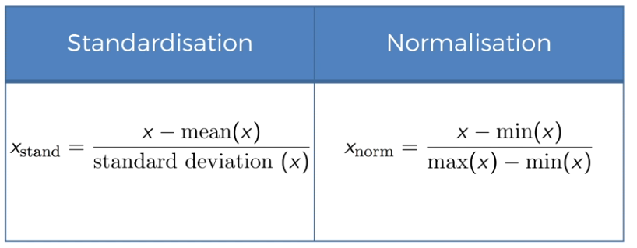

Don’t worry if the math is weird, just understand that no variable should be dominated by the other. All of our rows should look very similar.

Do we need to scale the dummy variables? There are many answers. It depends on the context and how much you want to keep interpretation, but we lose the interpretation of losing which observations belong to which country (our feature example that we made dummy features for).

Here’s what we do:

# Feature Scaling
from sklearn.preprocessing import StandardScaler
sc_X = StandardScaler()
X_train = sc_X.fit_transform(X_train)
# notice we remove "fit"
X_test = sc_X.transform(X_test)
print(X_train)

So do we need to apply feature-scaling to our target (dependent variable) ? Nope. We don’t need to do it. This is a categorical problem, and 0,1 (our encoded answers for yes/no) are our categories. No need to do feature scaling over here.

Feature Scaling in R:
This is extremely easy but with a caveat:

> training_set = scale(training_set)
Error in colMeans(x, na.rm = TRUE) : 'x' must be numeric

Hmmm what’s the issue? “Training set must be numeric?” It looks very numeric…..
But wait! We changed the categories to factors before remember? A FACTOR in R is NOT numeric!!!! We need to turn the country codes and purchased codes into EXCLUDED features (we’re not scaling them anyways! Remember?)
Exclude them with R’s column indexing (syntax is a little weird but watch):

training_set[, 2:3] = scale(training_set[, 2:3])
> training_set
Country Age Salary Purchased
1 1 0.90101716 0.9392746 0
2 2 -1.58847494 -1.3371160 1
3 3 -1.14915281 -0.7680183 0
4 2 0.02237289 -0.1040711 0
5 3 0.31525431 0.1594000 1
7 2 0.13627122 -0.9577176 0
8 1 1.48678000 1.6032218 1
10 1 -0.12406783 0.4650265 1
> test_set[, 2:3] = scale(test_set[, 2:3])
> test_set
Country Age Salary Purchased
6 1 -0.7071068 -0.7071068 1
9 3 0.7071068 0.7071068 0

And that’s it! That’s all there is to data_preprocessing to getting started with this tutorial. “Now it’s time to have fun”.

Making Templates for Data Preprocessing:

So now that we’ve learned what we needed to from data preprocessing we can save a nice and easy template (NOT MODULE). We won’t import it, but it’s a nice skeleton to get started-with and save time with as we come across new datasets. Obviously it will need to be tweaked each time we approach a new problem.

Over in R it’s the same thing.

Both of these templates are already in the git directory.

Now we’re going onward to use machine-learning to solve business problems!!!

PART 2:
REGRESSION

Regression models are about predicting a real value (like a salary, for example). Your independent variabels will forecast future events. Regression techniques vary. We will go over the following:

Simple Linear Regression
- Multiple Linear Regression
- Polynomial Regression
- Support Vector for Regression (SVR)
- Decision Tree Classification
- Random Forest Classification

Let’s get to it.

Getting the Dataset (Linear Regression):

Go back to www.superdatascience.com/machine-learning/
You’ll see the whole page dedicated to the course. Make sure you download the one

I’m going to download Simple_Linear_Regression.zip to start with

Here’s what my directory looks like now:

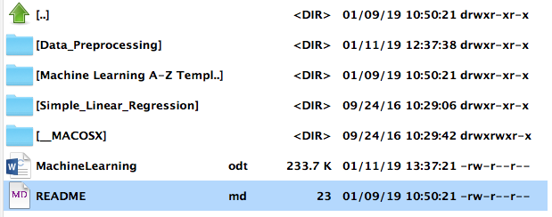

And we’re good to get started with simple linear regression

Introduction to Business Problem:

Our current dataset will be looking at YearsExperience vs Salary (open the csv in libreoffice or gnumeric to get a better look).
Suppose a manager asked you to find a correlation between Years of Experience and Salary. They want to find the range in which it fluctuates as well as ballpark estimates to build a strict rule. We’re GOING TO BE FINDING CORRELATIONS using a simple linear regression model. This will tell us what the best-fitting-line is for this relationship.
The business value here is that if the company doesn’t know, you can go back with this model and show them how so-far things have been going. The model ITSELF has value e-ven if you’re not using it for forecasting!

Simple Linear Regression Intuition – Step 1:

Time to learn Ordinary Least Squares Method!
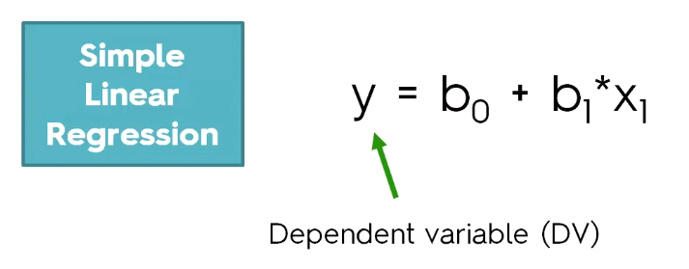
Remember in elementary school, y = mx + b ?

Well that’s basically what we’ll be doing for simple regression. We want to figure out how y depends on X.
b1 is the coefficient for the independent variable. It says how much a unit change in x1 affects a unit-change in y. It’s a multiplier. THE CONNECTOR between y and X. This can inflate or deflate change.
B0 is the constant.

For simple linear regression, we can look at this:
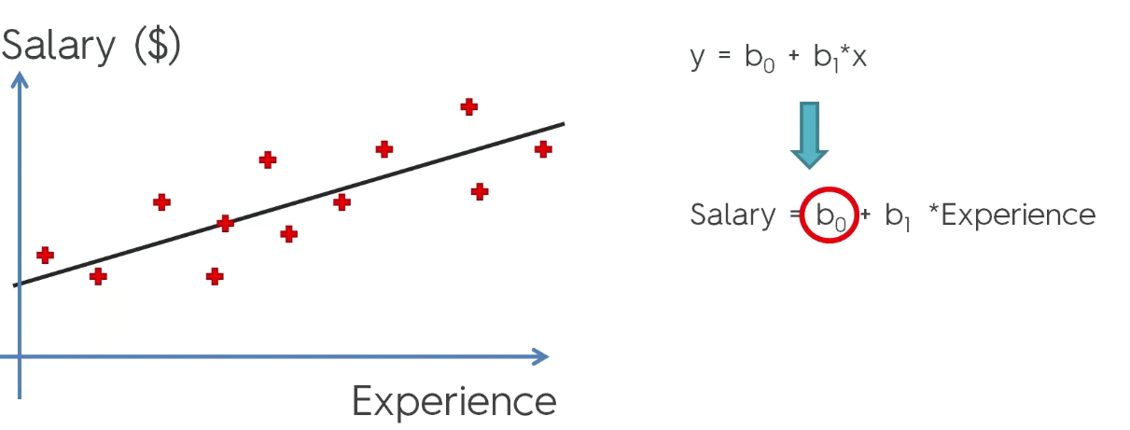
The constant means the Y-intercept (here it’s about 30,000 dollars). When X is zero, the line crosses the y-axis. The constant will tell you, in this example, where someone with zero experience will be starting!
B1 is the SLOPE of the line. It multiplies the impact that a single year of experience has on the y outcome (salary!)
The slope B1 can also DEFLATE the impact of 1 year on salary as well! These values are useful in explaining and learning from your model once we build it.

Now we’re going to find out HOW the linear regression finds the line for us. In the graph above, the red crosses represent each point of data that we have. So now let’s draw some vertical lines from the observation to the model.
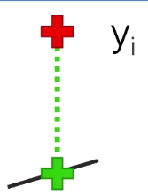
The red cross represents the datapoint still and the green cross is the position along the line of best fit. This distance (veritcal) is yi. In our example, the green line is the difference between what the employee is earning and what the model suggests they should be earning.

The method to find this line for our regressor is the SUM of the difference between these two points squared.
SUM(y-y^)^2 (across all data-points)
Linear regression draws lots and lots of these trend-lines and counts all of these sums up and records them in memory. It then finds the MINIMUM sum of squares and that line is the best-fitting line.
This is ordinary least squares method.

Simple Linear Regression in Python:

First we’re going to do this in python.
Set your directory over to the simple regression folder and just make sure you can see the salary_data csv file.

The first thing we’re going to do is preprocess out data…. Good thing we have a data-processing template! I copied it over.

We need to change a few things obviously, like the name of the csv file.
X is fine, but we need to change the index for “y” to [1].

Here’s our preprocessing:

import numpy as np
import matplotlib.pyplot as plt
import pandas as pd

# Importing the dataset
dataset = pd.read_csv('Salary_Data.csv')
X = dataset.iloc[:, :-1].values
y = dataset.iloc[:, 1].values

# Splitting the dataset into the Training set and Test set
from sklearn.model_selection import train_test_split
X_train, X_test, y_train, y_test = train_test_split(X, y, test_size = 1/3, random_state = 0)

Feature-Scaling is handled automatically in simple linear regression so we won’t need to do that here. A very short and very simple preprocessing section for us today.

First let’s create our regressor object:

from sklearn.linear_model import LinearRegression
regressor = LinearRegression()

Now we’re going to fit our regressor with its fit() method.

regressor.fit(X_train, # independent variables
y_train, # dependent variable
)

This is the most-simple machine-learning model and we created it. Now we have a linear regressor and can predict some new observations and learn about our data!

We’ll do this by using our now-fit regressor object:

# predicting the Test set results
y_pred = regressor.predict(X_test)

Now we’ve got y_pred. We’re going to COMPARE it to y_test. Remember, y_test is taken from REAL data. It’s the real outcomes. y_pred are the PREDICTED salaries. Print them our and compare the two. We can see that these are actually pretty close. Some of them are a little off, but for the most part it’s good.

In the next tutorial we’re going to plot this visually and see how/why everything worked out the way it did in our predictions. If we wanted to forecast we’d give new X data to the regressor just like we did with the predictor and look at y_pred here.

Visualizing our Data (Python):

We’re going to use a scatter-plot to visualize what happened. Here’s what our pyplot lines look like and a description of what they were/do:

# visualizing the Training Set Results
plt.scatter(X_train, y_train, # X-vs-Y for scatter
color = 'red')
# plot a line for X_train vs predicted results from X_train
plt.plot(X_train, regressor.predict(X_train), # X_train vs expected y from x_train
color = 'blue')
# give it a title
plt.title('Salary vs Experience (training set)')
# label to X axis
plt.xlabel('Years of Experience')
# label to Y axis
plt.ylabel('Salary')
plt.show()

And after executing we get a graph displayed for us! Let’s examine it!

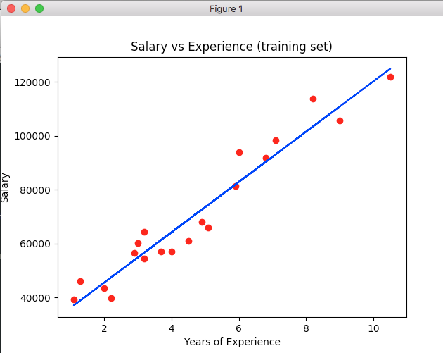

The real values are these red observation points with their real salary. The predicted values are all along the BLUE regression line!
Notice that it’s pretty good! There’s only a few that are a noticeable distance off from the reality.
The error-margin is the distance between the red dots (real values) and the blue line (regression line).
If a regression model works we can show that there’s good LINEAR DEPENDENCY.

Let’s see how the blue line can approach new observations (the test set) now! Let’s keep the same graph but plot the TEST points as well and see how it did!

plt.scatter(X_train, y_train, # X-vs-Y for scatter
color = 'red')
# plot a line for X_train vs predicted results from X_train
plt.plot(X_train, regressor.predict(X_train), # X_train vs expected y from x_train
color = 'blue')
# give it a title
plt.title('Salary vs Experience (training set)')
# label to X axis
plt.xlabel('Years of Experience')
# label to Y axis
plt.ylabel('Salary')
plt.show()

And the results for the test set are even more promising:

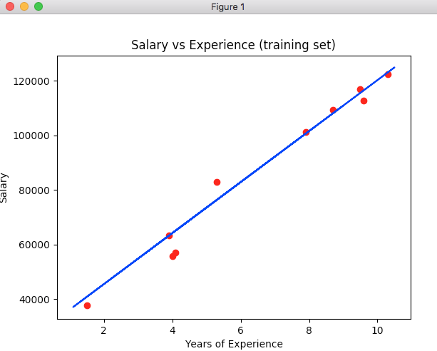

Data that the regressor hadn’t seen before and look how well it fits. Definitely Linear Dependency going on here.

Here’s what the visualization code ended up looking like for both the training data and the test data vs our linear regressor:

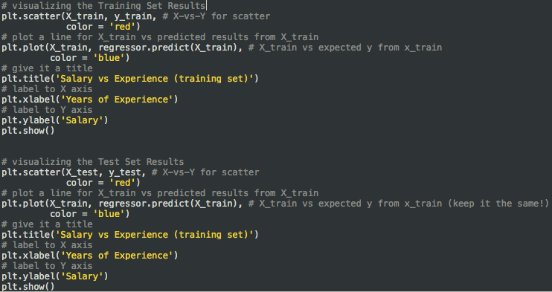
Simple enough. Two plots here, very little code. Moving on.

Simple Linear Regression in R:

The first step as always is to switch our working-directory to be the one that contains the Salary_Data.csv file in it.
Explorer → more → set as working directory
And that’s it! We’re ready to start with the first steps with our data-preprocessing so we’re going to start off with our skeleton R-template for data preprocessing.

# Importing the dataset
dataset = read.csv('Salary_Data.csv')

# Splitting the dataset into the Training set and Test set
# install.packages('caTools')
library(caTools)
set.seed(123)
split = sample.split(dataset$Salary, SplitRatio = 2/3)
training_set = subset(dataset, split == TRUE)
test_set = subset(dataset, split == FALSE)

Simple Linear Regression in R, much like in Python, handles the feature-scaling for us. The data-preprocessing phase is ready for us as soon as this is done!

So now we’re ready to fit our simple linear regressino to our dataset without any issues.
The simplest way is to use the lm function (Linear Models)

# Fit Simple Linear Regression to the Training Set
regressor = lm(formula = Salary ~ YearsExperience, # "~" = proportional
data = training_set)

Alright so we’ve got our regressor and we fit it in just one line! We can get some very useful data by now running summary(regressor) on our now-fit regressor:

Residuals:
Min 1Q Median 3Q Max
-7325.1 -3814.4 427.7 3559.7 8884.6

Coefficients:
Estimate Std. Error t value Pr(>|t|)
(Intercept) 25592 2646 9.672 1.49e-08 ***
YearsExperience 9365 421 22.245 1.52e-14 ***
---
Signif. codes: 0 ‘***’ 0.001 ‘**’ 0.01 ‘*’ 0.05 ‘.’ 0.1 ‘ ’ 1

Residual standard error: 5391 on 18 degrees of freedom
Multiple R-squared: 0.9649, Adjusted R-squared: 0.963
F-statistic: 494.8 on 1 and 18 DF, p-value: 1.524e-14

Starting to see why R is so recommended when handling data like this….

Look at the coefficients! That’s the statistical significance. Look at those three-stars there, that means it’s highly significant! (this is amazing actually… be sure to use this).
The P-value is another indicator of the statistical significance – and as you can see, the p-value under 5% it’s highly significant. Here there is a very very small p-value so “years” has HIGH effect on the salary outcome.
There is additional data which is very important and we will go over how to interpret it later on.
We’re done fitting the data – now let’s see how R can predict and forecast.

R is nice because we can do this in one-line:

y_pred = predict(regressor, newdata = test_set) # build vector of predictions

If we look at these predictions, it’s really not that far off! Some of them are almost exactly correct. This is incredible. Only two lines of code after our data preprocessing and we’ve managed to fit a simple linear regressor and use it to predict y based off of X fairly-well! And we learned about the summary(regressor) function that prints out useful information about your model!

Visualizing Linear Regression in R:

Let’s build the graphs in R. First we’ll need to import the right library, ggplot2.

If we go into our packages the ggplot2 is not there!

Execute (with R)

install.packages(‘ggplot2’)

I did this directly in the console of my R-script and it worked just fine. Took about sixs minutes on a mobile i7 as it looks like all of these need to compile after install rather than some being just flat-files like python modules sometimes are.

library(ggplot2)

The above will import it in your script. Leave that in the code.

ggplot() +
geom_point(aes(x = training_set$YearsExperience, # scatterplot our points
y = training_set$Salary),
colour = 'red') +
geom_line(aes(x = training_set$YearsExperience, # plot our regression line
y = predict(regressor, newdata = training_set)),
colour = 'blue') +
ggtitle('Salary vs Experience (training set)') +
xlab('Years of Experience') +
ylab('Salary')

The comments explain what everything is. It’s a very weird syntax (notice the “+” symbols) but I kind of prefer this to how python handles things.
Highlight it and click “run” in R-Studio and look at your graph in the corner!
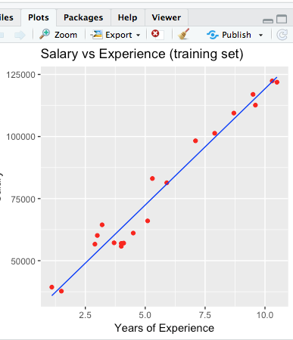

This was very fast and easy to do in R-Studio, but look. You can see that the regressor, working off of training data, did a very good job and there’s very clearly a linear dependency between Years of Experience and Salary.

So let’s see if our simple linear regression can handle our Test Data now! Copy all of that code above, and paste it underneath as this will be near-identical.

Here’s what that looks like (almost the same, we just changed the POINTS to test data. We didn’t change our line plot at all, since we want our training_data regressor)
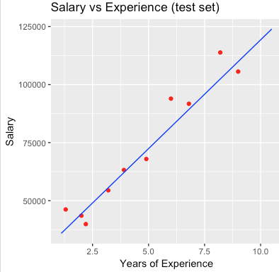

And there we go! Predictions look great. There’s a certain linear dependency.

That’s the end of SIMPLE linear regression! Going forward we’re going to have a new business problem and we’re going to solve it using MULTIPLE LINEAR REGRESSION.

Multiple Linear Regression:

Now – we’ll probably never use it for 1-to-1 comparisons like above. These problems are simple and the connection can be made by anyone with Microsoft Excel to be honest (or Libreoffice Calc!).
Real problems often have SEVERAL features and factors that influence the outcome. That’s what we’ll be looking into here.

Go to superdatascience.com/machine-learning and download the relevant dataset and extract it into a separate directory for this.

This one has THREE separate files:
- a zip for blueprints to build models
- multiple linear regression directory with data
- homework solutions

Extract them all into a new directory.

The Dataset and Business Problem:

This is a very realistic and lifelike business challenge. We have 50 companies and some extracts from their profit/loss statements across several columns.
RND, Administration, Marketing, What state they’re in, and their profit for that company for the year.
The challenge is that we need to decide which new companies are worth investing in! Pretend you’re in a venture-capitalist fund trying to figure out which companies you should invest in.
PROFIT will be our independent variable.
They want data from it including which states do better, does marketing or admin have a better effect? RND? Find out anything you can and have a solid linear model and regressor to provide them for new companies in the future.

You can’t tell off the top of your head looking at this one – so this is going to be our first example of something that a human would have trouble with.

Multiple Linear Regression Concepts:

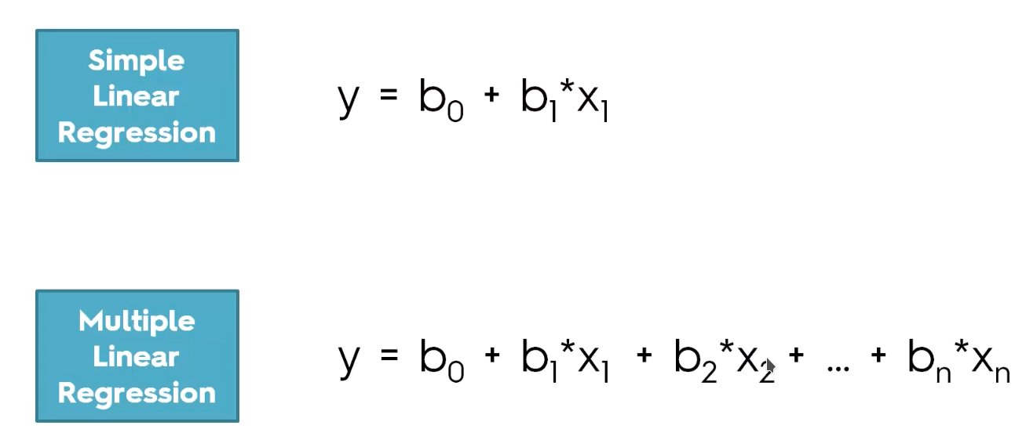

So once again we have the dependent variable, y, but now there’s SEVERAL b coefficients and x independent variables. It really just looks like a multivariable version of simple linear regressions.

Linear regressions have a list of assumptions:
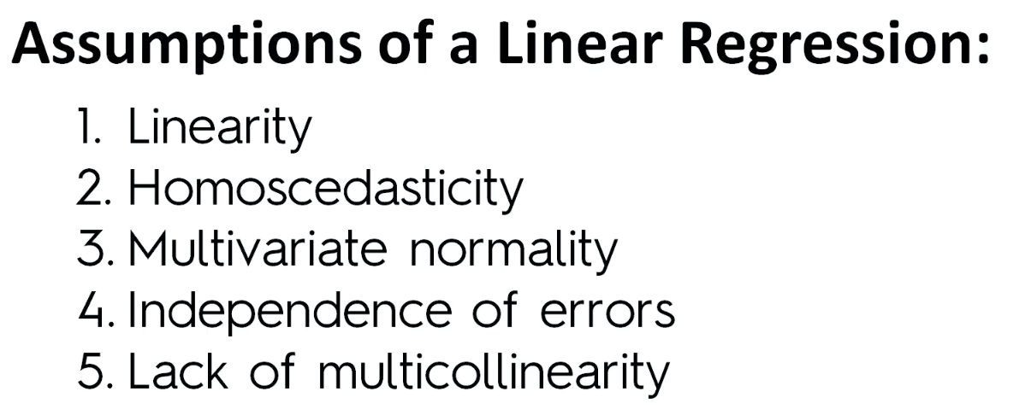
You NEED to figure out if these assumptions are met before going forward with a linear regression model:

We won’t be focusing on what the assumptions are, but don’t just blindly follow these steps without making sure that these assumptions are correct while building linear regression models.

Dummy Variables in Multiple Linear Regression:

So now we have four independent variables that we want to check for correlation to our dependent variable, profit for the company.
Profit = b0 + b1*(rnd spending) + b2*(admin spending) + b3*(marketing) + ???(state)

So now we’re wondering what to do with the STATE variable. It’s a categorical variable unlike the others, but it’s not something that can be left out. We can’t just throw it into the equation though.
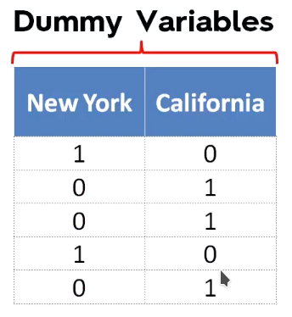
We need to create DUMMY VARIABLES (booleans, remember?!)

So we’re going to expand our dataset. Instead of states, we’re going to have IS_NEWYORK and IS_CALIFORNIA. If a state matches the row, it’ll be a 1! All others become 0. These columns are our dummy variables.

Now we can add on b4 * (is_new_york) + b5 * (is_california)

Now… we dont’ NEED the rest of our dummy variable columns! In fact, including dummy variables you don’t need will actually HURT your regression model!
Here we only have two categories, New York and California (not new york) so we retain ALL of our data just by including the one IS_NEW_YORK column.
Later on we’ll learn about the DUMMY VARIABLE TRAP – something bad that can happen if you include too many dummy variables. ALWAYS INCLUDE ONE LESS DUMMY VARIABLE THAN YOUR TOTAL NUMBER OF VARIABLES (huge).
It may seem bias – but with new york becoming the default, not-new-york gets baked into the b0 base coefficient !!!
→ this is actually pretty cool. Hadn’t thought of this.

Dummy Variable Trap:

So now we’ve twice created dummy variables. In the second time we excluded the is_california row…. So why did we exclude it?
THINK OF IT IN MATH TERMS.

D2 = 1 – D1

The model will not be able to distinguish the effects of D1 vs D2. You can’t have the constant b0 and both of the dummy variables.
THIS APPLIES TO ANY NUMBER OF DATASETS.
IF YOU HAVE 9 DUMMY VARIABLES, ONLY INCLUDE 8. The 9th will have its value baked into the b0 constant. Including all dummy variables introduces COLINEARITY and your regression model will get no value out of this as it can’t determine which dummy variable is influencing the line in which way since their influences all even-out in the end.

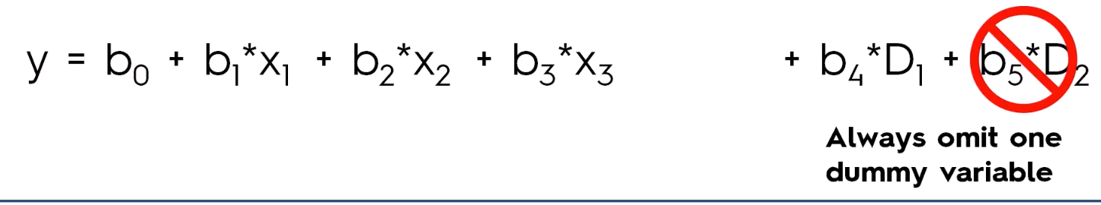
Hugely important. Don’t forget it, especially if you’ll be dealing with massive sets of dummy variables. If you have 1000 dummy variables, you should only include 999 and the 1000th will retain its value in the constant.

DON’T FALL VICTIM TO THE DUMMY-VARIABLE TRAP.

Null Hypothesis:

Null hypothesis is the theory that, for your business problem, there is no statistical correlation by your given independent variables.
If you find correlation you can REJECT a null hypothesis.

YOU START BY ASSUMING YOUR THEORY IS WRONG.

The P-Value:

What is the P-Value?
A small p-value makes you reject a null hypothesis… but what exactly does it represent?

P-value is NOT the probably of the claim
P-value is NOT the probably of the null hypothesis

The p-value is the probability of getting a sample like ours IF THE NULL HYPOTHESIS IS TRUE. The odds of duplicating our results given the idea that there’s no statistical correlation between the data and our outputs.

Sig “p-value” is the probability that IF the null hypothesis is true, sampling variation would produce an estimate that is further away from the hypothesised value.
The p-value tells us how likely it is to get a result like we got IF the null hypothesis is true.

We are trying to disprove H0 (H-naught)

If we use a significance value of 0.5 and the p-value is lower than it, we reject the null hypothesis.

EXAMPLE:
If my friend came up and said “I have a special way to roll 6’s more-often than usual on a regular dice” and rolled the die and ended up on a six, I wouldn’t be convinced. The odds of that happening would be 1/6 (or P=0.1675) without any technique.
If they rolled 100 dice and the outcome had sixes in a way that the odds of it happening were less than 5% (p=0.05) then yeah, we would start to believe the friend’s technique might be true.

Statistic Significance:

If the p-value is lower than 0.05 it’s a good argument in rejecting the null hypothesis.

1. Start with null hypothesis
2. Gather your info (do the learning)
3. calculate p-value
4. reject or confirm the null hypothesis

Building a model step-by-step:

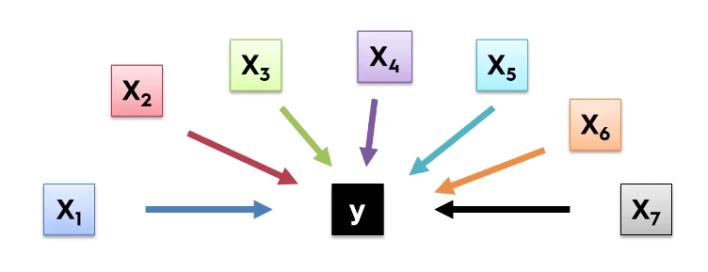
Life now is much harder than it was when we were dealing with a single variable.
We need to decide which to keep and which to throw out.
Why throw out?
GARBAGE-IN, GARBAGE-OUT:
if you throw too much into your model, you get a garbage-model out. The model will be drawing connections that aren’t there. You need to get rid of things that don’t predict something.
So… how do we construct a model?

- All-in
  - throw in ALL of your variables
    - do this if you have prior knowledge knowing these are the true predictors
    - unlikely if you’re just given data
    - use this method if you’re PREPARING for a backward elimination method
- Backward Elimination
  - Pick your Selection significance level to stay in the model (p=0.05 to start)
  - Fit full model with ALL possible predictors (independent variables) and fit it
  - is the p-value under 0.05? If not, go onto the next step...
  - Find the predictor with the HIGHEST P-value (worst significance)
    - remove the variable, and repeat
      - repeat this until your overall model has reached p<=0.05
- Forward Selection
  - select a significance level to enter the model (p=0.05 to start)
  - fit all simple regression models for each independent variable on its own
  - select the model with the lowest p-value, KEEP THIS VARIABLES
    - now redo the earlier steps doing the CHOSEN variable plus one other variable (two variables now)
      - keep the second variable with the lowest p-value
        - continue onward until you eventually reach the p-value that you desire!
  - Stop when you reach your p-value and use the PREVIOUS model (confusing, but do it)
- Bidirectional Elimination
  - select an enter and stay p-value (0.05 for both)
  - perform the FIRST step of forward-selection
  - perform the next step through backward elimination process
  - go back to first, then back, then first, then back, until you reach your pvalue =< p=0.05
- Score Comparison
  - ALL possible models
  - construct ALL possible regression models (2^n -1 ) total combinations
    - 10 columns gives you 1023 models of possible combinations. This is insane, but always works
      - not a good approach as this grows exponentially and it’s extremely resource-consuming
- (stepwise regression)
  - refers to backward, forward, and bidirectional altogether

In this example we’re going to look at the BACKWARD ELIMINATION process because it’s the fastest way to start with and very useful in real life.

Multiple Linear Regression in Python:

So make sure you’re working in the same directory as our csv file for this section 50_startups.csv

As usual, let’s copy over our data-preprocessing template from part1 and adjust it so that it makes sense for the dataset that we’ll be using for this business problem.

Now don’t forget we have to encode out categorical variable!

I correctly assumed and guessed that after encoding the data like we did earlier with OneHotEncoder(), we had to remove one of the dummy variable columns in order to avoid the dummy variable trap.

There is no feature-scaling needed here as scikitlearn’s linear regression libraries do that for us.

Here is the code that we’re left with:

# multiple linear regression

import numpy as np
import matplotlib.pyplot as plt
import pandas as pd

# Importing the dataset
dataset = pd.read_csv('50_Startups.csv')
X = dataset.iloc[:, :-1].values
y = dataset.iloc[:, 4].values # profit column

# Encode the Categorical Variable! (States)
from sklearn.preprocessing import LabelEncoder, OneHotEncoder
labelencoder_X = LabelEncoder()
X[:, 3] = labelencoder_X.fit_transform(X[:, 3])
onehotencoder = OneHotEncoder(categorical_features = [3])
X = onehotencoder.fit_transform(X).toarray()

# Avoiding the Dummy Variable Trap!
X = X[:, 1:] # remove first column! That's factored into constant b0
# always remove one column of dummy-variables

# Splitting the dataset into the Training set and Test set
from sklearn.model_selection import train_test_split
X_train, X_test, y_train, y_test = train_test_split(X, y, test_size = 0.2, random_state = 0)

As you can see, it’s very simple but LOOK AT THE LINE WHERE WE REMOVE THE DUMMY VARIABLE AND KNOW IT WELL:

X = X[:. 1:]

Keep all columns but strip one row to avoid the dummy variable trap. In this case, we’re removing the IS_NEW_YORK column dummy variable. This influence will be baked into our constant, b0.

Now we’re ready to fit the multiple linear regression model into our training set.

# Fit the Multiple Linear Regression to the Training Set
from sklearn.linear_model import LinearRegression
regressor = LinearRegression()
regressor.fit(X_train, y_train) # fit regressor to our training set

Extremely straightforward and does not stray from what we learned from simple regression.

Now time to test the accuracy of our regression.

# Predicting the Test Set's Results
y_pred = regressor.predict(X_test) # prediction vector
print(y_pred)
print(y_test)

And we’ll compare the two printouts… andddd – it actually does a fantastic job of predicting the outputs!

So as you can see, other than needing to handle a few extra varaibles and make sure to dodge the dummy-variable trap, this is veryyyy similar to simple linear regression in python.

BACKWARD ELIMINATION PREPARATION:

In the last example we successfully made a multiple linear regression model… but could we perhaps get a BETTER model? Let’s work with backwards elimination.

Let’s find a TEAM (term) of independent variables that are all highly-statistically significant to the dependent variable.
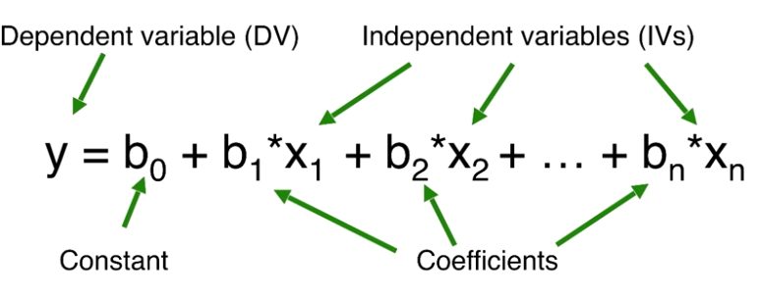
So first we need to set x0 = 1 in the following:

Why? Regression models (and most ML models) take into account the b0 * x0 constant that’s invisible, but these stats models libraries that we’re about to use will not assume that they’re there. We need to add them in on our own.

So how are we going to add it into our independent variables? By using numpy’s “append” method of course! It’s kind of like a python list’s append.

Alright – now with an extra FIRST column for b0 (see equation) to be multiplied against, we’re good to go forward with backwards elimination!

Remember – when using statsmodels (which we will do a lot) THE INTERCEPT NEEDS TO BE ADDED BY THE USER.

BACKWARDS ELIMINATION HOMEWORK:
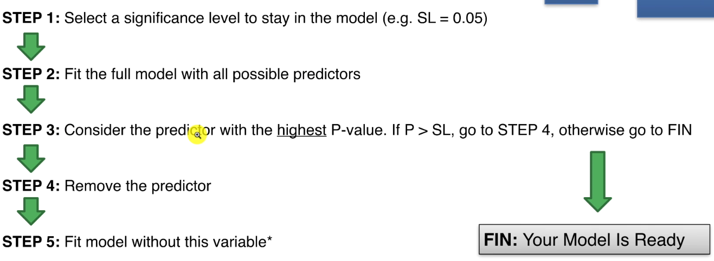
So now that we’ve prepared for backwards elimination we’re actually able to start it! This will be easy and fun, and we’ll get a powerful model to compare to our original one.

Let’s start by making X_opt:

X_opt = X[ :, [0, 1, 2, 3, 4, 5] ]

Okay… this is exactly the same as regular X, so what are we going to do with it? Start plucking things out and seeing if we can beat p<=0.05 !

We’ll make an OLS (Ordinary Least Squares) regressor and fit it all in one line with:

regressor_OLS = sm.OLS(endog = y, exog = X_opt).fit()

So let’s check which predictor has the highest p-value which is in the statsmodel library. The summary function (kind of like in R)

my_Summary = regressor_OLS.summary()
print(my_Summary)

So let’s take a look as these and see what has the highest p-value (so – the most-likely to occur given just randomness, and the least-contributing to linear dependency)

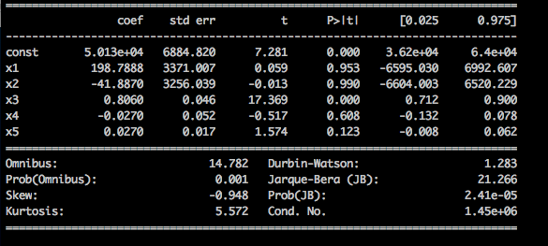

Wow look at that! Index 2 (one of our state dummy variables) has a p-value of 0.99, that’s huge. Let’s repeat the above steps ONLY THIS TIME we’re removing the worst index (2) from our list!!!

The homework is to continue backwards elimination until you find that the highest p-value is WITHIN the significance we set out to beat (0.05)

