UX Design for Web Development

https://www.udemy.com/user-experience-design-fundamentals/learn/v4/overview

We’re going to learn some tools, tricks of the trade, etc. We’re going to build out a responsive web projcect. We will create and maintain a web prototype.
Let’s get going!

Intro:
Touching only small specific parts of the whole make no sense. Think about three blind men trying to figure out what an elephant looks like! It would be VERY complex. It can be very time-consuming, and if you hide some of the relationships between parts, you will lose the meaningful functionality.

What UX is NOT:
It used to be called “design” - much of what designers learned was and is about PEOPLE. What they’ll react to, what they need, what they’re willing to use, and what’s appropriate to them!
UX IS NOT USER INTERFACE DESIGN – it’s a very important PART of this (what people see on the screen, the bridge between the user and the system). It’s a part, but there is much much more that is often lost on designs and developers.
It’s not about cosmetics or buttons, it’s EVERYONE’S CONCERN. Not just artistic types. It’s not just practiced by designers but also developers, DB designers, everyone who is involved has an impact and responsibility on the UX Design.
It’s not necessarily a step-by-step process.
It’s not a checkbox. You don’t do it and then move on, it needs to be integrated into everything you do. IT COMES FROM EVERYTHING THAT EVERYBODY DOES.
Form follows function (partially true). Every force should EVOLVE the form of the product. During a project there are CLIENT (user) NEEDS, time limits, preconceptions, political battles inside orgs. All of those things will have weight on what the final UX will be. It shouldn’t be as clear-cut as that.
Most people expect it to be a discrete activity. It’s not something you just do and it’s done. It should EVOLVE as your product/service evolves.
UX is not necessarily about digital products. All product design has to consider UX (think, ergonomics for a sink). There are functional considerations that decide whether or not the product is enjoyable or not.
UXD IS NOT ABOUT USABILITY – when you focus on only something that “will work” you lose practicality and end up with something people don’t want. A vacuum that cuts hair was a joke in the 90’s, but it worked well. It focussed PURELY on function and not whether anyone would ever want to use it! Do NOT make a product that just “works”. Make a product that works AND people would want to use. UXD should be able to make a product that is bad NOT BAD.
FUNCTIONALITY SHOULD NOT GET IN THE WAY OF LEARNABILITY – focusing on mechanical aspects leaves you forgetting how people feel about it even if it works. Focus more on the behavioral aspects and focus on making the product WANT to get used (Google Plus failed vs Facebook).
UXD is not just about users – it’s also about businesses and the creator of the product. Your stability and growth is dependent on what happens with your product. It’s creating a value TO YOU. Anybody can make BLANK, but not everyone can make VALUE. UXD is value that is a realizable success-metric. You have to look at business goals and sometimes you need to sacrifice a little bit for the sake of the users.
We have to find the sweet-spot between the user’s needs and business goals – focus on your branding and make sure the design reflects that.

WHAT UXD IS:
This is a very broad term. The interaction with the product. THINGS THAT GIVE YOU HINTS ON WHAT YOU HAVE TO DO AND HOW.
How are humans wired? What do they consider to be good, bad, or otherwise? It takes everything into consideration and puts it into an experience that will give a positive output.
USER EXPERIENCE is how the product behaves and is used IN THE REAL WORLD. It’s not what’s there, not what you made, it’s HOW IT’S USED.
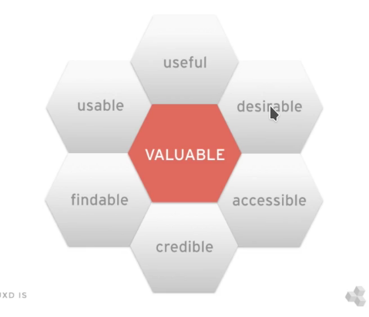
USABILITY is an attribute of user experience but that doesn’t make an experience positive altogether. It takes more than that.

UXD is the sum of an equation:
business goals + customer goals + user interface + backend process
= user experience design

Has to be:
useful
usable
desirable
findable
credible
accessible

On the right you’ll see the UX HONEYCOME which basically defines how to create value with a product. It holds some value for us, there’s a reason we use it in our daily activities.
Combines the result of multiple activities and sometimes very difference skills.
User research is very important – what do they want?
Interaction Design – how do they use it?
Visual Design – what do they see?
Information architecture – do they have all of the content? How is it prioritized? How much is there?
Frontend Development -
Writing – words and images are crucial and the proper treatment of words is useful
user testing – we want to validate these things with rigorous USER TESTING

See if the users have an easy time or hard time. It’s really just problem-solving! If you don’t have a solution to something then you don’t have a worthwhile problem. It’s all about identifying the right problems to solve.
What matters most? What has the most measurable value?
What can we do to address this? How CAN we address this? Anything involving humans is messy by-nature, keep this in mind!
UX DESIGN NEEDS TO BE COMPETITIVE – be sure to BEAT the alternative. This also reduces any kind of support because your product is intuitive. Effeciency = cost efficiency.
Problem-solving determines the feasibility of high quality products that can be created and implemented.
UX ENSURES THAT PEOPLE ACTUALLY USE YOUR TOOLS - they do this when the steps involved in fixing a task seem simple to discover to them. It’s likely because the cognitive load is minimal
Cognitive load is how much brainpower has to go into a certain task. We use things when we have immediate clear feedback on how something went. We get very anxious when something doesn’t work right away. AVOID THIS AT ALL COSTS. Constant feedback is important.
When we make a mistake there NEEDS TO BE A WAY to get back to where you were easily and quickly.
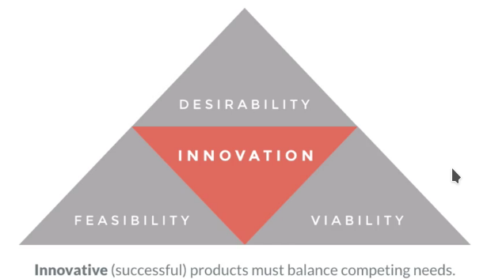
Innovation – an idea that hasn’t been created prior, brand new way of doing something. This is the core of a balancing act.
Desirability – do not apply innovation unless there is desirability.
Re-imagining of something that already exists – a way to make something that already exists DO SOMETHING no one thought it could ever do. Rely on the conditioning they already have.
Feasibility – can you actually build it..?
Viability – is this going to grow once we plant the seed?

Anything that wants to succeed needs to balance all of these competing needs. It’s not an easy feat but that’s why the discipline exists.

Why should we care about UXD?
Main reason is because our creations will be used BY PEOPLE. All people have good and bad experiences. The bad ones stick with you, unfortunately. Avoid repeating ANYTHING people don’t like (even in a redesign).
People will TALK about bad experiences. Do not make bad advertising for yourself.
Bad salespeople are showing you things that YOU DIDN’T ASK FOR. Give them ONLY WHAT THEY WANT and give the user CLEAR HONEST ANSWERS AS WELL.
Don’t be a bad used car salesmen – instead make something that will save time and energy, do not assume that the user will want to become an expert in your product.
Focus on meeting the needs and that’s it – you need a sense that what’s contained within can answer your questions.
The user wants to be respected – after spending time there, the time has to be respected. GIVE THE USER WHAT THEY CAME FOR and make it CLEAR that you addressed the things they’re ASKING FOR.
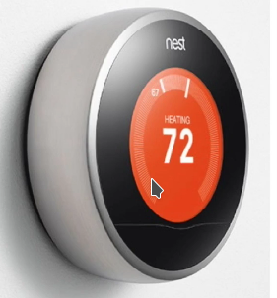
A lot of this will sound like the “old rules” of customer service! Human beings still have very high expectations of being GUILDED and LEAD to the solution. Talking the talk isn’t enough, you need to walk the walk.
Expectations are formed first VISUALLY. User needs to think “that might be what i’m looking after” on the first-impression. Does it NEED to look that way to function? No. But it should look like what they’re looking for if you know what they’re looking for, but in a MINIMAL EASIER method. Think about the nest. A user can tell that it’s a simplified (yet more advanced) version of the old thermostat that they WERE used to seeing everywhere. Do the same thing with any web tools you build in the future.
Very little effort, lots of value for that effort.
Cross-channel expectations are higher – we’re going to be using it in multiple formats and places. Mobile vs desktop vs tablet (a channel is a method of delivery). We expect it to behave the same way across all devices. This is very VERY difficult.
People will abandon loyalty the second you disappoint them – be sure to always focus on the user no matter what.
Task completion is not success – just because the person CAN do what they want to do, doesn’t mean that they were successful in doing so. They need to have been able to do it PAINLESSLY and EASILY and ELEGANTLY.

