 | 
 | MUSIC AND PERFORMING ARTS PROFESSIONS
Support | Room Instructions
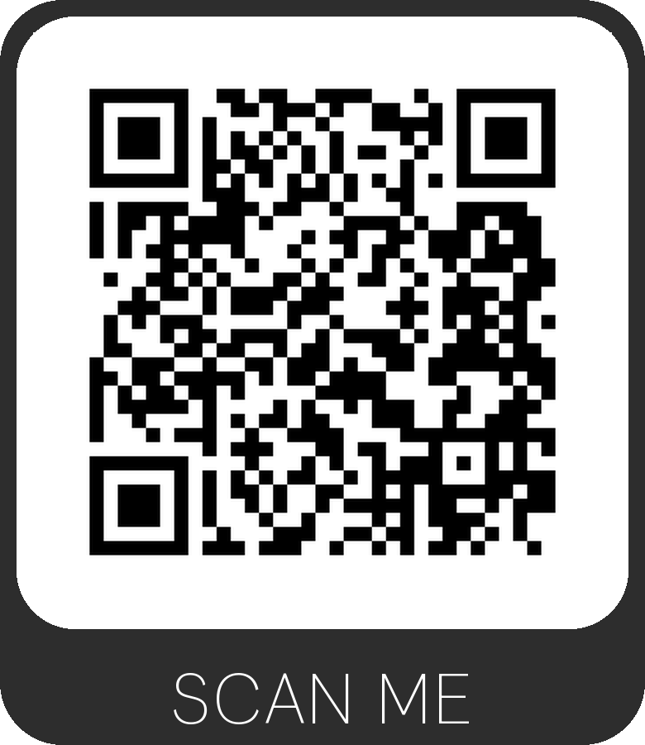 | 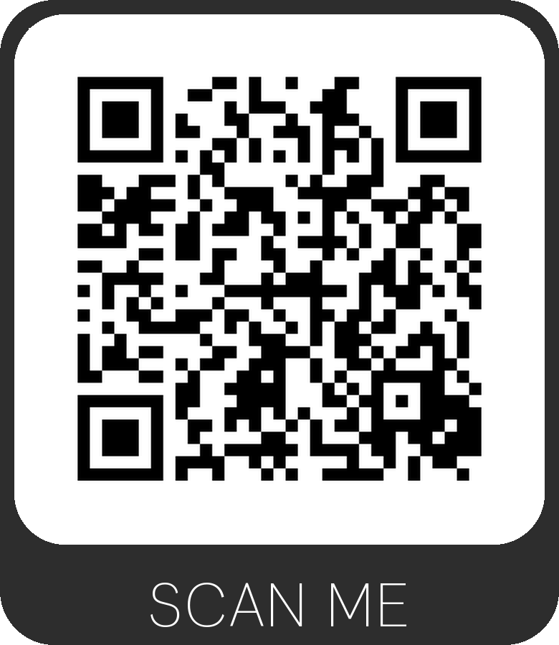
 | Studio A
 | 
 | MUSIC AND PERFORMING ARTS PROFESSIONS
Support | Room Instructions
 | 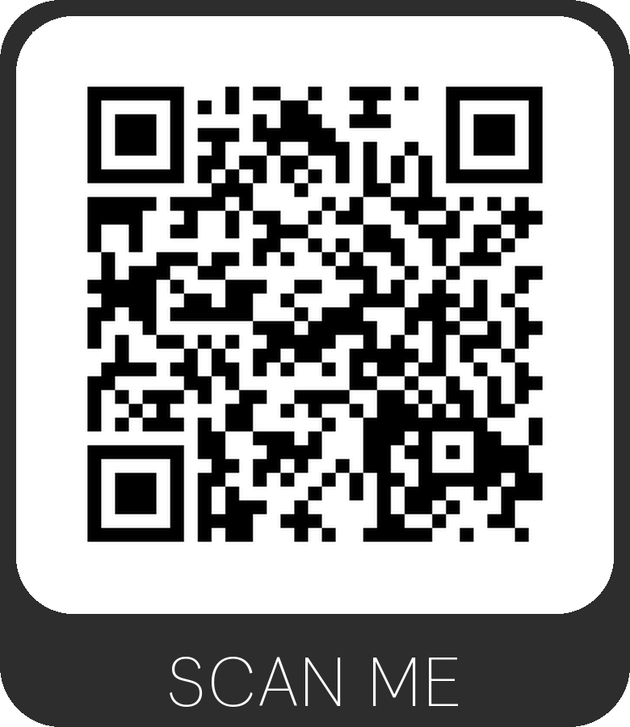
 | Studio C

 | 
 | MUSIC AND PERFORMING ARTS PROFESSIONS
Support | Room Instructions
 | 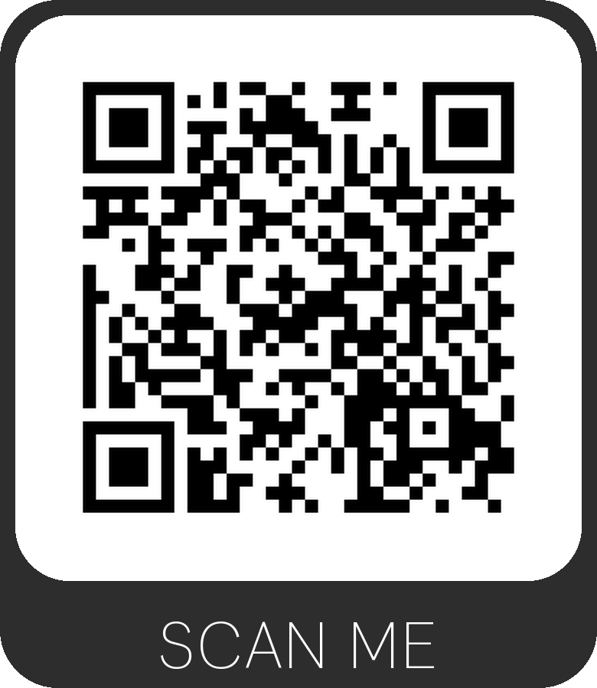
 | Studio D
 | 
 | MUSIC AND PERFORMING ARTS PROFESSIONS
Support | Room Instructions
 | 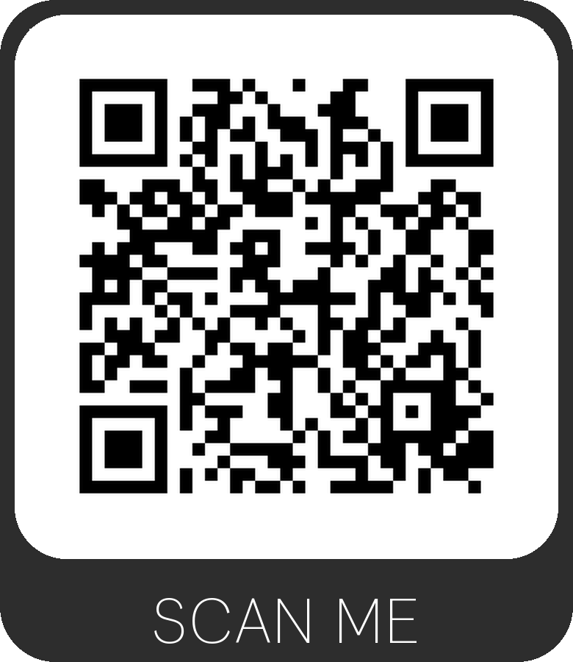
 | Studio D1

 | 
 | MUSIC AND PERFORMING ARTS PROFESSIONS
Support | Room Instructions
 | 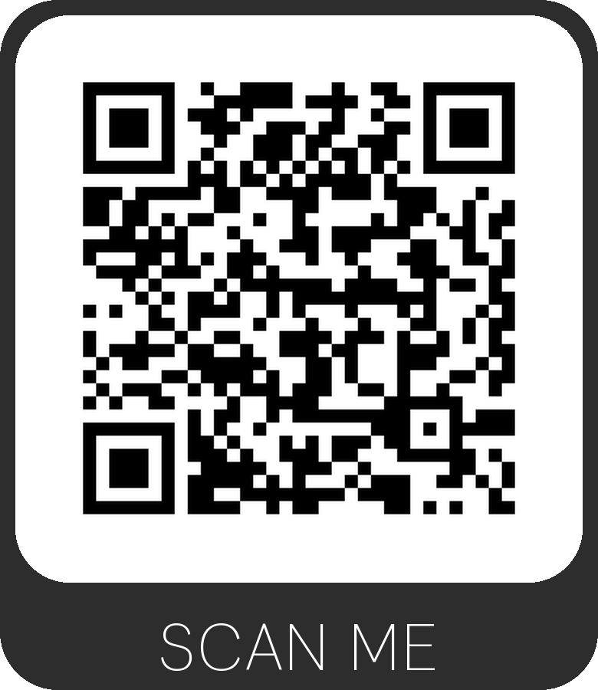
 | Studio E
 | 
 | MUSIC AND PERFORMING ARTS PROFESSIONS
Support | Room Instructions
 | 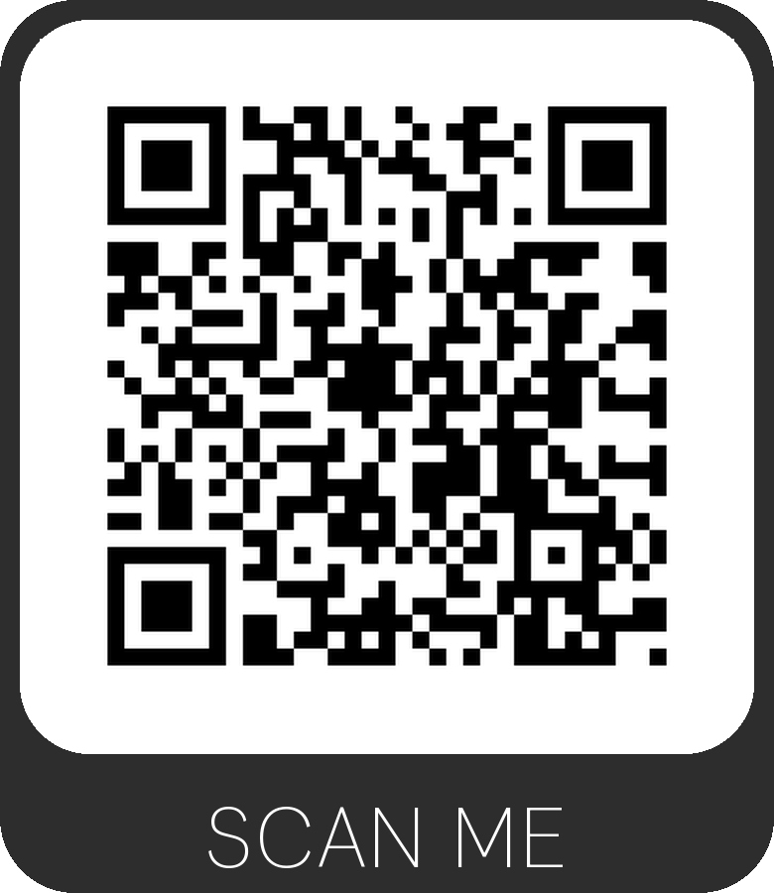
 | Studio F

 | 
 | MUSIC AND PERFORMING ARTS PROFESSIONS
Support | Room Instructions
 | 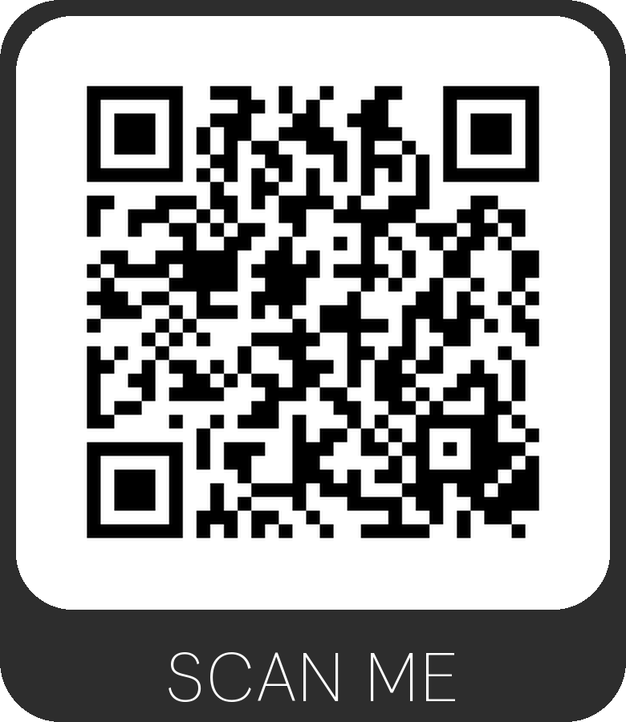
 | Room 302 A
 | 
 | MUSIC AND PERFORMING ARTS PROFESSIONS
Support | Room Instructions
 | 
 | Room 302 B

 | 
 | MUSIC AND PERFORMING ARTS PROFESSIONS
Support | Room Instructions
 | 
 | Room 302 C
 | 
 | MUSIC AND PERFORMING ARTS PROFESSIONS
Support | Room Instructions
 | 
 | Room 302 D

 | 
 | MUSIC AND PERFORMING ARTS PROFESSIONS
Support | Room Instructions
 | 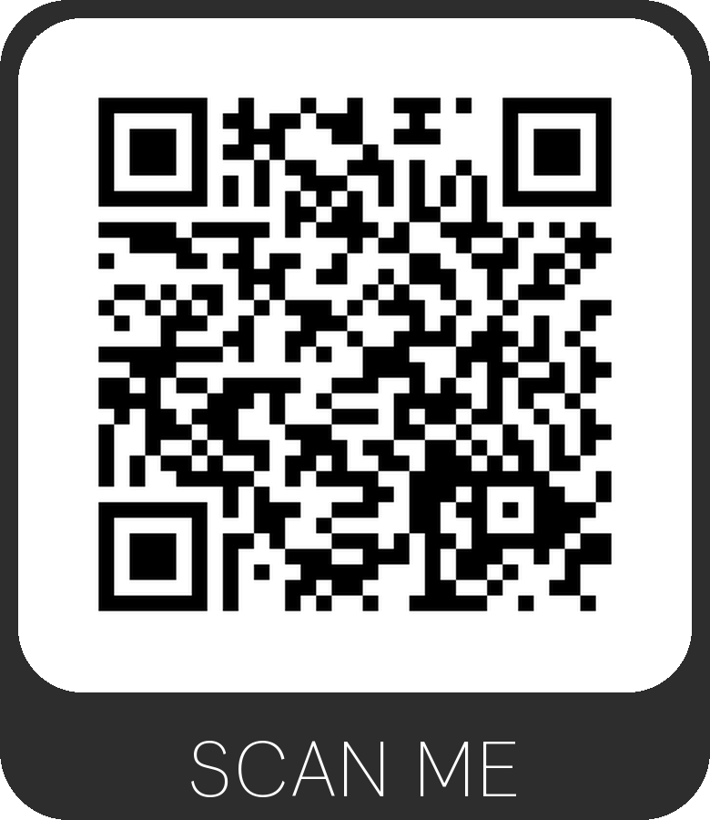
 | Room 303
 | 
 | MUSIC AND PERFORMING ARTS PROFESSIONS
Support | Room Instructions
 | 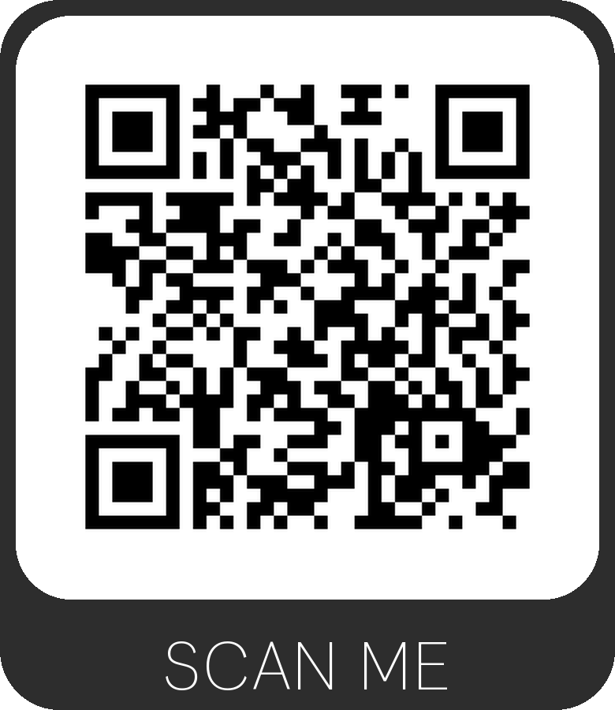
 | Room 304

 | 
 | MUSIC AND PERFORMING ARTS PROFESSIONS
Support | Room Instructions
 | 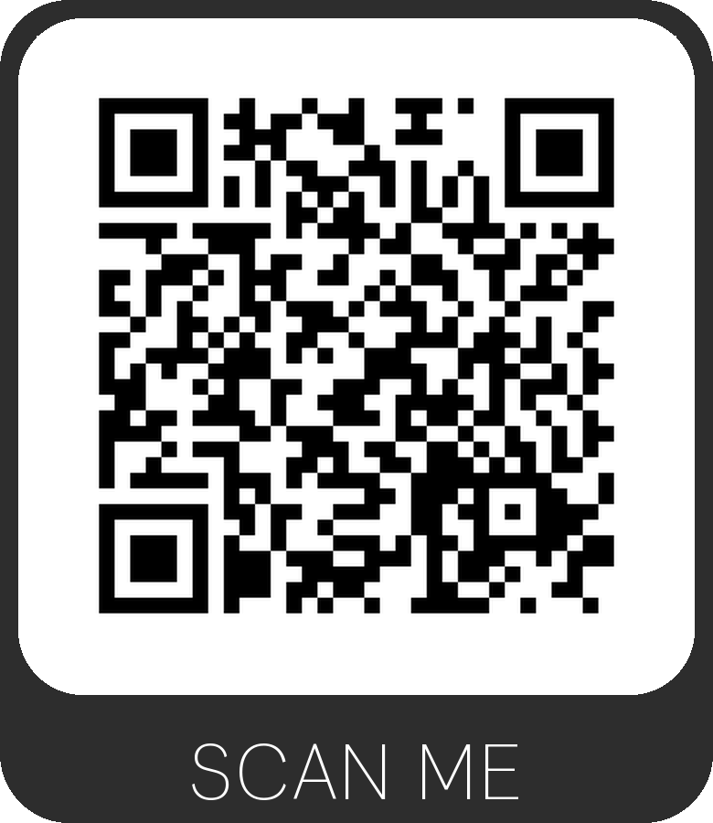
 | Room 305
 | 
 | MUSIC AND PERFORMING ARTS PROFESSIONS
Support | Room Instructions
 | 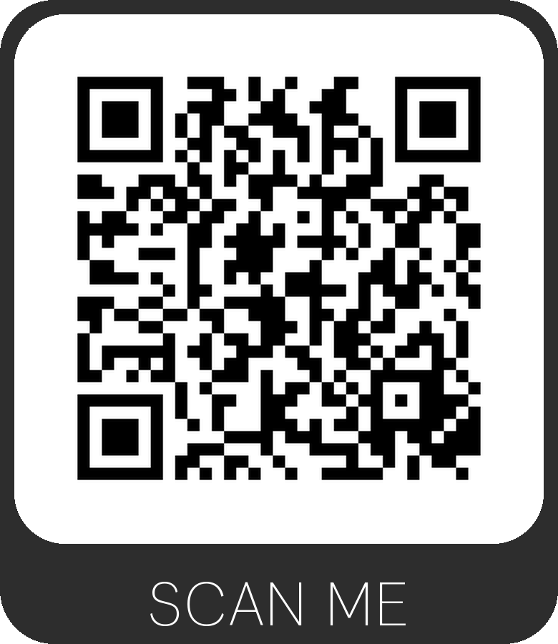
 | Room 306

 | 
 | MUSIC AND PERFORMING ARTS PROFESSIONS
Support | Room Instructions
 | 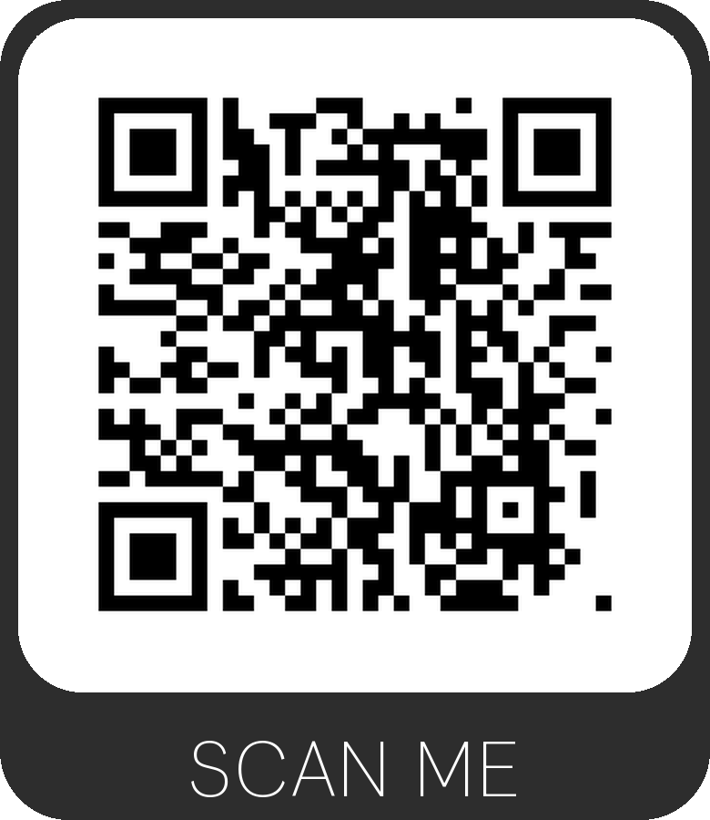
 | Room 307
 | 
 | MUSIC AND PERFORMING ARTS PROFESSIONS
Support | Room Instructions
 | 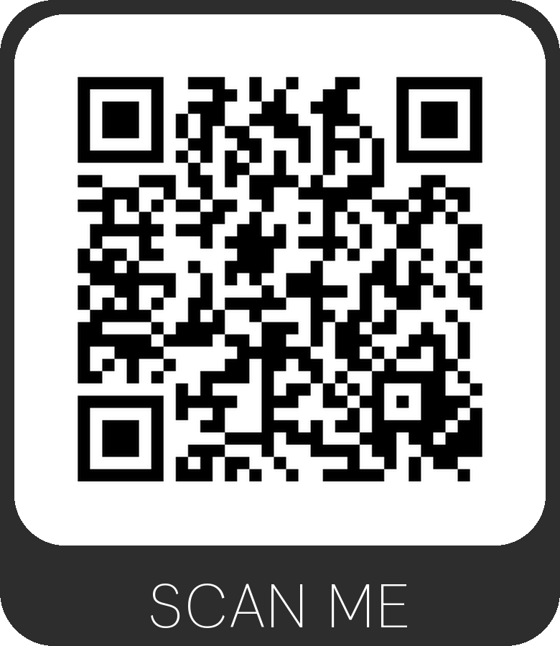
 | Room 770

 | 
 | MUSIC AND PERFORMING ARTS PROFESSIONS
Support | Room Instructions
 | 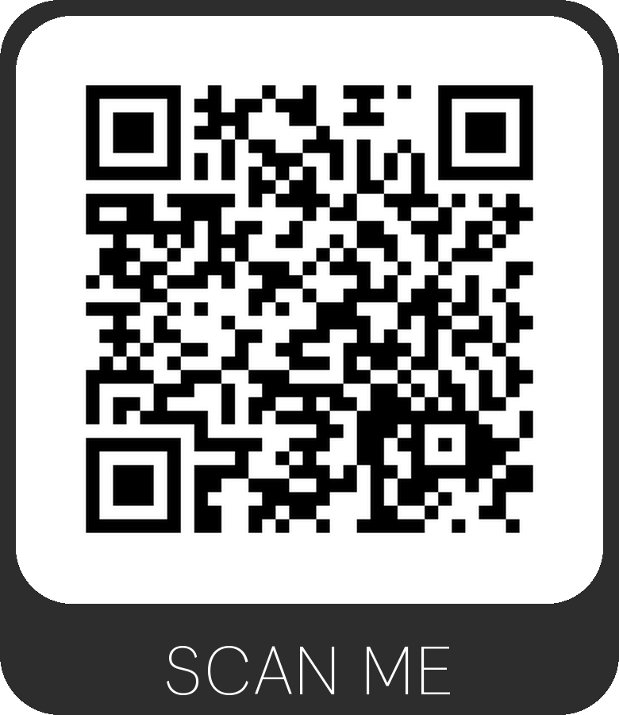
 | Room 771
 | 
 | MUSIC AND PERFORMING ARTS PROFESSIONS
Support | Room Instructions
 | 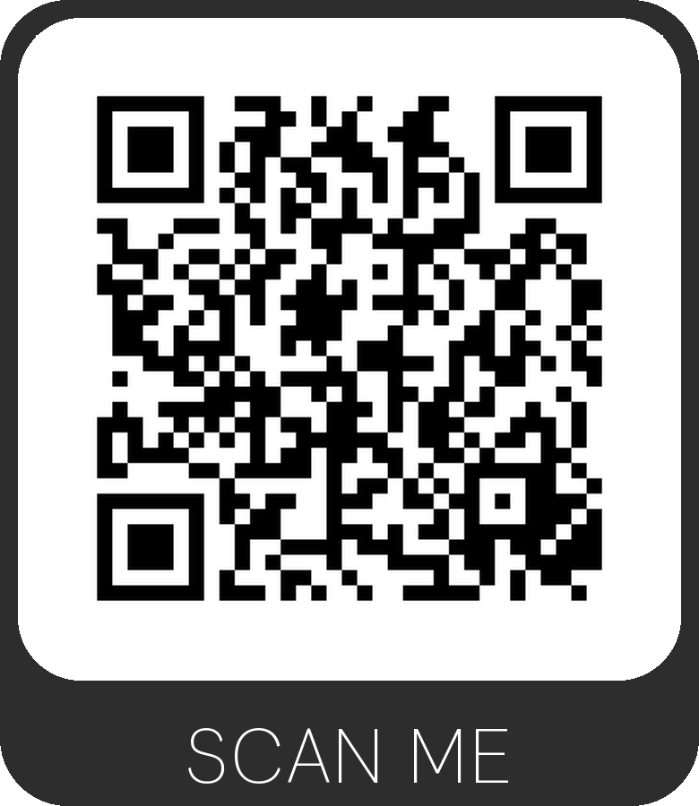
 | Room 774

 | 
 | MUSIC AND PERFORMING ARTS PROFESSIONS
Support | Room Instructions
 | 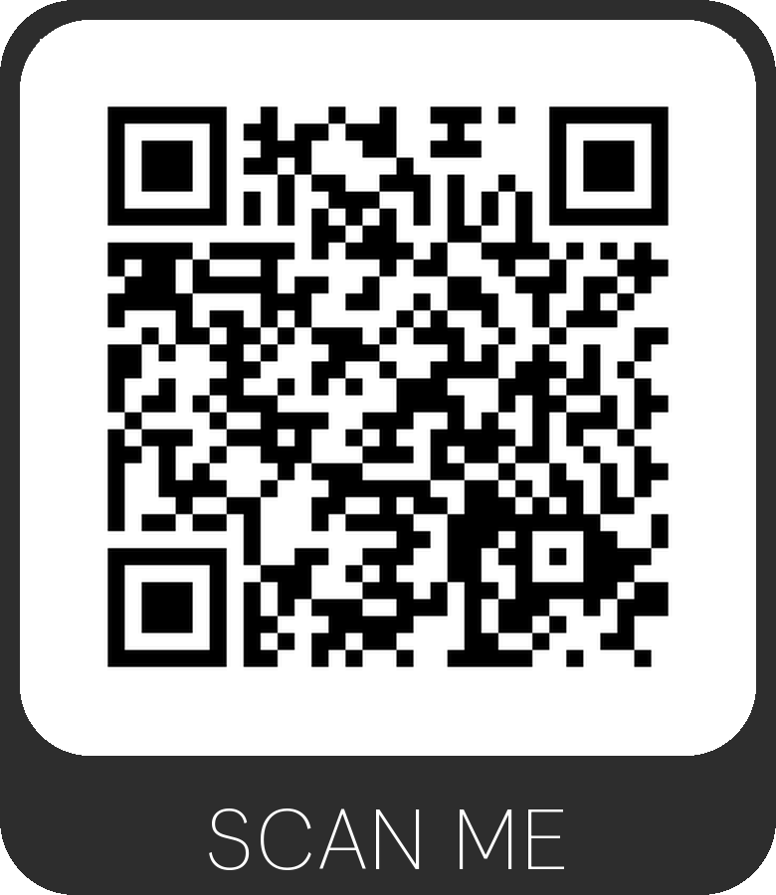
 | Room 777
 | 
 | MUSIC AND PERFORMING ARTS PROFESSIONS
Support | Room Instructions
 | 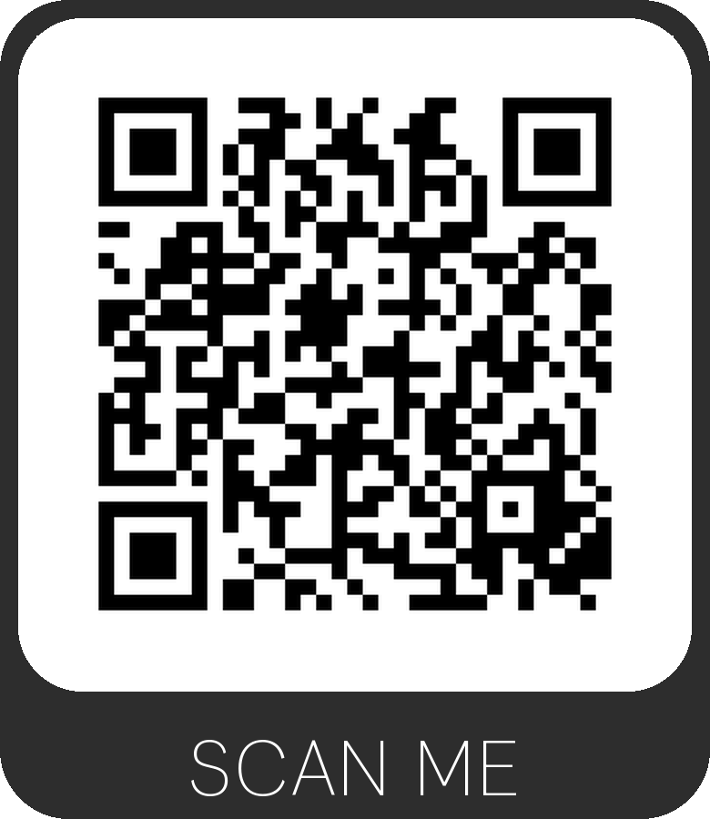
 | Room 778

 | 
 | MUSIC AND PERFORMING ARTS PROFESSIONS
Support | Room Instructions
 | 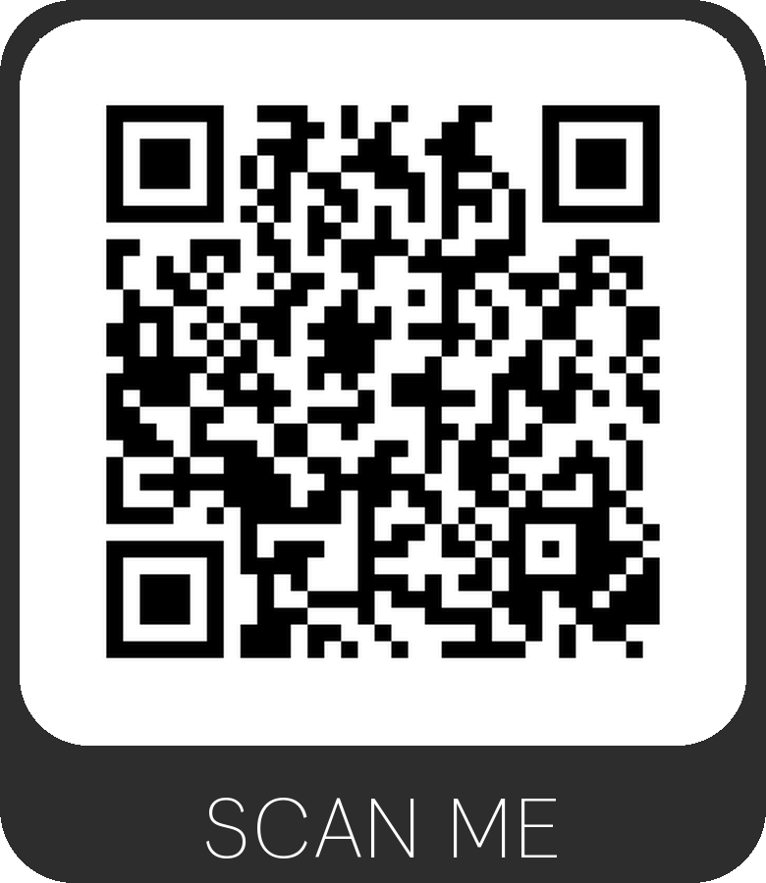
 | Room 779
 | 
 | MUSIC AND PERFORMING ARTS PROFESSIONS
Support | Room Instructions
 | 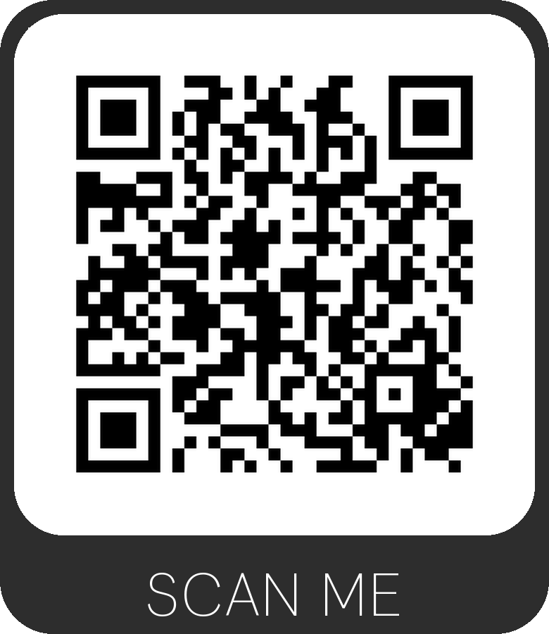
 | Room 876

 | 
 | MUSIC AND PERFORMING ARTS PROFESSIONS
Support | Room Instructions
 | 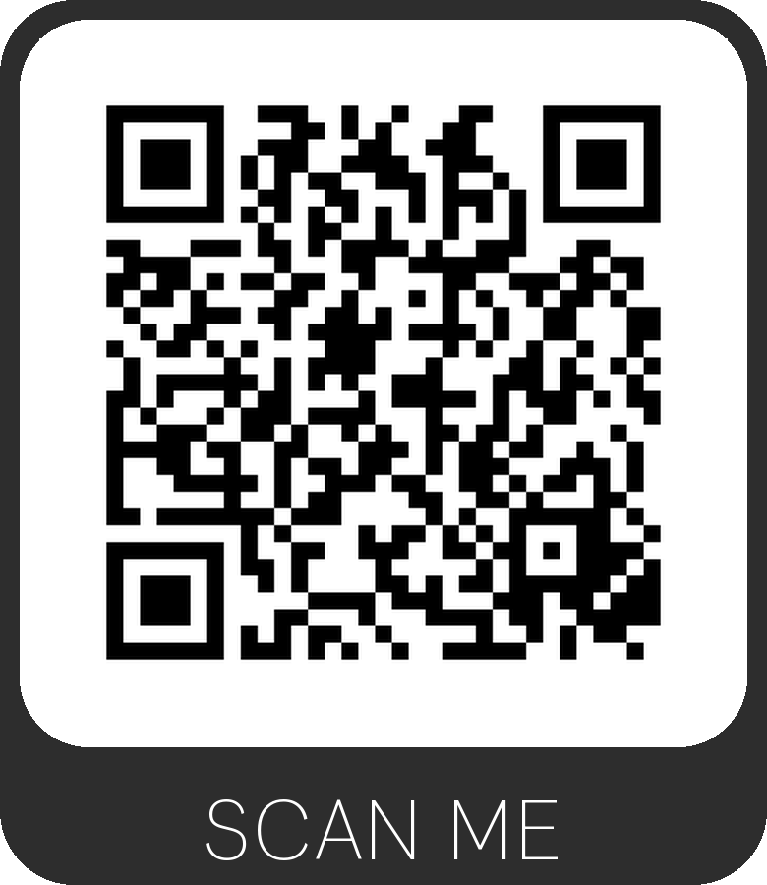
 | Room 985
 | 
 | MUSIC AND PERFORMING ARTS PROFESSIONS
Support | Room Instructions
 | 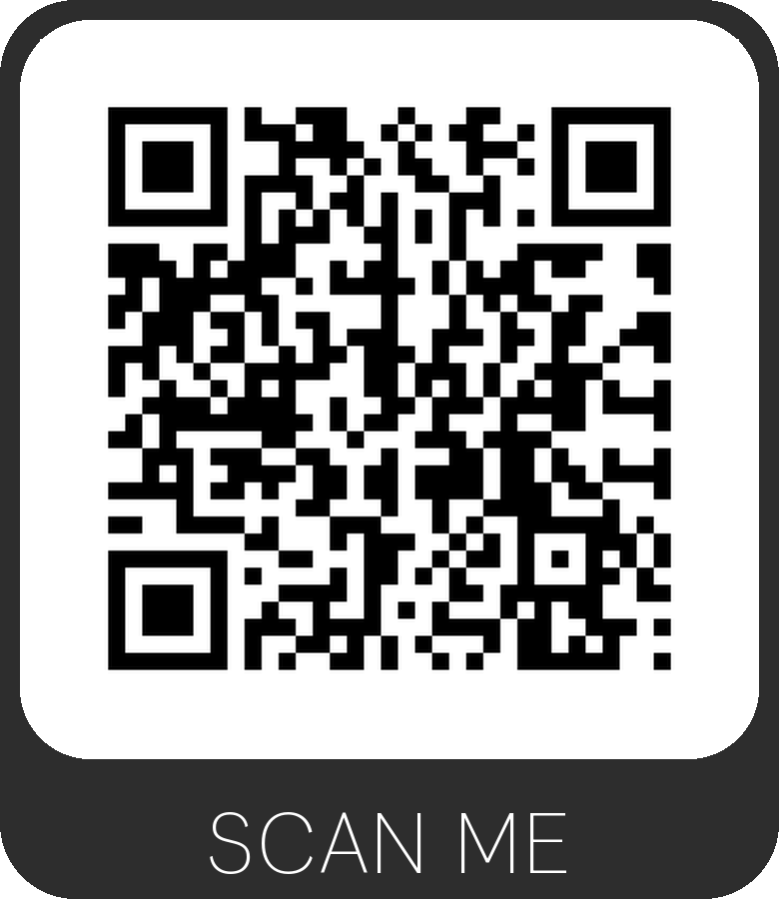
 | 6th Floor Conference Room

