 | 
 | MUSIC AND PERFORMING ARTS PROFESSIONS
Support | Room Instructions
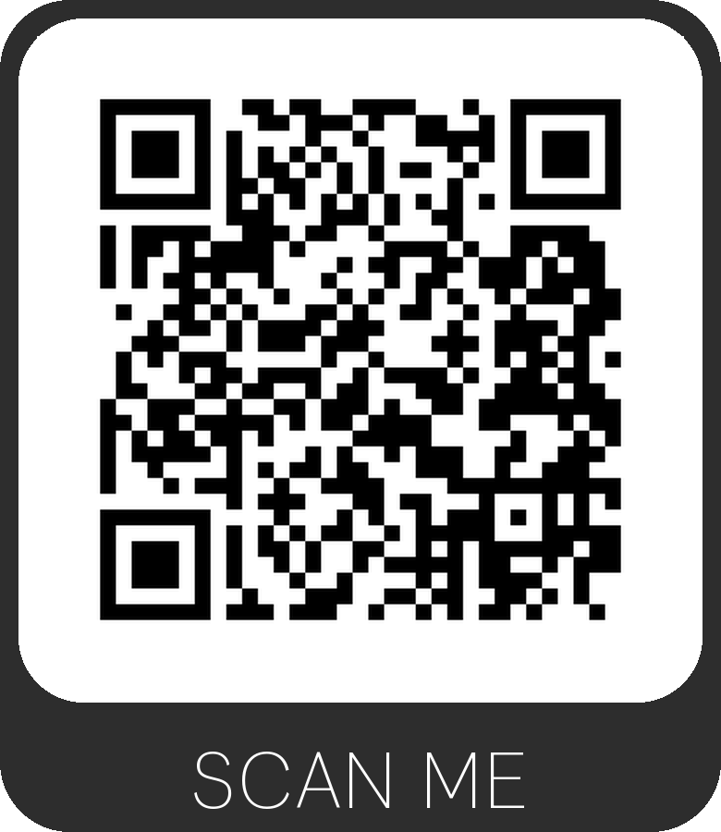 | 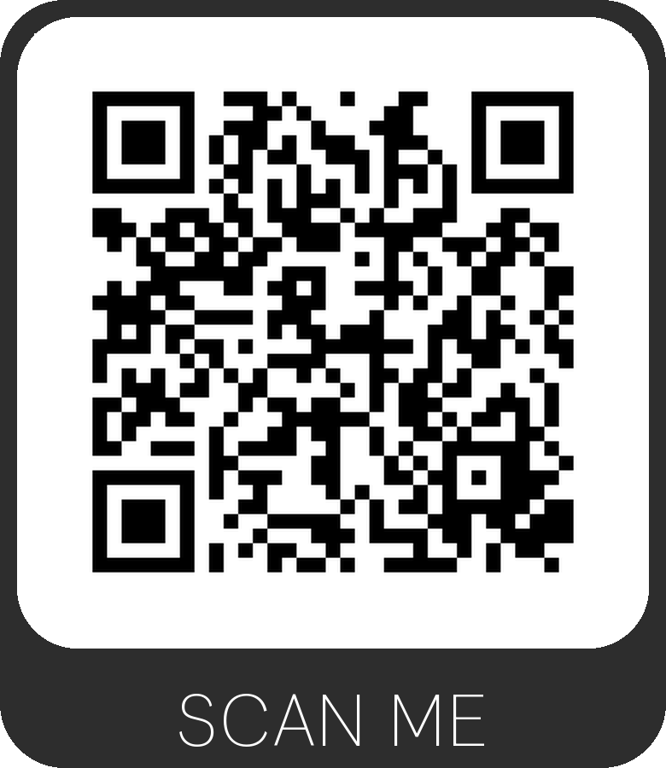
 | Studio D1
 | 
 | MUSIC AND PERFORMING ARTS PROFESSIONS
Support | Room Instructions
 | 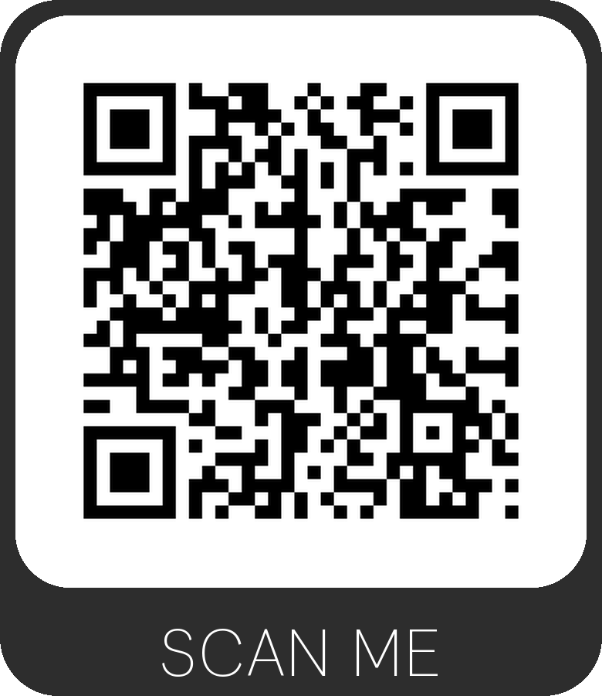
 | 6th Floor Conference Room

