Dear Pascariu,

PFA is the ASDR of India and six regions (total female) from the National Family Health Survey (NFHS) with age in Excel format.

I am intended to fit the Heligman-Pollard (HP) model for constructing lifetables. I have tried the model q[x]/p[x] = A^[(x + B)^C] + **D*exp[-E*{log(x/F)}^2]** + G*H^x.  Here A^[(x + B)^C]  is for early mortality, G*H^x is for old age mortality, and  **D*exp[-E*{log(x/F)}^2]** is for adult mortality**.**

The same is also available in the R package: "MortalityLaws" (<https://github.com/mpascariu/MortalityLaws>) by you. I have used the package "MortalityLaws" to get the values of all parameters, i.e. A, B, C, D, E, F, G, and H. It provides good estimates where data is of good quality or better to say the age pattern of mortality is smooth. The same package provides unreliable estimates if there are some problems in data maybe in early, adult, or old age groups. In my view, it is over fitting the data. For example, the package MortalityLaws in R software provides bad estimates of HP model parameters in the case of South India (Rural female); just because there is a dip in mortality rates in 10-14 age group.

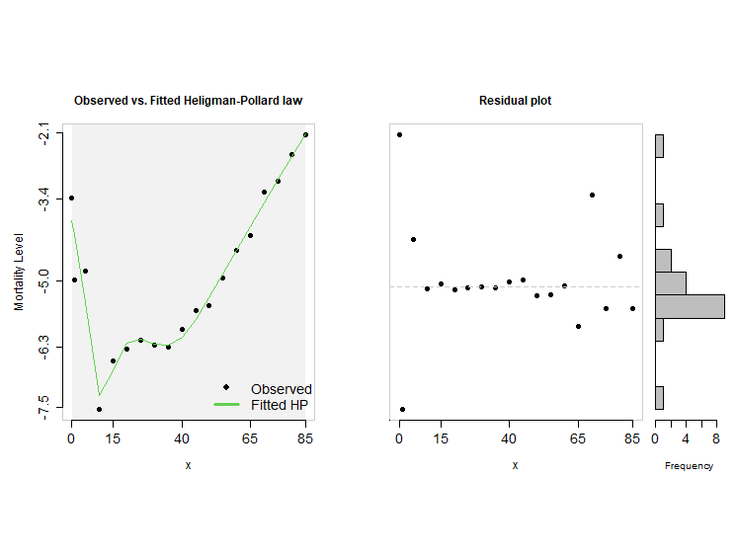

The HP model parameters obtained are:

|  |  |  |  |  |  |  |  |  |
| --- | --- | --- | --- | --- | --- | --- | --- | --- |
| **MortalityLaws in R Software** | A | B | C | D | E | F_ | G | H |
| Central India | 0.0068 | 0.0188 | 0.1301 | 0.0016 | 6.7519 | 21.8241 | 0.0001 | 1.0972 |
| East India | 0.0062 | 0.0067 | 0.1126 | 0.0011 | 5.0466 | 24.0071 | 0 | 1.1025 |
| India | 0.0066 | 0.0194 | 0.1221 | 0.0011 | 5.0412 | 23.4819 | 0 | 1.102 |
| North India | 0.0034 | 0.0016 | 0.0793 | 0.0007 | 2.0631 | 36.573 | 0 | 1.1111 |
| Northeast India | 0.0069 | 0.0326 | 0.1298 | 0.0008 | 7.0038 | 19.4645 | 0.0001 | 1.0915 |
| **South India** | **1** | **80.8738** | **6.0243** | **0.0018** | **4.1496** | **22.159** | **0** | **1.1008** |
| West India | 0.0049 | 0.0303 | 0.1042 | 0.001 | 3.132 | 26.3802 | 0 | 1.1171 |

The Rscript used is below:

# South India Rural female

m6 = c(0.034276966, 0.006760884, 0.008185525, 0.000532429, 0.001392143, 0.001750483, 0.002068983, 0.001906794, 0.001808759, 0.002597526, 0.003716968, 0.004090175, 0.007031934, 0.012318669, 0.016505802, 0.038739584, 0.048035947, 0.080451108, 0.11860436)

M6=MortalityLaw(x, mx=m6, opt.method="LF2", law='HP', show=F)

M6; ls(M6); coef(M6); summary(M6); fitted(M6); plot(M6)

I have to apply HP model at the state level of India wherein the age pattern of mortality may not be very smooth. I am facing problems, to get reliable estimates of HP model parameters at the regional level and for many states of India. The problem may be because of the estimation of all 8 HP model parameters simultaneously. However, if we do model in three parts for early, adult, and old mortality, the HP model can be applied on haphazard mortality data as well. I applied the parts of HP model for early and old mortality rates successfully in STATA/R.  However, at present, I am not able to solve or model adult mortality (the black-bold color) in the HP equation. I have attached a data file with age and regional ASDRs at the national level from NFHS (2015-16). You may give try solving the HP model parameters, especially for D, E, and F using mortality data of India. This one attempt may make you feel what I am going through, maybe wrong also. But I not of the view to blame data (ASDR) for the reason to avoid overfitting or other issues with model fitting.

I have also looked into the GitHub link (<https://github.com/mpascariu/MortalityLaws>) that may contain a code for estimation but I am not able to retrieve that.

So I request you to share your code of optimization of HP model for all the eight parameters with the focus on adult mortality part (**D*exp[-E*{log(x/F)}^2]**). It will be of grear help to me and for the mortality research on India. I would like to attempt with your R codes for estimating HP model parameters at different level of geography from national to state and district level of mortality.

Kind Regards

Suryakant