Skill Test 1: Cloud and Containers

Git Repo link : https://github.com/mpatellearning/Microservices-Task.git

https://github.com/mpatellearning/herovired/tree/2bccd4841a9640b50eeb1654320964c9bc104d84/skilltest1

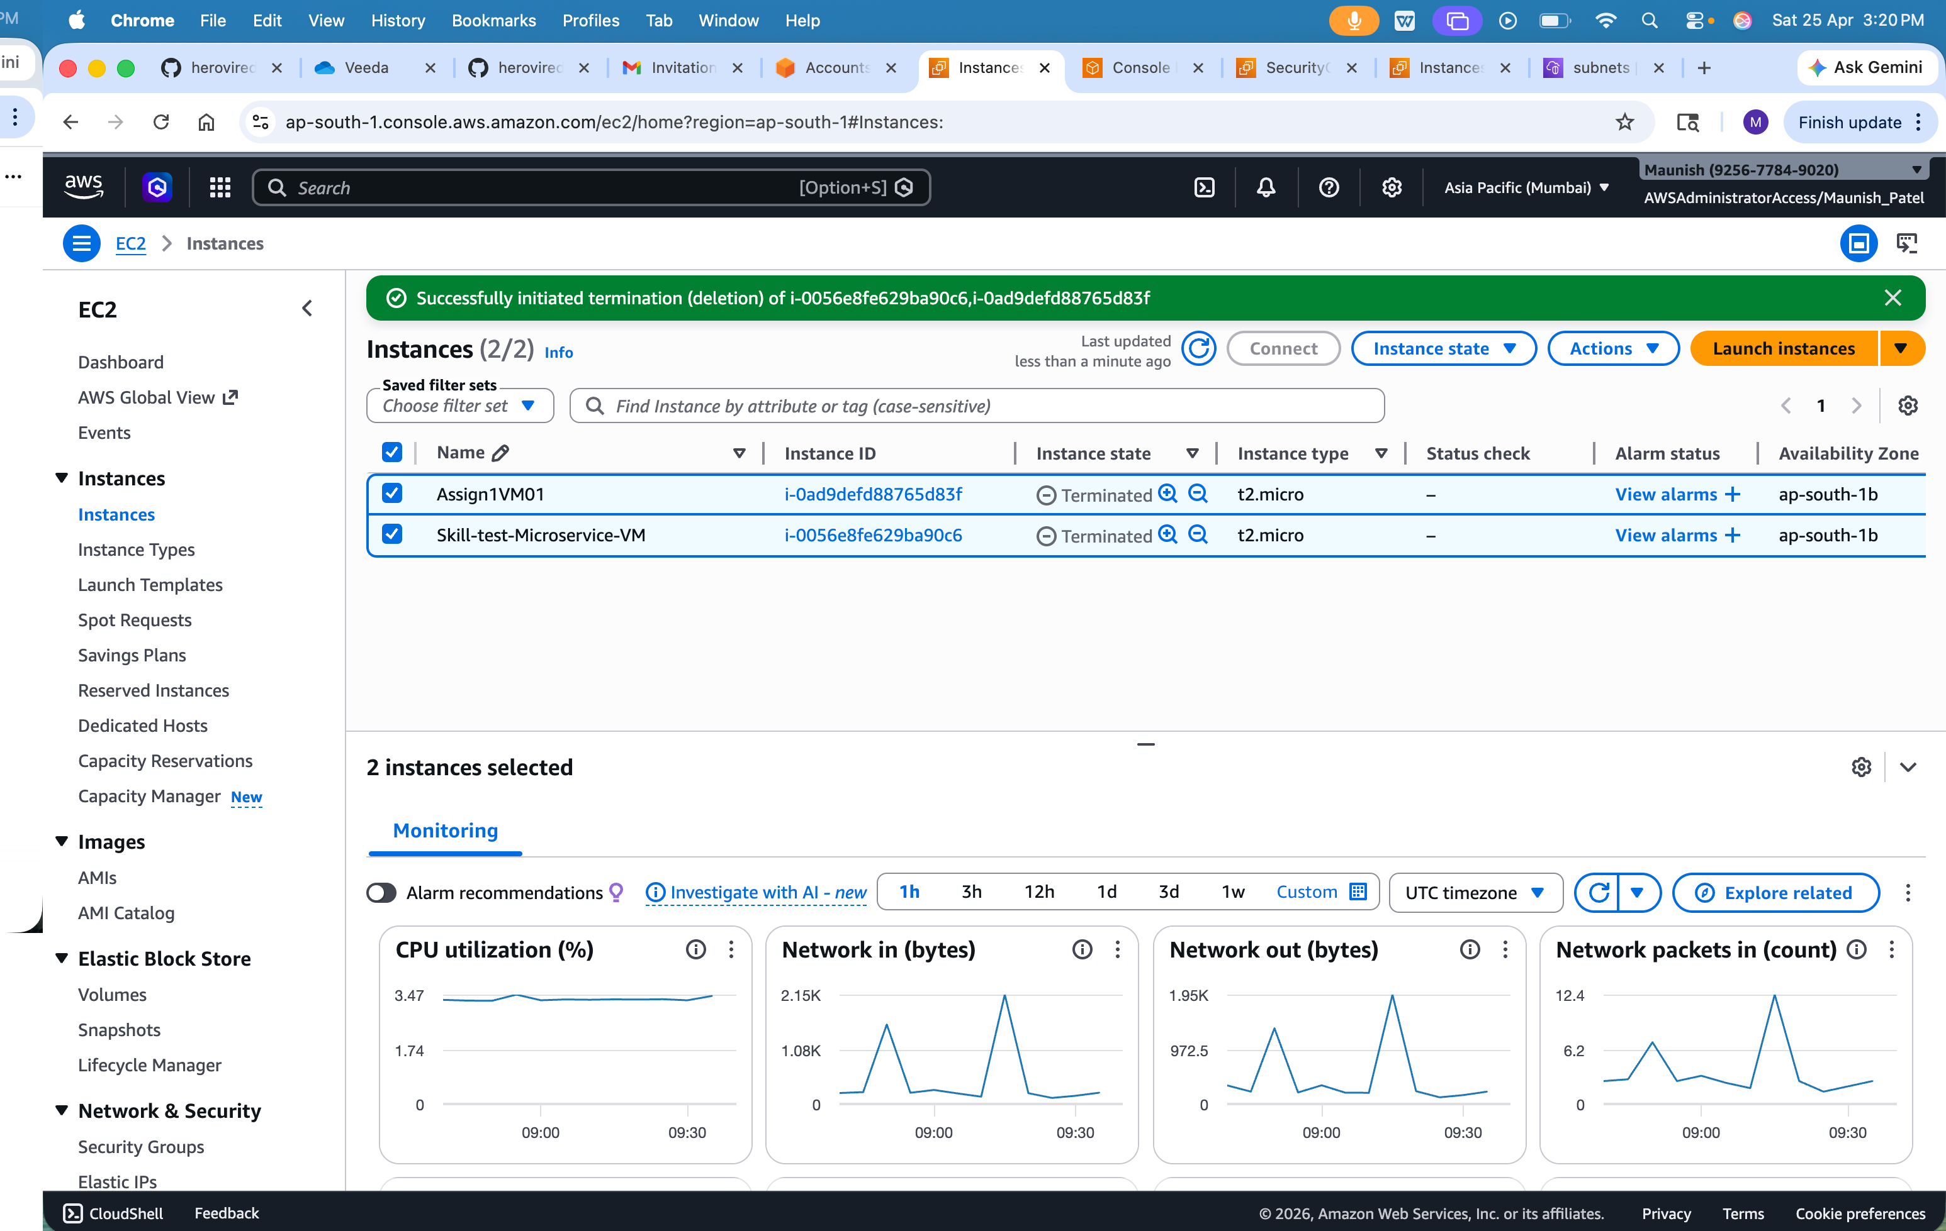
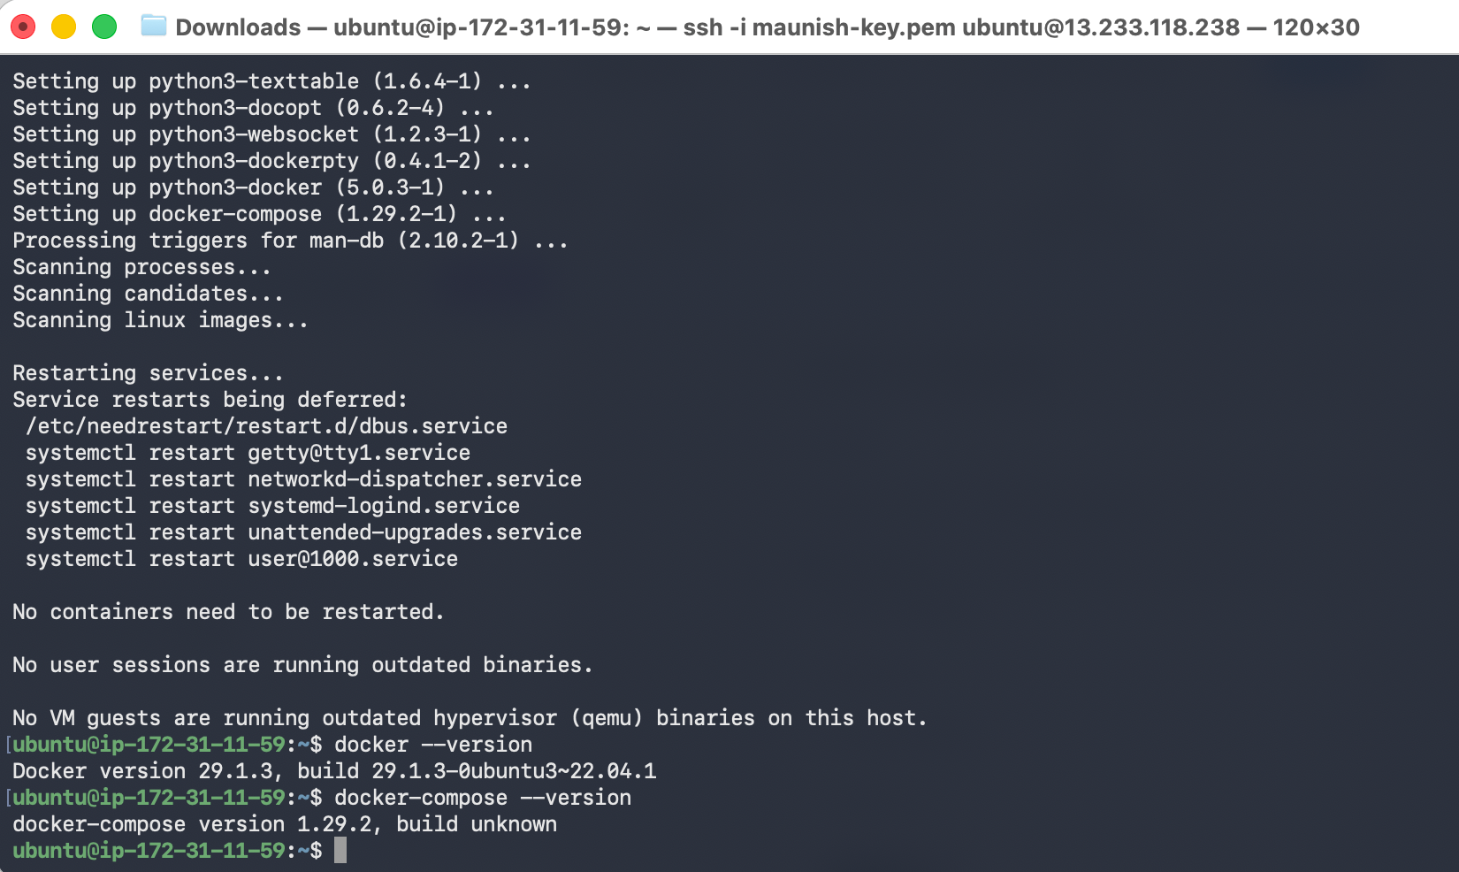

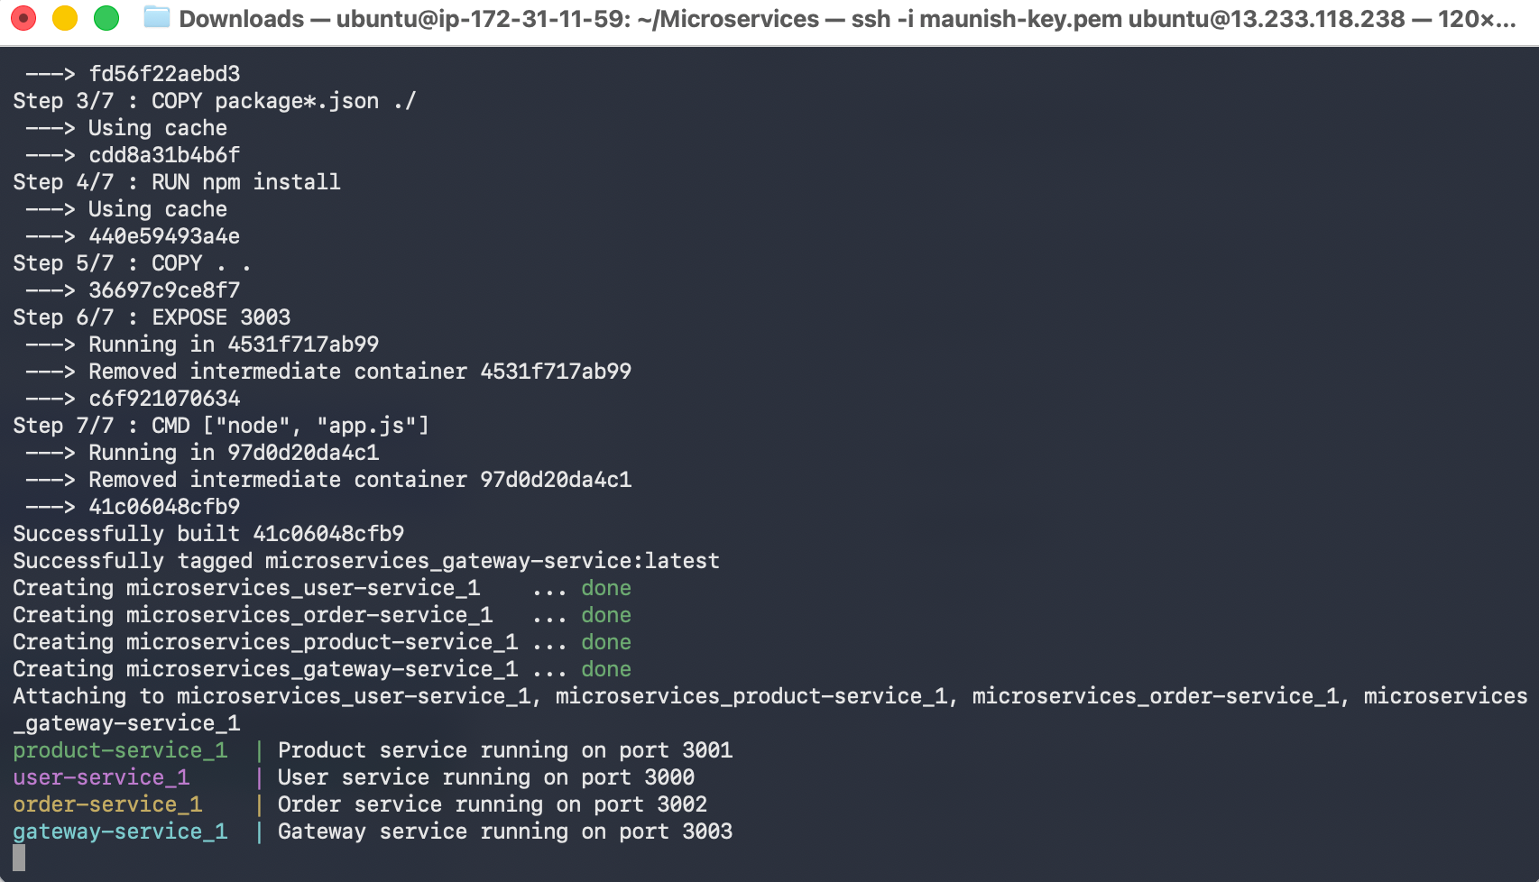

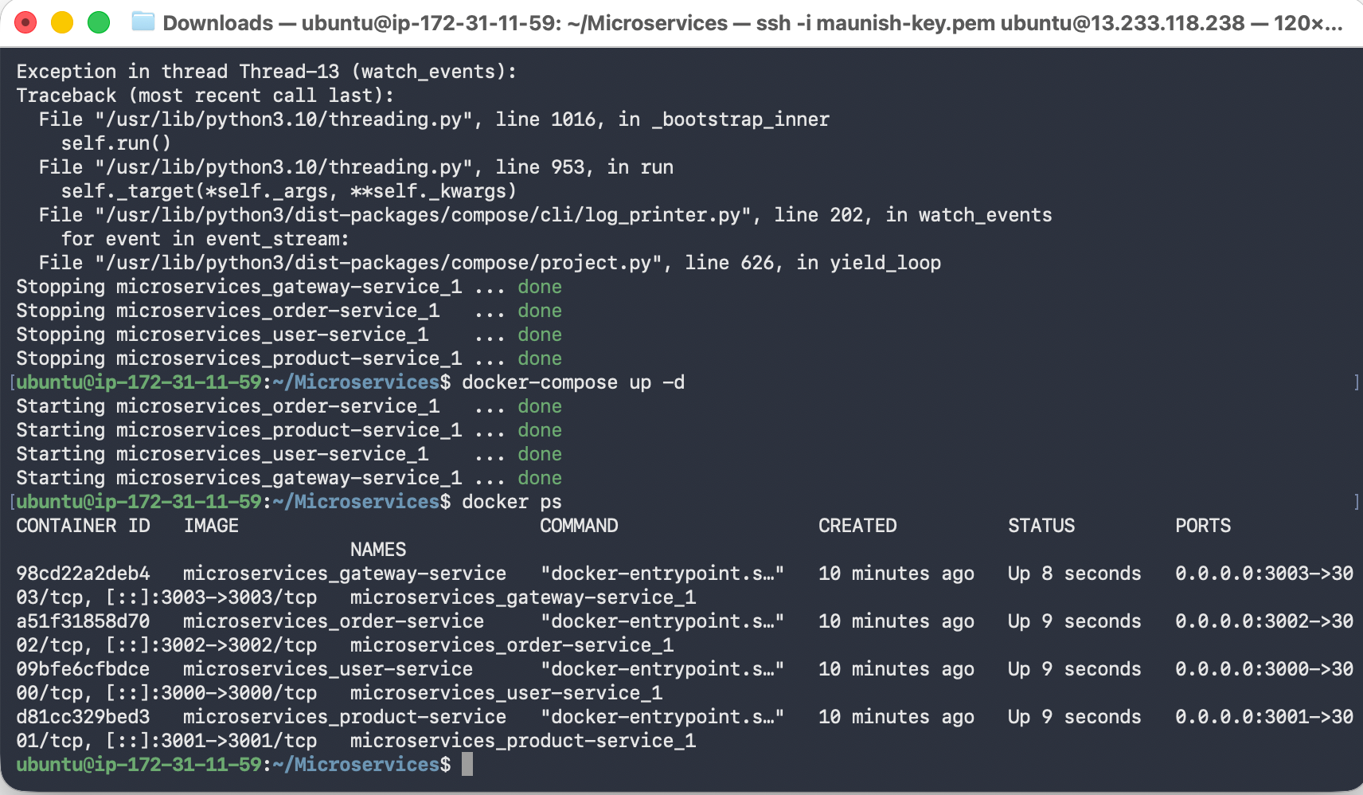
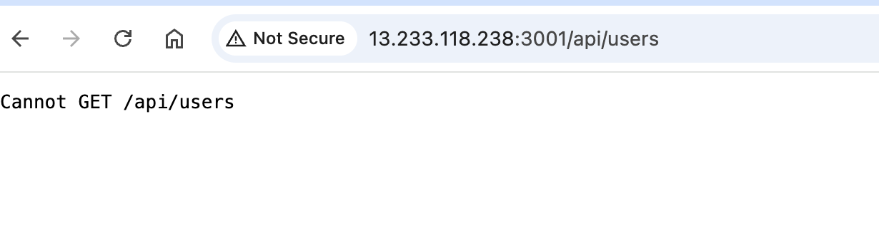
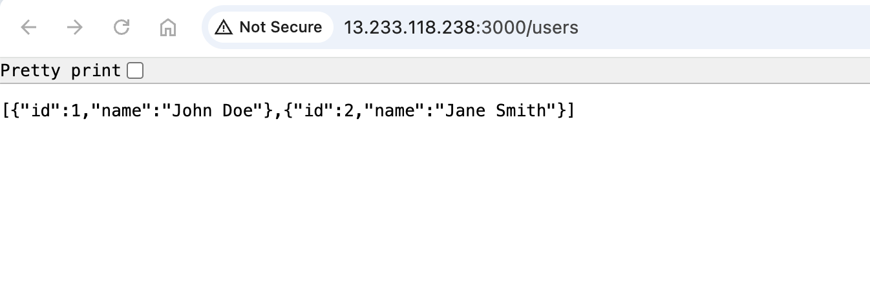
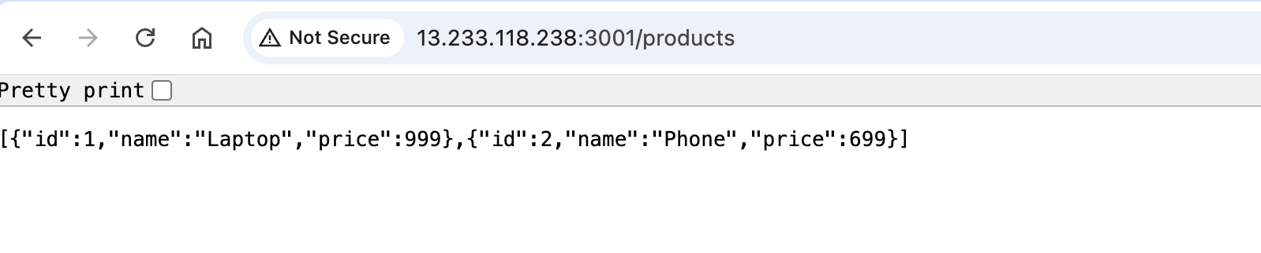

Task Overview
You are provided with source code for three Node.js microservices:

User Service (Port 3000)

Product Service (Port 3001)

Gateway Service (Port 3003)

Your task is to containerize these services and orchestrate them using Docker Compose.

Requirements

1. Dockerfile Creation (15 marks)
Create a Dockerfile for each service (3 services × 5 marks) that:

Uses an appropriate Node.js base image

Sets a working directory

Installs dependencies

Exposes the correct port

Includes a valid CMD instruction

2. Docker Compose Configuration (10 marks)
Create a docker-compose.yml file that:

Defines all three services

Maps correct ports

Configures a shared network for communication

3. Local Testing & Validation (10 marks)
Run the application using docker-compose up on your local machine.

Ensure all services start correctly

Confirm accessibility via localhost on respective ports

4. Documentation (10 marks)
Provide a README.md file that includes:

Setup instructions

How to test each service

Basic troubleshooting tips

Screenshots showing services running in Docker

Deliverables
Create a ZIP file with the following structure:
submission/
├── user-service/
│ └── Dockerfile
├── product-service/
│ └── Dockerfile
├── gateway-service/
│ └── Dockerfile
├── docker-compose.yml
└── README.md

Evaluation Criteria

Functionality: Services build and run successfully

Configuration: Correct Dockerfile and Compose setup

Documentation: Clear and concise README

Testing: All services accessible and working

Submission Guidelines

Create a ZIP file containing:

All Dockerfiles

docker-compose.yml

README.md

File structure should match:

submission/
├── user-service/
│ └── Dockerfile
├── product-service/
│ └── Dockerfile
├── order-service/
│ └── Dockerfile
├── gateway-service/
│ └── Dockerfile
├── docker-compose.yml
└── README.md

Fork the provided repository, push your changes and advancements to your forked repo, and share the link in the submission.

