* **How to import the resource to terraform** (ex: import ec2 instance)
  + Create a ‘.tf’ file like below

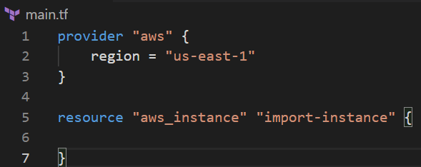

* + Now, note down the id of EC2 instance and issue following command



And result should be like below

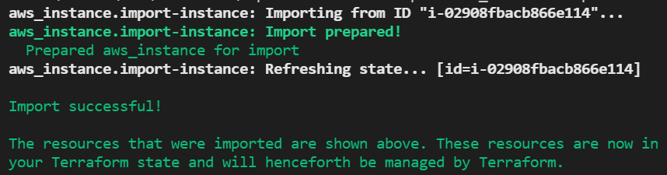

* + Now, check the ‘terraform.tfstate’ file. Resource must be present there.