Table 1: Summary of Data Received

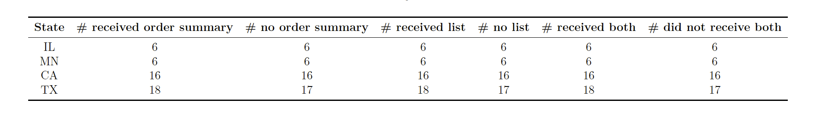

Table 2: Filter by Neighborhood Segments

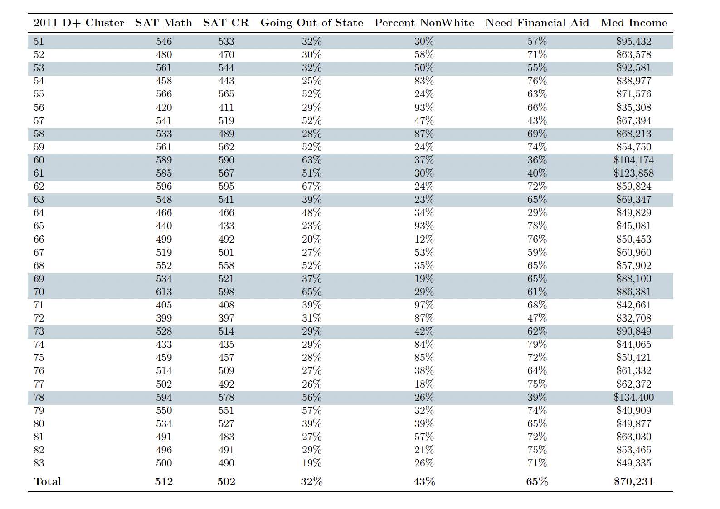

Table 3: Filter by High School Segments

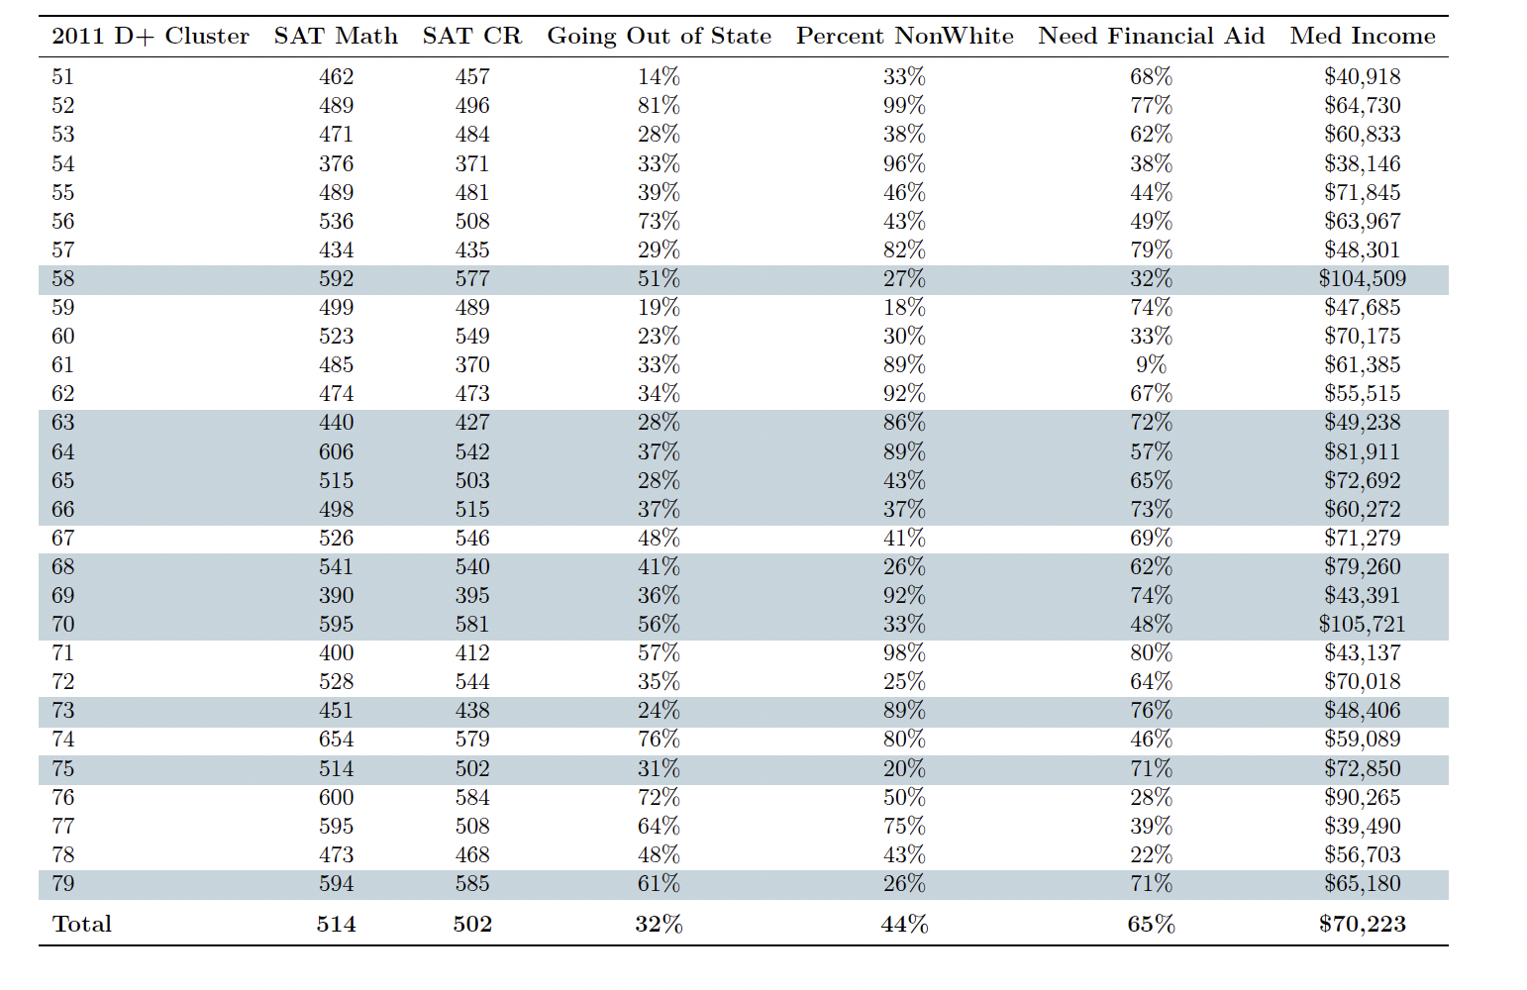

Figure 1: Segment Order Prospect and Public High School Characteristics

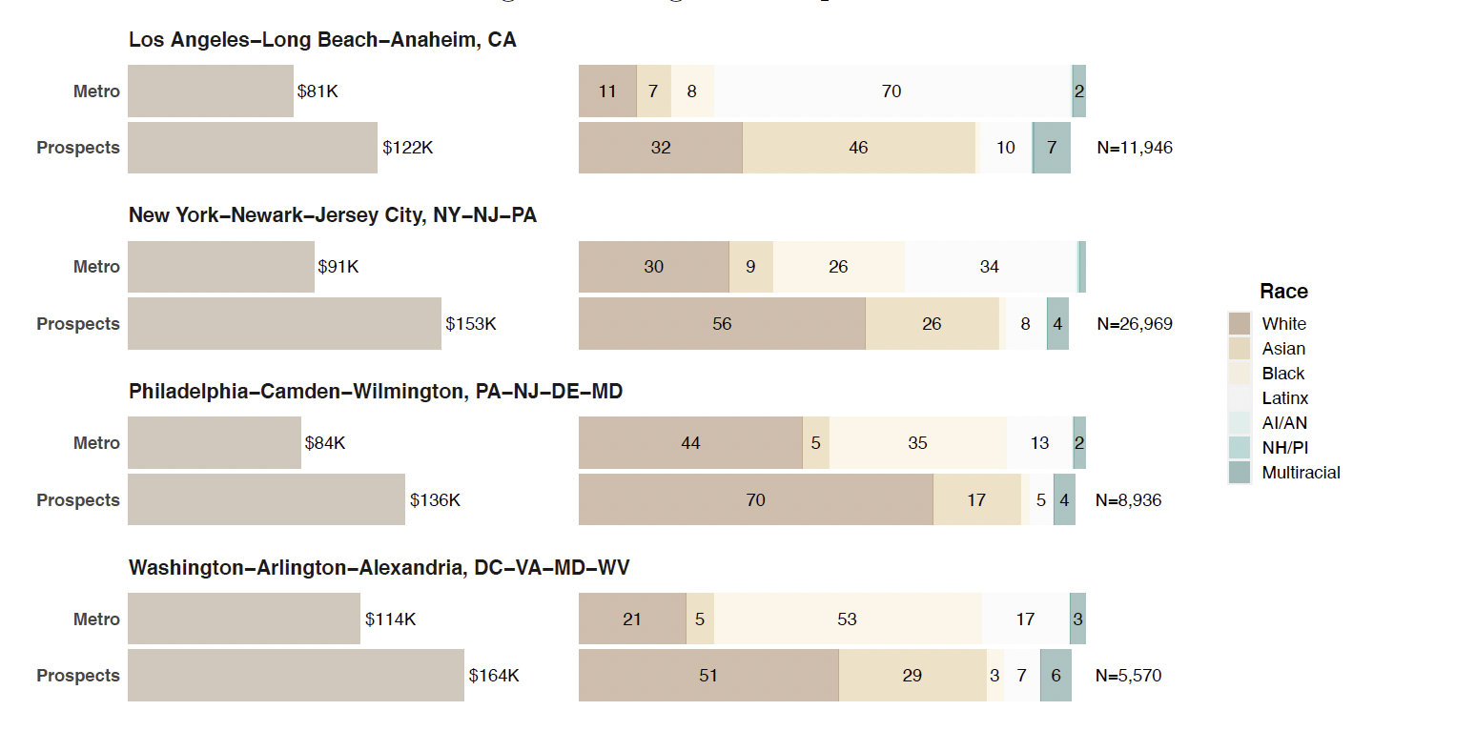

Figure 2: Hypothetical Zip Code Order Prospect Characteristics

