EA Team

Test Evidence I

|  |  |
| --- | --- |
| Title: | RLSE0016397– SOW-22-N013 SAP - Concur P-Card Integration |
| Change Request ID: | RLSE0016397 |
| Client | ED1-210 |
| Process Team: | ABAP |
| Transport #: | ED1K984786 210 NPALAGIRI RLSE0016397 - SAP - Concur P-Card Integration |
| Author: | Naresh Palagiri |
| Creation Date: | 08/07/2022 |
| Test Type | Unit Testing  Integration Testing  Regression Testing |

1. **Employee Data Report Full Load**

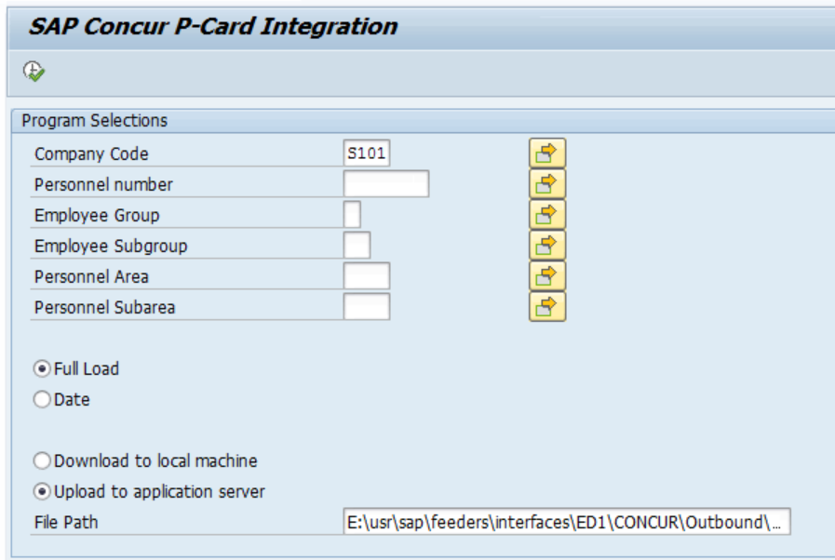

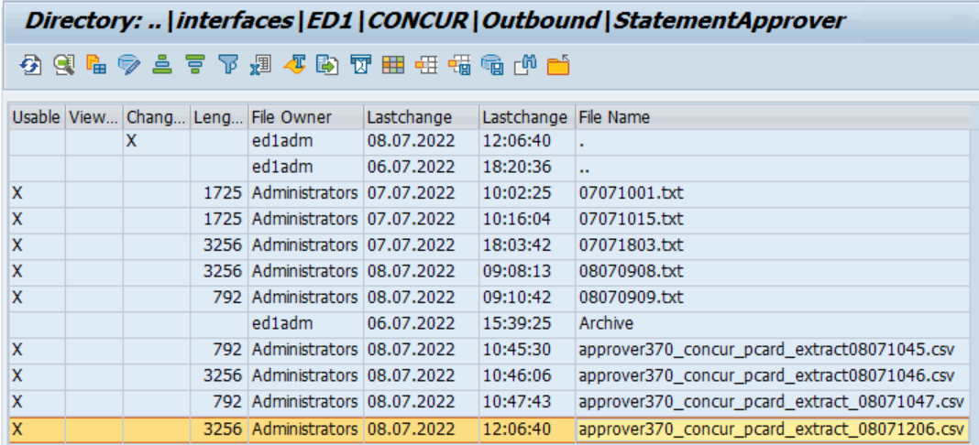

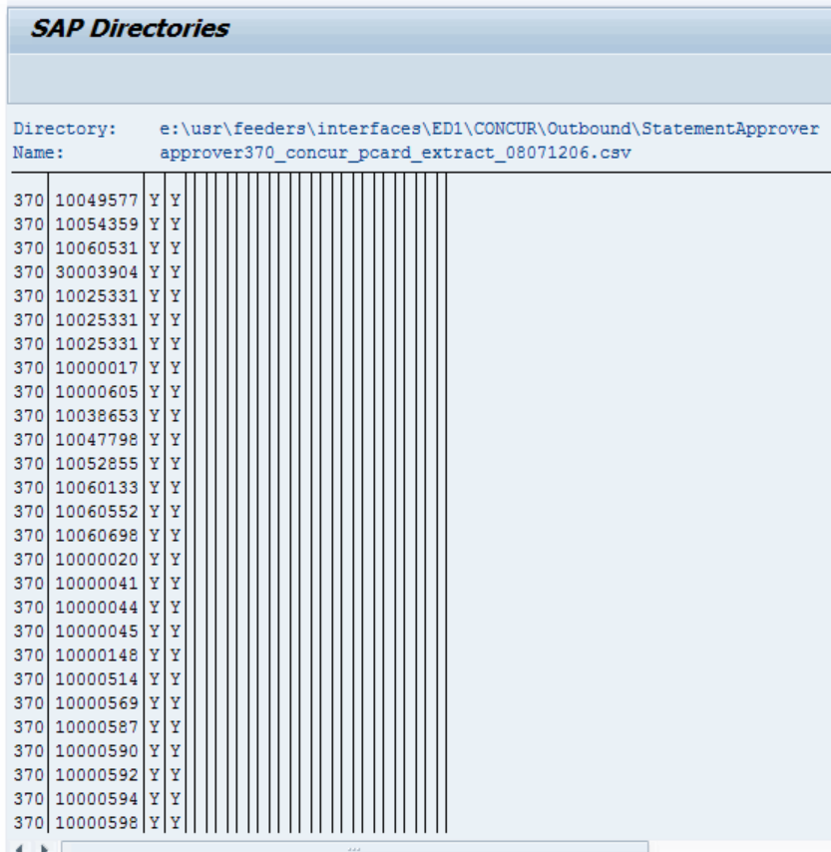

**2) Employee Data Report Delta Upload**

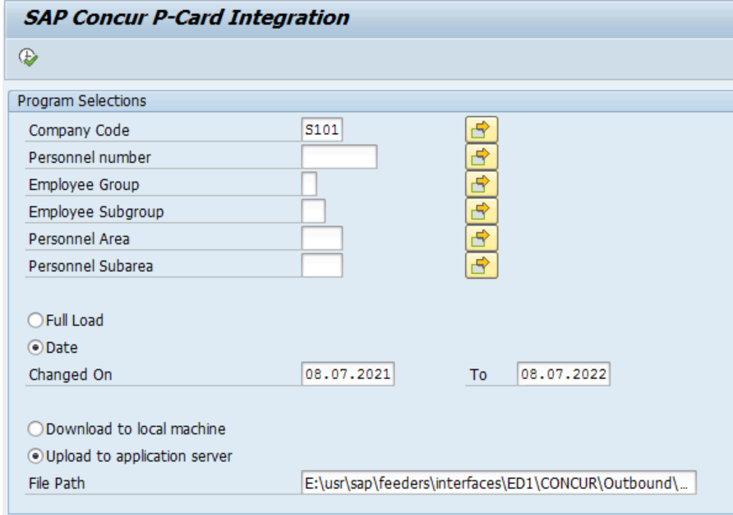

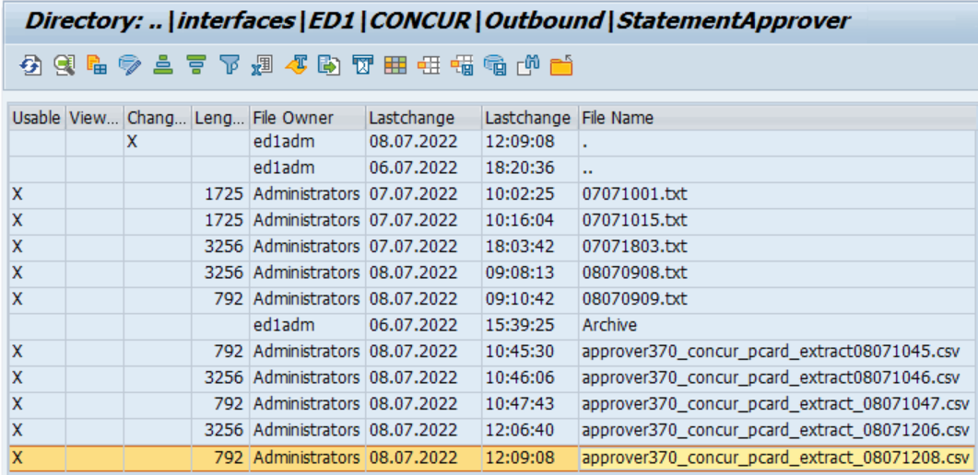

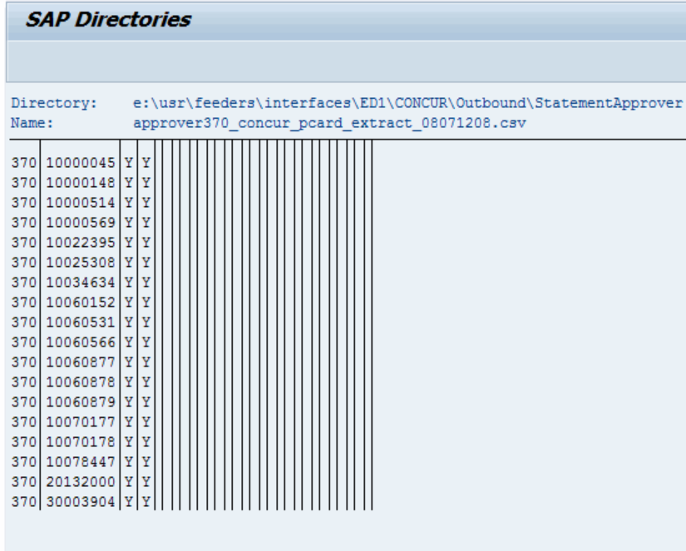

Test data in Excel.

