SAP Interface for Legacy
Document Ref:
Document Details
 |  | Signatures with Date
Title | SAP Interface for Legacy
Version | 1.0
Classification | Xxx
Release Date | Xxx
Description | SAP Interface configuration/data test for Legacy system
Review Date | Xxx
Author | Md. Kahinur Islam
Reviewer-
Custodian
Approved By
Owner | Md. Kahinur Islam
Distribution List
Name
Internal Distribution Only
Version History
Version Number | Version Date
1.0 | 18-Apr-19

Table of Contents
About 4
Step 1: SAP Configuration (BASIS Team) 5
Step 2: Data Checking 6
Legacy Database 8

About

This document is prepared to configure the SAP and Legacy system interface. Here also explained the data flow from SAP to Legacy VAT, LC system and how to validate/check data.

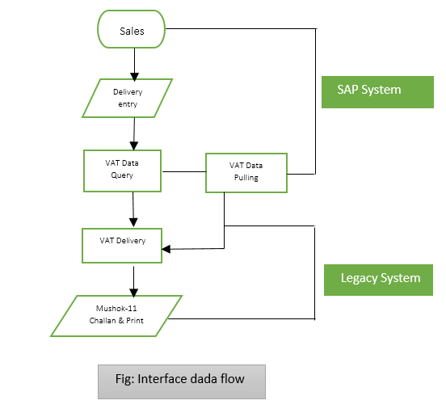

Step 1: SAP Configuration (BASIS Team)

SAP t-code: dbco or DBACOCKPIT/ DB02

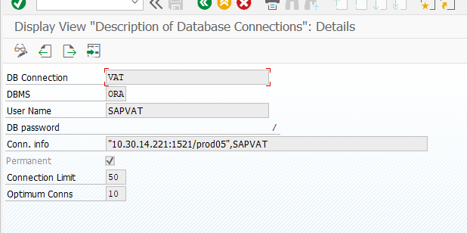
BGD VAT configuration from OS level.

SAPNote 819829 - Oracle Instant Client Installation and Configuration on Unix or Linux
Login SIDADM change environment variables as per given below
.dbenv.csh
setenv LD_LIBRARY_PATH /sapmnt/BRQ/client/122/instantclient:$LD_LIBRARY_PATH
.dbenv.sh
LD_LIBRARY_PATH=/sapmnt/BRQ/client/122/instantclient:$LD_LIBRARY_PATH export LD_LIBRARY_PATH

Step 2: Data Checking

VAT data:
Sales Delivery team create PGI using VL02N t-code and data will be transferred in Legacy VAT system in the below screen:
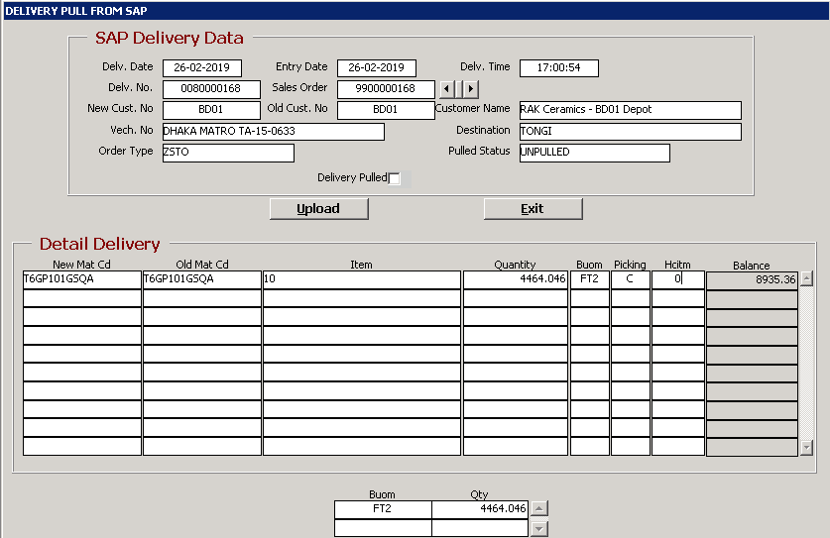

If SAP data is not came in Legacy VAT system, VAT Delivery team can check data in SAP system using ZSD_VAT_QUERY t-code.
Here record flag will be X if data has not been already transferred to Oracle DB. User can manually push data from ZS_VAT_SD t-code.

IF SAP data is not transferred to VAT system then SAP consultant can check the SAP table zecc_vat_deliver using SE16N t-code.

LC Data:
After creating Import Purchase Order, user can check and confirm data to tranfer in Legacy LC module using ZM_LC t-code.

After confirming from SAP system, data will come to Legacy LC system for further proceed in the below screen:
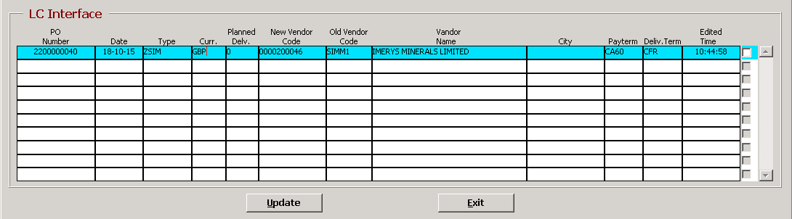

Legacy Database

Legacy Table:

VAT System:
Database user & Pass: sapvat
Production table: Prod_Order
Delivery table: VAT_Delivery

LC System
Database user & Pass: saplc
Table: LC_Test

