Introduction and Motivation
Additive manufacturing enables design and production to be directly connected through data-driven process control, but repeatability and part quality remain key challenges for fused deposition modeling (FDM). Small variations in extrusion flow, nozzle height, or feed rate can lead to under-extrusion or complete print failure, often developing too gradually to detect in real time.
This project uses the Cambridge Caxton dataset, which contains synchronized process logs and high-resolution images from open-loop FDM printing, to develop models that identify printability risk based on both process parameters and visual features. Unlike the deep learning approach presented in the CAXTON study by Brion and Pattinson, which focused on real-time control using large neural networks, this work emphasizes interpretable, lightweight models aligned with engineering design principles.
The project applies supervised learning to link process variation and image texture to print risk, while also exploring unsupervised anomaly detection to capture instability without labeled data. Together, these approaches aim to improve print reliability and support multi-objective optimization of process parameters for more consistent and efficient additive manufacturing.
Dataset & Visualization
This project uses the Cambridge Caxton dataset, a comprehensive collection of synchronized process and image data from fused deposition modeling (FDM) 3D printing. The dataset includes 192 prints and more than 1.2M paired records linking flow rate, feed rate, z-offset, temperature, and nozzle position with high-resolution images. Each record represents a single, time-aligned snapshot of the printer’s state and the corresponding surface outcome.
A subset of five prints (0-4) was analyzed to balance computational feasibility and data diversity, totaling about 14,000 image-parameter pairs. Print 2 was excluded due to limited sample count. This subset captures both stable and unstable printing behavior, providing variation essential for predictive modeling. A sample of the data can be seen in Figure 1.
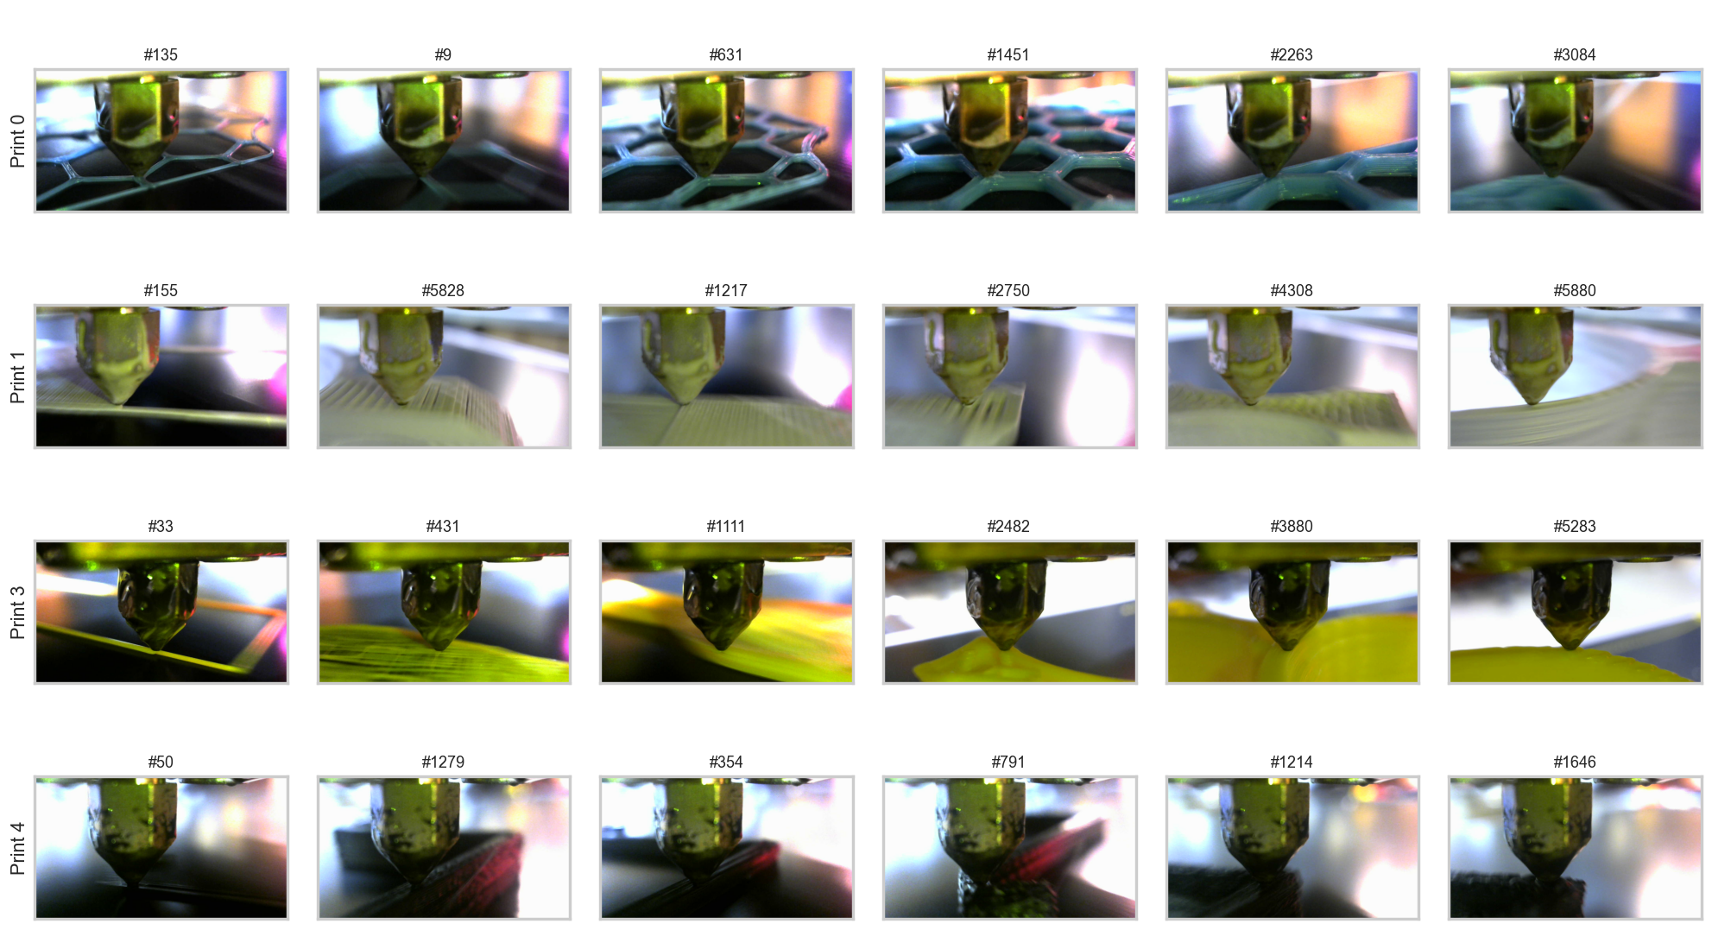
Figure 1: Representative Raw Image Collage Across Four Prints
Each image is paired with detailed process logs, as illustrated in Figure 2. This one-to-one linkage between numerical parameters and visual observations enables direct comparison between process state and print quality. The selected subset is well structured, with only minor missing timestamps, confirming that it can be used reliably for modeling.
Figure 2: Raw Process Data Snapshot
To understand variation across the prints, Figure 3 shows empirical cumulative distributions (ECDFs) for flow rate, feed rate, and z-offset. The plots demonstrate that the printer operated across distinct but overlapping regimes. Prints 3 and 4 maintained narrower ranges for flow rate and feed rate, while prints 0 and 1 showed broader variability, consistent with less stable conditions. Together, these results establish that the dataset is both balanced and diverse enough to support meaningful analysis.
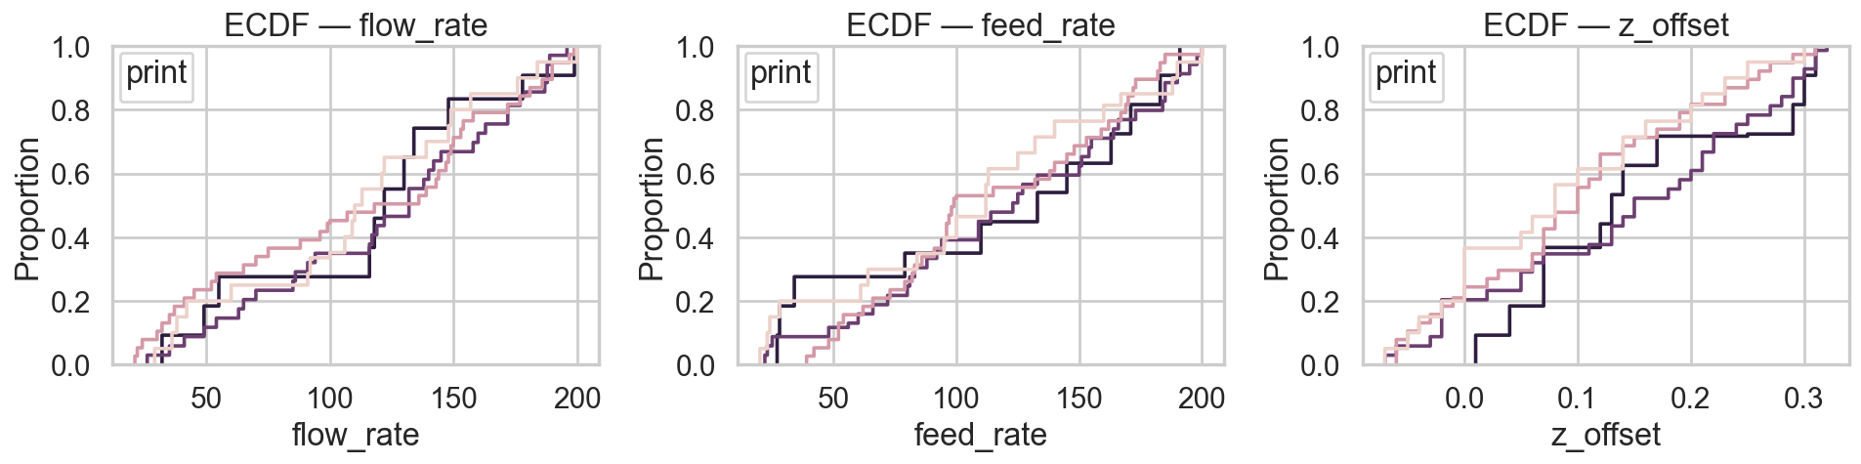
Figure 3: Empirical cumulative distributions of core process parameters by print.
Relationships among parameters were examined to assess how they varied during printing. The plots in Figures 4 and 5 reveal complementary insights: the image brightness distributions highlight differences in exposure across prints, while the correlation heatmap summarizes linear dependencies among process and image variables. Overall, process parameters show weak direct relationships, except for strong coupling between target and measured hotend temperature. These results suggest that the dataset contains sufficient independence among features to justify the use of nonlinear models capable of capturing more complex dependencies.
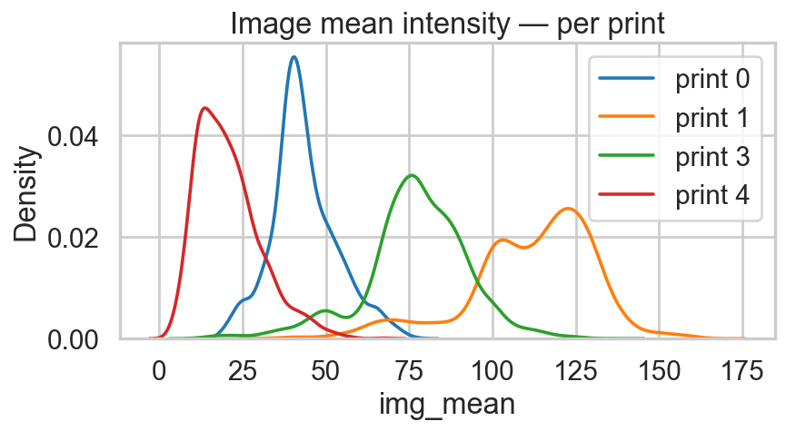Figure 4: Distribution of mean image brightness for each print. | 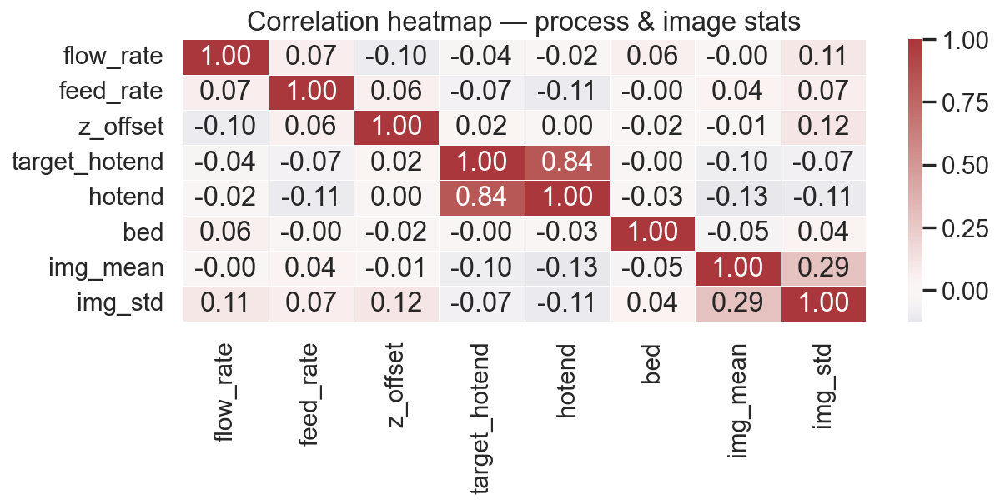  Figure 5: Summarizes linear dependencies between process temps and image statistics.
Preliminary Machine Learning
Supervised models were developed to detect printability risk using both process parameters and image-based features. Each record combined flow rate, feed rate, z-offset, and temperature data with image descriptors such as edge density, texture contrast, and intensity statistics. Image features were extracted from localized nozzle regions and summarized through simple statistical measures, providing a compact representation of visual texture without requiring deep learning.
A weak printability label was generated using robust z-scores of the process parameters. Observations with large deviations in flow rate, feed rate, or z-offset (|z| > 1.7) were flagged as potentially unstable, especially when accompanied by low image edge density. This method provided approximate supervision for early model training while avoiding the need for explicit failure annotations.
Three supervised methods were tested: Random Forest, LightGBM, and XGBoost. Prints 0, 1, and 3 were used for training and validation, while print 4 served as an unseen test case. All models performed well, with XGBoost achieving the best generalization (AP = 0.97, F1 = 0.91). Figures 6 and 7 show precision-recall curves and compares overall performance across the LightGBM models and the XGBoost model.
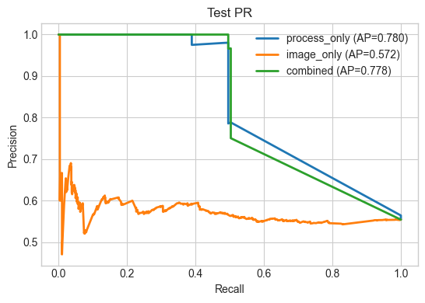  Figure 6: Precision–recall curves for models using process-only, image-only, and combined features. The combined model performs best, confirming the value of integrating both data types. | 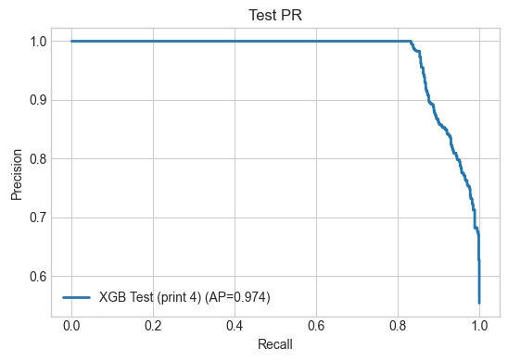Figure 7: Precision–recall curve for the XGBoost model on an unseen print, showing strong generalization (AP = 0.97).
Next Steps
The next phase will expand the dataset to include additional image data from the full Caxton repository. This will increase the diversity of lighting conditions, geometries, and print outcomes, improving model generalization. We will also normalize image brightness and extract higher-level visual features to strengthen the link between process variation and surface quality.
On the modeling side, the focus will shift toward unsupervised learning, using methods such as Isolation Forests or autoencoders to detect anomalies without predefined labels. These approaches will complement the supervised models by identifying new patterns of instability and validating risk predictions across unseen prints.
Finally, we will integrate the results into a multi-objective optimization framework to explore tradeoffs between print speed and stability. The goal is to identify process parameter combinations that minimize printability risk while maintaining throughput.

Brion, D., & Pattinson, S. (2022). Data set for “Generalisable 3D printing error detection and correction via multi-head neural networks”. Apollo - University of Cambridge Repository. https://doi.org/10.17863/CAM.84082
Brion, D. A. J., & Pattinson, S. W. (2022). Generalisable 3D printing error detection and correction via multi-head neural networks. Nature Communications, 13, Article 1. https://doi.org/10.1038/s41467-022-31985-y

