1. Install Jupyter notebook and run the first program and share the screenshot of the output.

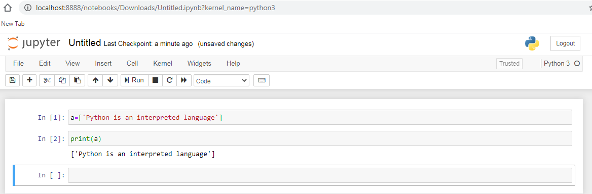

2. Write a program which will find all such numbers which are divisible by 7 but are not a multiple

of 5, between 2000 and 3200 (both included). The numbers obtained should be printed in a

comma-separated sequence on a single line.

l=[]

for y in range(2000,3000):

if(y%7==0) and (y%5==0):

l.append(str(y))

print(','.join(l))

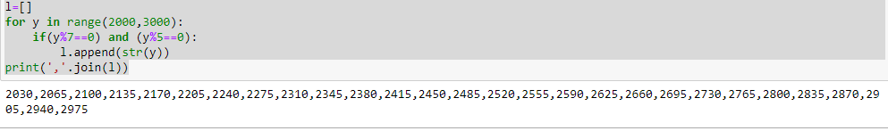

3. Write a Python program to accept the user's first and last name and then getting them printed in

the reverse order with a space between first name and last name.

f = input('enter your fisrt name')

l = input('enter your last name')

print (l + ' ' + f)

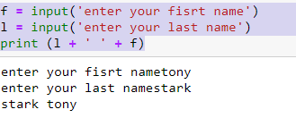

3. Write a Python program to accept the user's first and last name and then getting them printed in

the the reverse order with a space between first name and last name.

fname=input('enter your first name')

lname=input('enter your last name')

print(lname + ' ' +fname)

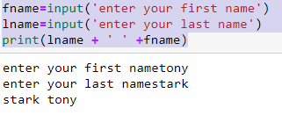

4. Write a Python program to find the volume of a sphere with diameter 12 cm.

d=12

pi= 3.1415926535897

V=4/3\*pi\*(d/2)\*\*3

print('volume of sphere is:',V)

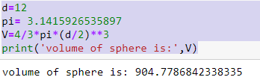

Task2.

1. Write a program which accepts a sequence of comma-separated numbers from console and generate a list

a=input('enter the values')

l=a.split(',')

print(l)

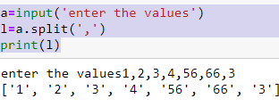

2. Create the below pattern using nested for loop in Python.

n=5;

for i in range(n):

for j in range(i):

print ('\* ', end="")

print('')

for i in range(n,0,-1):

for j in range(i):

print('\* ', end="")

print('')

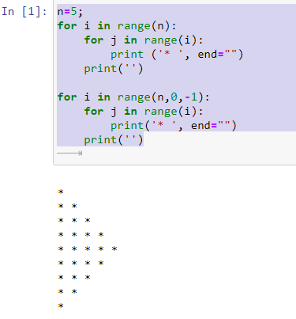

3. Write a Python program to reverse a word after accepting the input from the user.

a=input('enter word')

b=a[: : -1]

print(b

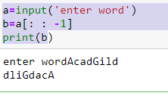

4. Write a Python Program to print the given string in the format specified in the sample output. WE, THE PEOPLE OF INDIA, having solemnly resolved to constitute India into a SOVEREIGN, SOCIALIST, SECULAR, DEMOCRATIC REPUBLIC and to secure to all its citizens Sample Output: WE, THE PEOPLE OF INDIA, having solemnly resolved to constitute India into a SOVEREIGN, ! SOCIALIST, SECULAR, DEMOCRATIC REPUBLIC and to secure to all its citizens

print("WE, THE PEOPLE OF INDIA,\n\thaving solemnly resolved to constitute India into a SOVEREIGN,! \n\t\tSOCIALIST, SECULAR, DEMOCRATIC REPUBLIC \n\t\t and to secure to all its citizens")

