1. For the first graph I didn’t feel like writing a script to parse graphml, so I spent about an hour manually inputting the data from the graphml file. I calculated the median, mean, and standard deviation using Excel.
   1. Standard Deviation: 367.9756
   2. Mean: 334.0301
   3. Median: 243
   4. Michael Nelson has 165 friends which is below all 3 of those numbers.

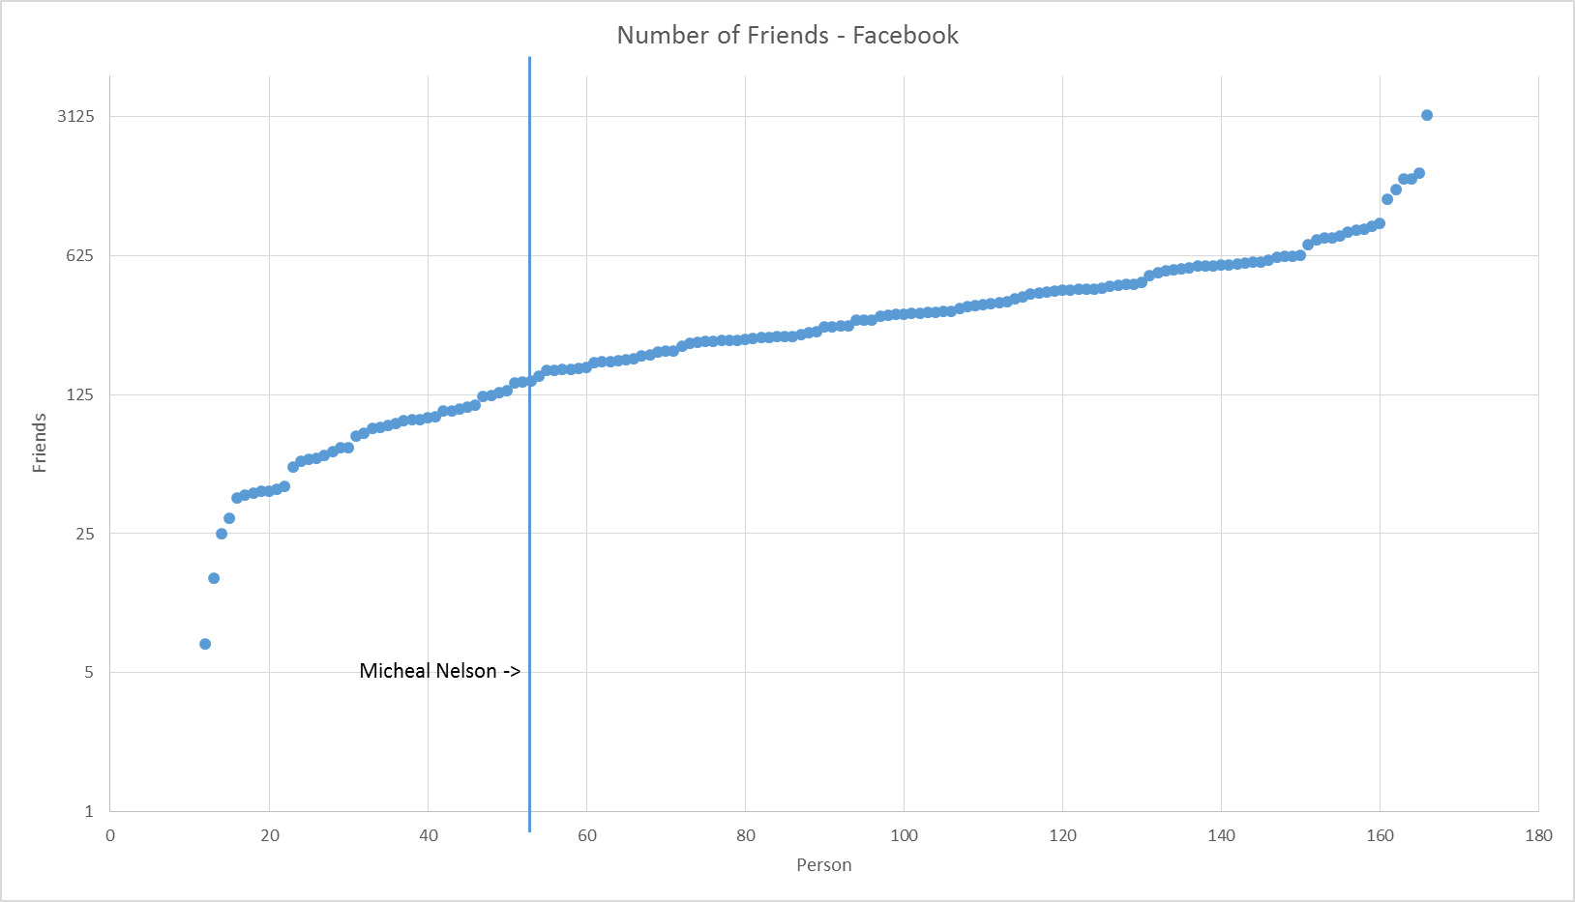

1. For the second graph I used a code that I borrowed from a friend named Kevin (I sadly do not know his last name) which is in the same directory as this called “twitter_friend_data.py” and “twitter_config.json” to extract the follower numbers for all of the friends whose followers were accessible. Once I had the raw data I manually inputted it into excel to create the graph and calculate all the information needed.
   1. Standard Deviation: 3003.853
   2. Mean: 941.5934
   3. Median: 223.5
   4. 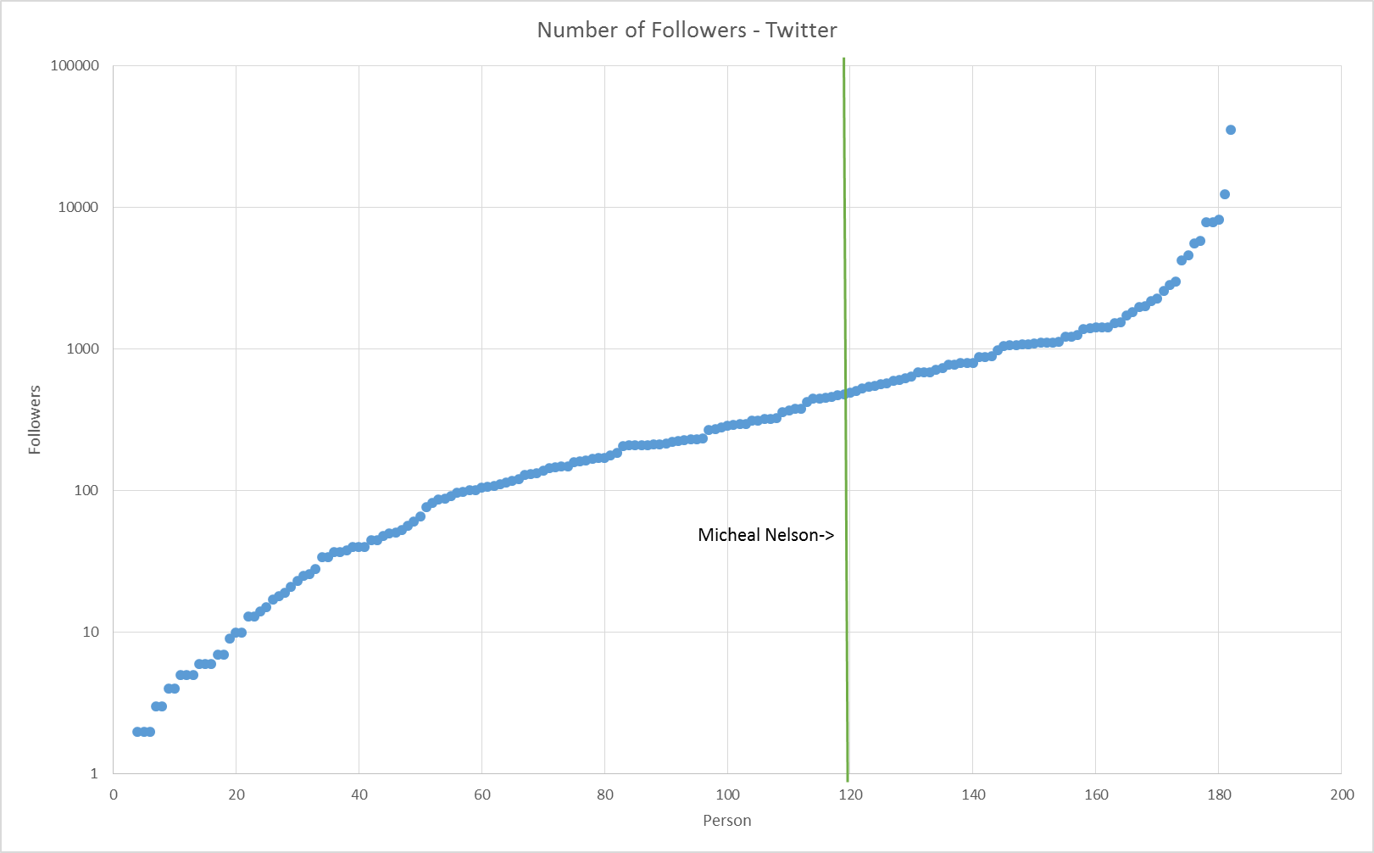Michael Nelson has 491 followers which is higher than the median, but much lower than the Standard Deviation or Mean, though these two values are probably skewed by his follower who has >35,000 followers (congrats on being followed by a Harvard professor?).