1. The graphs shown and the calculations made for this report were produced using a code produced by Mohammed Aturban and can be accessed at <https://github.com/maturban/cs595-f13/blob/master/assignment9/latex/Mohamed_Aturban_Assignment_9.tex> combined with a gml file created by Mark Newman. It uses the divisive method of group partitioning.

In order to separate the teams into two different groups, we start with the initial set.

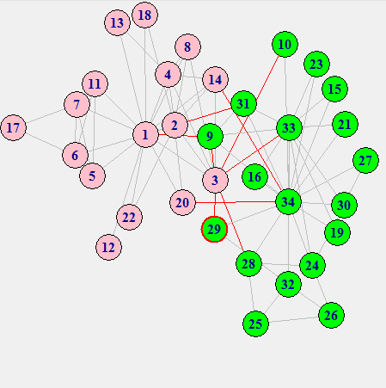

The lines show relationships between members, and the red lines indicate relationships between members who are going to end up being split apart. This does not indicate every

Next in order to begin group partitioning, we remove the weakest local bridge between 3 and 1.

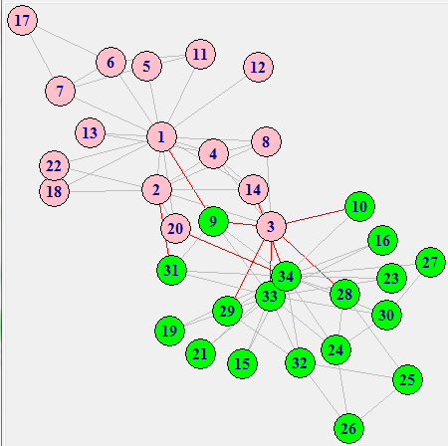

Member 3 has a stronger relationship with members from the other side then with Member 1.

Next we remove the local bridge between 9 and 1.

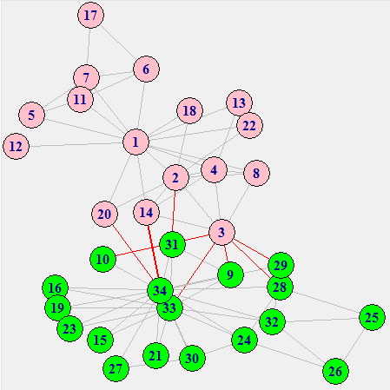

Member 1 had a much stronger connection to its side then Member 9, making this an obvious choice.

Next we remove the local bridge between 34 and 14.

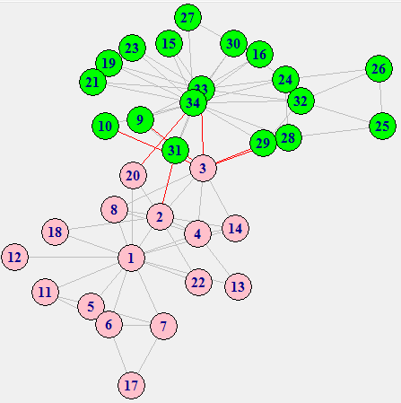

This time 34 had a very strong connection to its side and not 14.

Next, we remove the local bridge between 34 and 20, for basically the same reason as the last one.

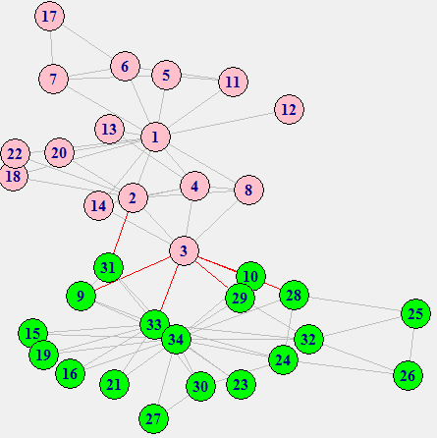

Next, we remove the local bridge between 33 and 3. Member 33 has the strongest connection to its side out of all the members that have local bridges at this point.

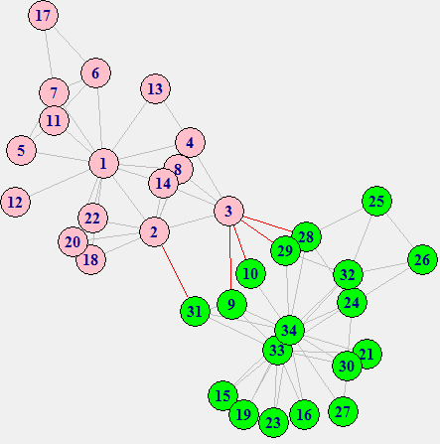

Next, we remove the local bridge between 2, and 31. Member 2 has a strong connection to its side.

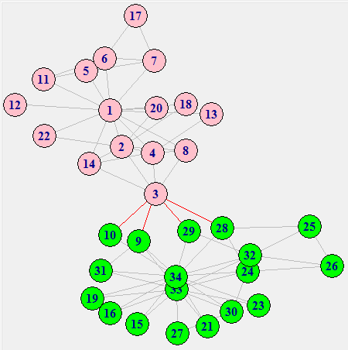

It’s made clear at this point that Member 3 will be the bridging member of the group.

Next, we remove the local bridge between 2 and 3.

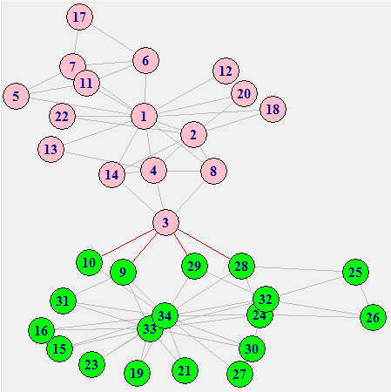

Then the local bridge between 3 and 4.

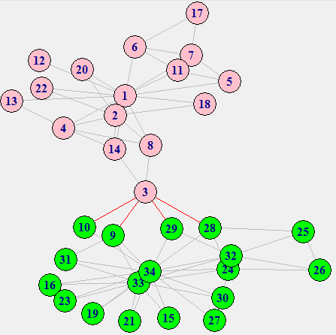

Then the local bridge between 3 and 8.

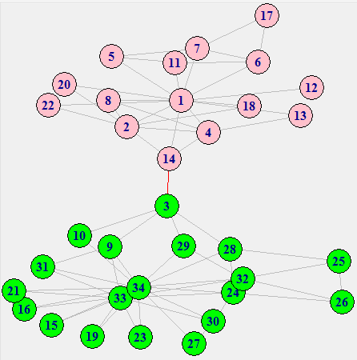

Finally, the split is completed when we remove the bridging relationship between Members 3 and 14.

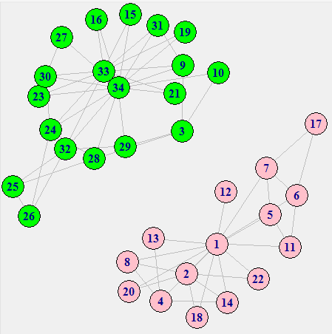

This is the final computed split between members.

Here are the real results:

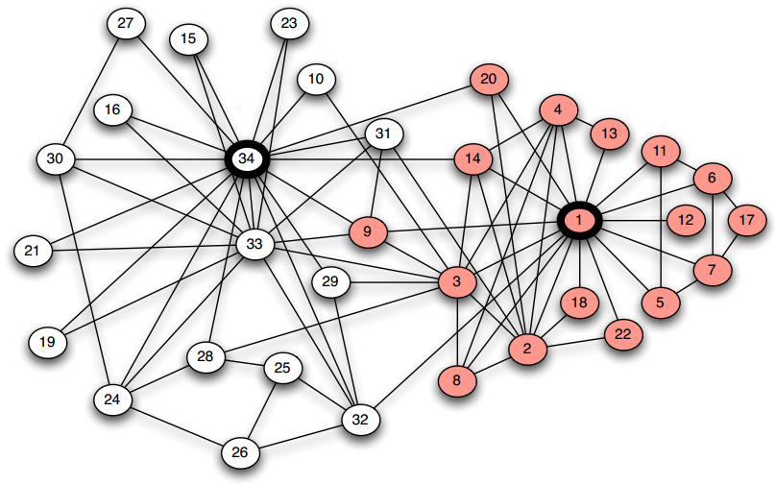

The white and red represent which groups they split into. When you compare the results, the only ones that were not predicted correctly are members 3, and 9.

32/34 = 94.12% accuracy which is a fairly accurate prediction.

1. Here are the results for further splits using the same code to calculate them (but changing the “cluster_no” variable to 3, 4, and 5 respectively). The images showing these splits step-by-step are in separate folders of their own.

3-Split

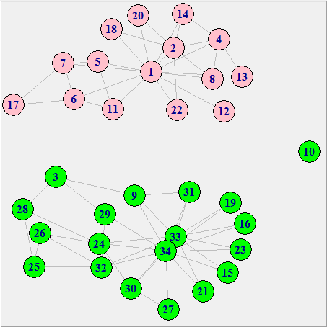

4-Split

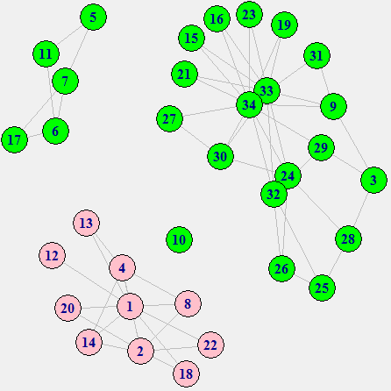

5-Split

