1. For part 1, I used a script from <http://bl.ocks.org/d3noob/5141278> and data collected by Kevin Clemmons (because 50 followers render faster than 500) to create my graph. The files for this are called “Htmlgraph.html” and “Force.csv”. They have to be placed inside the d3 program main folder to work and the html file only runs properly on Firefox.

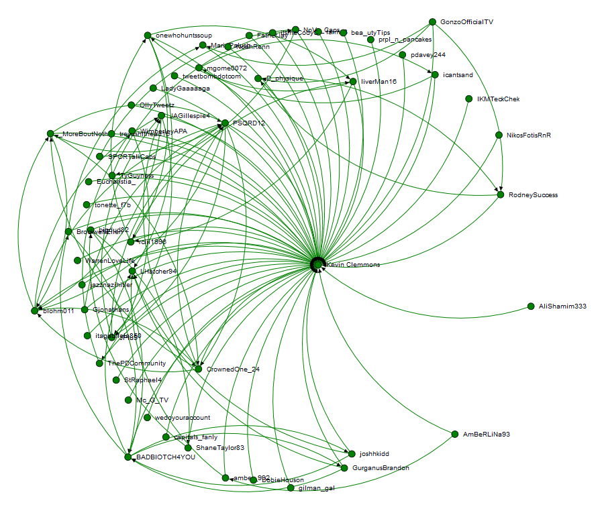

1. For part 2 I used the same script “Htmlgraph.html” to create the graph, but made a small modification to it to use Kevin Clemmons data for only those that had an identified gender called “kevin_gender_network.csv” to create the resulting graph. The gender information was determined using a script Kevin Clemmons developed called “get_user_genders.py” which is a part of the ZIP folder “gender_network.zip” that is supplied with this submission. I compiled the resulting data into an excel spreadsheet named “Gender.xlsx” and here is the resulting table.



