1. For this part I used four python scripts from [https://github.com/shawnmjones/cs595-f13/tree/master/assignment9](https://github.com/shawnmjones/cs595-f13/tree/master/assignment9%20) named fetchFeeds.py, generatefeedvector.py, eliminateWords.py and clusters.py. The scripts generatefeedvector.py and clusters.py originally belong to Toby Segaran. fetchFeeds.py generates feedlist.txt. Once feedlist.txt is generated, we run generatefeedvector.py with feedlist.txt as an input, and it generates the data contained in blogdata1.txt. Once blogdata1.txt is generated, we use it as an input for eliminateWords.py and give it 500 as an argument and blogDataClean.txt contains the output. A
2. For this part I used a slightly modified script from <https://github.com/shawnmjones/cs595-f13/tree/master/assignment9> named makeDendogram.py and clusters.py. The script makeDendogram.py generates both the jpj_dendogram.jpg and asci_dendogram.txt.

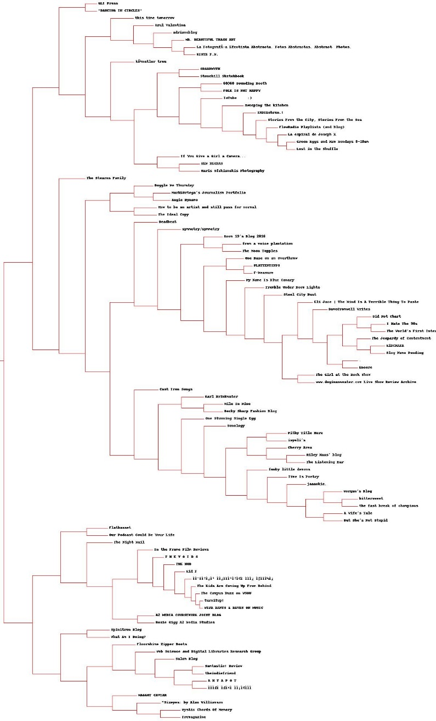

1. For this part I used a slightly modified script from <https://github.com/shawnmjones/cs595-f13/tree/master/assignment9> named makeClusters.py and clusters.py. The script makeClusters.py generates kmean.txt which shows for each value of k how many iterations are produced. K=5 has 5 iterations, K=10 has 6 iterations, and K=20 has 5 iterations.
2. For this part I used a slightly modified script from <https://github.com/shawnmjones/cs595-f13/tree/master/assignment9> named makeMDS.py and clusters.py. The script makeMDS.py generates 2-Dimensional coordinates, which are outputted into mdsOutput.txt, and it also generates the image blogsDataMDS.jpg based on those coordinates. 228 iterations were required.

