C Sc 335 Analysis and Design Artifacts for Final Project
This must be in a private Github repo in a directory named documents
with your project manager added as a collaborator

1. Team Name: The Blue Team
2. Team Members: Dan Decina Michael Carolin
Daniel Avetian Jacob Groh
3. Candidate Objects or Class Hierarchies

List the most important objects, or the name of an inheritance hierarchy, and the main responsibility.

Candidate Object | Single Responsibility in 1 or 2 sentences
Server | Manages interactions between clients
ClientGUI | User's interface with the persistent, server-managed document
User | Stores all the user's information
Document/Revision | Manages the text, formatting, and all changes that a user has initiated

These Class and Sequence Diagrams may be written by hand and scanned or drawn with a UML editor such as Violet http://sourceforge.net/projects/violet/files/violetumleditor/ and / or the sequence diagram editor or https://www.websequencediagrams.com/#

4. Class Diagram: Your team UML Class Diagram must show at least all of your candidate objects from above. Show any relationships between them the classes such as inheritance or interface implementation. Draw general associations such as dependency or aggregation. Label some to help explain things. Add any multiplicity adornments that seem appropriate. Use notes to explain things if you feel it will help. Each UML class must show the class name. For full credit, each class must have an average of at least one attribute per class. There must be an average of at least 2.0 methods per class, which may be implicit (no need to repeat methods) if the class implements a Java interface with methods shown there.

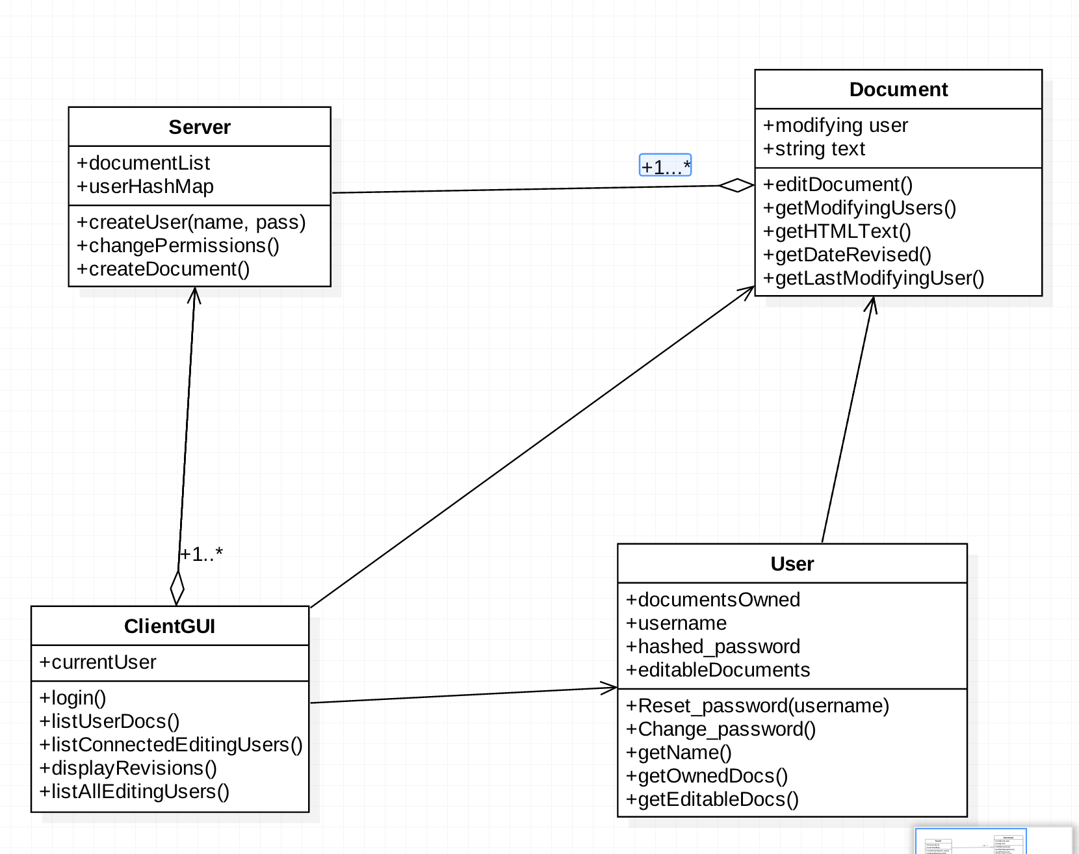

5. Sequence Diagram: Your team UML Sequence Diagram should show the most important scenario you can think of. Your sequence diagram should show most of your objects from above and how they communicate with each other.

