Drone Hunt

Emmanuel Martinez, Randy Aybar, Devesh Maharaj, Juammy Lora.

University of Central Florida, Department of

Computer and Electrical Engineering. Orlando, Florida, 32816, U.S.A.

***ABSTRACT-* This paper presents a different and new twist of this very hot trend of quadcopter drones. This group took a small quadcopter drone and fuzzed the idea of the old school video game Duck Hunt as well as Laser Tag. This project is all about a fun and unique way of using drones as a moving target to shoot with modified Infra-Red laser assault rifles where two players can interact with the web application and begin a short real-life shooting practice game.**

1. **INTRODUCTION**

At the beginning of this semester each member of the group came up with at least five ideas to the table. After narrowing down the best ideas, the team stumbled across deciding on making a quadcopter that simply overshadows a person and follows him/her. But it was then decided that that idea was yet too simple and common. Following that idea, it was then said that this group would make an autonomous drone that for simplicity carries a package, sends it to a destination and returns back. Then again, it was agreed that that idea was also too simple and common. Then, the group finally all came together and by just one of the member saying the word laser, the idea of combining duck hunt with a drone come to the table. This group believed that Drone Hunt would enable the group members from both engineering disciplines to utilize all of the knowledge obtained during the four years at UCF to not only create something fun, new, and exciting, but to create something that everyone will remember for many years to come. A clever member of this group said that the first letter of each of each names as an acronym should be used. Therefore, it was concluded that the name of the drone will be “Manny, Randy, Devesh, Juammy” in that order which produces the name “Mr. DJ.”

1. **OBJECTIVES**

First of all, as with any flying object, Mr. DJ must be lightweight, robust, and efficient with power consumption to provide maximum flight times and optimal aero-agility. Mr. DJ must be equipped with a flight controller that has the ability to sense and react to the many unpredictable forces of nature. In other words, the flight controller must compute algorithms based on the data it receives from external sensors and reacts accordingly. If a user wants to control the drone, he or she can simply switch the transmitter into user-mode to have full control of Mr. DJ. If the user wants to watch or play Drone Hunt, instead they can choose autonomous mode which will have custom waypoints and boundaries. In addition, for display purposes, the drone will be equipped with Neopixels strands on all four arms of the drone.

Secondly, the main feature of this product will be an aerial multi-player shooter using IR laser tag guns and IR receivers. The IR subsystem in this project will implement the means for the prototype to serve this purpose as it will be used by the end user (players) to interact with the drone while it is flying. IR technology is being used for this project because as laser tag industries, this group will use IR diodes as well as focus lenses to allow the Infra-Red to reach farther and become more accurate. Using this technology allows this group to apply a vast amount of knowledge acquired over the past four years in frequency modulation, circuit design, semiconductor devices, and use of microcontrollers.

While much of the subsystems can hold up on their own the most important aspect of presenting our design is having an application that takes all these subsystems and their features to produce gaming environment that the user would experience.  The application will come in the form of program coded and tailored to a specific platform and would provide the signals that each of the subsystems would receive to do the designed task.

Finally, to integrate this project, the group wants to fully design and develop a complete ground control system for users to have easy access for all the software, battery charging, and communication components for the complete drone experience all in one system. This subsystem is composed of a military case with the adequate space for all the components: An LCD screen, keyboard, a desktop motherboard, the BeagleBone Black microcontroller, router & antenna, two Sealed Lead Acid Batteries, etc. In conclusion, this group wants an end product that is presentable and professional looking. Instead of having all different components laying around in a table with lots of wires all over the place, this ground control station puts it all together and in a nice display for the users.

1. **DRONE HARDWARE**

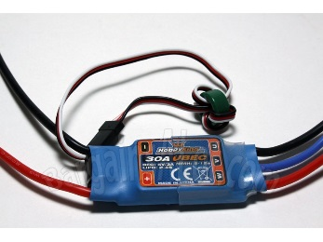

Figure - HobbyKing ESC's

1. **Frame Structure**

When choosing a multi rotor frame, one can easily get discouraged and overwhelmed from the hundreds of different choices to choose from. The first question is usually, “Where do I start?” Since quadcopters exist in many different shapes and sizes ranging from something smaller than your palm, to frames over 1500mm, one must first decide the primary flight features of his/her design. Therefore, this group decided to use the 450mm structure from HobbyKing after using a 700mm frame as a prototype and finding out that this measurement was too long and weak for this project.

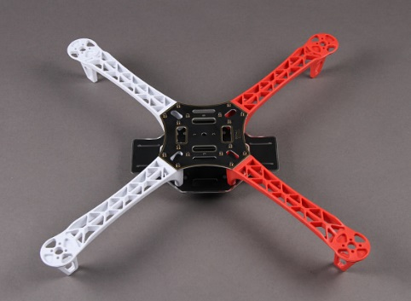

Figure - Z450-V2 QuadCopter Frame

1. **Flight System**

After choosing a frame size a suitable motor and propeller configuration can be selected. This requires that the motor and propeller be relative to the motor-to-motor distance which was decided to be above would be 450mm. The two common types of motors used in multicopters are brushed and brushless. After multiple days of looking at datasheets and taking weight and other important variables, the team chose the brushless motor simply because of its power-to-weight ratio.

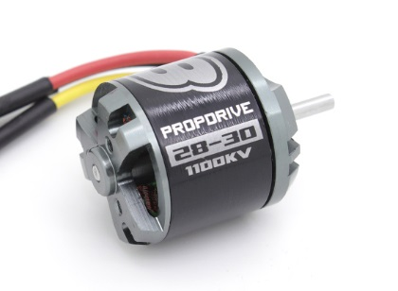After choosing a motor, propellers are required and must ensure that they generate enough thrust to fly the quadcopter. Propellers are classified by a length and a pitch. For the size of the frame of Mr. DJ, the propellers that were chosen where 10” x 4.5” APC-Style. The reason why this was the decision was because it is estimated that the 4.5” pitched propellers will provide the best trade-off between stability and efficiency.

The DC brushless motors need to be simultaneously controlled individually because that is essentially how quadcopters maneuver. The motors are multi-phased, so a direct supply of DC power will not actually turn the motors on. In order to turn theses motors on and control them individually. The group need *electronic speed controllers* or ECS’s (one for each motor). Each ESC is controlled by a pulse-with-modulation (PWM) signal that can vary in the 200-300Hz range so it must ensure that our selected ESC can handle the high enough frequency. The most important specification to keep in mind when selecting an ESC is the source current provided by the ESC. The general rule of thumb is to make sure the ESC sources at least 10A higher than the motor’s maximum current.

1. **Flight Control System**

The flight control system consists of the essential electrical components that are connected to the microcontroller which ultimately makes decisions as to how to control the motors with the given input information provided from sensors. These components combined give many luxurious flying capabilities such as gyro stabilization, and autonomous waypoint navigation. Our goal was to find a flight control system that had the most built-in sensors with the most freedom to manipulate these sensors all at the lowest possible cost. Our end result was the well-known open source ArduPilot Module v2.6 made by 3DRobotics. The ideal flight controller would be one with the most useful components already embedded into it to provide a more complete system.

1. **Power System**

While there are many different style batteries to choose from there is a lot of thought and number crunching that needs to go into choosing a battery to power your electrical components. Because of this tradeoff, a member performed careful and in-depth research on choosing a suitable battery for Mr. DJ. The group found a great guide provided by ***Oscar Liang*** on his blog over at oscarliang.net. His steps were fairly detailed and straightforward:

1. *Find max current draw and battery c-rating*: work out the possible max current drawn from the motors.

Figure - Drive 28-30S Brushless

*maxCurrent = capacity * C-rating*

1. *Gather initial data*: take data such as battery capacity, battery weight, and cost and make some charts.
2. *Choose a battery:* using the data collected, decide any battery that will fit your requirements.

As a result, after all these calculations and research, it was decided that the best battery for Mr. DJ will be a Turnigy Nano-Tech 4000 mAh 3S LiPo.

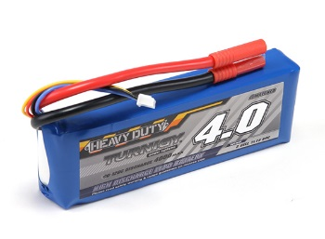

Figure - Turnigy Nano-Tech 4000 mAh LiPo

1. **IFRA-RED SYSTEM HARDWARE**

The laser subsystem consists of an Infra-Red transmitting device that will be used by individual players, and multiple IR receiving sensors that will be mounted on the drone. The main focus of this subsystem is to implement the gaming aspect of the Drone Hunt project which ,similar to laser tag, allows the players to fire at a target that then determines that it has been hit and assigns points to the player that made the hit. The implementation of this system will involve the design and assembly of two modified toy guns equipped with this IR transmitting circuit as a transmitter and a total of five IR sensors (VS1838) attached to the drone that demodulates the infrared signal and outputs the data when a IR beam hits any of the receivers. The data output by the transmitter and the data analysis by the receivers will all be done using a microcontroller that will be programmed to do so appropriately.

1. **IR Receiver**

The IR receiver subsystem will consist of five VS1838 receivers positioned on the underside of the drone in such a way to allow them to be the target of fire from the IR transmitters while the drone is in flight. This system will be able to detect a hit from an IR beam with the use of waiting to catch two different 38KHz signals that will be sent from the two different signal IR transmitting guns. These five receiver will act as one component and will be connected to a microcontroller that will be on the drone which will serve to detect when IR beams hit the drone. This information will then be transmitted by the Wi-Fi system that is onboard the drone to the server and then displayed through the web application.

In order to build the receiver system for this project, the following list of hardware will be required:

* Five VS1838 InfraRed Receiver with By-Pass filter and Demodulator incorporated inside.
* One MSP430G2553 microcontroller which will be on the drone and will be used for data manipulation.

With the above hardware list the receiver system will be assembled by connecting the solar panel to an input pin of the microcontroller. The microcontroller will be programmed appropriately to detect the inputs from the solar panel and then output the data received to the ground control station.

1. **IR Transmitter**

This section of the project involves a vast amount of design work as it requires the design of an IR signal transmitting circuit. This IR transmitting circuit will be embedded into a toy gun to give the player the ability to hold a gun to simulate a first person shooter interface. This gun will also have a Wi-Fi adapter inside as well that will allow for direct connectivity to the web application. The purpose for this connection is to transmit data to the web app each time the player pulls the trigger of their gun. Each trigger pull will be recorded by the application showing a total number of shots fired during each round of the game and also provide other gaming statistics as well.

The transmitter LED will be centered mounted in a one inch PVC pipe tube attached at the end of the toy gun. In order to produce hits at longer distances, and to make it easier to hit the drone at further distances, it is necessary to focus the IR light with a lens. In selecting the lens we needed to take into account that the IR LED TSAL6100 has an angle of half intensity of +/- 20°, which for a one inch diameter lens give the optimum focal distance that it is needed. Using a double convex lens with a one inch diameter and a good focal length has given the total range of 100 feet, more than adequate for our uses because the Wi-Fi modules determine the real range for our project.

In order to build the transmitter system for this project, the following list of hardware will be required:

* Two toy guns which will serve as the shell that houses the circuitry for the laser transmitter system and all its component.
* Two InfraRed LED diodes with the model number TSAL6100 .
* Three MSP430G2553 microcontrollers which two of these will be embedded into each guns (transmitters), and one on the drone (receiver).
* One SimpleLink Wi-Fi CC3100 booster pack for MSP430 microcontroller. This booster pack will add Wi-Fi connectivity to the IR guns and allow them to transmit trigger pull data to the web application.
* Two one inch double convex focus lenses that will be attached at the end of a one inch diameter tube at the end of the IR LED on each gun to serve to focus the IR beam for increased range.
* Two 9 Volt batteries on each gun to power up the circuit as well as two voltage regulator to drop the 9 volts to 3 volts for the MSP340 chip.

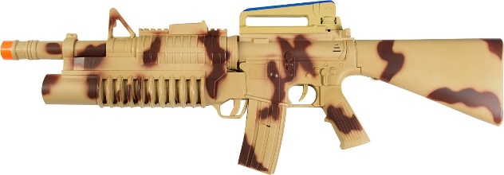

Figure - MAXX Action Toy Gun

1. **GROUND CONTROL STATION HARDWARE**

This section of our senior design project is considered as the icing on the cake. This subsystem has the main objective of bringing together every component required for a successful control, communication, and performance that a complete quadcopter drone must have into one portable medium military case. This subsystem called “Ground Control System” will be composed of a durable, lightweight, medium sized military case that the user will have to take with them wherever they will operate the quadcopter. Specifically, this ground control system will contain the following components:

* Router(Linkys)
* 2 Antennas(2.4Ghz and 915Mhz)
* Server(BeagleBone Black)
* LCD Screen
* PC Motherboard
* Laptop Keyboard and MousePad
* 2 SLA Batteries
* Turnegy Battery Charger
* Power Supply Unit from PC
* Several Rocker Toggle Switches
* Cooling Fans
* Housing for the Transmitter

All of these component into this military case provided by SKB cases.

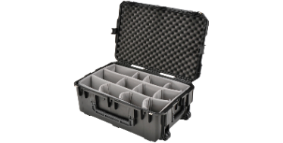

Figure - SKB case

Have you ever wonder what uses an old PC’s power supply has after years of simply laying around, well, this group does. It is planned to use the power supply of an old Desktop PC so that it can be used in our ground control system.  Our plan for this ground control system is to have the power system serve as the AC power for the entire ground control station if AC power outlet is available, but if it is not available, the ground control station will rely on the batteries. So, our main step here is to modify the PC power supply to only be used in this way. This modification consisted of some steps that were required to take in consideration in order to make our own power supply.

On the other hand, it was also planned on having a Sealed Lead Acid (SLA) battery to serve as a separate power supply so that the ground control system may be a complete portable system. The purpose for this is so that there would not be a need of a power outlet in order for the computer and software to operate for the controlling of the drone. This group wants to use a SLA battery that outputs 12 volts at 7 amperes max. As well as the output, this group focuses on the dimensions. The group members want a small battery that would not spill, and that will be easy to handle since it will be placed inside a compact case. These batteries are known to have three major traits: internal pressure regulation through valve construction, immobilized electrolytes and oxygen recombination.

These batteries are known to have various features. These include:

* Maintenance free; there is no water topping-up required
* No free acid(Sealed battery)
* Low self-discharge rate, lower than 3% capacity loss per month
* Can be used in any orientation(excluding used inverted)

1. **SOFTWARE IMPLEMENTAION**
2. **On-Drone Software**

The final coding plan provides insight on how the software aspect of the entire project will be accounted for. This includes any architectures and diagrams that we may need in order to implement the system.

To begin with, the microcontrollers on the IR guns must be programmed to consider several elements.  Each gun must be aware of the trigger count during each match as well as the player ID that the gun is associated with.  Along with the tasks it must perform it will also need to be programmed to allow data transfer via Wi-Fi to the IP network back at the ground control station.  The data emitted to the server at the station includes the current time and shot count information. On the laser receivers or the “targets” on Mr. DJ will also be controlled by a separate MSP430 controller which will decipher when a specific player hits a specific target.  This data will be bundled and be sent to the server via Wi-Fi as well each time one of the sensors is triggered by a laser hit.

As far as language goes, Since the system consists of a multitude of components, coding at different levels is necessary. This requires low-level languages such as C and possibly assembly.  While it’s been decided that prewritten libraries will be used for most of the microcontrollers it is likely that tweaking will be involved requiring the basics of the languages mentioned. Below is a quick flow diagram indicating the languages to be used and how they will communicate with each component of the system.



Figure - Programming Language Diagram

1. **Off-Drone Software**

The web application’s backend will drive the movements using calls to predefined scripts.  These scripts are to be written in Python since the Mission Planner API is compatible via this invocation and provides an object-oriented approach to organizing the actions.  The calls are to be made via PHP which the driving backend will be written in.  Apart from the external scripts calls, the PHP code will also handle any connections to the SQL database in order to store data in an efficient manner.

Figure - Game SetUp

The web application’s interface is just the eye candy of the entire application and will be constructed using the baseline HTML and CSS.  In an effort to provide an exciting interface, a variant of JavaScript will be layered on top to produce any additional client-side effects that will add to the experience.  This variant includes Node.js and it provides a flexible approach to the traditional JavaScript which can be cumbersome to rollout in a test environment.

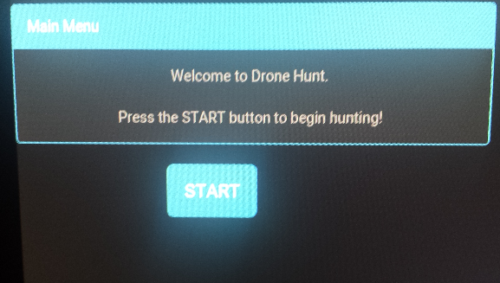

Figure - Main menu of Web App

The Drone Hunt application is broken up into several parts (tabs in the web application) in order to provide an organized system.  Features of the web application include the actual game function, override controls, and diagnostics.  The application will be primary written in JavaScript derivatives jQuery and Node.js along with Python to allow communications with the libraries available for the Mission Planner software.

In game configuration will allow for a single or two player games with the capability to add more players with addition hardware upon detection.  A difficulty setting will determine the patterns and semi-autonomous behavior that Mr. DJ should take on while the game is going on.  Movement randomness will be increased as the player chooses a higher difficulty setting and more sophisticated flight patterns would be taken.

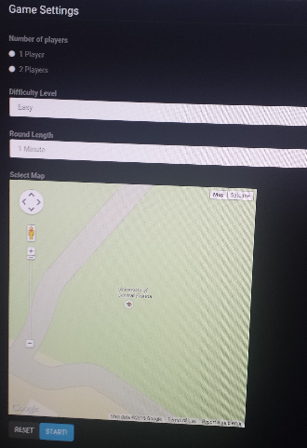Below are two pictures of how the web application will be presented on the ground control station for users to interact with Drone Hunt.

When the game starts the players would be shown a screen with each players score and the current leader in the game.  At the bottom, special achievement messages will briefly be displayed as the player fulfills the requirements for such a message.  The time remaining will be placed at the bottom letting players know how much time they have left to continue scoring.

1. **COMMUNICATION**

Much of the game data processing and communication will be handled by the dedicated game server.  This game server will be powered by a BeagleBone Black which features an ARM Cortex-A8 CPU running at 1GHz with 512MB RAM, sufficient enough to run a Linux based web server.  Equipped with an 8GB microSD card in addition to its internal 4GB there should be plenty of room to keep enough data for many game observations.  The distribution of Linux elected to run on this equipment will be the Angstrom Distribution since it has the highest level of support for this type of board.

The figure below provides a look at the feature set of the BeagleBone internally. Despite its physical appearance as an inexpensive microcontroller, internally it is capable of features that can be used to host a multitude of services including a web server which is crucial for the design of the project. The BeagleBone also supports high definition video output in the case that we may feature an upgrade design to the ground control station by added yet another LCD display showing relevant data



In order to make use of the data given off by the laser systems on the guns and Mr. DJ itself, all these devices will have a TI microcontroller added to their circuitry.  The TI MSP430F229 was chosen in conjunction with the TI CC3100 booster pack module to enable Wi-Fi communication on these devices since their inputs will solely be signals coming in from the laser equipment. The specifications for these TI devices are provided below.

|  |  |
| --- | --- |
| *Model* | MSP430G2553 |
| *Frequency (MHz)* | 16 |
| *Flash (KB)* | 128 |
| *SRAM (kB)* | 8 |
| *GPIO* | 63 |
| *I2C* | 2 |
| *SPI* | 2 |
| *DMA* | 3 |
| *ADC* | 12-bit SAR |
| *Comparators* | Yes |
| *Multiplier* | 32x32 |
| *BSL* | USB |
| *Operating Temperature Range (C)* | -40 to 85 |
| *Package Group* | LQFP |
| *Approx. Price (US$)* | 3.58 | 1ku |
| *Estimated Package Size (WxL) (mm2)* | 80LQFP: 12 x 12: 196 mm2 |

Texas Instruments MSP430G2553 Microcontroller Package

|  |  |
| --- | --- |
| *Device Type* | CC3100 |
| *Processor* | External MCU |
| *Key ROM Features* | Wi-Fi Driver & Supplicant  TCP/IP Stack  TLS/SSL Stack |
| *Key Wi-Fi Features* | 802.11bgn  STA, AP & Wi-Fi |
| *Throughput (Max) (Mbps)* | -16 (UDP)-12(TCP) |
| *Wi-Fi RX Current (mA)* | 53 (@54 OFDM) |
| *Wi-Fi TX Current (mA)* | 223 (@ 54 OFDM, |
| *Wi-Fi Idle Connect Current* | 0.69 (DTIM = 1) |
| *Wi-Fi TX Output Power dBm* | 18.0 (@ 1 DSSS) |
| *Wi-Fi RX Sensitivity (dBm)* | -95.7 (@ 1 DSSS) |
| *OperatingTemperature C* | -40 to 85 |

Table -CC3100 Module Specifications

To provide basic networking services and an access point for the Wi-Fi devices, the design calls for a traditional Linksys WRT54G to work from within the ground control station and take on such a duty.  Although the BeagleBone could have possibly provided routing services it may be wise to move that stress to a dedicated device since the BeagleBone Black may not multitask as well as a standard PC would.

1. **PCB & OTHER DESIGNS**
2. **PCB Vendor and Pricing**

The drone hunt project will be incorporating several printed circuit boards (PCB) into its design, with a complex one on the drone itself and then smaller, simpler ones in each transmitter gun. These PCBs will serve the purpose of electrically connecting electronic components within the device. For this project PCBs will be acquired from one of the numerous PCB vendors suggested on the senior design website. PCB Vendors provide services where they take Gerber files, which are files generated by a CAD software such as CADSoft Eagle, and use them to generate a PCB without any components soldered onto it. There are also PCB assembly houses which then professionally place and solder the components onto the fabricated PCB. In the assembly house machines are used to correctly place each component in the right location then runs the board through an oven that properly solders each component in place. Printed Circuit Board fabrication has a wide selection of possibilities to choose from. Due to time constraints a vendor which offers low pricing and quick turnaround time will be used for the PCB fabrication for this project.

This group agreed that one of the companies that would be considered for the printing of our design printed board printing were between 4PCB and OSH Park. At the end of the day, after looking at prices and turn-over time, the manufacturing company that the team went with was Osh Park. OSH Park accepts designs created using CADSoft Eagle, free PCB design software, and also offers an add-on for Eagle which will verify that your design meets their design rules and specifications. OSH Park prices their boards per square inch and they offer a 3 layer board at $5.00 per square inch. One of the benefits of choosing OSH Park to manufacture PCB is that they provide you with 3 copies of the PCB at no extra charge. OSH Park orders for the 2 layer board go to the fab every business day, and have a turn time of about 12 calendar days.

1. **Circuit Designs**
   1. **Drone**

The first circuit sent to a circuit printed board manufacturing company was the circuit that is it going to be mounted on Mr. DJ for the MSP430, the ATMEGA328, all the LED strips, and the IR Receivers that the drone will be equipped with. The circuit is composed of two voltage regulators. These two voltage regulators serve as a voltage drop from 12 volts to 5 volts and 3 volts. The 5 volts will be distributed to all the LED’s strips, the IR receivers, and the ATMEGA328. On the other hand, the 3 volts will only serve to turn on the MSP430G2553 chip. In addition, the PCB is ready for the two chips to be solder on the chip via thru holes. Also, the PCB has the thru holes to attach headers of the exact dimensions of one on the MSP430 Launch Pad in order to mount any booster pack. All the other components will be simply be surface mounted solder on the circuit for easier wire solder. Below are two pictures of the boards that had to be designed on Eagle CAD and also routed so that all the wires do not intersect. At the end of the design of the board, the Gerber file had to be created in order for the OSH PARK to take in the order and process the board with their system. After many emails and small fixes on the board, the order went through and we successfully got the boards in. Below are two picture of this PCB.

Figure - Wave Amplifier Circuit

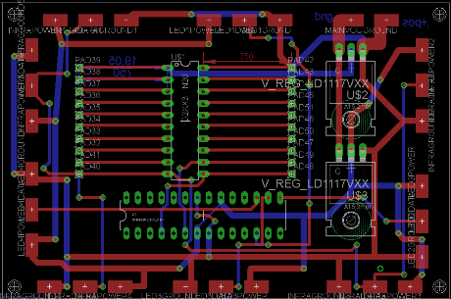

Figure - Printed Circuit Board

* 1. **InfraRed**

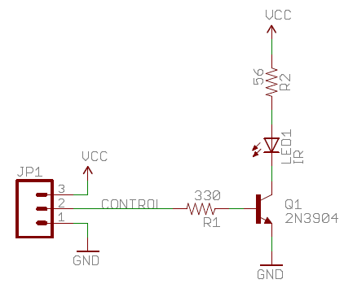A circuit was design to deliver enough current to the IR LED in order for the signal to reach further distance. The MSP430 is incapable of delivering this, so the consists of a MOSFET to deliver the PWM signal to the LED. The circuit is shown below. APWM signal will be sent consisting of a 2400µs header and a 5 bit data section indicating the hitting of the drone. PWM has been unnecessary for the basic application of Drone Hunt, and may be added in future iterations. This circuit is composed of a 2N3904 Transistor, various resistor, and the IR LED.

Also, it was necessary to design an oscillator circuit that generates the 38kHz carrier frequency for the infrared data signal. This circuit is designed using a LM555 timer and resistors and capacitor which were calculated to generate the required 38kHz frequency signal. Ra and Rb in the figure below were chosen as the same value to create a 50% duty cycle. Using a value of 0.1µF for C and 200ohm for both Ra and Rb, a frequency of 38kHz was achieved. This carrier frequency was passed through an AND gate along with the data signal to create the actual IR signal for each gun.

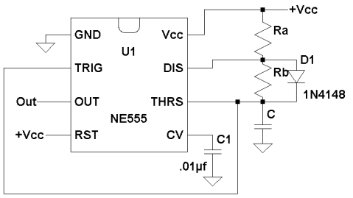

Figure - Frequency Circuit

* 1. **Ground Control Station**

One of the main features of the ground control station is that this system can be fully portable (use batteries) or if a AC power outlet is available, not portable (use Power Supply instead). In order for this to electronically function, a circuit had to be designed and constructed. The group came up with a brilliant way to switch between two different voltage sources. The circuit design uses two high current transistors that work in an inverse function to allow flow of current when the PSU is not plugged in and not allow flow when the PSU is plugged in. Below is a schematic of the circuit.

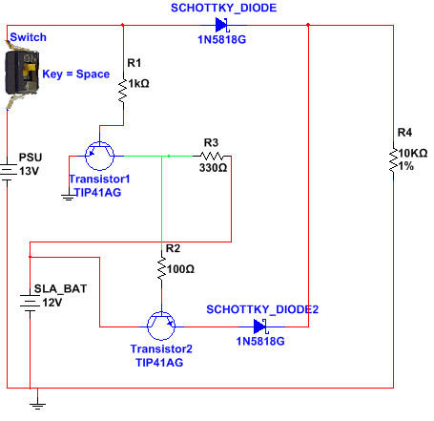

Figure - Battery Manager Circuit

1. **CONCLUSION**

In conclusion, the members of this group have earned a vast amount of experience in just being part of this two-semester long project. This group have learned how to indeed work in a team atmosphere, how to conduct professional meetings and how to professionally write a technical report.

At the beginning, this group understood that researching and developing a project like this will in fact force us to use all the small knowledge obtained from all the classes that we attended in our engineering college career, and in fact, that was how it developed.

1. **BIOGRAPHY**

Emmanuel Martinez is currently a senior at the University of Central Florida. He plans to graduate with a Bachelor’s of Science in Computer Engineering in May 2015 and continue his engineering career with The Boeing Company. Future plans may include a master’s degree and application development for the IoT’s.

Juammy Lora is a senior at the University of Central Florida earning his degree in Computer Engineering. His plans consist of beginning his engineering career as a Systems Engineer at Lockheed Martin, at the Mission Systems and Training location. Also plans on becoming part of the leadership program at Lockheed and earning a master’s degree.

Randy Aybar is senior computer engineering student at the University of Central Florida. He plans on earning his Bachelor’s degree and beginning his full time engineering career at Cisco.

Devesh Maharaj is an electrical engineering student at the University of Central Florida. Plans on obtaining his Bachelor’s Degree in Electrical Engineering. He will be graduating in the summer of 2015.

1. **REFERENCES**

[1] Mission Planner version 2 website:

<http://planner2.ardupilot.com/>

[2]DYI Drones Community blog for ideas and problems, website: <http://diydrones.com/>

[3] Laser Kart Previous Senior design project. <http://www.eecs.ucf.edu/seniordesign/su2013fa2013/g15/pages/page1.html>

[4] Node JS information: <https://nodejs.org/>