Matthew Conte
Usman Mahmood
CSE 3215 – Lab 2 Report

7) (Screenshot of adjusted square wave for PA3)
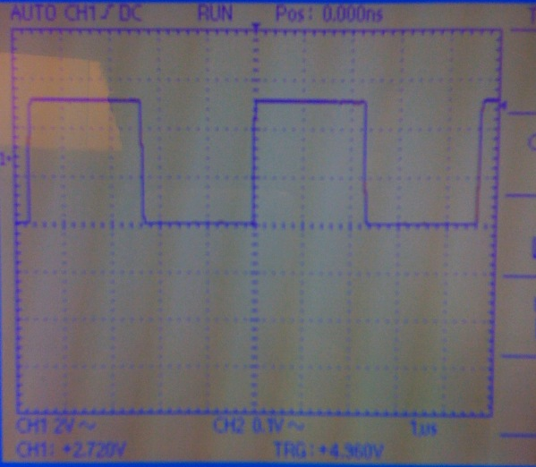

8) Trigger values below -0.24 volts and above +5.36 Volts produced an unstable graph.

9) Trigger Coupling Method:

DC: stable between -0.24 and +5.36 volts
AC: stable between -2.64 and +2.88 volts
HF Reject: stable between +2.08 and +2.96 volts
LF Reject: stable between -3.28 and +3.44 volts

14) Time/Div was set to 10 microseconds.

15) Since 1 cycle (trough and crest) was approximately 74 microseconds, the respective frequency is 1 / 74 microseconds = 13.51 kHz.

16) Essentially rising edge or falling edge do not make any difference to the waveform, triggering levels were adjusted and fixed. Below are the values for them.
DC: stable between -4.88 and +0.48 volts
AC: stable between -4.96 and +0.32 volts
HF Reject: stable between -4.56 and -0.64 volts
LF Reject: stable between -5.04 and -0.24 volts

17) Source: CH1 Coupling: DC Level: +5.0V
Source: CH2 Coupling: DC Level: -4.08V

18) CH1’s waveform is displayed as a solid block, indicating a very high frequency since its troughs and crests are very close to each other. Frequency observed for PA0 is 1.66 MHz, volts/div was set to 0.1 microseconds in order to view a complete waveform. PA7 was not visible on the scale, just a straight line.

19) In order to get a clear picture of the waveform, times per div was changed to 0.1 microseconds

20) If we change the trigger source it selects between different combinations of channel source i.e. channel 1 or channel 2, coupling (only observed AC and DC) and slope.

22) Volts/Div: 2 Volts/Div Time/Div: 1 microsecond

23) 1 cycle = 4.8 microseconds so:

Frequency: 1 / 4.8 microseconds = 208 kHz

Amplitude: 2.5 * 2 Volts/Div = 5.0 Volts

27) 1 cycle = 0.72 seconds so:

Frequency: 1 / 0.72 seconds = 2.77 Hz

Amplitude: 2.5 * 2 Volts/Div = 5.0 Volts

28) Major observations with waveform were that triggering level did not have any effect on it, and the wave kept moving. Both of the above mentioned reasons did not effect recording the measurement because the frequency was low and a real time changing wave could also be decoded easily.

29) No, autoset did not help. It made our waveform unstable and noisy. Volts/Div was set to 5mV, Time/Div 0.5 microseconds

31) We used DC coupling, but other couplings were presenting a clear waveform too.

32) 0.2 times/div was set in order to get a nice clear waveform.

33) Wave is stable on display, but it’s a propagating wave.

34) Freq : 2.77 Hz Amp: 5 Volts (same as before)

35) Amplitude is reduced by factor of 10.

36) Amp: 5.0 V

37) Amp: 0.5V

Truth Table between Dragon12 and Altera for Oscilloscope

C | B | A | Y
0 | 0 | 0 | 0
0 | 0 | 1 | 1
0 | 1 | 0 | 1
0 | 1 | 1 | 0
1 | 0 | 0 | 1
1 | 0 | 1 | 1
1 | 1 | 0 | 0
1 | 1 | 1 | 1

