Final Report for Web Tournaments Project

Group #7
Michael Davis
Mark Gollnick
Taehyun Park
Maxwell Peterson
Rob Sheehy

Version | Date | Author | Change
1 | 11/24/12 | MP | Initial Document

Table of Contents
1 Introduction 3
1.1 Purpose 3
1.2 Scope 3
1.3 Definitions, Acronyms, Abbreviations 3
1.4 Design Goals (based on Deliverables, Functional, Non-Functional, User-Interface Requirements) 3
2 References 4
3 User Interface Description 5
4 Decomposition Description 6
4.1 Module Decomposition 6
4.2 Concurrent Process 6
4.3 Data Decomposition 6
4.4 OverALL System Specification 6
5 Dependency Description 7
5.1 Intermodule Dependencies 7
5.2 InterProcess Dependencies 7
5.3 Data Dependencies 7
6 Interface Description 8
6.1 Module Interface 8
6.2 Process Interface 8
7 Design Rationale 9
7.1 Design Issues (challenges you faced) 9
7.2 <Issue 1> 9
7.3 <Issue 1> 9
8 Tracability 10
9 Language/Framework/Tools Used 11
10 Individual Responsibilities 12
10.1 Group Member 1 12
10.2 Group Member 2 12
10.3 Group Member 3 12
10.4 Group Member 4 12
10.5 … 12

Introduction

<DO NOT DELETE ANY SECTION. INSTEAD, if you have nothing to write in any section, then write [NONE] or NA (not applicable)
Regularly update this document to avoid last minute major updates; this must be part of your repository>

<< Please delete ALL instructor comments before submission>>

Purpose
<purpose of the document, who will use this, why he/she will use this>
The purpose of this document is to enumerate and elaborate on the requirements and design of the Web Tournaments web application. This document should enable the reader to understand the thought process of the programmers as they put together the different components of the project.

Scope
<scope of project, deliverables>
The project aims to solve the problems presented when keeping track of tournaments on paper and white boards. There is a lot of manual work and logic involved when doing tournaments the old fashioned way, such as calculating seeds after a round robin or trying to draw a double elimination bracket for 17 people. The goal of this project is to create a platform on the web that can handle many different kinds of tournaments. A platform that will eventually be expanded upon, but for the purposes of this project we will only implement a few kinds of tournaments due to time constraints. The plan for this project is to fully implement single and double elimination tournaments, as well as round robin tournaments. If there is time we would like to be able to calculate seeds from round robin results to go into a single or double elimination bracket.

Definitions, Acronyms, Abbreviations
Term | Description
Round Robin Tournament | A type of tournament in which each player or team plays every other player or team in the tournament or pool.
Single Elimination Tournament | A type of tournament in which a player or team can only lose once before they are out of the tournament.
Double Elimination Tournament | A type of tournament in which a player or team can lose twice before being out of the tournament. After losing once, they enter the consolation bracket, which at best can win third place.

Design Goals (based on Deliverables, Functional, Non-Functional, User-Interface Requirements)
<Put in order of your team’s priorities. Also, explain what each item means and be very specific about each item you put in here. Some example of non-functional requirements are given below>
<Note from Max: Not sure if we are supposed to mix functional and non-functional?>
- Usability
  - The end product should be easy to use, and intuitive. It should not require an instruction manual or help pages to use. The user should not be confused about what to do next, and it should have a kind of ‘flow’ of easiness.
- Extensibility
  - The project should be able to be expanded upon after the semester has ended. New tournament types and user interface interactions should easily be able to be added and modified.
- Reliability
- User should be able to create his or her first tournament easily and quickly.
  - Creating a user’s first tournament should not require logging in until after they have gone through the tournament creation wizard.
  - Entering data to create a tournament should be easy and intuitive, and must not be confusing or tedious.
- Response Time
  - The service should respond quickly when an action is performed. No page should take more than 3 full seconds to load (internet connection not being the limiting factor)
- Users can update the status and score of matches, and the changes will be reflected to the rest of the users/viewers.
- Users can create tournaments of different types and rule sets.
- Users can share their tournament with other people via a URL or Facebook post.
- …

References
(If any – usage of pre-existing code, where available)

Backend
Flask – A slim web application framework for Python. Our team discovered this as a replacement for webapp2 and thought it looked really nice. This framework handles HTTP requests and routing based on URL patterns.

wtforms – The forms library. It allows developers to create a form class with field attributes which end up being rendered into HTML forms easily.

Jinja Templates – The HTML templating language. Create HTML templates with variables passed into them; ability to do loops and template subclassing/extension.

Flask extensions – Various flask extensions are used such as flask-login, flask-oauth, and flask-assets.

Frontend

Twitter Bootstrap – An awesome frontend framework that provides us with a slick look and feel for the web application, without having a graphic designer on the team.

User Interface Description
#TODO: Need descriptions for each of these.
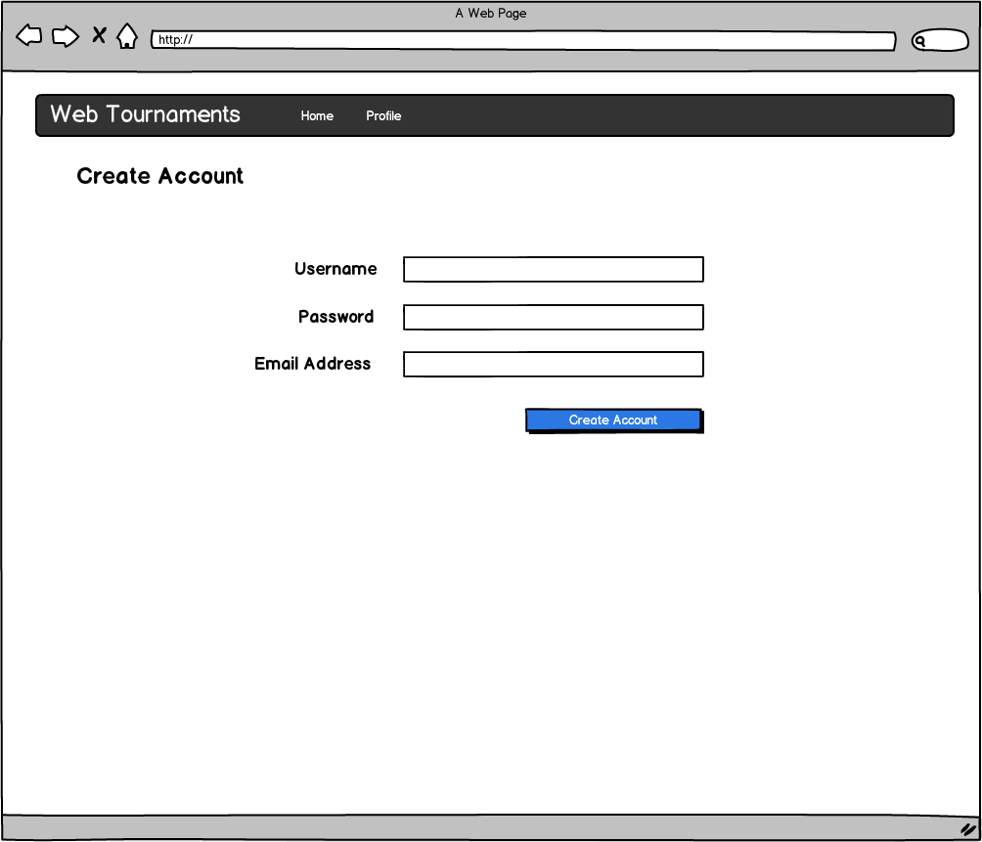
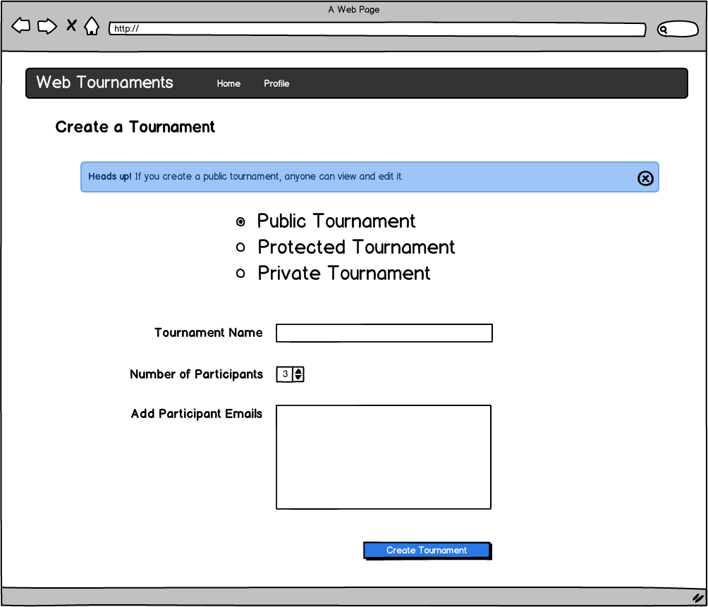
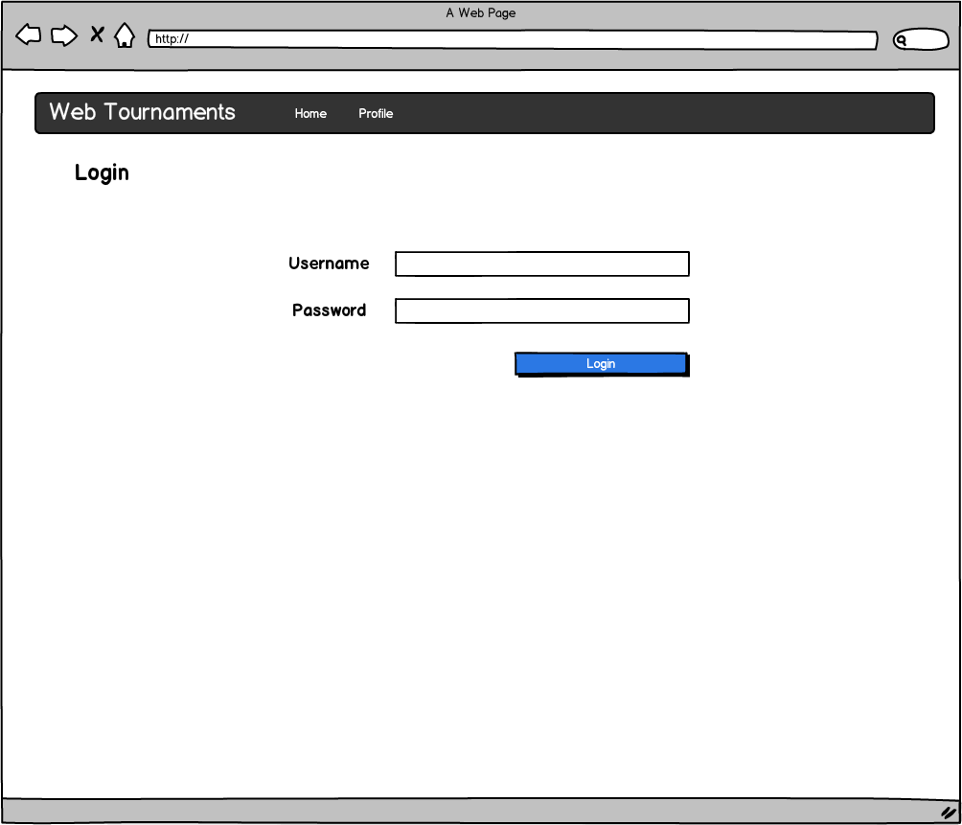
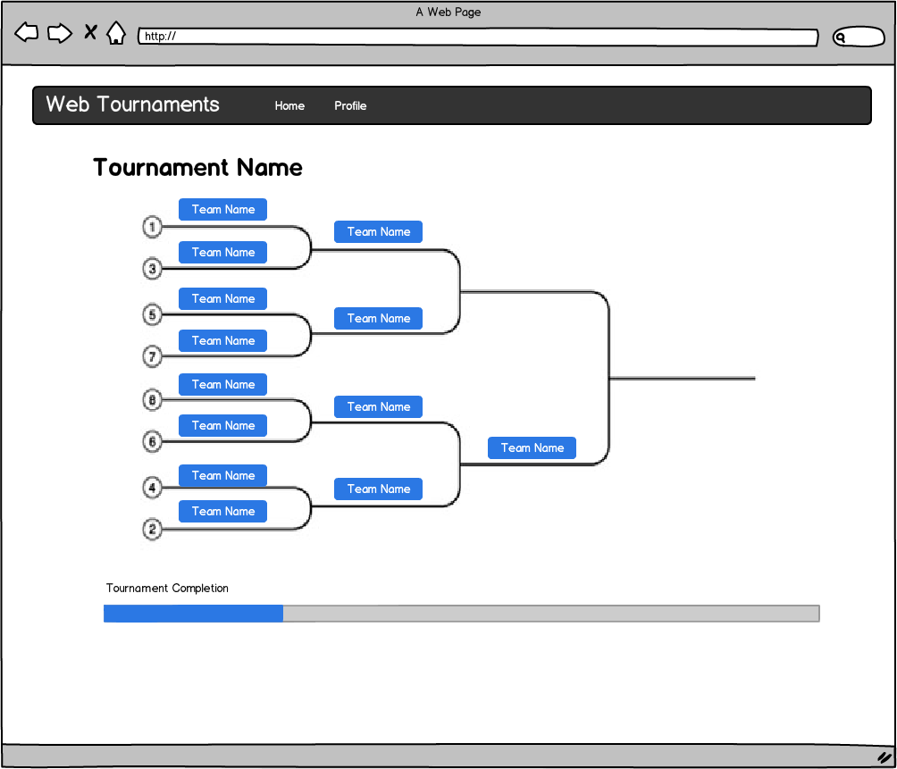
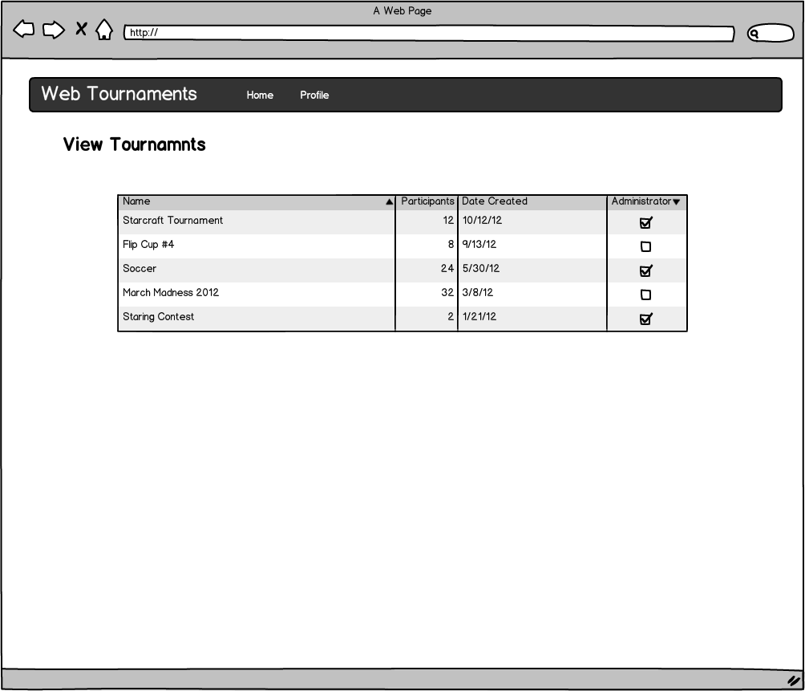

Decomposition Description

Module Decomposition
<Give an overall description + Give an Architectural diagram>

<Module 1 > Description

<Module 2> Description

<Repeat for as many subsystems that you have>

Concurrent Process
<Give an overall description of the different processes, threads, instantiations>

<Process 1 > Description
<Use sequence diagram to depict an use-case that uses this process(es)/thread(s). Also describe overall operation of the process. Also – describe what the threads do.>

<Process 2> Description
<Repeat for as many subsystems that you have>

Data Decomposition

<Class 1> Description

<Class 2> Description

OverALL System Specification

<State/System 1 > Description

Dependency Description

Intermodule Dependencies

InterProcess Dependencies

Data Dependencies

Interface Description

Module Interface

<Module 1> Interface

<Module 2> Interface

Process Interface

<Process 1> Interface

<Process 2> Interface

Design Rationale

Design Issues (challenges you faced)

<Issue 1>

Description

Factors affecting Issue

Alternatives and their pros and cons

Resolution of Issue

<Issue 1>

Description

Factors affecting Issue

Alternatives and their pros and cons

Resolution of Issue

Tracability

No | Use Case/ Non-functional Description | Subsystem/Module/classes that handles it
1
2

Language/Framework/Tools Used

Individual Responsibilities

<Explain your contributions to the project; tie up the contributions with the design decisions you have helped develop and artifacts that you have implemented>

Group Member 1

Group Member 2

Group Member 3

Group Member 4

…

FEEL FREE TO ADD APPENDICES AS NEEDED. UPDATE TOC BEFORE SUBMITTING

