Human language is naturally redundant. This allows conversations without pauses. One person talks and the other listens. There is a slowing down as a Person A gets to the end of a sentence or thought, and by then the listener already know what Person A is going to say.

This allows Person B to speak immediately without pausing. Person B already has a good idea:
- What Person A is going to say.
- That Person A is ready to finish the thought.

As part of this, and as a way of comprising, communication words are very short.
- To
- Be
- At
- We
- You
- I
- Of
- By
- My
- The

Short words are no trouble for those who do captioning and sign language. They are translated automatically. So we want to add a bias to the words to prefer.
- Unusual words
- Longer words

Make sort key = Word Freq × 100 + Word Length
- Sort this down.
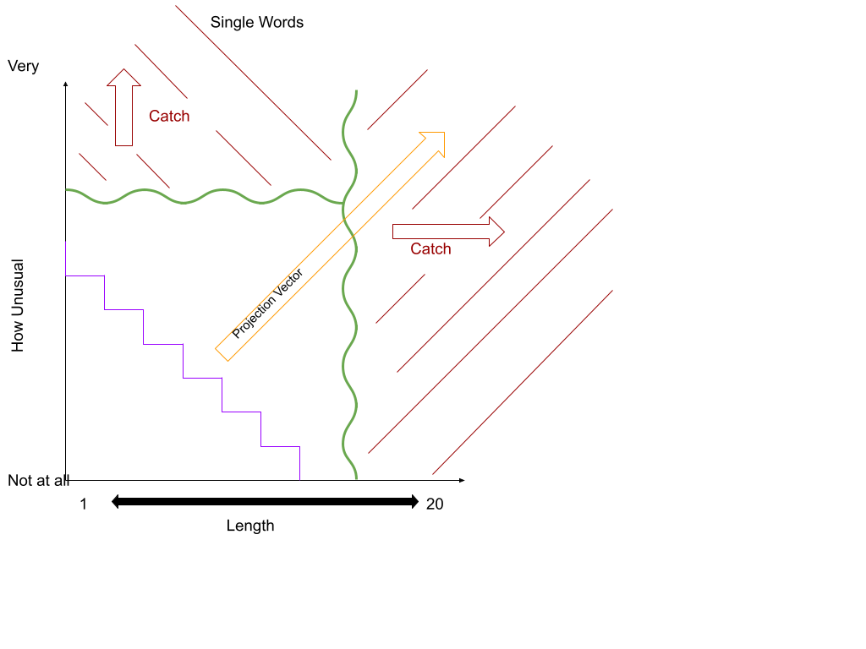
- Want to “catch” single words like:
  - Mahalanobis
  - Regularization
- Want to “catch” multi-words like:
  - center-of-mass
  - common-basis-of-comparison
- Will need different rules for single words, doubles, triples, and quads.
Question: How can the parts of speech help us?
Notes on adjectives:
- “Big” is noise.
- “Linear” is helpful

Long Words
- Pneumonultramicrosphic
- Silicovolcanoconiosis
- Supercalifragilisticexpialidocious
- Antidisetablishmentarianism
- Floccinaucinihilipilification
- Pseudopseudohypoparathyroidism

