TAP Project
Phase I Report
National Technical Institute for the Deaf (NTID)
Rochester Institute of Technology (RIT)
Michael Donovan
Thomas Kinsman
May 23, 2023

Abstract
To provide fair and equal access to a college education for deaf and hard of hearing students, college lectures given by speaking professors must be translated into another language, either written English or ASL (American Sign Language). This is not a speech-to-text problem, but a translation problem. The translators (captionists and interpreters) must perform their function in real time, with only a strictly limited lag behind the professor. The language conversion must provide a form of communication that is accurate and complete. The task requires a human-in-the-loop two, too, to make the conversions correctly, and capture nuances of the language. This project shows that the analysis of prior transcripts can be used to prepare the captionists and interpreters for uncommon, unusual, or difficult words that will occur in a particular lecture.

Overview
TODO
The use of Natural Language Processing (NLP) allows computers to capture statistics about written text and use language models to determine wonderful insights. The successful results are widely published in academic literature. The mistakes are never shown.

The set of pre-captured data must be carefully curated and protected.

TODO: Add notes on PRIMING and the benefits.

Outline and Overview -

The Transcription Problem is a Real Problem:
A direct speech-to-text conversion of spoken English copies all of the spoken disfluencies. Disfluencies are spoken hesitations that are inserted in spoken English to indicate that the speaker still wants control of the conversation, but is considering and composing the next section of the conversation. These are words such as: “like”, “um”, “ah…”, “err”, and “so…”. Verbatim, conversion from audio to written transcription leaves in these hesitations and filler words which we would want edited out.
Automated speech-to-text also have issues when trying to decide which stop words should be removed from the translations. For example, the word “of” is often ignored as an unimportant word in natural language processing. Yet, in the context of a lecture the word “of” is important. Phrases like, “center of mass”, “King of Spain”, and “basis of comparison” require that the word “of” be retained in the text.

With the recent publicity of large language AI models, comes a public misperception that AI can do almost any task desired. The statistical AI models do not replace human thought.

People must be used to make sense of and validate the work. The process of converting spoken lectures into written transcripts of English is not fully automatic, yet.
To prove that computer models are inaccurate, consider the problem of typing texts on a cell phone. In the context of typing a text, even the letters physically typed by a human are not correctly converted into English. Consider the sentence, “Mom, this is your daughter, I am coming home for the weekend, and I am bringing drugs.” The author meant “… bringing Doug.” However, the computer could not make sense of what it thought the speaker said. Using concept mapping, it intuited the expression “… bringing dug” did not semantically parse correctly, so the computer found another word that was close to the word “dug”, and substituted in “drugs”.
Recently a Teaching Assistant texted Dr. Kinsman asking if Dr. Kinsman was having a relaxing summer. Dr. Kinsman replied that he was “Very busy”, which was converted by his cell phone to “Very busty.” There are numerous examples in which the autocorrect program on a cell phone accidentally substitutes in the wrong word. (The worst offenses are so tragic that they cannot be repeated here.) The point is that even given a sentence on a phone, with the proper letters, the wrong word is generated. This has led to the common meme “Damn Autocorrect.”

Transcribing speech to text will always require a human-in-the-loop to correctly translate the spoken words into written English. Transcribing is analogous to converting written script into typed English. For example, consider figure (TODO reference, Following figure). In this process a human has to read the words, correct mistakes that happened along the way, and then type the desired output.

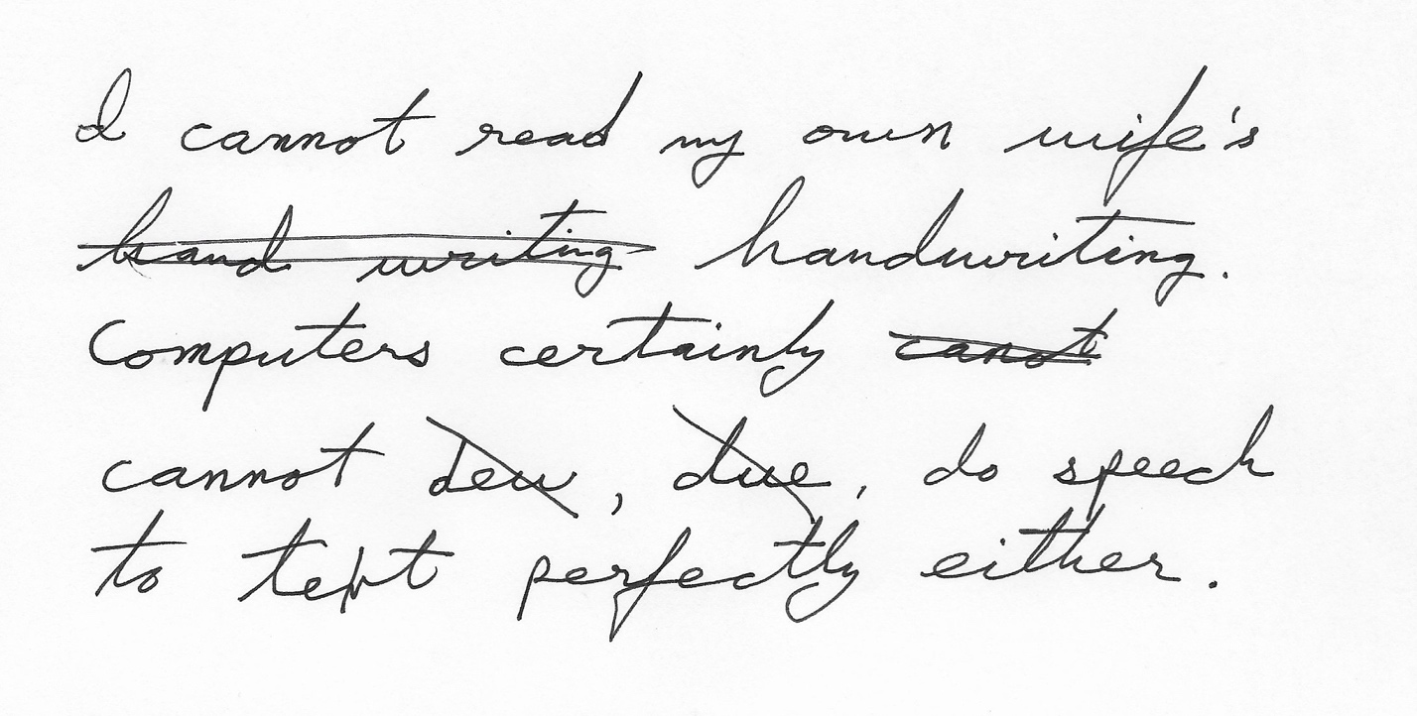
Figure 1 – The task of transcription can be analogous to converting script to text, with corrections made in real time..
While computers are making progress understanding humans, they cannot be perfect. After 30 years of marriage, Dr. Kinsman cannot read Mrs. Kinsman’s handwriting. When he goes grocery shopping with a grocery list written in script, he has to skip purchasing items for which the script is unintelligible.

Given this scenario, one would naturally ask, why doesn’t Mrs. Kinsman simply print the shopping lists? After all, OCR is pretty good now. To illustrate why this is a problem, consider the following example. Dr. Kinsman has been taking notes using printing for 40 years. His printing is very consistent. He would like to be able to train an OCR system to convert his scanned notes into ASCII text. To make the problem simple, he always prints in all upper-case letters.

In the (TODO Following figure) a sample of all upper-case letters was fed into an OCR engine. While humans can clearly read it, the results also clearly demonstrate that a straight computer conversion is not correct.

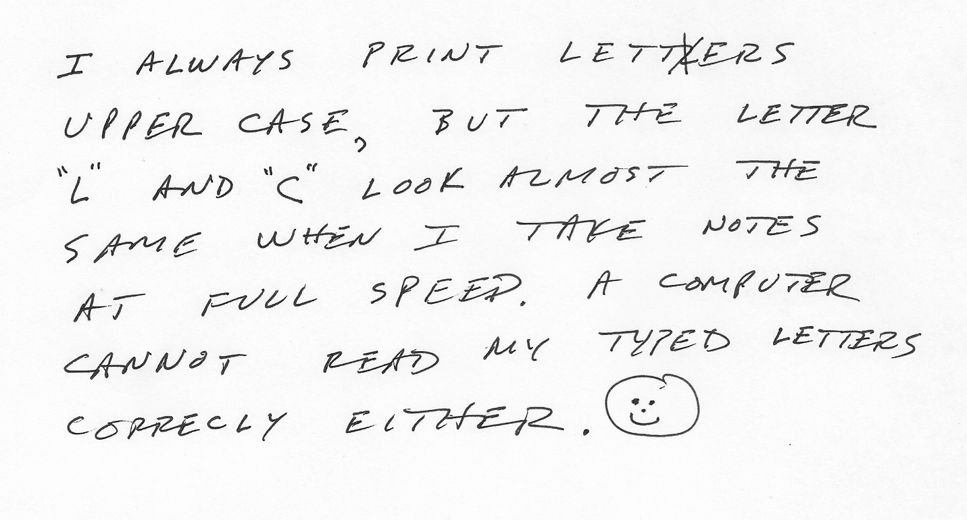
Figure 2 -- TODO Add caption here.

OCR on the above figure generates the following output:
“I ALWAYS UPPER CASE, "2" PRINT LETTERS BUT THE AND "C" LOOK ALMOST SAME AT WHEN I FULL CANNOT CORRECLY SPEED READ му EITHER. TAKE LETTER THE NOTES A COMPUTER TYPED LETTERS”
Captioning a lecture is not speech to text. Spoken English is different from written English. To

sadf

Captioning is not speech to text -- it is translating.
It is like converting script to printed words.
It is analogous to converting speech to ASL.
OR English to French.

AND

Speech to Text does not filter out words correctly.

"Damn autocorrect" -- machine methods for fixing spelling error and grammar errors actually inject mistakes.
Many

Complexity of the problem:
- Ethical Issues:
- Ethics issues: using the voice of professors and students without explicit consent.
- This is why we focused on Kinsman's lecture.
( Ignore other ethical issue. )

Scope of the problem.

Experimental 1 Description: - Mike
- Summary from Mike.
- The traditional methods do not apply in this case.
- Typical "noise" words are actually import to us.
= Example some "stop words" are not stop words
- "Basis Of Comparison" -- search the text for concordances for "Comparison" to "Basis".
Example: Project
Project for the course, versus Project (as in projection vector)
Homonyms -- pronounced differently, but spelled the same.

- "Center Of Mass"
- "King of Spain"

Results for Experiment 1 - TFIDF
- Finds the words to do.

What was done? - Mike

Results - Mike

Discussion - Joint
Future Work

Conclusion

PRIMING THE CAPTIONISTS HELP

Credits

Thanking fast and slow

Product details

Thinking, Fast and Slow Hardcover – October 25, 2011
by Daniel Kahneman (Author)
- Publisher ‏ : ‎ Farrar, Straus and Giroux; 1st edition (October 25, 2011)
- Hardcover ‏ : ‎ 512 pages
- ISBN-10 ‏ : ‎ 0374275637
- ISBN-13 ‏ : ‎ 978-0374275631

