Preliminary Design thoughts:
Regardless of who you are, most of us use roughly 600 I believe this but where did you get 600 from? words routinely. For specific situations, such as when giving presentations, people switch vocabulary sets based on the context. We can guess that the professors who are lecturing will switch to

The terms are confusing. Pay close attention:
1. Frequently used by the professor vs rarely used by the professor.
This is in terms of what the Prof says in the corpus of the lecture.
Stats in the lecture will tell us this.

2. Commonly used by most people, vs rarely used by most people.
In other words: usual words vs uncommon words.
the nltk toolkit will tell us this. I could be wrong.
We need a ranking here.

These two distinctions break the corpus up into four quadrants, and avoids needing to store other words to compare with. We do not need to compare one lecture to another professor's lecture, for example.

Discussion of Words by Cases:

We can consider words as falling into four basic quadrants for discussion:
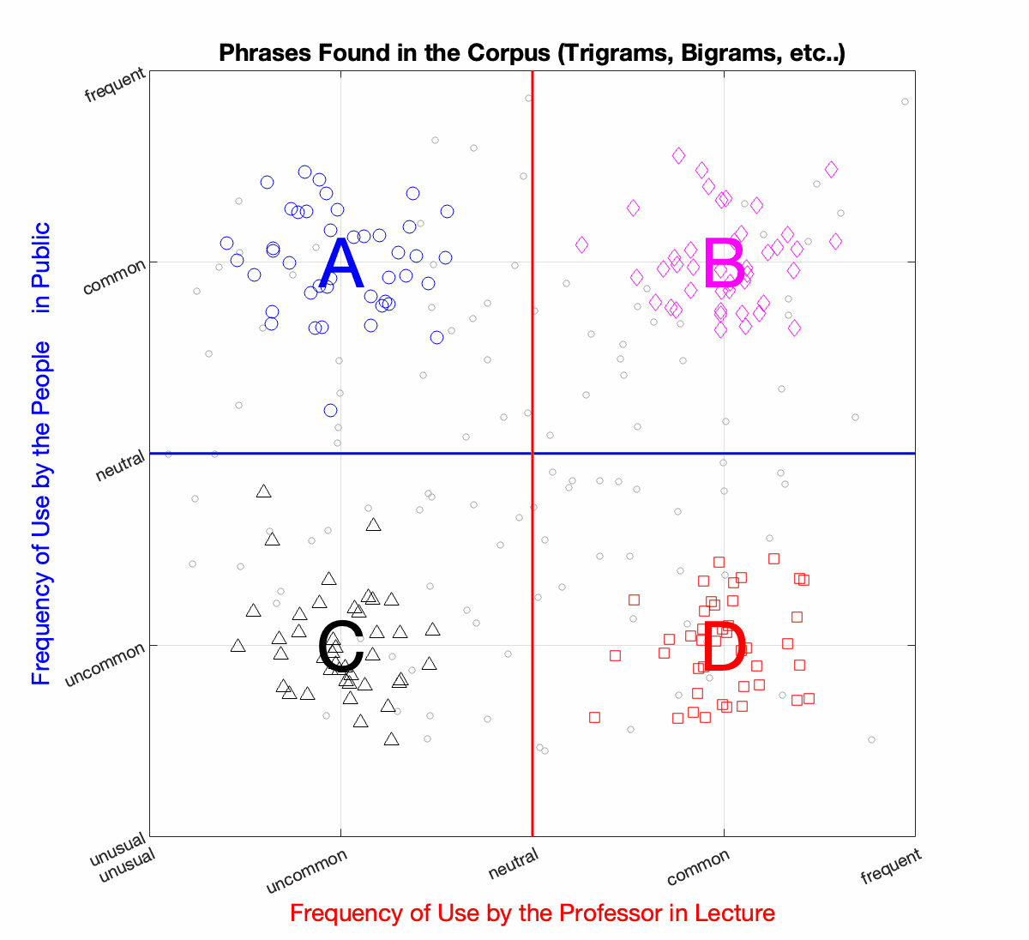

Regions by Case:
- These words are not commonly used by the professor, but are commonly used by people in general.
We can guess that the captionist would handle these well without any preparation or warning.
  - After rethinking this, it may not be words that captionists know. Words frequently used by people in general and not professors may include things like slang.
    - Example: Lit (“cool”)
    - Example: No cap (“not lying”)
    - Popular culture terms: think TikTok. Things that go viral.
    - NFT’s, bitcoin, etc…
    - This will probably change over time as popular words come and go.
We will probably have to run the test, and see what happens.

- These words are frequently used by the professor, and are frequently used by people in general.
I am not sure how to think about these. Michael Donovan, what do you think?
Initial thought: We want to capture the “Top X” words that are used.
The software should capture everything in region D, and then rank those in region B.

  - “Top 40” – basic training handles these. Captionists know these using muscle memory.
  - “Top 500” – Not sure about this.

I have a list of the top 40 and top 500 words as it relates to captioning and I can share these.

What does Michael Donovan think?

Michael Donovan thinks that we may find phrases in here, such as pretty much and very good. I believe we will also find most of the “TOP 40” and ”TOP 500” here. This will be a big section and will need to be sifted through. There could be and probably will be words and phrases here that we need because it’s still relevant to the class and useful for a captionist to know. But there will also be a lot to filter out.
- These words are not commonly used by the professor, and not commonly used by people in public.
We can think of these as “outliers”. They would be difficult to prepare for.
The cost is high, the benefit is low.
And, since they are infrequent, the captionist would be able to handle them on the fly.
Or, these might be made-up words, and the captionist can handle them just as they normally would.
“Adjuncting” is not really a word. “Captionist” is flagged as a misspelling.
Anything misspelled.
- These words are commonly used by the professor, and not commonly used by people in general.
These words and phrases are absolutely what we would like to capture.
And give the captionist a warning about.

OTHER Considerations:
Bigrams / trigrams etc :
If a trigram is frequent, “center-of-mass”, then you want to ignore the two bigrams that go into it. The a-priori algorithm can help solve this problem. BUT, WE MUST NOT REMOVE COMMON STOP WORDS BEFORE DOING THIS!! The standard thing is to first remove common stop words, which would shoot ourselves in the foot.

Who is the main speaker?
Is it INSTRUCTOR, or LECTURER, or PROFESSOR, or SPEAKER?
Instead of trying to solve some clever set of synonyms, process the document, and see which speaker says the most words. The computer program can do this easily while simultaneously removing contractions and noise.
EITHER: who was tagged most commonly, OR ,who said the most words.
In either case, the software can tell us.

Points of Confusion for Students are Not Confusing for Captionists:
There is another set of words I think we should try to identify: words in the corpus that are easily confused:
- "Ions" vs "cations" in chemistry.
- “Objective” versus “Ocular” in optics.
- “Reflection” vs “refraction”.
- “Clustering” vs “classification”.
- “intra-class” vs “inter-class”.
- “Hydronium” vs “Hydroxyl”
- “homogeneous” vs “homogenized”
These words are similar in terms of the Levenshtein distance (the edit distance), but they also tend to be used near each other in the corpus. They tend to be used within a few paragraphs of each other.

So, a modified similarity metric can be used for finding "confusing" words.

Initial thought: Mike says that these are not confusing for a captionist.

I want to elaborate on this.

When using our software, TypeWell breaks down abbreviations into very basic forms based on a set of rules. Let’s look at hydronium versus hydroxyl, which initially you thought would be a confusion point.

Abbreviation for hydronium = hdnim
Abbreviation for hydroxyl = hdrxl

This is what I mean when I say they are not confusing for captionists. Very different letters are used, based on a set of rules pre-defined by the software that we should all know and learn.

More confusing words for captionists would be collaboration and celebration because of the commonality when abbreviating. When broken down using TypeWell rules, celebration and collaboration are very similar and need conflict resolution through inserting an extra character.

Celebration = clbj
Collaboration = colbj

These abbreviation rules are used by TypeWell.

Our project does not need to worry about these conflicts. This is a separate issue that I deal with while teaching people how to use the software most efficiently.

Note that the standard technique of removing stop-words to start with will not work. Phrases like “center of mass” would become “center” “mass” and the meaning would be lost.

ACTION ITEMS:
Examine
NLTK trained models:
https://www.nltk.org/nltk_data/
Most links here are broken and may not be useful for us.

Links for review:
https://www.kaggle.com/
https://www.wordfrequency.info/coca.asp

Consider also:
Princeton Wordnet: https://wordnet.princeton.edu/

Discussion ( 2023-03-13 )
We think that NLTK requires you to create a customized set of words, and data model for word frequency.
This means that we would want to create our own model. TBK: Create a background model of all other captioned files. This gives us the Conditional Probability as follows. Professors and students speak differently in class than in generic social situations. We want to compare Professors to other professors, so that we know what is unique for a particular class, compared to other captioning situations.
However, the corpus of RIT captions might not be “cleaned” enough for us. It might not show accurate up-to-date words. A captionist who is not “up to date” on current words might drop some words. TBK: Let’s leave this for “future work” to worry about.

TBK Goal for Today (Monday March 13th)
Create Top 200 Words I use in a class/section.

How to get your own Transcripts:
- Go to https://myaccess.rit.edu
- Sign in on that website.
- The top tabs let me click on the courses.
Click on “Instructors”
- Then click on the captioned course.
- Click “View Notes” next to the course.

Notes as of March 15th, 2023:
We discussed the usage of different metrics for how important two words are with relationship to each other. There are many measures: cross-correlation coefficient, PMI, and many others.
The phrases that come back from colocations (bigrams, trigrams, and quad-grams) are ranked based on :
- How unlikely they are by these measures.
- They are compared to the Kappa-Statistic ( random chance)
However, some word combinations such as “Obi-Wan Kenobi” occur only once, so they pop to the top of the “improbable” list. YET, we should still look at these and delete them using the rule:
If the professor only says a phrase once, it probably is not something that we need the captionist to learn an abbreviation for.
Similarly, interpreters might need to learn these things.
Michael says:
Could we use the frequency distribution to get keywords to use as an index when we find colocations?
In other words:
Can we use the keywords that come back to help the colocation finder identify the most important words?
TBK Thought:
Sure. We would create our own “distance metric” or function that incorporates how frequently the word is used, and how ( complicated the word is ) or ( common the word is ) or

Possible Flaw:
This might work per class. But, not for an entire semester’s worth of classes.
Some words will go up and down in importance per lecture, as the semester goes on.
Example: proper distance metrics are covered for the first few lectures, but then they are not important overall.
TBK Thought:
So, a word or phrase is important IF:
- It is important in an individual lecture, or
- It is important to the entire semester.
Both of these rules will have different thresholds for acceptance.

TBK Analogy: Someone goes to the grocery store. What is the chances of them buying a food “ABCD”?
The chances of this person buying “ABCD” is high if:
- They routinely buy ABCD, over the course of the year.
- OR, at some point in time, say one week, they buy ABCD and ABCD is not commonly purchased over the entire year.
Example:
- Corn-beef and cabbage (CBC).
Someone will buy CBC if they every bought it once,
OR, if they routinely buy CBC on a monthly basis.
( Of course, there is always the first time. )
- Calamari:
Someone will buy Calamari if they have every bought Calamari before,
or if they routinely buy Calamari.
( Of course, there is always the first time. )

Michael Analogy:
The pixels of an image are the words.
Is the thing you are looking at a duck?
If the feet are duck feet, then it is a duck, or a goose.
If the mouth is a duck bill, then it is a duck or a platypus.
if the wings are a duck, then it is a duck, or a pigeon.
So, the parts do not guarantee the final result, but they can certainly help guide the overall learnings.
TBK: Think about “location by parts” in computer vision. Ears, eyes, nose, mouth all guide understanding of where the face is. The combined parts.

