Network Health Survey: Supplemental Report  
2021-2022 School Year

Baltimore City Public Schools

Report produced on February 23, 2022

Part of the Networks for School Improvement Initiative  
Funded by The Bill and Melinda Gates Foundation

*Prepared by*:

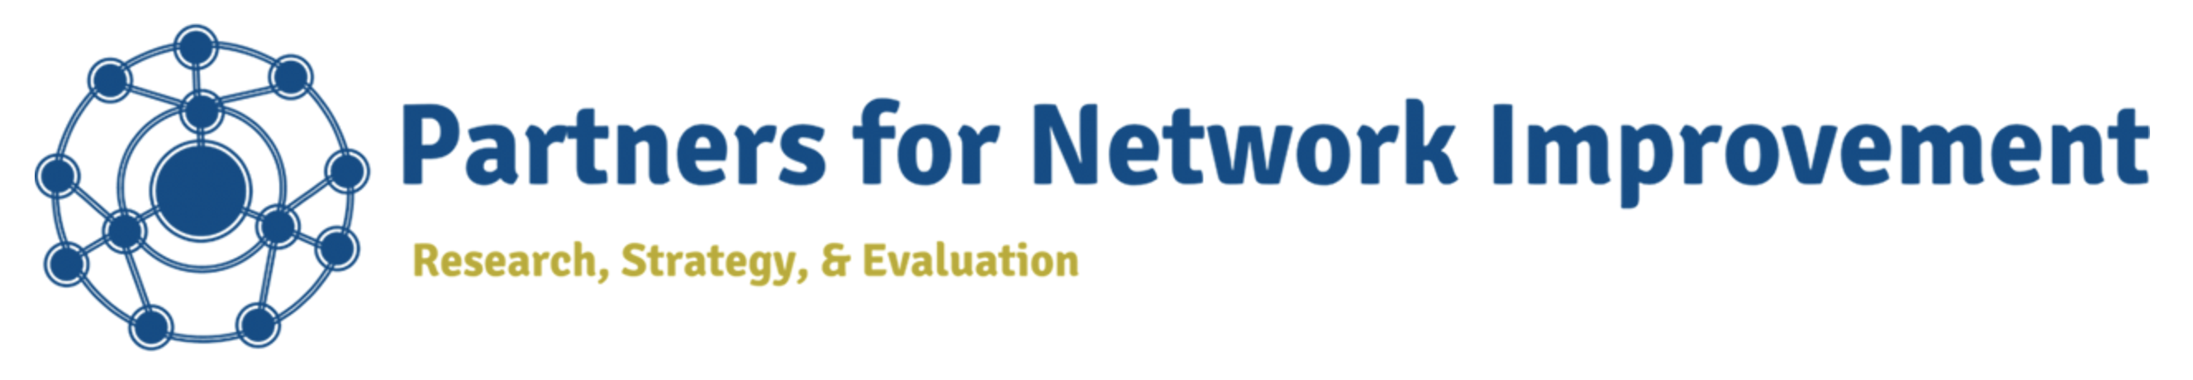 

Learning Research and Development Center  
University of Pittsburgh  
  
  
In collaboration with

