**ISTA 331 Curve-fitting Worksheet Name:**

What is the equation for the dashed curve?

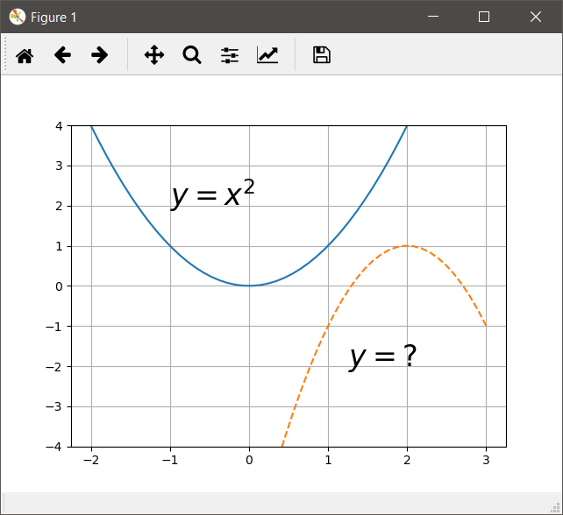

What is the equation for the dashed curve in form $y=a* sin\left(bx+c\right)+d$? What is it in form $y=a* sin\left(b(x+c)\right)+d?$

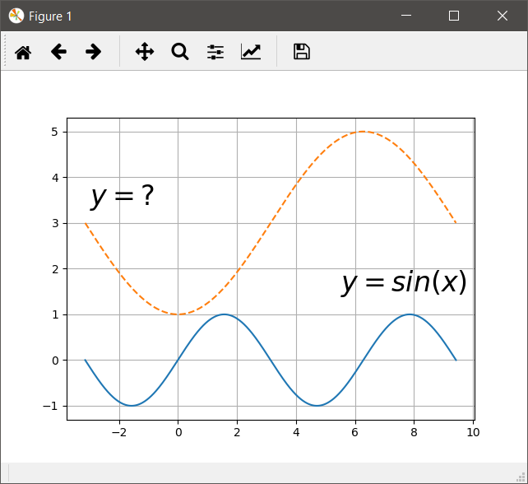

Write a function called get_parabola that takes a list of 2-element lists and returns the a, b, and c coefficients of the best fit parabola in that order. The first element of each inner list is an *x*-coordinate and the second element is the corresponding *y*-coordinate.