**ISTA 331 Curve-fitting Worksheet Name:**

What is the equation for the dashed curve? **y = -2 * (x - 2)**2 + 1**

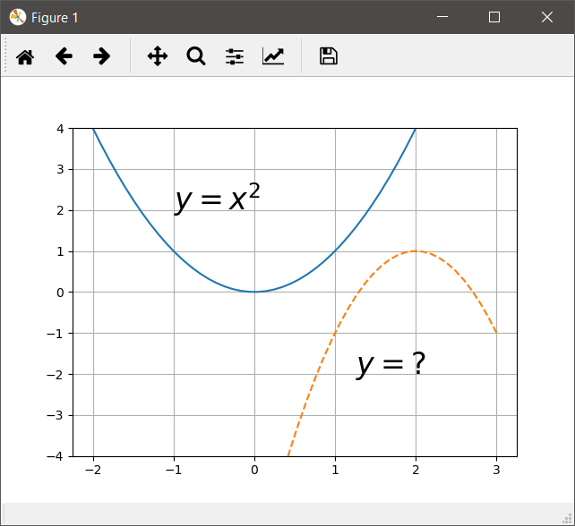

What is the equation for the dashed curve in form $y=a* sin\left(bx+c\right)+d$? What is it in form $y=a* sin\left(b(x+c)\right)+d?$**y = 2 * sin(x / 2 - π / 2) + 3; c = π**

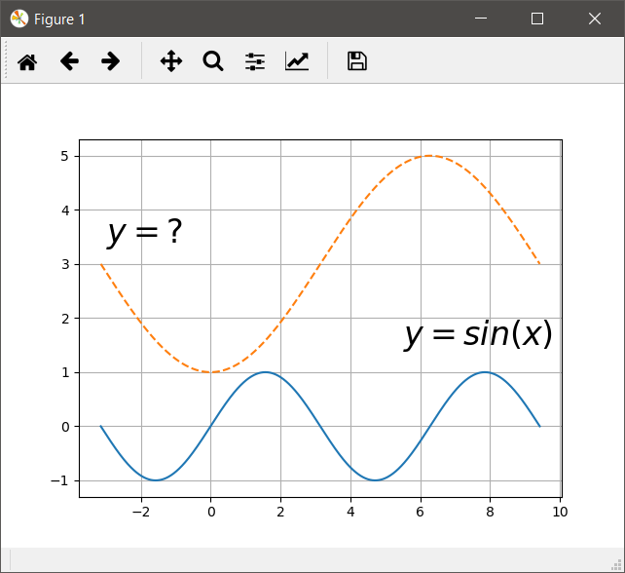

Write a function called get_parabola that takes a list of 2-element lists and returns the a, b, and c coefficients of the best fit parabola in that order. The first element of each inner list is an *x*-coordinate and the second element is the corresponding *y*-coordinate.

**def** get_parabola**(**xy_lst**):**

x **=** np**.**array**([**coords**[**0**]** **for** coords **in** xy_lst**])**

y_lst **=** **[**coords**[**1**]** **for** coords **in** xy_lst**]**

X **=** np**.**column_stack**([**x**,** x**\*\***2**])**

X **=** sm**.**add_constant**(**X**)**

model **=** sm**.**OLS**(**y_lst**,** X**)**

results **=** model**.**fit**()**

# results.params is an array because we fit to a list, not a Series

# order is reversed (sort of) compared to if it was a Series

**return** results**.**params**[**2**],** results**.**params**[**1**],** results**.**params**[**0**]**