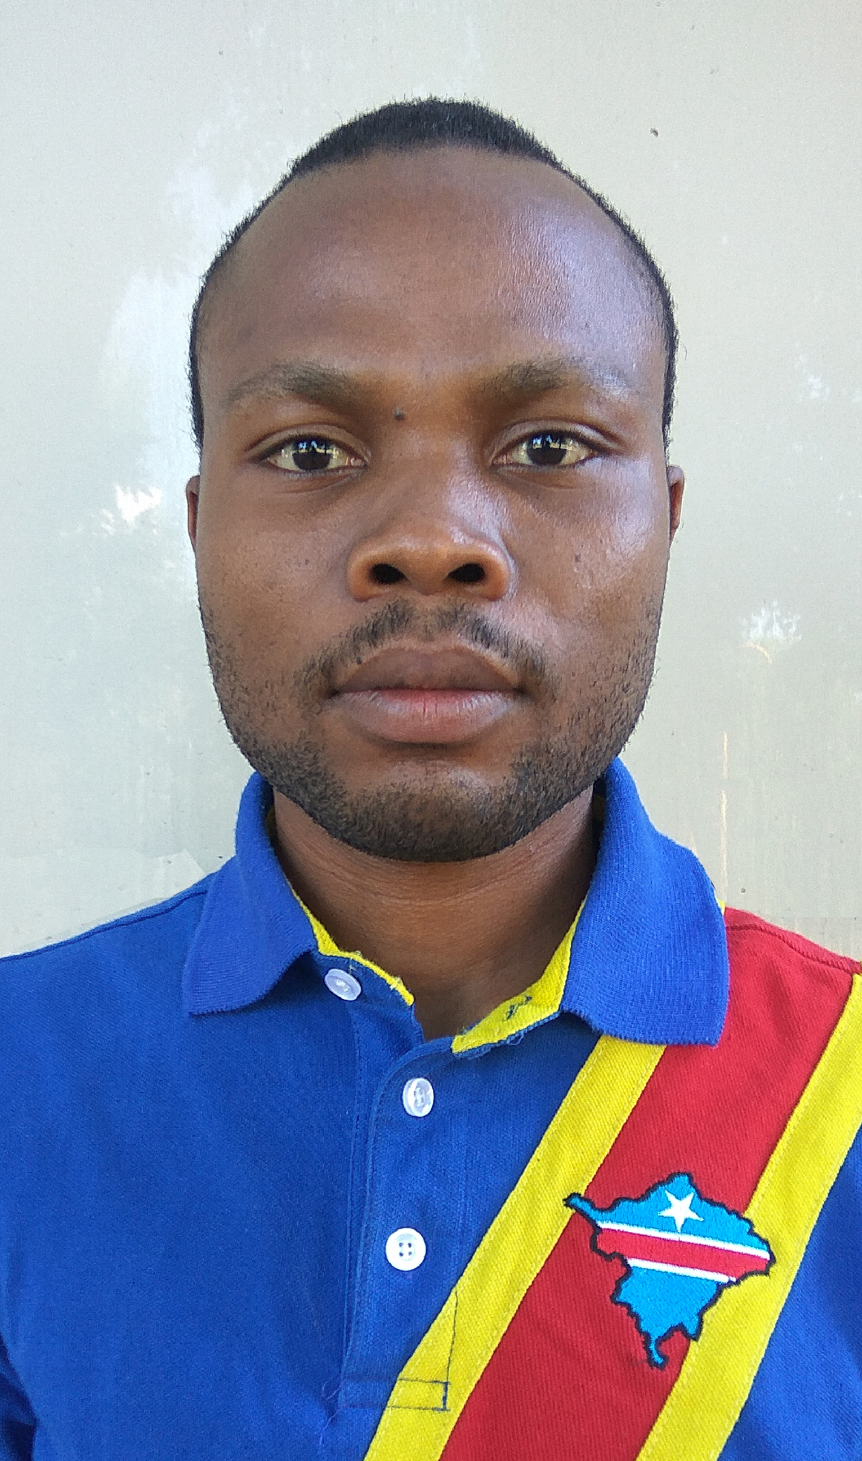

**MPENGELE BISAMBA ERIC**

Date of birth: April 17, 1990 (32 years)

Place of birth: Nyembo-DR Congo

Nationality: Congolese (DRC)

Passport №: OP0548579

Civil status: Bachelor

Sex: Masculine

**Mechatronics and robotics engineer**

PROFILE (Main professional educational program)

**DIPLOMAS Y HOBBIES**

**Formaciones :** Diplomados, Congresos, xxxxxxxxxx xxxxxx xxxxxxxxx xxxxxxxxxxxxxxxxx

**Hobbies:** xxxxxxxxxxxxxxxxxxxxxxxxxxxxxx



EDUCATION

PhD student at Don State Technical University (DSTU).

* PhD subject: Inertial navigation of a mobile robot;
* Specialty: Robots, Mechatronics and Robotics Systems;

Studies of Mechatronics and Robotics Engineering (15.04.06) at Don State Technical University.

* **Master's degree (diploma)** in mechatronics and robotics with **distinction** obtained.
* Obtaining **Two Certificates of participation** in the all-Russian (national) scientific-practical conference, "actual problems of science and technology, 2021 and 2022".

Study of Russian language and additional courses at Don State Technical University, at the preparatory faculty.

**Russian language certificate** obtained.

Electromechanical Engineering Studies at the Higher Institute of Applied Technologies.

**Technician Engineer Diploma** obtained**.**

Secondary School (Studies) in Math-Physics

**State diploma** obtained**.**

**Sept 2022 - 2026**

**Rostov-Russia**

**2020 - 2022**

**Rostov-Russia**

**2019 - 2020**

**Rostov-Russia**

**2010 - 2014**

**Kolwezi-DRC**

**2002 - 2009**

**DRC**

* **Control, information and software of mechatronic and robotic systems.**
* **Maintenance of mechanical and electromechanical systems.**

CONTACT



Location : Rostov on Don, Russia

Phone : +7 (918) 891-92-44

Email : [mpebiser@gmail.com](mailto:mpebiser@gmail.com)

[mpebiser@yahoo.com](mailto:mpebiser@yahoo.com)

[mpebiser@live.fr](mailto:mpebiser@live.fr)





**2020 - 2022**

**Rostov-Russia**

**(DSTU Mech.**

**Lab.)**

**January 2017 - February 2019**

**(2 years and 2 months)**

**Kolwezi-DRC**

**Many works in the field of automation and control**

**(Embedded electronics), which works are**

**defended in conferences.**

* **Technologies and equipment used are: microcontrollers, different controllable motors (servomotor, stepper motor, etc.), several sensors (MEMS);**
* **IDE used are: Cube Max, Arduino, etc.**

**STS / MUMI COMPANY (Glencore's subsidiary)**

**Held position: Maintenance Mechanical fitter**

**Achieved works**: the maintenance of various mechanical equipment of the plant: Horizontal Belt Filters (HBF), Gearboxes (Afromix, Mixtec, etc.), belt conveyors, horizontal and vertical pumps (Samco, Warman, etc.),

PROFESSIONAL EXPERIENCE

C (C++), Python, Matlab, Lua, Assembler

PROGRAMMING LANGUAGE

French

English

Russian

Lingala

Swahili

SPOKENLANGUAGES

SOFTWARE

AutoCAD, SolidWorks, Creo Parametric, Kompas, Matlab, Ms Access,CoppeliaSim

IDE (Integrated development environment)

Html, CSS, Django (Python)

WEB TECHNOLOGIES

Cobalt hydroxide dryers and its various components (Screw feeder, exhaust fan, motorized rotary valves, etc.), as well as horizontal and vertical pumps refurbishment.

**GMB / ABB COMPANY (ABB-Sweden’s subsidiary)**

**Held position: Mechanical (Electromechanical) Supervisor**

**Achieved works**: Wiring, connections of cables on different electrical cabinets, assembly and/or installation of various electrical devices (Circuit breaker, disconnecting switch, compressors, etc.), MV terminating and checking, connections checking, and some drawing modification at the conversion station of Kolwezi.

**TFM COMPANY (Freeport McMoRan Copper & Gold subsidiary)**

**Held position: Professional trainee**

**Achieved works**: Maintenance for different mechanical equipment (pumps, compressors, blowers, gearboxes, etc.

**SNEL COMPANY (National Electricity Company)**

**Held position: Trainee**

**Achieved works**: (New year holiday training) Maintenance and installation of various electrical equipment (cabinet, circuit breaker, capacitor, etc.)

**TFM COMPANY (Freeport McMoRan Copper & Gold subsidiary)**

**Held position: Trainee**

**Achieved works**: (Holiday training) Maintenance for different mechanical equipment (pumps, compressors, blowers, gearboxes, etc.).

**GPM AUTOMOTIVE GARAGE**

**Held position: Trainee**

**Achieved works**: (Holiday training) Vehicles maintenance and repair.

**March 2015 - November 2016 (≈ 2 years)**

**Kolwezi-DRC**

**March 2014 - May 2014**

**(2 months)**

**Fungurume-DRC**

**December 2013**

**(1 month)**

**Kolwezi-DRC**

**March 2013 - May 2013**

**(2 months)**

**Fungurume-DRC**

**April 2012**

**(1 month)**

**Kolwezi-DRC**

PROFESSIONAL EXPERIENCE

Arduino, Cubemax, Processing, Proteus, Pycharm, CodeBloacks, Visual studio code, Matlab

**I under sign on my honor that supplied information given above are sincere and exact.**

Russia-Rostov on Don, Thursday, August 3, 2023

**Mpengele Bisamba Eric**

