Checkout flow and triggers
OrderService coordinates checkout through a process manager. Web starts checkout over HTTP; requests and replies between services travel through RabbitMQ. Each reply triggers a small handler that saves progress and requests the next step. Inventory must reserve and confirm stock before the order is confirmed and the basket is cleared.
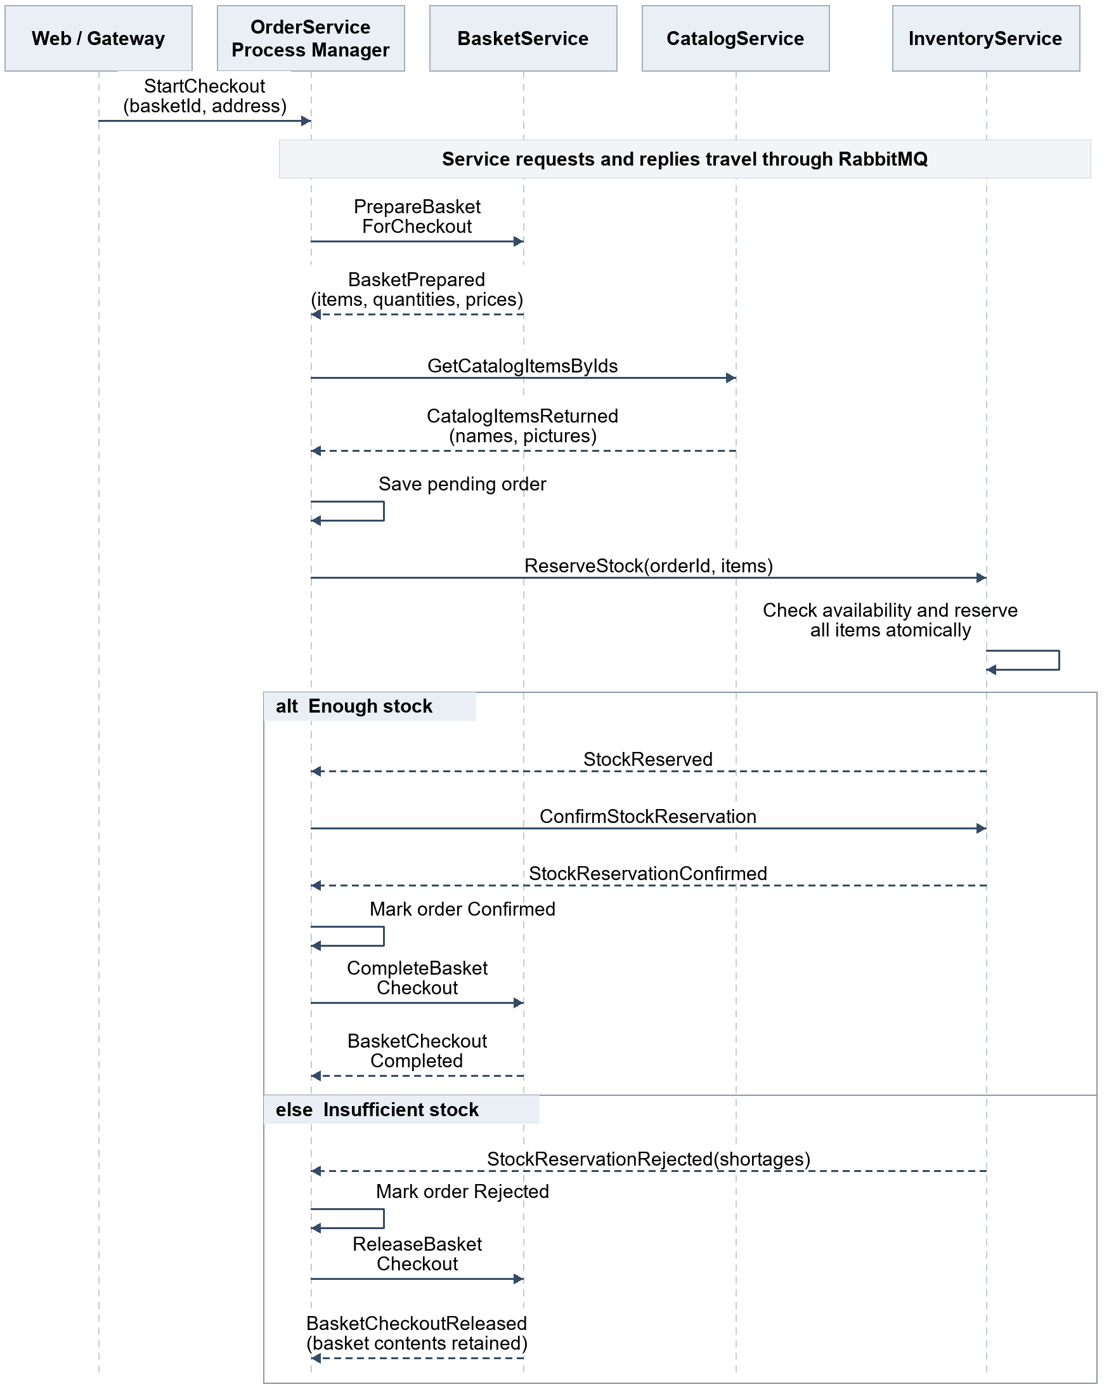

Triggers in OrderService
These handlers belong to the OrderService process manager. Basket, Catalog, and Inventory each handle the requests addressed to them and reply to OrderService; they do not trigger the next service directly.
Trigger | What its handler does
StartCheckout | Saves checkout progress and requests basket preparation
BasketPrepared | Saves the basket snapshot and requests catalog details
CatalogItemsReturned | Saves the pending order and requests stock reservation
StockReserved | Requests reservation confirmation
StockReservationConfirmed | Confirms the order and requests basket cleanup
BasketCheckoutCompleted | Marks checkout completed
A rejection | Starts the appropriate failure/release flow

Essential implementation rules
- UI: Return 202 Accepted with a checkout ID. Web shows processing and polls status through HTTP. The pending order provides the order ID required by Inventory; it is not yet a successful purchase.
- Progress and duplicates: Use separate handlers, persist progress, and carry the same checkout ID through the flow. Save each state change and its outgoing message together using an outbox. Retries must not create another order or reserve stock twice.
- Basket and stock: Prepare a stable basket snapshot. Inventory checks and reserves all lines in one transaction. Basket prices/quantities and Catalog names/pictures become order snapshots.
- Failure: If checkout is cancelled after stock may have been reserved or confirmed, request stock release and wait for confirmation before finalizing failure. Unlock the basket without clearing its contents. A timeout alone does not prove that an operation failed.
- After order confirmation: Basket cleanup can retry in the background; it must not cancel the order or release its stock. Web can show purchase success once the order is confirmed.
- Retries and dead letters: Use bounded technical retries and a dead-letter queue for unprocessable messages. Insufficient stock is a normal rejection reply. A dead-lettered message does not automatically cancel checkout or release stock.

