Bibliometric Analysis: Matthew A. Peeples

Matthew A. Peeples

2025-02-15

## 

## Introduction

This document contains bibliometric and citation analyses for the published work of Matthew Peeples. This information was prepared for the purposes of consideration for academic promotion. The data used here come directly from Google Scholar and Scopus and were scraped (2/15/2025) using the Harzing Publish or Perish Windows application and the R package ‘scholar’. All of the data and raw code used in this document can be viewed on Github here: <https://github.com/mpeeples2008/PeeplesCitation>. Note that I have been at ASU since 2015 and received tenure and was promoted in 2019 (submitted review in 2018). These data are current up to 2024 which is the last full year available at the time of writing.

## 

## Google Scholar Citations Per Year

The plot below shows the number of citations I have received per year up to 2024, with the pre- and post-tenure intervals indicated. Note that the number of annual citations has generally shown an upward trajectory. The large peak in 2023 is associated with my co-edited *Oxford Handbook of Archaeological Network Science* which included 42 chapters explicitly focused on archaeological networks and included a large number of citations to my work. Although the book was officially released in 2024 the online version was first made available in December 2023 and thus, Google Scholar counts those citations in 2023.

As of 2/15/2025 my work has been **cited 2,945 times** with an **h-index of 30** and an **i10-index of 51**. At the time of my last review for tenure I had **717 citations** with a **h-index of 15**. This trajectory suggests that citations and apparent impact have both increased substantially since tenure.

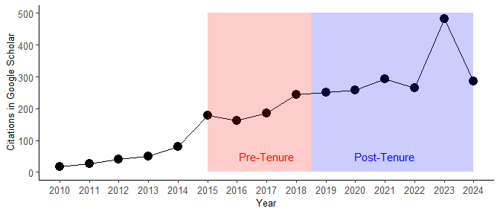

## Journal Impact Factors

Next, I explore the Scopus impact factors/percentiles for journals in which I have published through time. In order to do this, I created a file of all of my journal publications that have Scopus CiteScores and recorded both the CiteScore and the highest percentile by field/area for each journal. The vast majority of my publications through time have appeared in highly ranked journals. All but one of my publications are in journals in the **top quartile** by field and **84% are in the top 10% of journals by field**. Given the consistency with which I have published in highly ranked journals there is little room for improvement through time but, as the boxplots below illustrate, there is a trend toward my publications narrowing to the most highly ranked journals by field in my time at ASU and post-tenure.

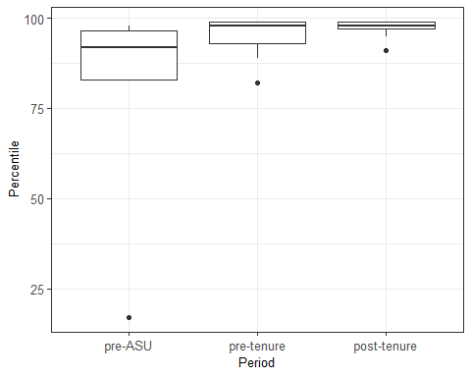

## 

## Citations and Publication Reach

In order to document the expanding reach of my research since I earned tenure, I used Publish or Perish to scrape and download information on all papers that have cited my work since my first publication in 2003. I then cleaned and checked these data (in particular adding years where they were absent) and added two additional variables: Academic Field and Language. These represent the general academic field in which a citing publication falls and the original language in which it was published. Languages were automatically detected using the Google “Language Detect” tool. Academic field was determined based on the primary field for a given publication in Scopus and where this was not available, based on my own assessment of the publication content or title.

The plots below show the proportion of publications per year since I arrived at ASU that fall into academic fields outside of anthropology and archaeology (top) and publications appearing in languages other than English (bottom). Note that there are pronounced increases in both non-Anthropology/Archaeology citations and non-English citations in recent years, demonstrating the increasing reach of my research.

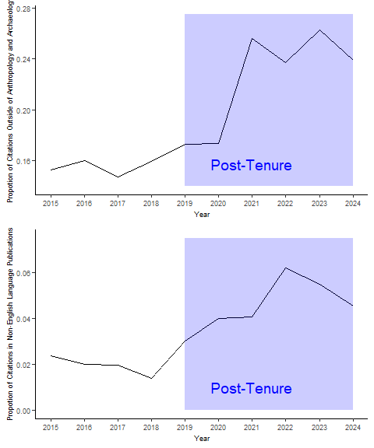

In order to dig into this a little further, I display a chart with the fields (other than Anthropology and Archaeology) for publications citing my work. As this shows, my work is being recognized and used by researchers in the computational, social, and environmental sciences in particular. I have received a few additional citations in fields like education, health science, library science, cognitive science, mathematics, and political science largely based on methodological contributions of my research.

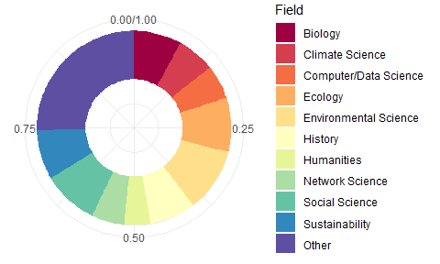

The chart below shows the languages of non-English publications that cite my work. As of 2024, my work has been cited in 18 different languages, in particular in Spanish and French. The “other” languages representing only one citation each are Arabic, Czech, Dutch, German, Indonesian, Norwegian, Polish, Serbian, and Swedish. This illustrates that my publications are beginning to be recognized broadly across the world.

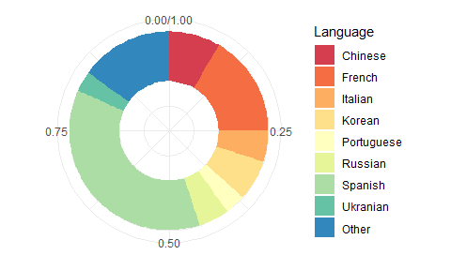

## Co-Authorship Network

One additional way of looking at the impact and reach of my publications is exploring my co-authorship network. In order to do this, I scraped all of my “coauthor” data from Google Scholar using the ‘scholar’ package. Note that this package will only locate co-authors who have an active Google Scholar profile. The resulting data are shown below as an ego network focused on me. Note that there are many distinct sub-groups in this network that are only connected via their path through me. Indeed, the transitivity of this network is relatively low at **0.105** indicating an ego centered network with substantial structural holes (gaps in network structure). Although this sample is somewhat limited, the results here illustrate my key role as a “broker” and collaborator connecting many communities of scholars who would otherwise be disconnected.

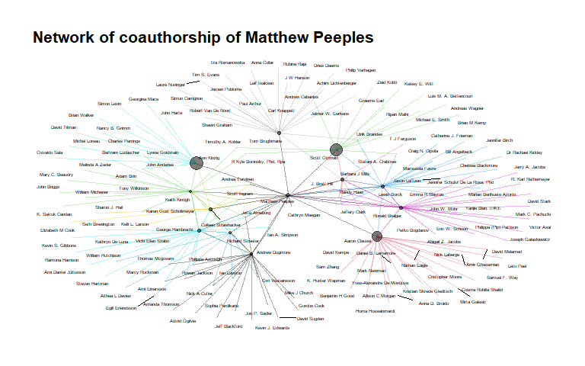

## International Collaborations and Impact

In order to illustrate my international profile as a researcher I provide a map showing the worldwide distribution of my collaborators. As this map shows, I have collaborators across the US as well as many in Europe. This map was generated by manually compiling the cities/affiliation for my co-authors, including only the interval since I started my position at ASU.

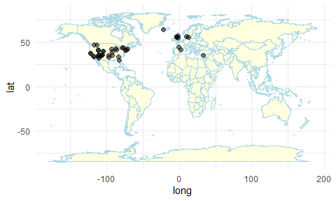

In addition to looking at my publications, it is also instructive to look at the use of online resources I have created. For example, according to Google Analytics data scraped using the ‘googleAnalyticsR’ package, the online companion to my book *Network Science in Archaeology* available at <https://book.archnetworks.net> has received **6,823 unique visitors** since the book was released from more than **100 different countries**. The table below shows information on unique visits and active users by country for the top 20 counties represented. This list shows that my work is being used by researchers across the world.

## country activeUsers newUsers sessions screenPageViews  
## 1 United States 1745 1814 3149 4538  
## 2 United Kingdom 479 512 1104 1553  
## 3 Germany 322 329 830 1193  
## 4 Japan 291 294 441 613  
## 5 Italy 249 264 573 864  
## 6 Canada 240 259 585 1158  
## 7 France 228 237 423 633  
## 8 Spain 201 205 609 1264  
## 9 Netherlands 193 195 424 617  
## 10 South Korea 177 180 286 348  
## 11 China 151 140 292 368  
## 12 Brazil 135 133 225 272  
## 13 Australia 133 137 282 366  
## 14 Switzerland 114 119 183 280  
## 15 India 110 105 147 172  
## 16 Denmark 105 114 349 571  
## 17 Austria 101 103 156 182  
## 18 Mexico 88 96 335 426  
## 19 Finland 87 88 265 564  
## 20 Sweden 81 82 122 132