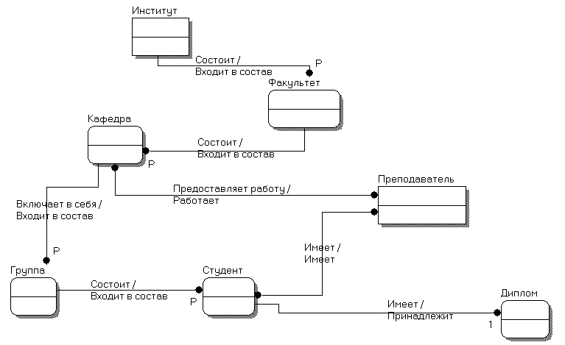

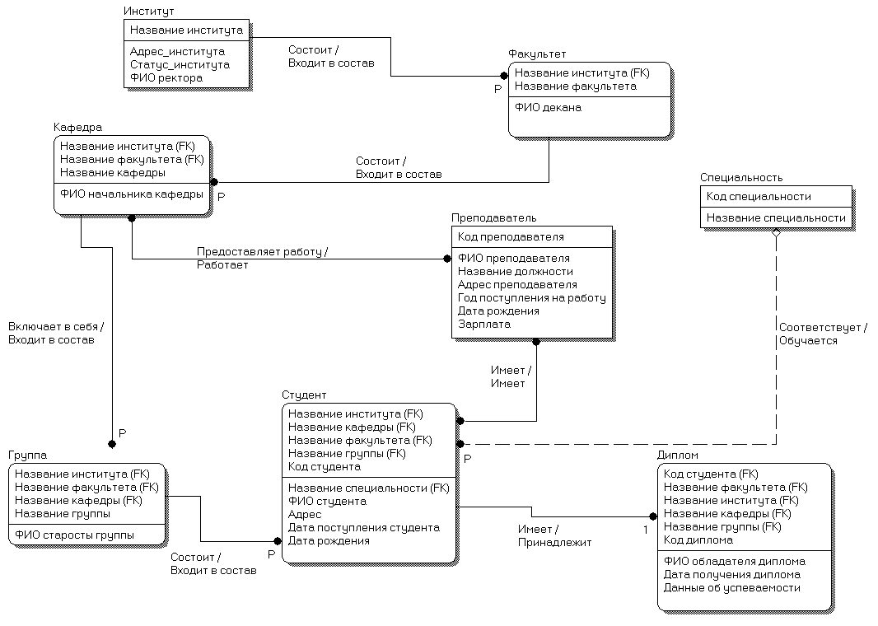

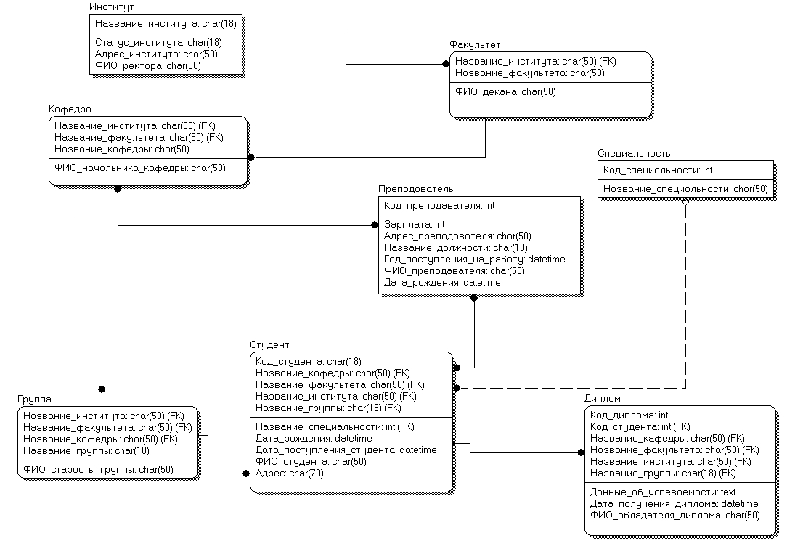

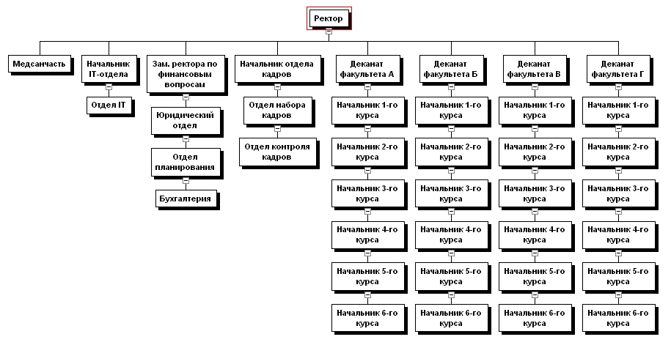

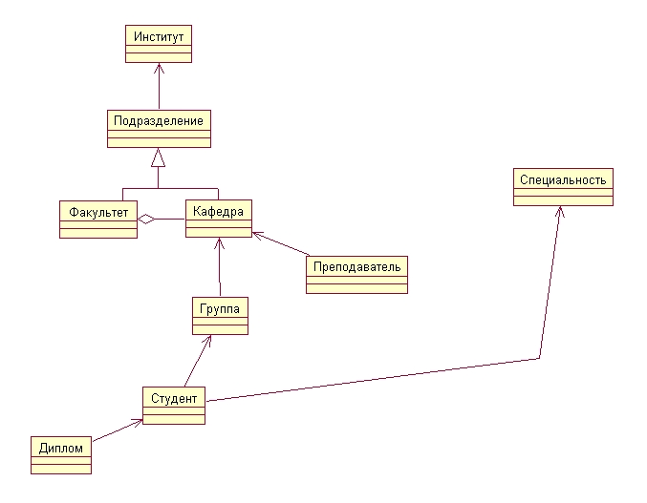

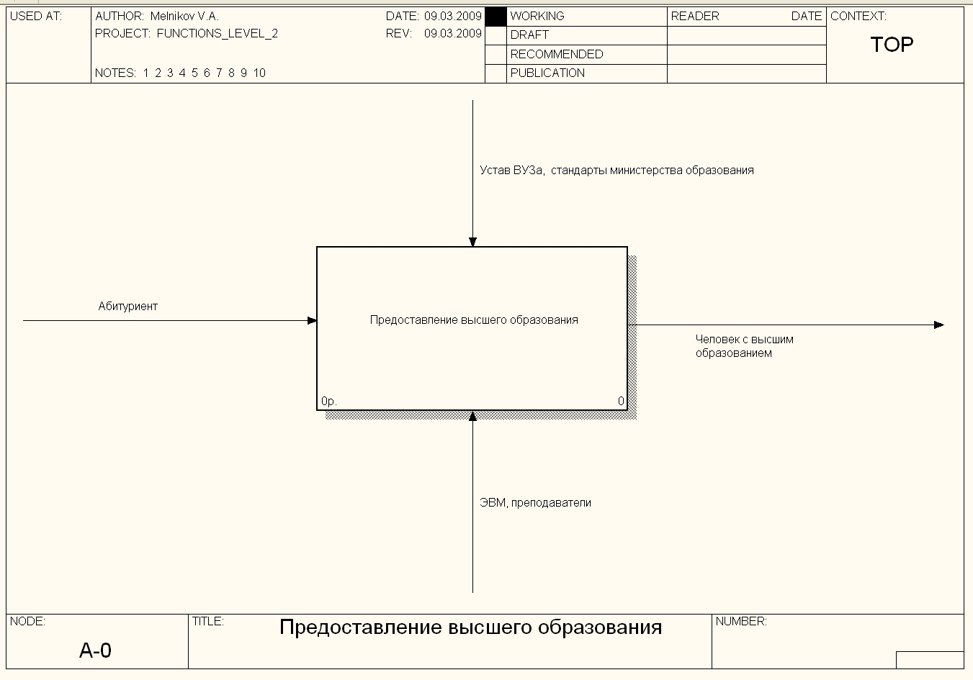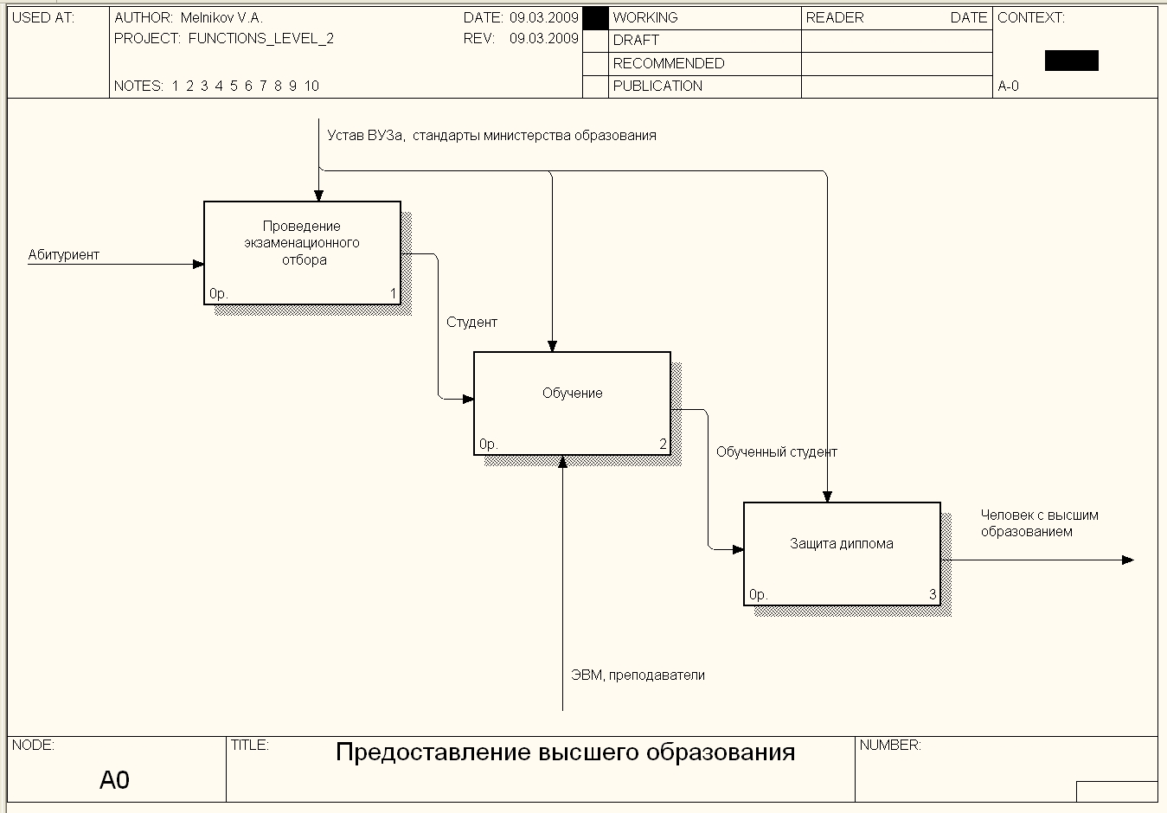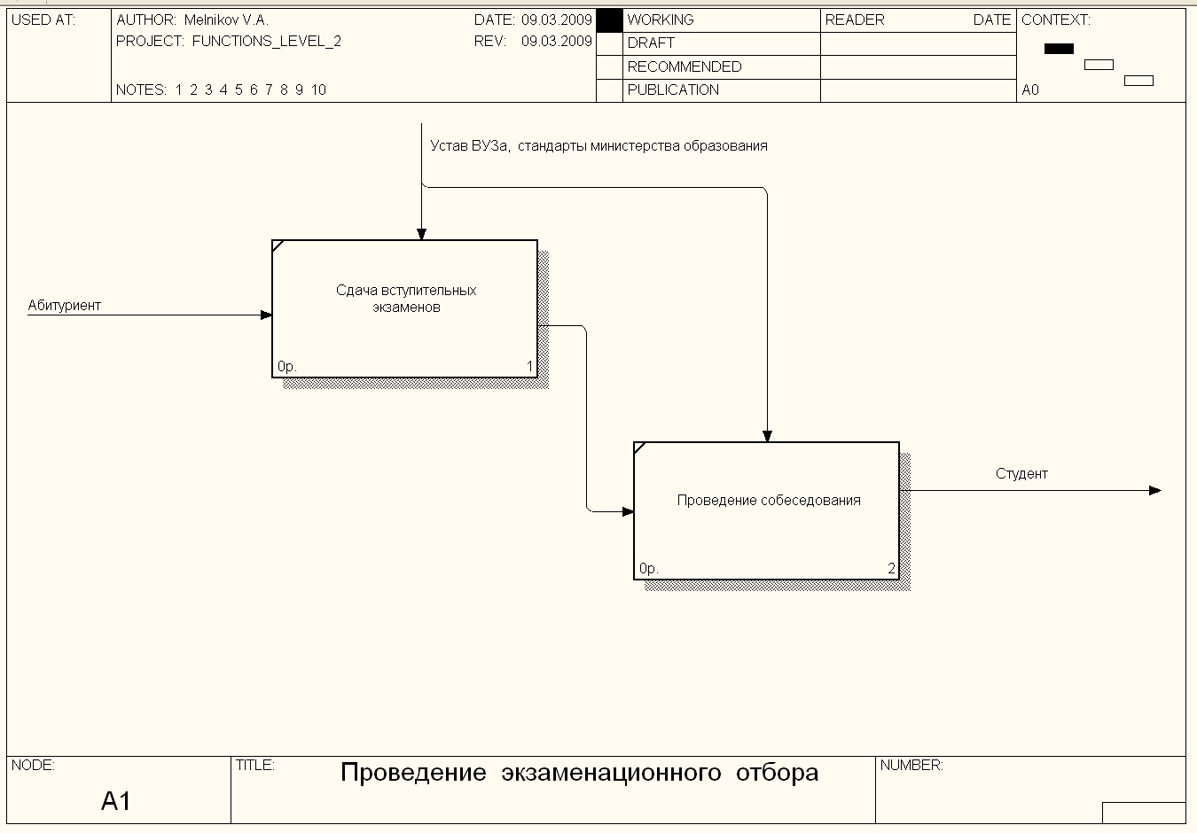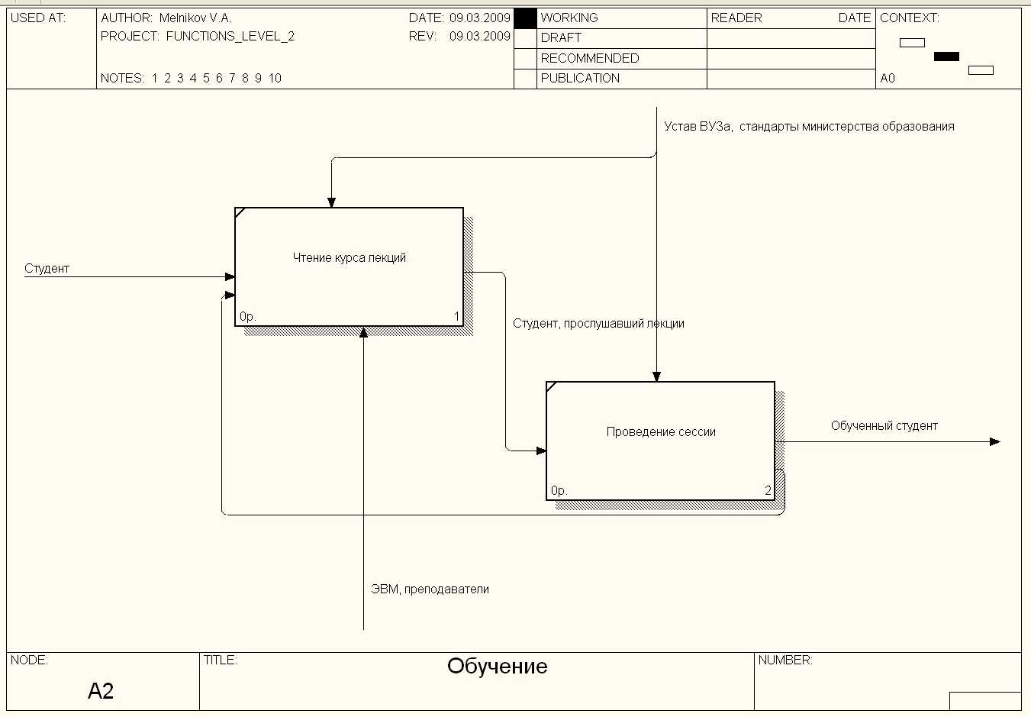

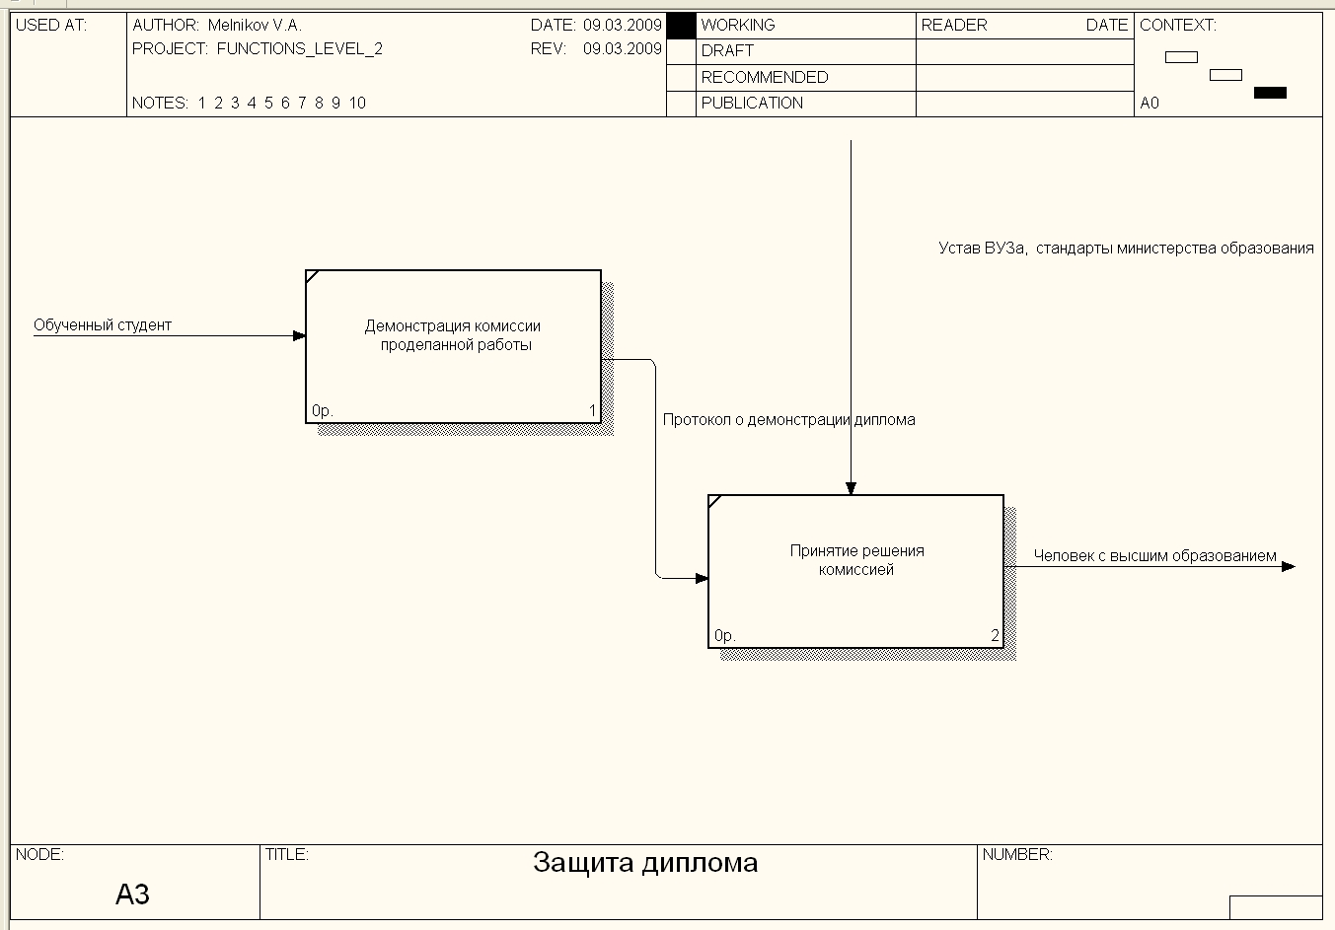

CREATE TABLE institut

(

nazvanie VARCHAR(50) PRIMARY KEY,

status VARCHAR(50) NOT NULL,

fio_rektora VARCHAR(50) NOT NULL

)

CREATE TABLE fakultet

(

nazvanie VARCHAR(50) PRIMARY KEY,

fio_dekana VARCHAR(50) NOT NULL,

nazvanie_insituta VARCHAR(50) NOT NULL

)

CREATE TABLE kafedra

(

nazvanie VARCHAR(50) PRIMARY KEY,

fio_nachalnika VARCHAR(50) NOT NULL,

nazvanie_insituta VARCHAR(50) NOT NULL

nazvanie_fakulteta VARCHAR(50) NOT NULL

)

CREATE TABLE prepodavatel

(

kod INT PRIMARY KEY IDENTITY,

fio VARCHAR(50) NOT NULL,

zarplata INT NOT NULL,

adres VARCHAR(50) NOT NULL,

nazvanie_dolzhnosti VARCHAR(50) NOT NULL,

data_post DATETIME NOT NULL,

data_rojd DATETIME NOT NULL

)

CREATE TABLE specialnost

(

kod INT PRIMARY KEY,

nazvanie VARCHAR(50) NOT NULL

)

CREATE TABLE gruppa

(

nazvanie VARCHAR(50) PRIMARY KEY,

nazvanie_insituta VARCHAR(50) NOT NULL,

nazvanie_fakulteta VARCHAR(50) NOT NULL,

nazvanie_kafedry VARCHAR(50) NOT NULL,

fio_starosty VARCHAR(50) NOT NULL,

)

CREATE TABLE student

(

kod INT PRIMARY KEY IDENTITY,

fio VARCHAR(50) NOT NULL,

nazvanie_insituta VARCHAR(50) NOT NULL,

nazvanie_fakulteta VARCHAR(50) NOT NULL,

nazvanie_kafedry VARCHAR(50) NOT NULL,

nazvanie_gruppy VARCHAR(50) NOT NULL,

kod_spec INT NOT NULL,

data_rojd DATETIME NOT NULL,

data_post DATETIME NOT NULL,

adres VARCHAR(50) NOT NULL

)

CREATE TABLE diplom

(

kod INT PRIMARY KEY IDENTITY,

kod_studenta INT NOT NULL,

uspevaemost TEXT NOT NULL,

data_poluch DATETIME NOT NULL

)