Table of Contents
  THE IMPACT OF ONLINE SERVICES(BANKING) ON THE CONSUMER  Phase 3 Final Report | NAME: Londeka  SURNAME: shabangu  GRADE:12  school:

Contents
Table of Contents 2
Table of Figures 3
1. Introduction 4
2. Task Definition 4
3. Focus Question 4
4. Discussion and Analysis 5
4.1 Digital Trends and Accessibility in South Africa 5
4.2 Modern Fraud and Financial Security 5
4.3 Technological Literacy Gap 6
4.4 Benefits and Disadvantages of Online Banking 7
5. Findings 8
Finding 1: Online banking is expanding rapidly 8
Finding 2: Online banking improves convenience but does not guarantee equal accessibility 8
Finding 3: Consumer behaviour is a major part of banking security 8
Finding 4: The shift away from physical branches creates additional pressure for some consumers 8
6. Conclusion 8
7. Recommendations 9
7.1 Improve Digital Literacy 9
7.2 Increase Consumer Awareness of Fraud 9
7.3 Support Consumers with Limited Connectivity 9
7.4 Provide Support for Elderly Consumers 9
7.5 Maintain Strong Technical Security 9
8. Bibliography 9
9. Appendices 10
Appendix A: Folder Structure 10
Appendix B: Learner Declaration of Authenticity 10

1. Introduction
In 2026, online banking has become an important part of everyday financial activity in South Africa. Banking services that previously required a visit to a physical branch can now be accessed through smartphone applications, web portals and USSD services. This shift has increased convenience for many consumers, but it has also created new concerns about financial security and equal access.
This investigation focuses on the Johannesburg metropolitan area and examines whether the move towards digital-first banking benefits different consumer groups equally. The research considers the advantages of online banking, including convenience, 24/7 availability and potentially lower transaction costs, while also examining barriers such as cyber-fraud, unreliable connectivity, mobile-data costs and differences in digital literacy.
The investigation is particularly relevant to young adults entering the workforce, elderly consumers who may be moving away from branch-based banking, and small business owners who increasingly use digital payments. The purpose is not simply to determine whether online banking is useful, but to assess the extent to which it is secure and accessible for consumers with different circumstances.

2. Task Definition
The current situation is that banking in South Africa is increasingly moving from physical branches to digital channels. While this transition can make financial services faster and more convenient, it can also exclude consumers who have limited internet access, expensive data, low digital literacy or concerns about online security. The investigation therefore evaluates the socio-economic impact of online banking on Johannesburg residents, with particular attention to financial security and accessibility.
The investigation uses credible secondary sources, including information from SABRIC, the Gauteng City-Region Observatory (GCRO), ITWeb, Financial Mail, The Citizen, Daily Investor, EY South Africa, the Department of Communications and Digify Africa. The research process also included plans for primary data collection through a questionnaire, analysis in Microsoft Excel and comparison of bank information in Microsoft Access. The final report interprets the available information and presents findings and recommendations for consumers.
The target audience is the general consumer base of Johannesburg, especially young adults entering the workforce, elderly consumers transitioning away from physical branches, and small business owners.

3. Focus Question
To what extent does the transition to online banking in 2026 impact the financial security and accessibility of diverse consumer groups within the Johannesburg metropolitan area?

4. Discussion and Analysis

4.1 Digital Trends and Accessibility in South Africa
The research indicates that the growth of digital banking has not automatically resulted in equal access. The GCRO research recorded in the investigation states that only 46% of households in Gauteng have a home internet connection. This highlights a significant digital divide between consumers who have reliable connectivity and those who depend more heavily on mobile data.
The research also identified mobile-data cost as a barrier. The investigation records mobile data costs of approximately R85 per GB in some township contexts. For students, unemployed consumers and lower-income households, repeated use of banking applications can therefore become an additional cost. This means that the availability of a digital banking service does not necessarily mean that every consumer can use it easily or affordably.
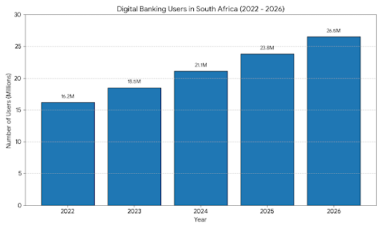
Figure 1: Digital banking users in South Africa (2022–2026), as included in the research document.
The graph included in the research document shows a rise in the number of digital banking users from 16.2 million in 2022 to 26.5 million in 2026. This supports the broader finding that digital banking is becoming increasingly important in South Africa.

4.2 Modern Fraud and Financial Security
Online banking creates convenience, but security remains a major concern. The research based on SABRIC information states that digital banking fraud accounts for 65.3% of financial crime in South Africa and that many cases involve social engineering rather than a direct attack on the bank's systems. This is important because it shows that consumer awareness is a major part of online banking security.
The investigation also found that fraud is evolving beyond traditional phishing. The research discusses the use of artificial intelligence to create convincing content and clone voices, making it harder for consumers to recognise fraudulent communication. Banks are also introducing measures such as biometric authentication and AI-supported fraud detection, but these technologies do not remove the need for consumers to recognise suspicious requests and protect their personal information.
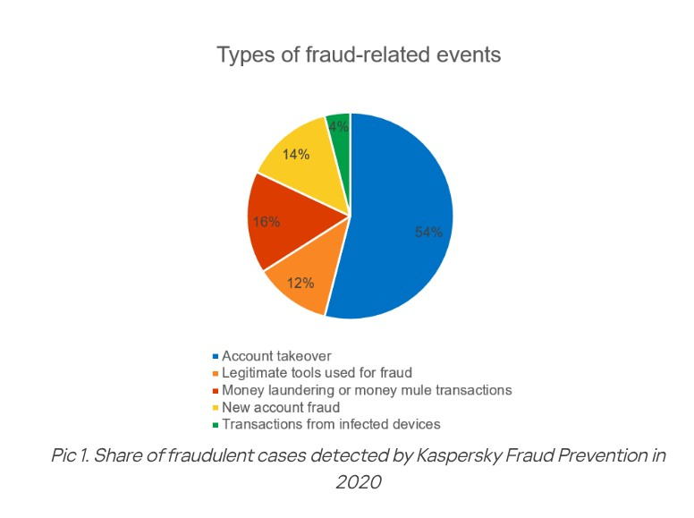
Figure 2: Types of fraud-related events, as included in the research document.

4.3 Technological Literacy Gap
Another important issue identified in the research is the technological literacy gap. As banking applications introduce more features such as biometric authentication, artificial-intelligence tools and digital payment functions, some consumers may find the interfaces difficult to understand.
Elderly consumers are particularly important in this discussion because some may have less experience with digital banking and may feel uncertain about making transactions through an application. A consumer who is afraid of making a mistake may depend on another person for assistance, which can create additional risks if private banking information is shared.
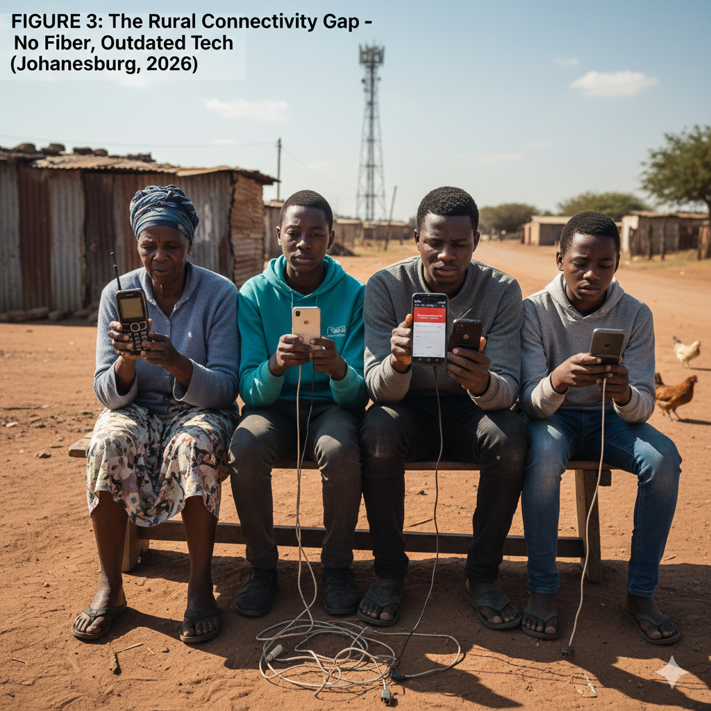
Figure 3: The rural connectivity gap, as included in the research document.

4.4 Benefits and Disadvantages of Online Banking
Disadvantages | Advantages
Security risks: phishing and social-engineering scams can target consumers and their authentication information. | 24/7 availability: consumers can perform many banking activities without visiting a branch.
System outages: banking access can be affected when bank systems or networks are unavailable. | Convenience: digital transactions can reduce the need to travel and wait in queues.
Hidden costs: smartphones and mobile data can be a barrier where services are not zero-rated. | Potentially lower costs: some digital services have lower or no monthly fees compared with traditional options.

5. Findings

Finding 1: Online banking is expanding rapidly
The research shows substantial growth in digital banking. Approximately 26.5 million South Africans were identified as active digital banking users in early 2026, and the market was described as growing at nearly 20% annually. The research also states that 9 out of 10 urban consumers prefer an application to a teller for everyday tasks. This demonstrates the increasing importance of digital banking in consumer financial behaviour.

Finding 2: Online banking improves convenience but does not guarantee equal accessibility
Digital banking allows consumers to transact through smartphone applications, web portals and USSD. These channels can reduce travel and waiting time and can make financial services available around the clock. However, the 46% home-internet figure recorded in the research and the identified mobile-data costs show that access to a service is not the same as equal ability to use it.

Finding 3: Consumer behaviour is a major part of banking security
The research indicates that many digital banking fraud cases involve social engineering, where criminals manipulate people into revealing information. This means that technical security measures such as biometrics and fraud-detection systems need to be supported by consumer awareness and digital literacy.

Finding 4: The shift away from physical branches creates additional pressure for some consumers
The research records a 42% reduction in physical bank branches since 2017 and associates branch closures with difficulties for approximately 3.9 million unbanked or elderly adults. For consumers who prefer face-to-face assistance, the move to digital banking can therefore increase feelings of exclusion and dependence on others.

6. Conclusion
The investigation indicates that the transition to online banking has had a significant impact on consumers in the Johannesburg context. Online banking improves convenience, reduces the need for physical branch visits and provides access to financial services through several digital channels. The growth in digital banking users shows that these services are becoming an increasingly important part of everyday financial activity.
However, the transition also creates unequal experiences. Consumers with reliable internet access, suitable devices and strong digital skills are better positioned to benefit from digital banking. Consumers affected by high data costs, poor connectivity, limited digital literacy or discomfort with technology may experience greater barriers. Financial security is another major concern because social engineering and other fraud methods can target consumers directly.
Overall, the evidence suggests that online banking can improve financial accessibility, but its benefits are not automatically shared equally by all consumer groups. The transition will have a more positive impact when digital services are supported by affordable access, clear user education and strong security awareness.

7. Recommendations

7.1 Improve Digital Literacy
Banks, schools and community organisations should provide simple digital-literacy education covering the use of banking applications, safe passwords, phishing awareness, OTP protection and how to report suspicious activity.

7.2 Increase Consumer Awareness of Fraud
Consumers should be reminded not to disclose passwords, PINs or OTPs to people who contact them unexpectedly. Banking messages and links should be checked carefully, particularly when a message creates urgency or asks for confidential information.

7.3 Support Consumers with Limited Connectivity
Digital banking providers should continue considering consumers who rely on mobile data or have unreliable connectivity. Accessible channels such as USSD and appropriately designed low-data services can help reduce exclusion.

7.4 Provide Support for Elderly Consumers
Banks should provide clear instructions, demonstrations and assistance for elderly consumers moving from branch-based banking to digital services. Support should help users become independent rather than encouraging them to give their banking credentials to other people.

7.5 Maintain Strong Technical Security
Banks should continue investing in measures such as biometrics, two-factor authentication and AI-supported fraud detection. Technical controls should complement, rather than replace, consumer education.

8. Bibliography
BusinessTech Staff. 2026. BusinessTech South Africa, Banking. 22 January 2026. Accessed 13 February 2026. https://businesstech.co.za/news/banking/849978/
SABRIC (South African Banking Risk Information Centre). 2025/2026. Annual Crime Statistics / media statement. Accessed 10 February 2026. https://www.sabric.co.za/media-statement-2024-stats/
South African Banking Risk Information Centre (SABRIC). Annual Crime Statistics report material recorded in the research document. Accessed February 2026.
Gauteng City-Region Observatory (GCRO). 2025. Map of the Month: The Digital Divide in Gauteng. Released 29 December 2025.
ITWeb South Africa. 2026. AI reshapes South African banks' investment priorities. Author: Admire Moyo. Published 11 February 2026.
Financial Mail. 2026. The PayShap Revolution transforming the informal economy. Published February 2026.
The Citizen. 2026. Capitec vs The Big Five 2026. Published February 2026.
Minnaar, K. 2026. South Africa kisses cash goodbye. Daily Investor. Date and URL as recorded in the learner's research document.
EY South Africa. 2025/2026. Biometrics and Future Payments. EY Insights.
Department of Communications. 2025–2027. Digital Transformation Roadmap. Government of South Africa.
Digify Africa. 2026. Digify Bytes: Digital Literacy for All. Digify Academy.
Redlinghuis, A. South African Journal of Information Management. 2026 content, as recorded in the learner's research document.

9. Appendices

Appendix A: Folder Structure
Insert a screenshot/diagram of your actual Phase 3 PAT folder structure here. The screenshot should show the report, website files and associated resources.

Appendix B: Learner Declaration of Authenticity

