ParametricOptimizableBeam – ToDos – 07.11.2019

1. how mass (and more importantly outrigger → point mass) is handled in: total mass calculation, effective modal mass calculation (neglected) (and mass taken from mid element ↔ DoF value from node), optimization to target mass

source → model → structure_model.py
- get_mass()
- calculate_total_mass()
- apply_point_values()
- decompose_and_quantify_eigenmodes()
- write_properties() and plot_properties()

source → model → structure_model.py
- adjust_density_for_target_total_mass()

2. outrigger (and generically point) stiffness entry → probably add increment to corresponding rotational DoF as well

source → model → structure_model.py
- get_stiffness()
- apply_point_values()
- decompose_and_quantify_eigenmodes()
- write_properties() and plot_properties()

3. relative shear → probably derive a hybrid element from the Timoshenko where Py and Pz are parametrized (with the help of some shape/distribution functions)

4. possible problems due to above and optimization for sway
caarc → turb → 0_000 → CaarcBeamIntOut → 60:
- mass seems to be also reduced drastically for upper part (check)
- Iy gets smaller than Iz (similar Py and Pz)
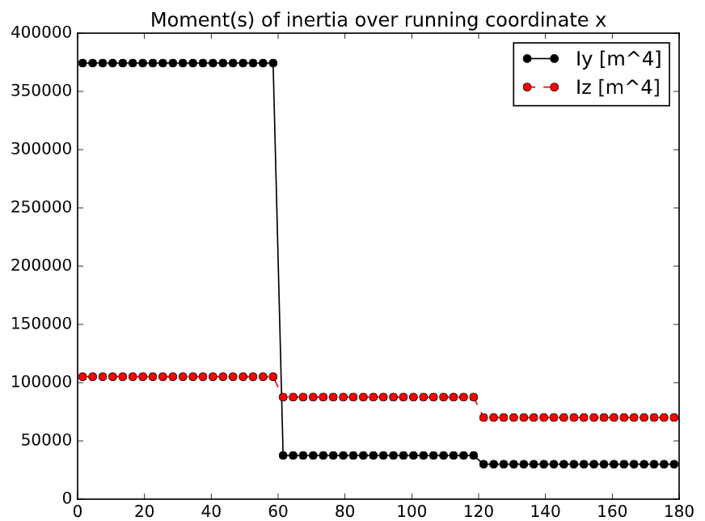
- in identification of eigenmodes → eff total mass probably is wrong (point mass not included, see above)
- why are shear areas Asy and Asz different? Check definition

5. observations in time series
- peak in reaction DoF 1 & 0 (2) (y & x (z) component) (sometimes also moments → such as for 45 degrees) → at around 30-45s → probably due to ramp-up (take out of statistical evaluation
- modifications in source → postprocess → writer_utilities and plotter_utilities: add also DoF number correspondent (0: x, 1: y, 2:z, 3:a, 4:b, 5:g → easier to identify based upon local axis with letters when looking at results)

6. observations in xy plots of displacement and accelerations
- for Caarc 0 & 90 degree + turbulence + damping 0.025 → the displacement jump at the beginning
- for Caarc 90 degree + NO turbulence + damping 0.025 → the displacement jump at the beginning
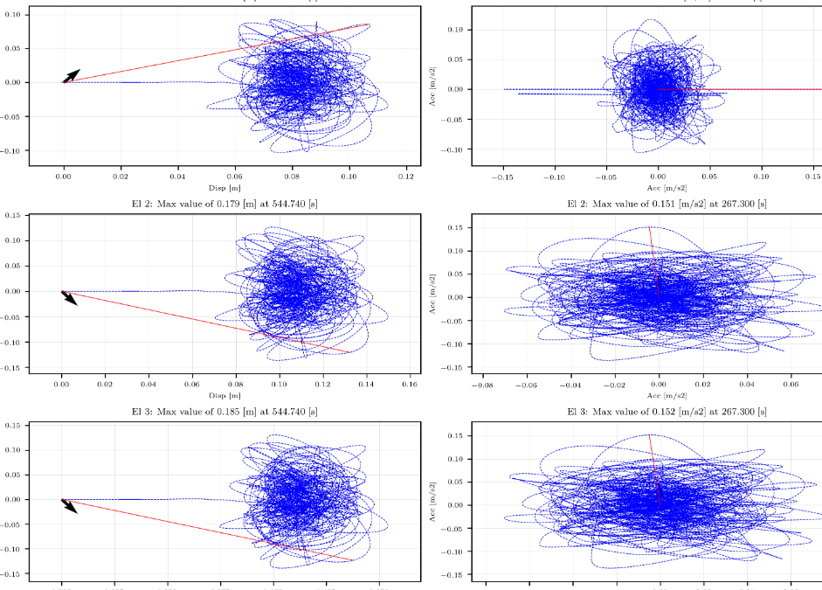
7. St-number for Caarc
according to EC (figure E1)
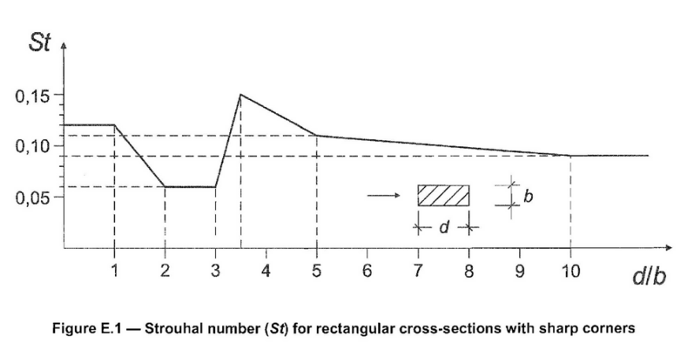
- 0 degrees D/B = 30/45 = 0.667 → St = 0.12
- 90 degrees D/B = 45/30 = 1.5 → St = 0.09

modification according to JWEIA Corrigendum
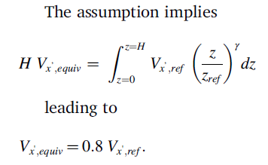
Vxref = 40 m/s → Vxechiv = 40*0.8 = 32 m/s
- 0 degrees → St = 0.12, B = 45 m →f = St * Vxechiv / B = 0.085 Hz
- 90 degrees → St = 0.12, B = 30 m →f = St * Vxechiv / B = 0.128 Hz

