Nama : RAMADHAN FERIANSYAH

NIM : 2019114017

PRODI : SI ENTERPRISE 5

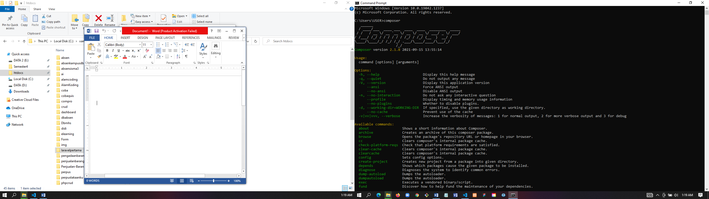

Instal composer

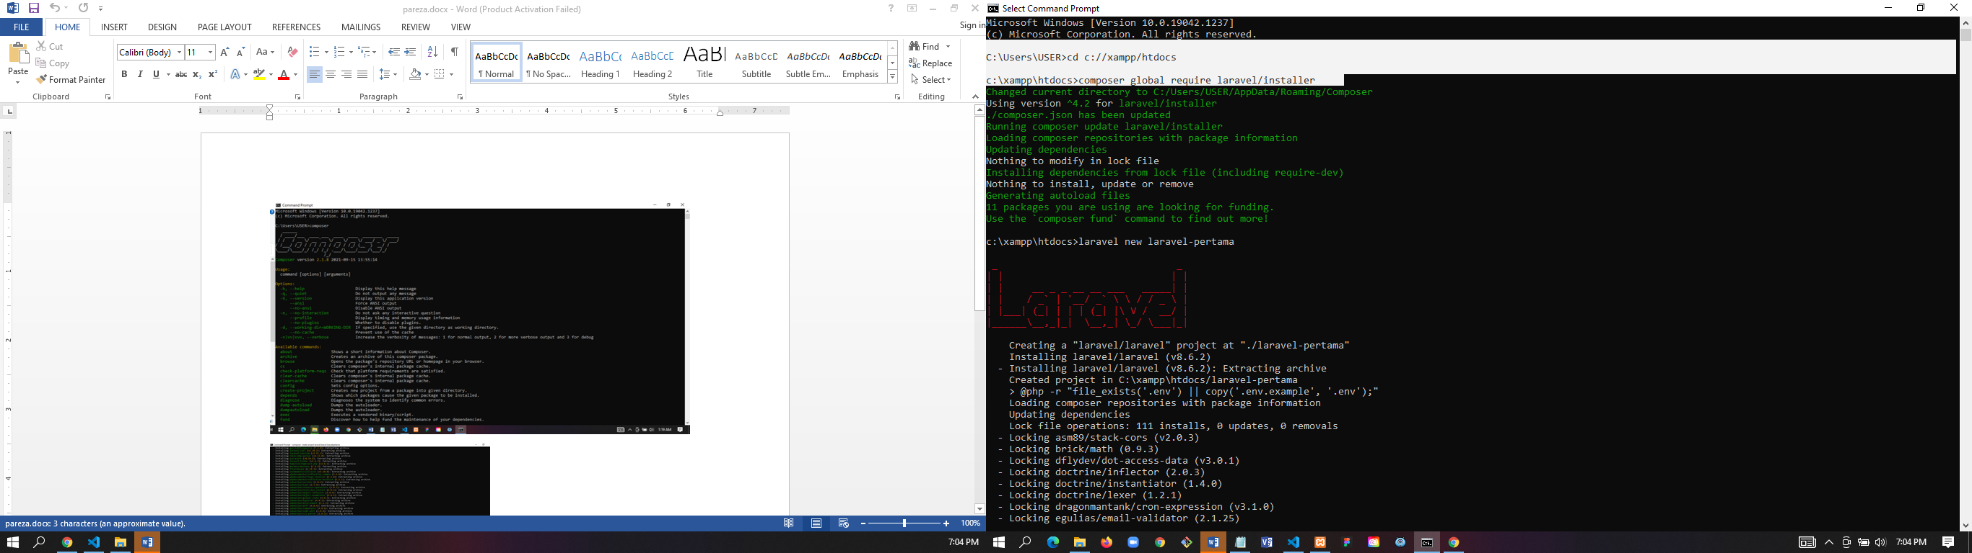

Instal Laravel

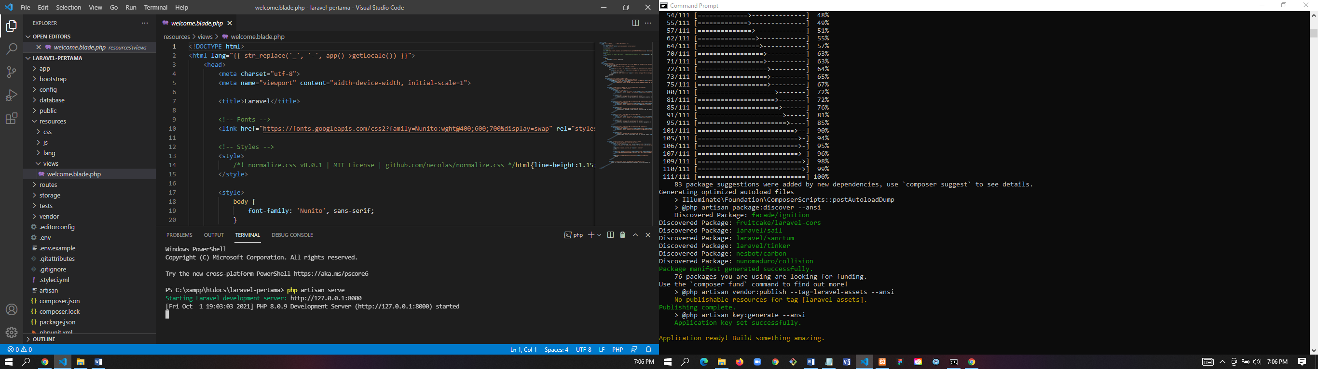

Php artisan serve

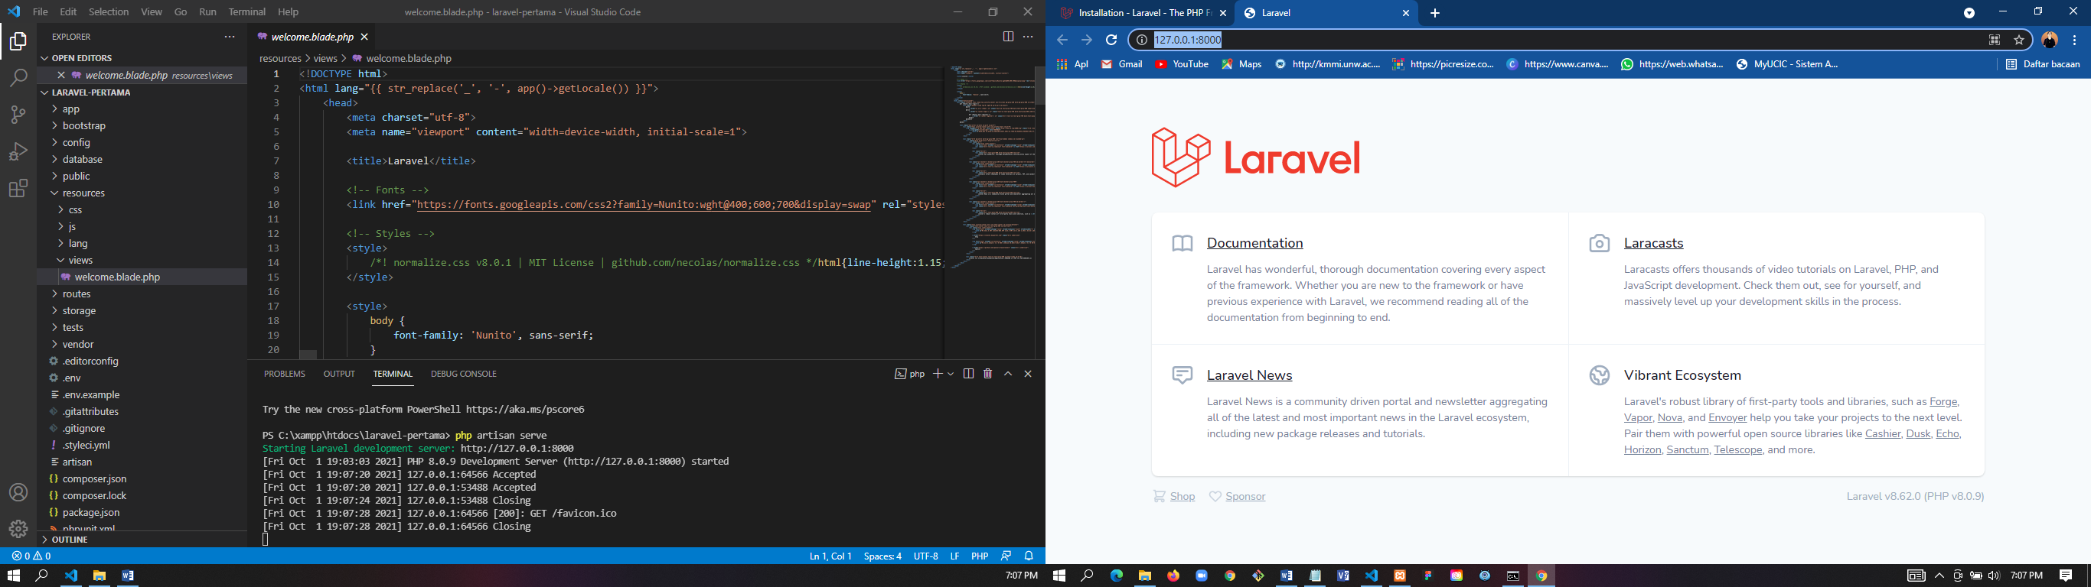

Tampilan awal <http://127.0.0.1:8000/>