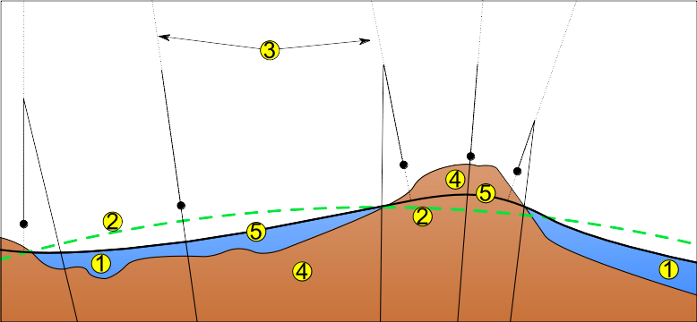
1: Ocean
2: reference ellipsoid
3: local plumb lines
4: continent
5: geoid

EPSG:4326 (WGS84) is a geograpic coordinate system (i.e. unprojected), datum: World Geodetic System 1984

EPSG:3857 (Pseudo-Mercator) is a projected coordinate system that uses the WGS84 reference ellipsoid. Datum: same as EPSG:4326

EPSG:2100 (GGRS87 / HGRS87 / Greek Grid), datum: Greek Geodetic Reference System 1987

Proj4 by default knows the following projections:
- EPSG:4326
- EPSG:3857
- EPSG:4269 (NAD83) – North America-based projection

