The Steps
The method presented here divides the cube into layers and you can solve each layer applying a given algorithm not messing up the pieces already in place. You can find a separate page for each one of the seven stages if the description on this page needs further explanation and examples.

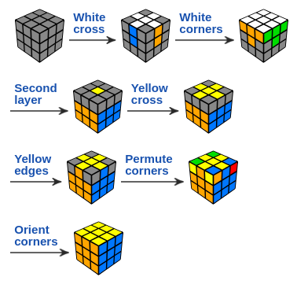

Notation
Before you get started, it helps if you to read the basic cubing terminology and you will need to know the Rubik's Cube notation ie what the letters mean in the algorithms:
F: front, R: right, U: up, L: left, D: down.

Clockwise rotations: FRULD
Counterclockwise rotations are marked with an apostrophe ('):

Step 1: White Cross
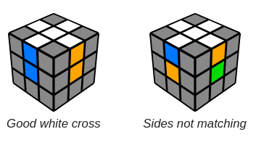
Let's begin with the white face. First we have to make a white cross paying attention to the color of the side center pieces. You can try to do this without reading the instructions.
Use this stage to familiarize yourself with the puzzle and see how far you can get without help. This step is relatively intuitive because there are no solved pieces to watch out for. Just practice and don't give up easily. Try move the white edges to their places not messing up the ones already fixed.

