Step 2: How To Solve The White Corners In The First Layer

The second step of the beginner's Rubik's Cube tutorial doesn't require long algorithms. You just have to apply a couple of short permutations which are easy to understand and to memorize.

Examples
Here are a few examples which you might be facing while solving your Rubik's Cube when you want to move a white corner piece to the top layer. In each example the piece we're fixing is the last white corner to demonstrate that these moves don't break the solved pieces. According to the orientation there are three cases:

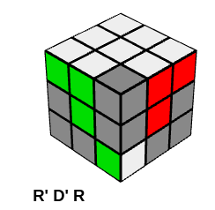
White sticker facing to the right

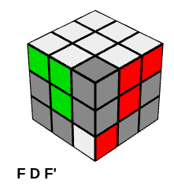
White facing in the front face

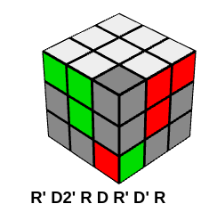
White sticker at the bottom of the cube

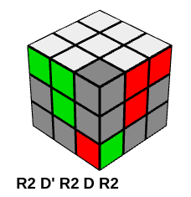
White sticker at the bottom of the cube (faster method)
The same case with a shortcut in only 5 turns and very fast. It's a bit surprising how it works, but after studying it, you'll see it. With R2 you put the whole UR bar, i.e., URF-UR-URB in the bottom, followed by D' where the wrong corner is now at FRD and the rest of the bar at FD, followed by R2 that fixes the corner (it was at the diagonally opposite corner URB, as a result of the first R2), followed by D to restore the completed bar at RD, then with R2 you place it back in the top.

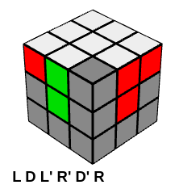
Good layer, wrong position
When the white corner piece is in the white layer just in a wrong spot you first need to take it out to the bottom layer and do one of the previous moves. An example:

Using only one algorithm: R' D' R D
There's an algorithm which works all the time in every cases. The bad thing is that it's longer than the optimal moves. If you have already read this tutorial then it might be familiar from the last step when we're completing the yellow layer corners.

Let's say we want to bring a white corner piece to the front-right-up position. The idea is to move the corresponding corner piece below this spot, move the corner piece in question to the front-right-down spot and do the R' D' R D algorighm until the cubelet will fit in the white layer.

Depending of the initial orientation you'll have to perform this permutation (R’D’RD):
- once, if the white is facing right
- thrice, if the white is facing down
- five times when white is facing forward. NB: you can achieve the same in only four steps with the inverse of the algorithm: D' R' D R

