Aplicar las reglas de normalización y realizar el modelo relacional.

**TABLA 1.**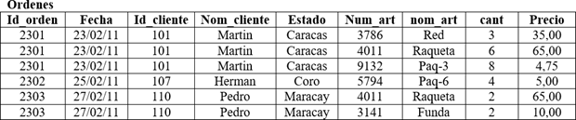

**1NF.**

**Ordenes**

|  |  |  |  |  |
| --- | --- | --- | --- | --- |
| **Id_orden** | **Fecha** | **Id_cliente** | **Nom_cliente** | **Estado** |
| 2301 | 23/02/11 | 101 | Martin | Caracas |
| 2302 | 25/02/11 | 107 | Herman | Coro |
| 2303 | 27/02/11 | 110 | Pedro | Maracay |

**Articulos_ordenes**

|  |  |  |  |  |
| --- | --- | --- | --- | --- |
| **Id_orden** | **Num_art** | **Nom_art** | **Cantidad** | **Precio** |
| 2301 | 3786 | Red | 3 | 35,00 |
| 2301 | 4011 | Raqueta | 6 | 65,00 |
| 2301 | 9132 | Paq-3 | 8 | 4,75 |
| 2302 | 5794 | Paq-6 | 4 | 5,00 |
| 2303 | 4011 | Raqueta | 2 | 65,00 |
| 2303 | 3141 | Funda | 2 | 10,00 |

**2NF.**

**Articulos_ordenes**

|  |  |  |
| --- | --- | --- |
| **Id_orden** | **Num_art** | **Cantidad** |
| 2301 | 3786 | 3 |
| 2301 | 4011 | 6 |
| 2301 | 9132 | 8 |
| 2302 | 5794 | 4 |
| 2303 | 4011 | 2 |
| 2303 | 3141 | 2 |

**Articulos**

|  |  |  |
| --- | --- | --- |
| **Num_art** | **Nom_art** | **Precio** |
| 3786 | Red | 35,00 |
| 4011 | Raqueta | 65,00 |
| 9132 | Paq-3 | 4,75 |
| 5794 | Paq-6 | 5,00 |
| 3141 | Funda | 10,00 |

**3NF.**

**Ordenes**

|  |  |  |
| --- | --- | --- |
| **Id_orden** | **Fecha** | **Id_cliente** |
| 2301 | 23/02/11 | 101 |
| 2302 | 25/02/11 | 107 |
| 2303 | 27/02/11 | 110 |

**Clientes**

|  |  |  |
| --- | --- | --- |
| **Id_cliente** | **Nom_cliente** | **Estado** |
| 101 | Martin | Caracas |
| 107 | Herman | Coro |
| 110 | Pedro | Maracay |

**TABLA 3.**

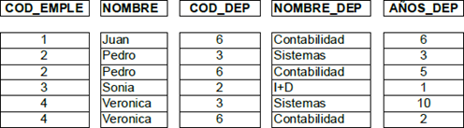

**Aplico 1F y la 2F**

**Empleados**

|  |  |
| --- | --- |
| **COD_EMPLE** | **NOMBRE** |
| 1 | Juan |
| 2 | Pedro |
| 3 | Sonia |
| 4 | Veronica |

**Departamentos**

|  |  |
| --- | --- |
| **COD_DEP** | **NOMBRE_DEP** |
| 2 | I+D |
| 3 | Sistemas |
| 6 | Contabilidad |

**Empleados_departamentos**

|  |  |  |
| --- | --- | --- |
| **COD_EMPLE** | **COD_DEP** | **AÑOS_DEP** |
| 1 | 6 | 6 |
| 2 | 3 | 3 |
| 2 | 6 | 5 |
| 3 | 2 | 1 |
| 4 | 3 | 10 |
| 4 | 6 | 2 |