**Final Project**

**Survey Engine**

**CSC-17B**

**40502**

**6/12/2020**

**Martin Perina**

**Table of Contents**

1. Intro

2. How to Use with Sample Input and Output

3. Development Summary

4. Checklist

5. References

6. Screenshots

7. Pseudo Code

8. Code

**1 Intro**

For my project I decided to make a simple survey engine. The website consists of a login page and a main survey page. The login page allows a user to create an account if they do not already have one as well as login. Upon logging in, the user will be sent to the main survey page where they can select a survey to take. The website is very simple and has room for expansion.

GitHub Location: In 17B/Survey_Engine_Final/ Folder

<https://github.com/mperina11/My_Work>

**2 How to Use with Sample Input and Output**

This project can be launched from the NetBeans IDE (I used version 8.2) using the ‘loginpage.html’ file. The website will open in a browser window and the user will be greeted with a login page. You may use the existing user credentials (User: Adam, Password: West) or create a new account. Using these credentials, the user may now login, once done the user will be sent to the main survey page. On this page the user can decide which survey to take.

**3 Development Summary**

The development of this project was very slow and spanned over many weeks. Being new to web development, I was forced to research and practice various parts. I started by making small websites that had one simple functionality, for example a button that opens a form, simple formatting of titles and images, and reading writing from a database. Once I had made each part work individually, I then combined everything into one website.

The biggest challenge for me was figuring out what method to use to make different languages/files communicate effectively. I experimented with JavaScript and PHP and ultimately sided more with using PHP out of preference.

Ultimately, I learned a lot about web development, more than I thought I would. I now know how to format and style a webpage, create buttons and forms, communicate with a database, and some simple security. I do have a lot to improve on however, my website could have more functionality and features as well as more security.

**4 Checklist**

1. MVC - How you delineated your objects

-made a list

2) Objects - Javascript/PHP - Serialization

Passing info with Javascript Objects to PHP Objects with Cookies

-NA

3) Reading/Writing Files/Local Storage

JSON – Javascript

-NA

-used to store products

4) Databases SQL - Identify Entities, Xref, and Enum Tables

-login, session, user, result_1, result_2, result_3

-enum_survey

-xref_user_login

5) Form Validation - Reqular Expressions

-createaccount.php

-used to clean user input

6) User-Admin-Login

-login.php, logout.php

-Login for users

7) Cookies - Sessions - Securing Pages

- login.php and logout.php

- sets unique ID for user

**5 References**

https://www.w3schools.com/

**6 Screenshots**

Figure A: Login Page

Figure B: Login form

Figure C: Create Account Form

Figure D: Survey 1

Figure E: Survey 2

Figure F: Survey 3

Figure G: DB Table

A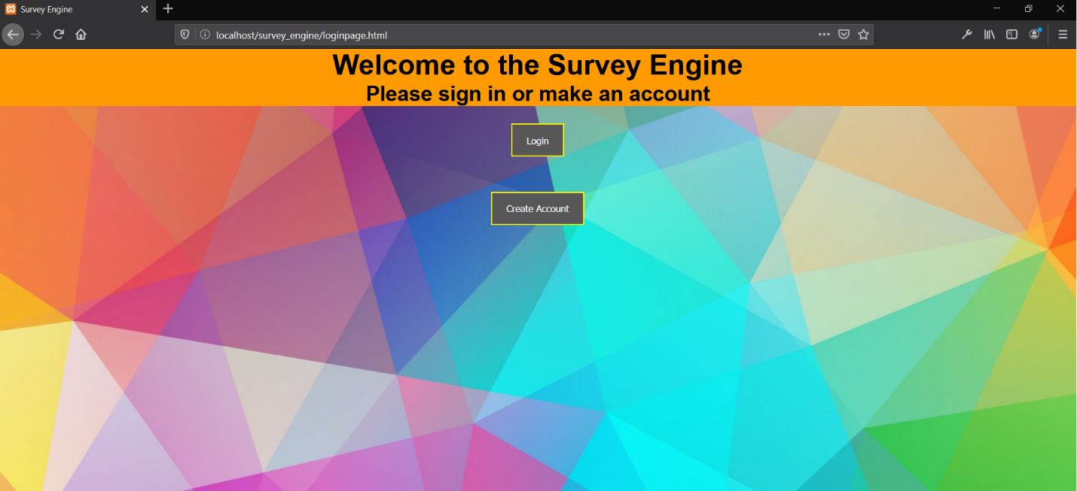

B

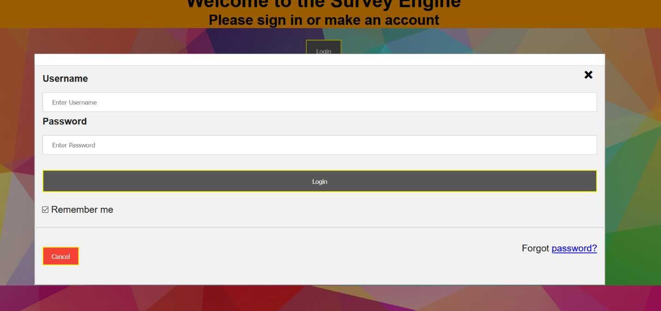

C

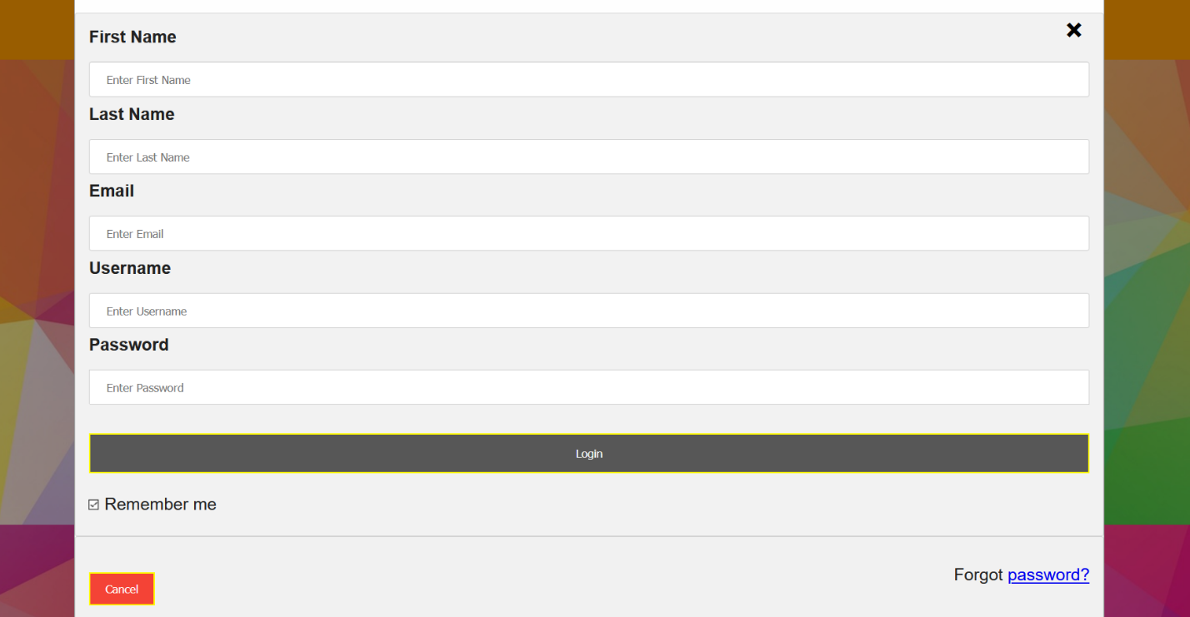

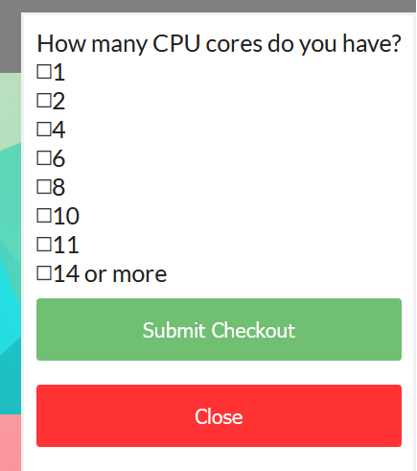

D

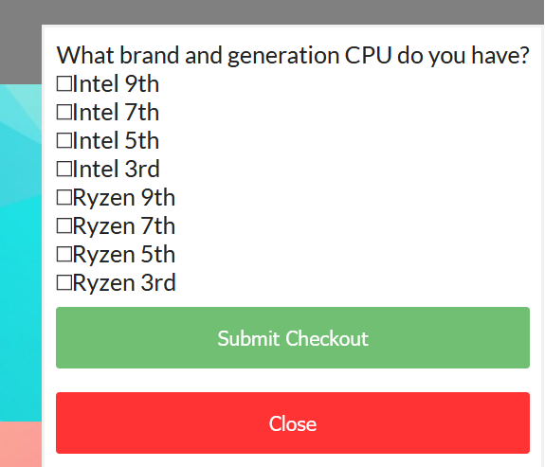

E

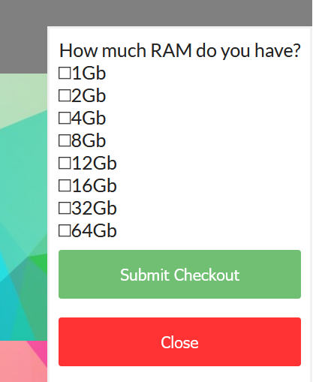

F

G

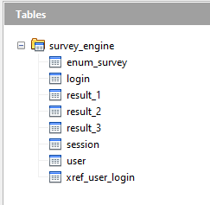

**7 Pseudo Code**

loginpage

if login

enter username and password

check against database

log the time in database

send to main page

if create account

enter username, password, first name, last name, email

check with REGEX

mainpage

if logout

send user back to loginpage

log tim in database

if survey 1

show survey form

send results to database

if survey 2

show survey form

send results to database

if survey 3

show survey form

send results to database

**8 Code**

<!DOCTYPE html>

<html lang="en">

<head>

<meta charset="UTF-8" />

<meta name="viewport" content="width=device-width, initial-scale=1.0" />

<meta http-equiv="X-UA-Compatible" content="ie=edge" />

<title>Survey Engine</title>

<link

rel="stylesheet"

href="https://use.fontawesome.com/releases/v5.8.1/css/all.css"

integrity="sha384-50oBUHEmvpQ+1lW4y57PTFmhCaXp0ML5d60M1M7uH2+nqUivzIebhndOJK28anvf"

crossorigin="anonymous"

/>

<link rel="stylesheet" href="main.css" />

<!--log in form-->

<head>

<meta name="viewport" content="width=device-width, initial-scale=1">

<style>

body {

font-family: Arial, Helvetica, sans-serif;

background: url("./images/backround1.jpg") center repeat;

}

/* Full-width input fields */

input[type=text], input[type=password] {

width: 100%;

padding: 12px 20px;

margin: 8px 0;

display: inline-block;

border: 1px solid #ccc;

box-sizing: border-box;

}

/* Set a style for all buttons */

button {

background-color: #575757;

color: white;

padding: 14px 20px;

margin: 25px 0;

border-style: solid;

border-color: #fffb00;

cursor: pointer;

width: 100%;

}

button:hover {

opacity: 0.8;

}

/* Style for title */

.title {

color: black;

background-color: #ff9b00;

}

/* Extra styles for the cancel button */

.cancelbtn {

width: auto;

padding: 10px 18px;

background-color: #f44336;

}

/* Center the image and position the close button */

.imgcontainer {

text-align: center;

margin: 24px 0 12px 0;

position: relative;

}

img.avatar {

width: 40%;

border-radius: 50%;

}

.container {

padding: 16px;

}

span.psw {

float: right;

padding-top: 16px;

}

/* The Modal (background) */

.modal {

display: none; /* Hidden by default */

position: fixed; /* Stay in place */

z-index: 1; /* Sit on top */

left: 0;

top: 0;

width: 100%; /* Full width */

height: 100%; /* Full height */

overflow: auto; /* Enable scroll if needed */

background-color: rgb(0,0,0); /* Fallback color */

background-color: rgba(0,0,0,0.4); /* Black w/ opacity */

padding-top: 60px;

}

/* Modal Content/Box */

.modal-content {

background-color: #fefefe;

margin: 5% auto 15% auto; /* 5% from the top, 15% from the bottom and centered */

border: 1px solid #888;

width: 80%; /* Could be more or less, depending on screen size */

}

/* The Close Button (x) */

.close {

position: absolute;

right: 25px;

top: 0;

color: #000;

font-size: 35px;

font-weight: bold;

}

.close:hover,

.close:focus {

color: red;

cursor: pointer;

}

/* Add Zoom Animation */

.animate {

-webkit-animation: animatezoom 0.6s;

animation: animatezoom 0.6s

}

@-webkit-keyframes animatezoom {

from {-webkit-transform: scale(0)}

to {-webkit-transform: scale(1)}

}

@keyframes animatezoom {

from {transform: scale(0)}

to {transform: scale(1)}

}

/* Change styles for span and cancel button on extra small screens */

@media screen and (max-width: 300px) {

span.psw {

display: block;

float: none;

}

.cancelbtn {

width: 100%;

}

}

</style>

</head>

<body>

<div class="title" style="text-align:center;">

<h1>Welcome to the Survey Engine</h1>

<h2>Please sign in or make an account</h2>

</div>

<!-- login -->

<div style="text-align:center;">

<button onclick="document.getElementById('id01').style.display='block'" style="width:auto;">Login</button>

</div>

<div id="id01" class="modal">

<form class="modal-content animate" action="login.php" method="post">

<div class="imgcontainer">

<span onclick="document.getElementById('id01').style.display='none'" class="close" title="Close Modal">&times;</span>

</div>

<div class="container">

<label for="uname"><b>Username</b></label>

<input type="text" placeholder="Enter Username" name="uname" required>

<label for="psw"><b>Password</b></label>

<input type="password" placeholder="Enter Password" name="psw" required>

<button type="submit" >Login</button>

<label>

<input type="checkbox" checked="checked" name="remember"> Remember me

</label>

</div>

<div class="container" style="background-color:#f1f1f1">

<button type="button" onclick="document.getElementById('id01').style.display='none'" class="cancelbtn">Cancel</button>

<span class="psw">Forgot <a href="#">password?</a></span>

</div>

</form>

</div>

<script>

// Get the modal

var modal = document.getElementById('id01');

// When the user clicks anywhere outside of the modal, close it

window.onclick = function(event) {

if (event.target == modal) {

modal.style.display = "none";

}

}

</script>

<!-- create user -->

<div style="text-align:center;">

<button onclick="document.getElementById('id02').style.display='block'" style="width:auto;">Create Account</button>

</div>

<div id="id02" class="modal">

<form class="modal-content animate" action="createaccount.php" method="post">

<div class="imgcontainer">

<span onclick="document.getElementById('id02').style.display='none'" class="close" title="Close Modal">&times;</span>

</div>

<div class="container">

<label for="firstname"><b>First Name</b></label>

<input type="text" placeholder="Enter First Name" name="firstname" required>

<label for="lastname"><b>Last Name</b></label>

<input type="text" placeholder="Enter Last Name" name="lastname" required>

<label for="email"><b>Email</b></label>

<input type="text" placeholder="Enter Email" name="email" required>

<label for="uname"><b>Username</b></label>

<input type="text" placeholder="Enter Username" name="uname" required>

<label for="psw"><b>Password</b></label>

<input type="password" placeholder="Enter Password" name="psw" required>

<button type="submit" >Login</button>

<label>

<input type="checkbox" checked="checked" name="remember"> Remember me

</label>

</div>

<div class="container" style="background-color:#f1f1f1">

<button type="button" onclick="document.getElementById('id02').style.display='none'" class="cancelbtn">Cancel</button>

<span class="psw">Forgot <a href="#">password?</a></span>

</div>

</form>

</div>

<script>

// Get the modal

var modal = document.getElementById('id02');

// When the user clicks anywhere outside of the modal, close it

window.onclick = function(event) {

if (event.target == modal) {

modal.style.display = "none";

}

}

</script>

</body>

<!--end log in form-->

<!DOCTYPE html>

<html>

<head>

<title>TODO supply a title</title>

<meta charset="UTF-8">

<meta name="viewport" content="width=device-width, initial-scale=1.0">

<link rel="stylesheet" href="main.css" />

</head>

<body>

<nav class="navbar">

<div class="navbar-center">

<span class="nav-icon">

<button type="submit" class="btn logout" onclick="Logout()">Logout</button>

</span>

<strong >Take a Survey today!</strong>

</div>

</nav>

<!-- survey 1 -->

<div class="open-button" style="text-align:center;">

<button class="open-button" onclick="openForm_1()">Survey 1</button>

</div>

<div class="form-popup" id="survey1">

<form action="results.php" method="post" class="form-container">

<div class="row">

<div class="col-50">

How many CPU cores do you have?

<div class= "checkbox">

<input type="checkbox" name="check1[]" value="A" />1<br>

<input type="checkbox" name="check1[]" value="B" />2<br>

<input type="checkbox" name="check1[]" value="C" />4<br>

<input type="checkbox" name="check1[]" value="D" />6<br>

<input type="checkbox" name="check1[]" value="E" />8<br>

<input type="checkbox" name="check1[]" value="F" />10<br>

<input type="checkbox" name="check1[]" value="G" />11<br>

<input type="checkbox" name="check1[]" value="H" />14 or more

</div>

</div>

</div>

<input type="submit" value="Submit Checkout" class="btn">

<button type="submit" class="btn cancel" onclick="closeForm_1()">Close</button>

</form>

</div>

<!-- survey 2 -->

<div class="open-button" style="text-align:center;">

<button class="open-button" onclick="openForm_2()">Survey 2</button>

</div>

<div class="form-popup" id="survey2">

<form action="results.php" method="post" class="form-container">

<div class="row">

<div class="col-50">

What brand and generation CPU do you have?

<div class= "checkbox">

<input type="checkbox" name="check2[]" value="A" />Intel 9th<br>

<input type="checkbox" name="check2[]" value="B" />Intel 7th<br>

<input type="checkbox" name="check2[]" value="C" />Intel 5th<br>

<input type="checkbox" name="check2[]" value="D" />Intel 3rd <br>

<input type="checkbox" name="check2[]" value="E" />Ryzen 9th <br>

<input type="checkbox" name="check2[]" value="F" />Ryzen 7th<br>

<input type="checkbox" name="check2[]" value="G" />Ryzen 5th<br>

<input type="checkbox" name="check2[]" value="H" />Ryzen 3rd

</div>

</div>

</div>

<input type="submit" value="Submit Checkout" class="btn">

<button type="submit" class="btn cancel" onclick="closeForm_2()">Close</button>

</form>

</div>

<!-- survey 3 -->

<div class="open-button" style="text-align:center;">

<button class="open-button" onclick="openForm_3()">Survey 3</button>

</div>

<div class="form-popup" id="survey3">

<form action="results.php" method="post" class="form-container">

<div class="row">

<div class="col-50">

How much RAM do you have?

<div class= "checkbox">

<input type="checkbox" name="check3[]" value="A" />1Gb<br>

<input type="checkbox" name="check3[]" value="B" />2Gb<br>

<input type="checkbox" name="check3[]" value="C" />4Gb<br>

<input type="checkbox" name="check3[]" value="D" />8Gb<br>

<input type="checkbox" name="check3[]" value="E" />12Gb<br>

<input type="checkbox" name="check3[]" value="F" />16Gb<br>

<input type="checkbox" name="check3[]" value="G" />32Gb<br>

<input type="checkbox" name="check3[]" value="H" />64Gb

</div>

</div>

</div>

<input type="submit" value="Submit Checkout" class="btn">

<button type="submit" class="btn cancel" onclick="closeForm_3()">Close</button>

</form>

</div>

<script>

function openForm_1() {

document.getElementById("survey1").style.display = "block";

}

function closeForm_1() {

document.getElementById("survey1").style.display = "none";

}

function openForm_2() {

document.getElementById("survey2").style.display = "block";

}

function closeForm_2() {

document.getElementById("survey2").style.display = "none";

}

function openForm_3() {

document.getElementById("survey3").style.display = "block";

}

function closeForm_3() {

document.getElementById("survey3").style.display = "none";

}

function Logout() {

location.href = 'loginpage.html';

}

</script>

</body>

</html>