AI-Enabled Multidimensional Antibody Developability Engineering: A Lineage-Aware Synthetic Benchmark Integrating Molecular Liabilities, Predictive Modelling, and Pareto-Guided Sequence Optimisation
Mark Ihrwell R. Petalcorin
Independent Researcher, London, United Kingdom
Article type: Computational methods and proof-of-concept study

Abstract
Antibody discovery increasingly produces molecules with strong target binding but heterogeneous manufacturability, stability, specificity, and high-concentration solution behaviour. Developability is therefore a systems-level property emerging from coupled sequence, structural, colloidal, chemical, and format-dependent mechanisms. We developed a transparent computational proof of concept that integrates lineage-aware sequence simulation, molecular-liability analysis, literature-benchmarked biophysical assays, predictive modelling, and multi-objective sequence engineering. A synthetic library of 720 antibody candidates from 180 parent lineages was generated across IgG1, common-light-chain bispecific, and scFv-fusion architectures. Interpretable descriptors captured CDRH3 length, hydrophobicity, aromaticity, charge asymmetry, sequence entropy, and motifs associated with deamidation, isomerisation, oxidation, glycosylation, and cysteine imbalance. Experimental-like outputs included expression titre, thermal transition, hydrophobic interaction chromatography retention, polyspecificity, self-interaction, diffusion interaction parameter, viscosity, stress-induced monomer loss, affinity, and clearance. Parent-lineage-held-out evaluation yielded an AUROC of 0.827, average precision of 0.768, and Brier score of 0.164 for composite high-risk classification. Sequence-only regression showed moderate generalisation for expression, HIC retention, and AC-SINS, consistent with irreducible structural and process effects. Targeted CDR substitutions followed by Pareto optimisation reduced predicted high-risk probability from 0.874 to 0.592 in the selected variant while retaining predicted nanomolar affinity. The framework demonstrates how artificial intelligence can focus experiments without replacing them. Its principal scientific implication is that antibody progression should be treated as constrained multi-objective optimisation across molecular function, physical chemistry, manufacturability, pharmacokinetics, and architecture. All sequences and measurements are synthetic and are not experimental or clinical evidence.
Keywords: antibody developability; bispecific antibodies; molecular design; machine learning; hydrophobicity; polyspecificity; self-association; Pareto optimisation
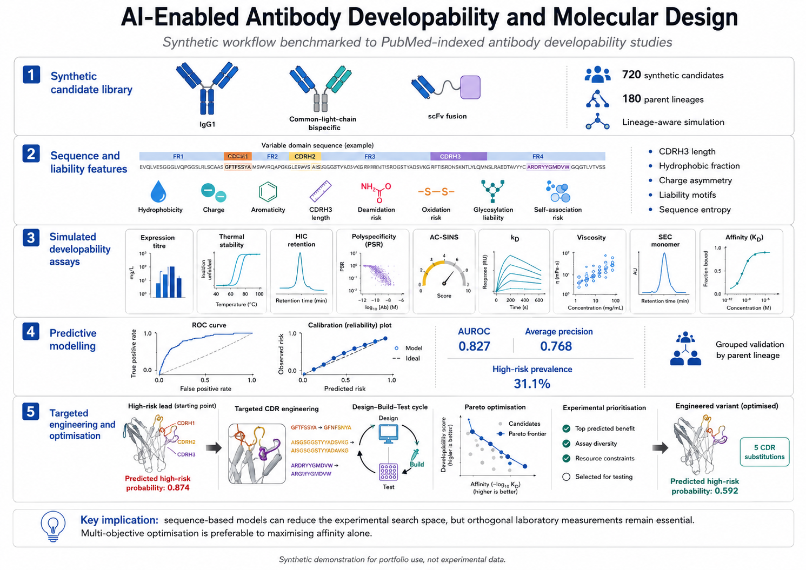
Figure 1. AI-enabled antibody developability and molecular design workflow. A lineage-aware synthetic library was transformed into sequence and liability features, linked to simulated orthogonal developability assays, evaluated using grouped predictive modelling, and subjected to targeted CDR engineering and Pareto optimisation. The displayed values are outputs of the synthetic analysis and not experimental measurements.

Introduction
Monoclonal antibodies have become central therapeutic modalities because their modular immunoglobulin architecture can combine high target specificity with Fc-mediated pharmacology and established manufacturing platforms. Binding potency alone, however, is insufficient for drug development. Candidate antibodies must also express efficiently, retain conformational stability, avoid irreversible and reversible association, remain soluble at clinically useful concentrations, resist chemical degradation, exhibit acceptable specificity, and preserve pharmacokinetic behaviour. These properties collectively define developability and determine whether a molecular concept can be translated into a robust biological product (Jain et al., 2017; Xu et al., 2019).
At the molecular level, developability liabilities arise from the spatial distribution of hydrophobic, charged, aromatic, and chemically reactive residues. Exposed hydrophobic patches can stabilise non-native intermolecular contacts and increase hydrophobic interaction chromatography retention, aggregation, opalescence, and viscosity. Strongly positive or asymmetric electrostatic patches can promote interactions with anionic biomolecules and cellular surfaces, increasing polyspecificity and accelerating systemic clearance. CDR loops are particularly important because they are sequence-diverse, solvent exposed, and functionally constrained by antigen recognition. Long or hydrophobic CDRH3 loops can therefore create an affinity–developability conflict in which residues that support binding also reduce colloidal stability or specificity (Raybould et al., 2019; Starr and Tessier, 2019).
Chemical stability adds a second layer. Asparagine deamidation, aspartate isomerisation, methionine and tryptophan oxidation, non-canonical glycosylation motifs, and unpaired cysteines may alter charge, conformation, potency, or heterogeneity. The probability that a motif becomes an actual liability depends on solvent accessibility, local flexibility, neighbouring residues, pH, temperature, oxygen exposure, formulation, and storage time. Consequently, sequence flags are hypotheses rather than definitive failure mechanisms. Structure-based modelling and orthogonal experiments are needed to distinguish silent motifs from actionable risks (Lauer et al., 2012; Xu et al., 2019).
At the systems level, developability emerges from interactions among molecular format, expression host, purification process, formulation, concentration, route of administration, target biology, and dose. Complex antibody architectures increase the accessible design space but introduce additional constraints, including chain pairing, linker stability, domain–domain interactions, asymmetric assembly, and format-specific pharmacokinetics. Bispecific and multispecific molecules cannot be treated simply as two monoclonal antibodies joined together because their architecture changes effective avidity, geometry, expression, purification, self-association, and tissue disposition (Spiess et al., 2015; Datta-Mannan et al., 2022; Brinkmann and Kontermann, 2017).
High-throughput experimental platforms can measure many of these properties early, but the combinatorial space of sequences and formats exceeds practical laboratory capacity. Computational approaches can prioritise candidates, identify likely sequence liabilities, and propose variants before expression. The Therapeutic Antibody Profiler formalised interpretable guidelines based on CDR length, surface hydrophobicity, CDR charge, and heavy–light charge asymmetry, while subsequent machine-learning studies have sought to predict developability directly from sequence and structure (Raybould et al., 2019; Park et al., 2024; Gupta et al., 2024). Model value nevertheless depends on data quality, relevant endpoints, lineage-aware validation, calibrated uncertainty, and experimental feedback.
This study presents a synthetic, reproducible workflow designed to demonstrate these principles. The objectives were to: generate a format-diverse antibody library with shared parent lineages; encode mechanistically interpretable sequence and liability descriptors; simulate a multidimensional assay panel within literature-informed ranges; quantify cross-assay and format-level relationships; assess sequence-only predictive models under parent-lineage-held-out validation; and demonstrate targeted CDR engineering through multi-objective Pareto optimisation. The study was not intended to reproduce a proprietary dataset or validate a universal specification. Instead, it provides an auditable computational test bed for connecting molecular mechanisms to systems-level development decisions.

Materials and Methods

Study design and reproducibility
A deterministic simulation was implemented in Python with random seed 20260729. The library comprised 720 candidates derived from 180 independent parent lineages, with four variants per lineage. The analysis used pandas, NumPy, SciPy, scikit-learn, and Matplotlib. All exported sequence, assay, model, and optimisation files were generated locally. No patient data, animal data, proprietary GSK data, or experimentally measured antibody data were used.

Synthetic antibody architectures
Candidates were assigned to IgG1, common-light-chain IgG-like bispecific, or scFv-fusion classes. Variable-domain-like sequences were generated from weighted amino-acid distributions. CDR-like segments were enriched variably for hydrophobic, aromatic, and basic residues to create a continuum of physicochemical risk. Each parent yielded a baseline sequence and three related variants containing one to four CDR substitutions. Bispecific and scFv-fusion classes incorporated modest penalties for expression and stability and increased variance, reflecting the broader manufacturability challenges of engineered architectures rather than an assumption that every complex format is intrinsically inferior.

Sequence and chemical-liability features
Descriptors included total sequence length, mean and maximum CDRH3 length, global and CDR hydrophobic fractions, aromatic fractions, positive and negative residue fractions, net and absolute charge proxies, heavy–light charge asymmetry, longest hydrophobic run, and Shannon sequence entropy. Chemical-liability counts included NG, NS, NN, and NT motifs as simplified deamidation indicators; DG, DS, and DT motifs as isomerisation indicators; methionine and tryptophan counts as oxidation-sensitive sites; N-X-S/T motifs, excluding proline at X, as potential glycosylation sites; and odd cysteine counts as a warning for disulfide imbalance. These descriptors were intentionally interpretable and were not presented as substitutes for antibody numbering, three-dimensional solvent accessibility, molecular dynamics, or formulation-dependent stress studies.

Simulation of developability assays
The assay simulator represented coupled but non-identical mechanisms. CDR hydrophobicity and hydrophobic runs increased HIC retention, self-interaction, viscosity, and stress aggregation. Charge burden and heavy–light asymmetry increased a PSR-like polyspecificity signal. Format complexity influenced expression and thermal stability. Hidden process and structural variables and assay-specific random noise created irreducible variance. Outputs were constrained to broad literature-informed regions: expression 0.05–4.2 g/L, thermal transition 54–83 °C, HIC retention 3.5–19.5 min, PSR 0–1, AC-SINS shift 0–15 nm, kD −38 to 36 mL/g, viscosity 2–48 mPa·s, stress SEC monomer 81–100%, and affinity 0.03–300 nM. The simulated clearance endpoint depended on polyspecificity, hydrophobicity, attractive interactions, and format. These rules reflect established qualitative relationships but do not claim exact biological coefficients (Jain et al., 2017; Kingsbury et al., 2020; Avery et al., 2018).

Composite risk definition
Eight didactic screening flags were defined for low expression, low thermal stability, high HIC retention, high polyspecificity, high AC-SINS response, attractive intermolecular interactions, high viscosity, and stress-induced monomer loss. A candidate was labelled high risk when at least three flags were present or when severe polyspecificity or aggregation criteria were met. This composite endpoint mirrors the concept that multiple moderate liabilities can jointly impede development, while a single extreme liability can dominate progression (Jain et al., 2017). Thresholds were used only to construct a synthetic learning task.

Statistical analysis
Spearman correlation quantified monotonic relationships among assays. Format differences were tested with Kruskal–Wallis tests because several endpoints were asymmetric, and epsilon-squared was used as an omnibus effect-size estimate. Association between molecular format and composite high-risk status was evaluated by chi-square testing and Cramér's V. Principal-component analysis was applied to standardised sequence features for visualisation. Technical replicate simulations were analysed by Spearman correlation and the standard deviation of replicate differences.

Predictive modelling and validation
The predictive inputs contained molecular format and sequence-derived descriptors only. Assay values, latent simulation variables, candidate identifiers, and parent identifiers were excluded. Parent lineages were divided into training and test sets using grouped splitting, ensuring that close variants from the same lineage did not occur on both sides of evaluation. An Extra Trees classifier predicted composite high risk. Performance was summarised by AUROC, average precision, Brier score, confusion matrix, precision–recall curves, and calibration. A nonparametric bootstrap generated the AUROC confidence interval. Permutation importance measured the decrease in held-out AUROC after each feature was shuffled. A multi-output Extra Trees regressor predicted expression, thermal transition, HIC retention, PSR, and AC-SINS; performance was measured by mean absolute error, R-squared, and Spearman correlation.

Targeted CDR engineering and Pareto optimisation
A starting lead was selected among high-risk candidates in the strongest-affinity quartile. One to three hydrophobic or strongly charged CDR residues per arm were replaced preferentially with polar residues. For complex formats, the second arm was modified probabilistically. Sequence-only models predicted each variant's developability outputs. Affinity retention was represented by an explicit heuristic penalty that increased with mutation count and aromatic residue replacement; it was not an antigen-aware binding model. Variants were ranked using a weighted multi-objective utility and a two-dimensional Pareto frontier across predicted high-risk probability and predicted affinity. Pareto-optimal variants were those for which no other generated molecule improved both objectives simultaneously.

Results

Library composition and liability burden
The final dataset contained 720 candidates from 180 independent parent lineages. Composite high-risk prevalence was 31.1%. Format-level risk was lowest for IgG1 (20.8%) and highest for scFv_fusion (51.5%). The broad overlap between formats indicated that architecture shifted probability distributions without deterministically assigning individual outcomes. Chemical-liability motifs were common across the library, but risk classification depended on their integration with hydrophobicity, charge, stability, self-interaction, and expression rather than motif count alone.

Multidimensional assay relationships
The simulated assay matrix recovered mechanistically coherent dependencies (Figure 2). The strongest absolute pairwise association was between kD_mL_g and viscosity_150mg_mPa_s (Spearman r = -0.95). HIC retention increased with CDR hydrophobicity and tended to accompany lower expression, greater self-interaction, more attractive kD values, higher viscosity, and lower SEC monomer after stress. PSR-like polyspecificity tracked charge burden and charge asymmetry and contributed to the simulated clearance endpoint. These patterns created partially overlapping liability clusters rather than a single universal developability dimension.
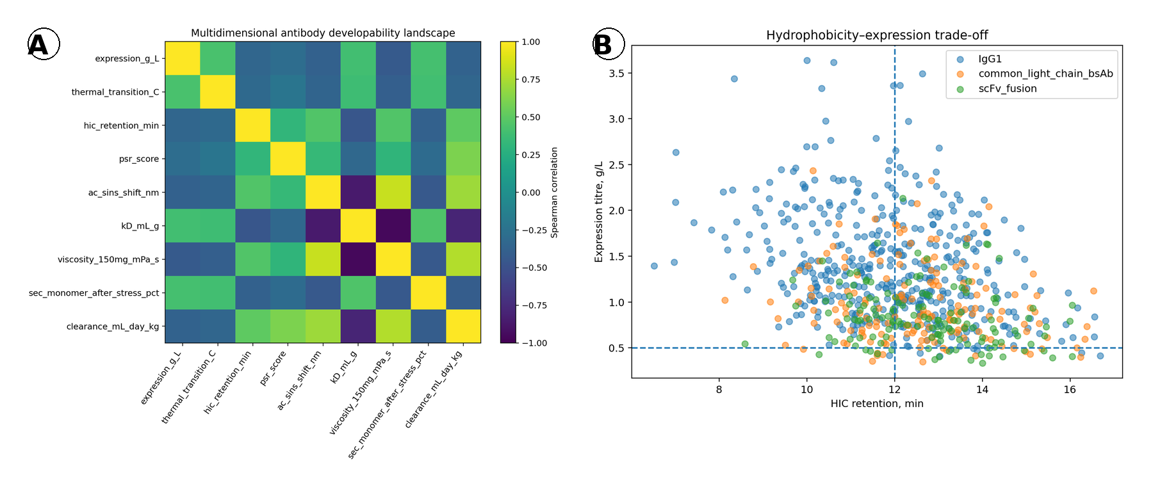
Figure 2. Multidimensional developability relationships. (A) Spearman correlation matrix across simulated assay outputs. (B) HIC retention versus expression titre, stratified by molecular format. Dashed lines indicate didactic screening thresholds.

Lineage-held-out risk prediction
The Extra Trees classifier achieved AUROC 0.827, average precision 0.768, and Brier score 0.164 in parent-lineage-held-out test data (Figure 3). The result indicated useful enrichment but not complete separation. Calibration analysis showed that predicted probabilities broadly tracked observed risk while retaining deviations expected from finite sample size and a composite heuristic endpoint. The lineage-based split provided a stricter estimate than random variant-level splitting because closely related sequences could not leak into the test set.
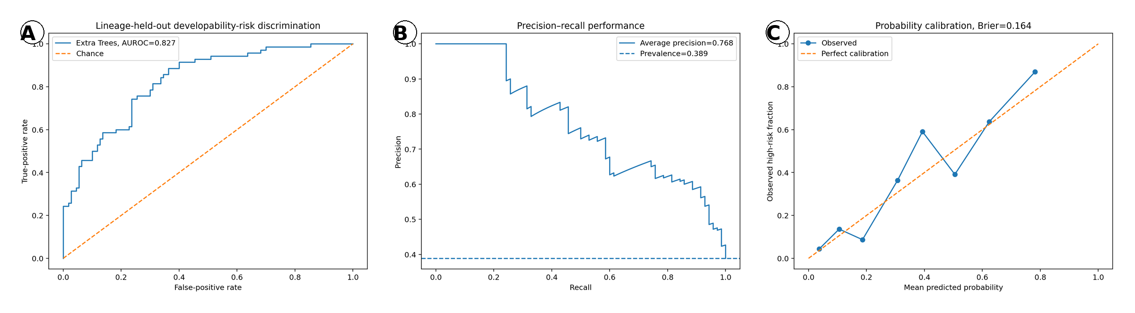
Figure 3. Parent-lineage-held-out model evaluation. (A) Receiver operating characteristic curve. (B) Precision–recall curve. (C) Reliability diagram comparing predicted and observed high-risk probabilities.

Prediction of individual assay outputs
Sequence-only multi-output regression predicted expression with MAE 0.342 g/L, R² 0.432, and Spearman r 0.706. HIC retention was predicted with MAE 0.995 min, R² 0.402, and Spearman r 0.627. AC-SINS prediction yielded MAE 1.493 nm, R² 0.322, and Spearman r 0.618. Thermal transition and PSR were less completely captured, with R² values of 0.199 and 0.185, respectively. The hierarchy is scientifically plausible because HIC and expression were directly connected to the encoded sequence features, whereas thermal stability and polyspecificity depended more strongly on hidden structural, conformational, and environmental factors.

Interpretability and experimental prioritisation
Permutation analysis identified sequence-level physicochemical variables as the dominant risk drivers (Figure 4A). The experimental value-of-information curve showed that ranking by predicted risk enriched true high-risk candidates relative to random-order screening (Figure 4B). This demonstrates the operational role of computation: models can allocate scarce assay capacity toward informative candidates, while the assays remain the source of biological evidence.
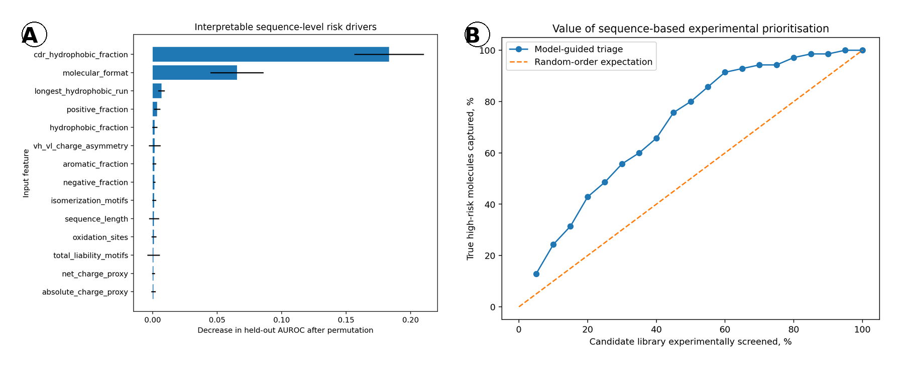
Figure 4. Model interpretation and experimental prioritisation. (A) Permutation importance measured as loss of held-out AUROC after feature randomisation. (B) Fraction of true high-risk molecules captured as a function of the proportion experimentally screened.

Engineering of a high-affinity, high-risk lead
Targeted CDR mutation generated 300 variants around a high-affinity, high-risk lead. The selected Pareto-ranked variant, P053_V2_ENG025, contained 5 CDR substitutions. Predicted high-risk probability decreased from 0.874 to 0.592, while predicted expression was 0.904 g/L, thermal transition 69.0 °C, HIC retention 13.11 min, PSR 0.567, AC-SINS shift 8.42 nm, and heuristic affinity 1.034 nM. The Pareto frontier made the affinity–developability trade-off explicit rather than collapsing all candidates into a single potency ranking (Figure 5).
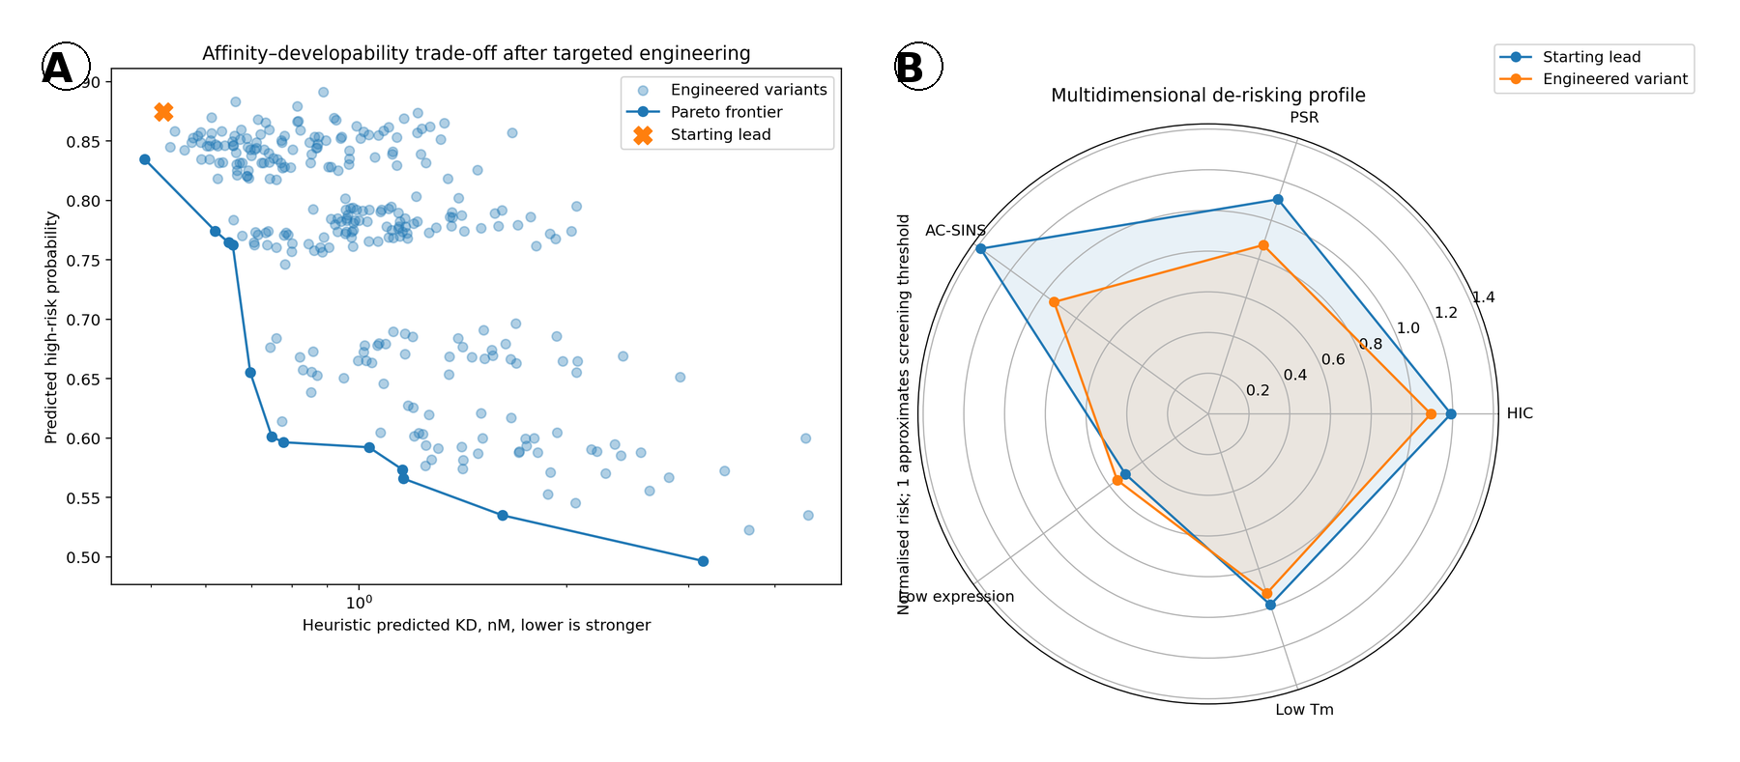
Figure 5. Multi-objective antibody engineering. (A) Predicted affinity–developability Pareto frontier for targeted CDR variants. (B) Normalised multidimensional risk profile of the starting lead and selected engineered variant.

Discussion
This proof-of-concept study integrates molecular and systems-level reasoning into a single antibody design workflow. The central observation is that developability cannot be reduced to one residue, one assay, or one scalar score. It is an emergent phenotype generated by sequence composition, three-dimensional surface organisation, conformational dynamics, intermolecular interactions, molecular architecture, production context, and intended clinical use. The synthetic results reproduce this multidimensionality by producing correlated but non-redundant assay clusters and by limiting the performance of sequence-only prediction.
Hydrophobicity provides a mechanistic example. A hydrophobic CDR patch can increase antigen-contact energy, but the same patch can create non-native contacts among antibody molecules or with chromatographic surfaces. At low concentration, these effects may appear as increased HIC retention or AC-SINS signal. At high concentration, repeated weak contacts can generate network-like association, reduced diffusion, high viscosity, opalescence, or phase separation. kD is therefore not simply another assay value; it is a systems-level readout of net colloidal interactions that can integrate electrostatic attraction, excluded volume, hydration, and hydrophobic association. The reported relationship between kD and high-concentration solution behaviour supports its use as an early risk indicator, although no single descriptor is universally sufficient (Kingsbury et al., 2020).
Charge is similarly context dependent. Positive CDR patches can favour binding to negatively charged epitopes but also promote non-specific interaction with nucleic acids, membranes, extracellular matrix, and serum proteins. Such interactions can increase apparent polyspecificity and tissue uptake and reduce circulating exposure. Heavy–light charge asymmetry can create local electrostatic patches even when global net charge appears acceptable. This explains why sequence-level counts should be mapped onto three-dimensional molecular surfaces and interpreted together with cognate binding and off-target assays (Raybould et al., 2019; Avery et al., 2018; Kelly et al., 2021).
The moderate assay-prediction performance is a strength rather than a defect of the demonstration. Perfect prediction would imply that all experimental outputs were direct deterministic functions of the selected descriptors. In reality, thermal stability depends on packing, hydrogen-bond networks, disulfide geometry, domain interfaces, glycosylation, and conformational ensembles. Polyspecificity depends on the distribution of electrostatic and hydrophobic surfaces and on the composition of the experimental reagent panel. Expression reflects transcription, translation, folding, secretion, assembly, cellular quality control, and construct design. Sequence encodes these processes, but simple descriptors capture them incompletely. Modern protein language models and structure-based machine learning may improve representation, yet their value still depends on relevant training data and external validation (Gupta et al., 2024; Parkinson et al., 2025).
Lineage-aware splitting is particularly important in antibody engineering. Variants generated from the same parent often differ at only a few residues. Random splitting allows the model to memorise lineage-specific patterns and produces optimistic performance that may not transfer to a new antibody family or project. Holding out complete parent lineages tests the more relevant use case of prioritising previously unseen scaffolds. A still stronger evaluation would hold out whole antigen programmes, discovery campaigns, laboratories, or molecular formats. Prospective testing should also report calibration and decision utility, not only discrimination.
The engineering analysis illustrates why Pareto optimisation is preferable to affinity maximisation. Mutating a hydrophobic aromatic residue may reduce self-association but weaken antigen contact. Removing positive charge may improve specificity but alter epitope complementarity. Increasing polarity may improve solubility while destabilising a buried packing interaction. A Pareto frontier preserves candidates representing different compromises so that experimental evidence and programme priorities can determine the next decision. In a therapeutic project, the objective vector should include potency, specificity, expression, stability, aggregation, viscosity, immunogenicity, chain pairing, pharmacokinetics, target-mediated disposition, formulation concentration, and manufacturability.
Complex formats require additional caution. Common-light-chain bispecifics can reduce light-chain mispairing, but selection of a common light chain can constrain affinity and sequence diversity. scFv fusions introduce linkers and additional domain interfaces that may create proteolytic, aggregation, or conformational risks. IgG-like bispecifics may retain FcRn recycling and effector functions but require controlled heavy-chain heterodimerisation and correct assembly. Format selection should therefore follow the required biology, geometry, valency, and pharmacology, then be accompanied by format-specific developability assays (Spiess et al., 2015; Brinkmann and Kontermann, 2017; Datta-Mannan et al., 2022).
The workflow has several limitations. All data are synthetic, and the thresholds and coefficients are didactic. The sequence generator does not reconstruct human germlines, canonical loops, somatic hypermutation, or realistic antigen-selection pressures. Liability motifs are not evaluated in structural context. The affinity model is heuristic and lacks an antigen structure. The composite risk label is partially determined by the same conceptual rules represented in the features, and therefore model performance cannot be interpreted as external biological validation. No formulation conditions, pH-dependent behaviour, glycan heterogeneity, Fc function, immunogenicity, or cell-based potency were simulated.
The next step is a prospective design–build–test–learn study. A diverse set of parent antibodies should be expressed in the intended formats and assessed using harmonised assays with internal standards, replicate plates, and metadata for batch, day, operator, construct, host, purification, and formulation. Structural models should be generated with uncertainty estimates, and surface descriptors should be computed across conformational ensembles. Active learning can then choose molecules that maximise both expected improvement and information gain. The ultimate criterion is not retrospective correlation but whether model-guided design reduces the number of experiments, accelerates identification of robust candidates, and maintains biological function.

Conclusion
Antibody developability is a constrained systems-engineering problem rooted in molecular sequence and structure but expressed through manufacturing, formulation, pharmacokinetic, and biological contexts. The synthetic workflow developed here demonstrates a practical integration of interpretable liabilities, orthogonal assay simulation, lineage-aware machine learning, calibrated risk estimation, experimental prioritisation, and Pareto-guided CDR optimisation. The analysis supports three principles. First, potency and developability must be optimised together. Second, grouped validation and uncertainty are required for trustworthy prediction. Third, computation should focus and accelerate laboratory work rather than replace it. A prospective experimental implementation could provide a rigorous portfolio demonstration of AI-enabled biologics design while maintaining mechanistic interpretability and clear decision accountability.

Data and Code Availability
The manuscript is based on a self-contained Jupyter notebook and exported synthetic datasets. All sequences and assay measurements are computationally generated. The workflow can be adapted to public or experimentally generated antibody datasets after appropriate licence, provenance, assay-harmonisation, and validation review.

Conflict of Interest Statement
The author declares no competing interests. This independent portfolio study is not affiliated with, sponsored by, or based on proprietary data from GSK or any other biopharmaceutical company.

References
Avery, L. B., et al. (2018). Establishing in vitro in vivo correlations to screen monoclonal antibodies for physicochemical properties related to favorable human pharmacokinetics. mAbs, 10, 244–255. https://doi.org/10.1080/19420862.2017.1417718
Bailly, M., et al. (2020). Predicting antibody developability profiles through early stage discovery screening. mAbs, 12, 1743053. https://doi.org/10.1080/19420862.2020.1743053
Brinkmann, U., & Kontermann, R. E. (2017). The making of bispecific antibodies. mAbs, 9, 182–212. https://doi.org/10.1080/19420862.2016.1268307
Datta-Mannan, A., et al. (2022). Pharmacokinetic developability and disposition profiles of bispecific antibodies: A case study with two molecules. Antibodies, 11, 2. https://doi.org/10.3390/antib11010002
Gupta, S., et al. (2024). Best practices for machine learning in antibody discovery and development. Drug Discovery Today, 29, 104025. https://doi.org/10.1016/j.drudis.2024.104025
Jain, T., et al. (2017). Biophysical properties of the clinical-stage antibody landscape. Proceedings of the National Academy of Sciences of the United States of America, 114, 944–949. https://doi.org/10.1073/pnas.1616408114
Kelly, R. L., et al. (2021). Polyreactivity and polyspecificity in therapeutic antibody development: Risk factors for failure in preclinical and clinical development campaigns. mAbs, 13, 1999195. https://doi.org/10.1080/19420862.2021.1999195
Kingsbury, J. S., et al. (2020). A single molecular descriptor to predict solution behavior of therapeutic antibodies. Science Advances, 6, eabb0372. https://doi.org/10.1126/sciadv.abb0372
Lauer, T. M., et al. (2012). Developability index: A rapid in silico tool for the screening of antibody aggregation propensity. Journal of Pharmaceutical Sciences, 101, 102–115. https://doi.org/10.1002/jps.22758
Park, E., et al. (2024). Molecular surface descriptors to predict antibody developability: Sensitivity to parameters, structure models, and conformational sampling. mAbs, 16, 2362788. https://doi.org/10.1080/19420862.2024.2362788
Raybould, M. I. J., et al. (2019). Five computational developability guidelines for therapeutic antibody profiling. Proceedings of the National Academy of Sciences of the United States of America, 116, 4025–4030. https://doi.org/10.1073/pnas.1810576116
Shan, L., et al. (2018). Developability assessment of engineered monoclonal antibody variants with a complex self-association behavior using complementary analytical and in silico tools. Molecular Pharmaceutics, 15, 5697–5710. https://doi.org/10.1021/acs.molpharmaceut.8b00867
Spiess, C., Zhai, Q., & Carter, P. J. (2015). Alternative molecular formats and therapeutic applications for bispecific antibodies. Molecular Immunology, 67, 95–106. https://doi.org/10.1016/j.molimm.2015.01.003
Starr, C. G., & Tessier, P. M. (2019). Selecting and engineering monoclonal antibodies with drug-like specificity. Current Opinion in Biotechnology, 60, 119–127. https://doi.org/10.1016/j.copbio.2019.01.008
Xu, Y., et al. (2019). Structure, heterogeneity and developability assessment of therapeutic antibodies. mAbs, 11, 239–264. https://doi.org/10.1080/19420862.2018.1553476

Supplementary Material
All tables are placed in the supplementary section to preserve an uninterrupted figure-led narrative in the main manuscript.

Supplementary Table S1. Literature-informed simulation ranges and didactic screening thresholds
Assay | Simulated range | Unfavourable direction | Didactic threshold | Biological interpretation
Expression titre | 0.05–4.2 g/L | Lower | <0.50 g/L | Poor folding, secretion, assembly, or construct compatibility
Thermal transition | 54–83 °C | Lower | <64 °C | Reduced conformational stability
HIC retention | 3.5–19.5 min | Higher | >12 min | Greater exposed hydrophobic interaction
PSR-like score | 0–1 | Higher | >0.35 | Elevated nonspecific or polyreactive interaction
AC-SINS shift | 0–15 nm | Higher | >6 nm | Greater reversible self-association
Diffusion interaction parameter, kD | −38 to 36 mL/g | More negative | <−10 mL/g | Net attractive colloidal interactions
Viscosity at 150 mg/mL | 2–48 mPa·s | Higher | >20 mPa·s | Concentration-dependent association and delivery risk
SEC monomer after stress | 81–100% | Lower | <95% | Irreversible aggregation or fragmentation
Affinity, KD | 0.03–300 nM | Higher, context dependent | No universal cutoff | Target-binding function; must be co-optimised with developability

Supplementary Table S2. Parent-lineage-held-out model performance
Task/endpoint | AUROC or R² | Average precision or Spearman r | Brier score or MAE | Interpretation
High-risk classification | 0.827 | 0.768 | 0.164 | Useful enrichment with incomplete separation and non-perfect calibration
expression_g_L | 0.432 | 0.706 | 0.342 | Sequence-only prediction; residual variance represents structural and process effects
thermal_transition_C | 0.199 | 0.478 | 1.727 | Sequence-only prediction; residual variance represents structural and process effects
hic_retention_min | 0.402 | 0.627 | 0.995 | Sequence-only prediction; residual variance represents structural and process effects
psr_score | 0.185 | 0.455 | 0.125 | Sequence-only prediction; residual variance represents structural and process effects
ac_sins_shift_nm | 0.322 | 0.618 | 1.493 | Sequence-only prediction; residual variance represents structural and process effects

Supplementary Table S3. Top Pareto-ranked engineered variants
Candidate | Changes | n | Risk probability | Expression, g/L | Tm, °C | HIC, min | KD, nM
P053_V2_ENG025 | M19T;A3S;V5Q;M3G;F8E | 5 | 0.592 | 0.904 | 69.0 | 13.11 | 1.034
P053_V2_ENG123 | I17D;A3T;L4G;V5G;I16N | 5 | 0.596 | 0.856 | 68.4 | 13.10 | 0.777
P053_V2_ENG075 | A3Q;V5G;L7D;L1E;L7D | 5 | 0.601 | 0.851 | 68.4 | 13.10 | 0.748
P053_V2_ENG160 | V6S;W13S;L7D;L9D;F11D | 5 | 0.593 | 0.912 | 69.2 | 13.04 | 1.408
P053_V2_ENG139 | I2G;M19N;L11T;F8Q;M3G | 5 | 0.594 | 0.901 | 69.0 | 13.12 | 1.249
P053_V2_ENG161 | W13D;I16N;I2E;L9Q;I4N | 5 | 0.592 | 0.890 | 68.9 | 13.13 | 1.303
P053_V2_ENG070 | W13N;I2Q;V5T;L9G;L2D | 5 | 0.602 | 0.891 | 68.9 | 13.11 | 1.201
P053_V2_ENG171 | L11Q;I2T;I16G;L9T;I4Q | 5 | 0.614 | 0.857 | 68.3 | 13.12 | 0.774
P053_V2_ENG126 | M19S;L7N;A3Q;L9Q;F11Q | 5 | 0.603 | 0.889 | 68.9 | 13.12 | 1.237
P053_V2_ENG297 | I16Q;I17G;Y12D;M3N;L7T | 5 | 0.604 | 0.896 | 68.9 | 13.22 | 1.221

