An End-to-End Clinical Data and Trial Analytics Framework Integrating SDTM/ADaM Transformation, Pharmacokinetics, Safety, Survival, Biomarkers, and Governed Generative Artificial Intelligence
A Reproducible Synthetic Oncology Study
Mark Ihrwell R. Petalcorin, PhD
aAidea, London, United Kingdom
ORCID: 0000-0001-8211-9440
Correspondence: mark.petalcorin@a-aidea.com

Abstract
Background: Clinical development depends on a continuous chain linking biologically meaningful questions to standardised data, analysis-ready datasets, pharmacokinetic and safety characterisation, time-to-event inference, biomarker interpretation, and governed decision support. Fragmentation across these layers can impair traceability and delay evidence generation. Methods: We developed and executed a synthetic Phase II oncology workflow comprising 360 participants randomised to a control dose strategy or an AI-guided treatment strategy. Six SDTM-style domains were constructed and transformed into ADSL, ADTTE, and ADRESP datasets. Noncompartmental pharmacokinetic analyses estimated Cmax, Tmax, AUC0-24, terminal half-life, and AUCinf in 72 participants. Treatment-emergent adverse events, Grade 3 or higher events, objective response, Kaplan-Meier survival, log-rank testing, Cox proportional-hazards modelling, biomarker subgroups, and a cross-validated response model were evaluated. A generative-AI support layer operated only on aggregate, de-identified summaries and required deterministic verification. Results: The workflow generated 8,984 SDTM-style records and three subject-level analysis datasets without programmed structural-validation failures. Objective response was 47.9% with AI-guided treatment and 29.7% with control. Median overall survival was 214 versus 150 days (log-rank p=0.0002); the adjusted treatment hazard ratio was 0.61 (95% CI 0.45-0.82). Grade 3 or higher events occurred in 46.8% and 38.4% of participants. Biomarker-positive participants showed a larger descriptive response difference, although the treatment-by-biomarker interaction in the Cox model was not significant. The response model achieved an AUROC of 0.645 and Brier score of 0.221. Conclusions: The framework demonstrates how data standards, quantitative pharmacology, safety, survival, biomarker science, predictive analytics, and constrained generative AI can be integrated into one reproducible clinical-development workflow. Because all data were simulated, numerical effects illustrate analytical behaviour and do not provide evidence for clinical efficacy, safety, or regulatory acceptability.
Keywords: clinical development; SDTM; ADaM; pharmacokinetics; adverse events; survival analysis; biomarkers; generative artificial intelligence; synthetic data; reproducibility

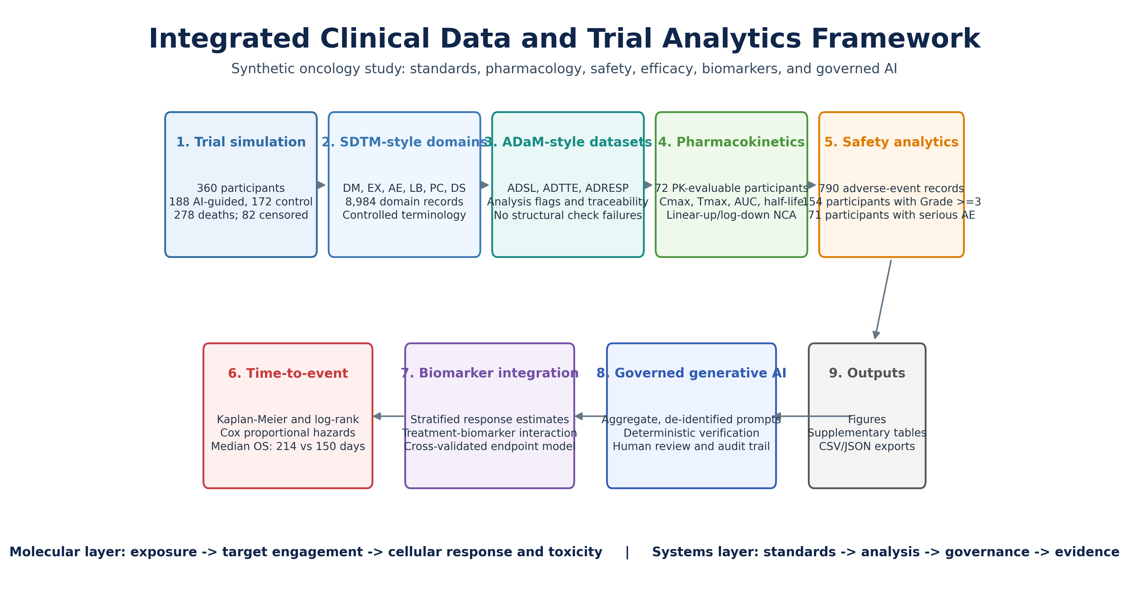
Figure 1. Integrated clinical data and trial analytics architecture. A synthetic randomised oncology study was transformed into six SDTM-style domains and three ADaM-style analysis datasets, followed by noncompartmental pharmacokinetics, adverse-event analysis, time-to-event modelling, biomarker-stratified efficacy evaluation, and a governed generative-AI support layer. The molecular layer connects dose and exposure to target engagement, cellular response, and toxicity; the systems layer connects standards, traceability, statistical analysis, governance, and evidence generation. All values derive from simulated data.

Introduction
Clinical development is an evidence-engineering process in which molecular hypotheses, participant-level observations, quantitative analyses, and regulatory narratives must remain connected. A therapeutic programme begins with a biological proposition, for example that modulation of a receptor, enzyme, DNA-repair dependency, metabolic pathway, or immune checkpoint will alter a disease state. That proposition becomes clinically interpretable only after dose and exposure are linked to pharmacodynamic activity, efficacy endpoints, adverse events, and time-dependent outcomes. At the same time, the operational system must preserve provenance from data acquisition through transformation, analysis, review, and reporting. When these layers are implemented as isolated activities, inconsistencies in definitions, populations, censoring, and metadata can propagate into scientific conclusions.
The Clinical Data Interchange Standards Consortium has developed standards that support structured exchange and analysis of clinical research data. The Operational Data Model and related standards facilitate consistent representation of study metadata and observations, while the Study Data Tabulation Model and Analysis Data Model distinguish standardised tabulations from analysis-ready derivations (Babre, 2013; Hume et al., 2016). Their value is not merely terminological. Standardisation makes relationships among subjects, treatments, visits, laboratory measurements, adverse events, pharmacokinetic samples, and disposition events computationally explicit. It can also support reuse across data-management, statistical-programming, and regulatory-review contexts (Facile et al., 2022). These objectives are aligned with the broader principles that data and software should be findable, accessible under appropriate controls, interoperable, and reusable (Wilkinson et al., 2016).
Analysis standards are most useful when they are coupled to a precise scientific question. The estimand framework emphasises that treatment, population, endpoint, intercurrent events, and summary measure jointly define what a trial analysis is intended to estimate (Kahan et al., 2024). In oncology, this requirement is especially important because response, progression, survival, treatment discontinuation, rescue therapy, toxicity, and biomarker status interact over time. Transparent protocol and report structures, including CONSORT principles, remain essential even in simulated studies because they expose assumptions that would otherwise remain implicit (Schulz et al., 2010).
Pharmacokinetic analysis provides the molecular-to-system bridge. Absorption, distribution, metabolism, and excretion determine the concentration of an intervention available to interact with its molecular target. Cmax can reflect peak exposure and acute toxicity risk, AUC integrates systemic exposure over time, Tmax describes the timing of peak concentration, and the terminal half-life influences dosing interval, accumulation, and duration of target engagement. Noncompartmental analysis provides model-light summaries of these properties, whereas model-informed drug development extends the same logic to trial design, dose selection, uncertainty quantification, and decision analysis (EFPIA MID3 Workgroup, 2016; Marshall et al., 2019; Noe, 2020). Clinical trial simulation can test these assumptions before exposing participants to an intervention and can reveal whether a proposed design can recover the intended effect under realistic variability (Bonate, 2000).
Safety evidence requires equally explicit denominators, time windows, seriousness definitions, severity grades, and treatment-emergent rules. Adverse-event tables remain common, but inconsistent collection and analysis can obscure both common toxicities and clinically important rare events (Phillips et al., 2019). The Common Terminology Criteria for Adverse Events provides an ordinal severity structure that links clinical observations to functional consequences and intervention requirements (Trotti et al., 2003). However, a grade is not a molecular mechanism. In a real oncology programme, cytopenias may reflect proliferative stress in bone marrow, transaminase elevations may reflect hepatocellular injury or immune activation, and gastrointestinal events may arise from epithelial, neuronal, microbial, or inflammatory perturbations. A useful analytics system must therefore preserve both standard categories and the context needed for mechanistic interpretation.
Time-to-event analysis adds another systems dimension because participant follow-up is incomplete and risk changes over time. Kaplan-Meier estimators describe survival under censoring, log-rank tests compare curves, and Cox models estimate covariate-adjusted relative hazards under proportional-hazards assumptions (Clark et al., 2003). Hazard ratios are not direct measures of absolute survival gain and can become difficult to interpret when hazards are non-proportional; restricted mean survival time is one complementary measure (Royston & Parmar, 2013). Biomarkers add a further distinction between prognosis and prediction. A prognostic biomarker is associated with outcome regardless of treatment, whereas a predictive biomarker modifies treatment effect and requires an interaction assessment rather than separate within-subgroup significance tests (Ballman, 2015; Sargent et al., 2005).
Artificial intelligence can support clinical development by identifying patterns, automating repetitive transformations, and assisting interpretation, but performance in a development environment depends on data quality, workflow integration, external validity, and governance rather than model accuracy alone (Kelly et al., 2019; Rajpurkar et al., 2022). Large language models can encode substantial clinical knowledge, yet they can also generate unsupported claims, omit uncertainty, or reproduce bias (Singhal et al., 2023). Responsible deployment therefore requires constrained inputs, human oversight, auditability, error analysis, and explicit reporting of human-AI interaction (Wiens et al., 2019; Liu et al., 2020; Cruz Rivera et al., 2020). Prediction models also require transparent specification, calibration, and validation under contemporary TRIPOD+AI guidance (Collins et al., 2024; Efthimiou et al., 2024).
The present study integrates these components into one executable synthetic oncology workflow. It extends the author's prior preprint frameworks for synthetic clinical-trial analytics, translational DMPK, and molecular bioenergetic simulation (Petalcorin, 2026a, 2026b, 2026c). The primary objective was methodological: to demonstrate traceable construction of standardised domains and analysis datasets, generate reproducible pharmacokinetic, safety, survival, and biomarker outputs, and define a governed role for generative AI. A secondary objective was explanatory: to show how molecular pharmacology and cellular heterogeneity map onto system-level clinical-development decisions without overstating what simulated data can establish.

Materials and Methods

Study architecture and reproducibility
A synthetic, parallel-group Phase II oncology study, designated NVS-AI-001, was generated in Python with a fixed random seed of 20260714. The protocol model included 360 participants recruited across simulated sites in the United Kingdom, United States, Switzerland, and Ireland. Participants were assigned to a control dose strategy or an AI-guided treatment strategy. The arm names describe the simulated allocation logic and do not represent an actual investigational product, approved treatment, or deployed clinical AI system. The workflow was executed from a Jupyter notebook and exported source domains, analysis datasets, summary tables, and an aggregate JSON review object. All patient identifiers were synthetic.
The analytical design followed a layered architecture. The first layer generated subject characteristics, exposure, longitudinal laboratory tests, pharmacokinetic concentrations, adverse events, disposition, response, and survival. The second layer represented these observations in SDTM-style domains. The third layer generated analysis-ready subject, response, and time-to-event datasets. The fourth layer calculated pharmacokinetic, safety, efficacy, survival, and predictive-model outputs. The final layer generated aggregate, de-identified prompts for optional generative-AI review. Deterministic data checks were performed before interpretation.

Synthetic cohort, biological variables, and endpoints
Age was sampled from a truncated normal distribution centred near 61 years. Sex, race, Eastern Cooperative Oncology Group performance status, stage III or IV disease, country, and site were generated from prespecified categorical distributions. Body mass index and baseline tumour burden were continuous variables. A synthetic biomarker was generated from a latent standard-normal variable, with a stage-dependent shift and additional measurement noise; positivity was defined at the 60th percentile of the simulated distribution. This construction represents a generic molecular feature, such as pathway activation, target abundance, DNA-repair deficiency, circulating analyte concentration, or immune-state score, but it was not mapped to a named gene or protein.
Overall-survival times were drawn from exponential distributions with individual hazards determined by performance status, disease stage, age, tumour burden, biomarker status, treatment assignment, and a treatment-by-biomarker term. Administrative censoring was sampled between 300 and 540 days. Objective response was generated from a logistic function containing treatment, biomarker, treatment-by-biomarker interaction, performance status, and stage. These equations created known signal structure for analytical testing. They did not represent a validated natural-history or pharmacodynamic model.
At a molecular level, the simulated biomarker can be interpreted as a latent determinant of cellular susceptibility. In a real programme, such a determinant could modify target dependence, drug uptake, target occupancy, stress signalling, apoptosis, immune recognition, or resistance. At a systems level, the same variable becomes a stratification factor, an interaction term, an eligibility criterion, or a component of a treatment policy. The framework was designed to preserve this connection while clearly separating hypothetical mechanism from observed clinical evidence.

SDTM-style domain construction
Six SDTM-style domains were generated. DM contained one record per participant with demographics, site, country, reference start date, and planned and actual arm. EX contained cycle-level treatment exposure, dose, dose unit, formulation, and start and end times. AE contained preferred terms, system organ classes, onset and end dates, severity, toxicity grade, seriousness, relatedness, and treatment-emergent status. LB contained haemoglobin, neutrophils, alanine aminotransferase, and creatinine at baseline and post-baseline visits. PC contained plasma concentration records at 0, 0.5, 1, 2, 4, 8, 12, and 24 hours. DS contained randomisation and end-of-study disposition events. These domains were deliberately simplified; they demonstrate transformation logic but are not asserted to comply with a specific implementation guide version or regulatory submission package.

ADaM-style datasets and traceability
ADSL contained one record per participant and derived planned and actual treatment, first and last exposure dates, intent-to-treat, safety, and efficacy flags, age group, biomarker group, Grade 3 or higher adverse-event flag, baseline variables, response, and survival variables. ADTTE represented overall survival with analysis value in days, censoring indicator, event description, start date, and analysis date. ADRESP represented objective response as a binary analysis value and responder category. Traceability was assessed by confirming unique participants, correspondence between the intent-to-treat population and randomised cohort, exposure for all safety participants, valid binary event and response indicators, non-negative time-to-event values, and complete treatment variables.

Pharmacokinetic simulation and noncompartmental analysis
A stratified subset of 72 participants, 36 per treatment arm, was selected for pharmacokinetic analysis. The nominal doses were 100 mg for control and 120 mg for the AI-guided strategy. Concentrations were generated using a one-compartment, first-order absorption and elimination equation with inter-individual log-normal variability in absorption rate, elimination rate, and apparent volume of distribution, followed by multiplicative residual variability. Although both arms received simulated Drug X, the dose difference allowed the workflow to test exposure summaries across strategies.
Cmax and Tmax were identified directly from observed concentration-time profiles. AUC0-24 was computed with the linear-up/log-down trapezoidal method. The terminal elimination rate constant was estimated by log-linear regression of the final four positive concentrations; half-life was ln(2)/lambda-z. AUCinf was calculated as AUC0-24 plus the final concentration divided by lambda-z. Geometric means were used for Cmax, AUC0-24, and AUCinf because exposure parameters are commonly right-skewed. These calculations follow standard noncompartmental principles but do not replace validated pharmacokinetic software or prespecified terminal-phase selection rules (Noe, 2020).

Adverse-event analysis
Treatment-emergent adverse events were summarised by preferred term and treatment arm using the number and percentage of safety participants with at least one event. Multiple records for the same preferred term within a participant contributed once to the incidence denominator. Grade 3 or higher events were identified from numeric toxicity grades. Serious adverse events were identified from the seriousness flag. The relative risk of experiencing at least one Grade 3 or higher event was calculated with a log-scale Wald confidence interval. The simulated terms included nausea, fatigue, neutropenia, anaemia, diarrhoea, rash, pyrexia, and thrombocytopenia.

Survival analysis
Kaplan-Meier curves were estimated separately by treatment. Median overall survival was the earliest time at which the survival estimate was 0.50 or lower. A two-sided log-rank test compared treatment groups. A Cox proportional-hazards model included treatment, age, sex, performance status, stage, biomarker positivity, tumour burden, and treatment-by-biomarker interaction. Efron handling of tied times was used. Hazard ratios and 95% confidence intervals were exponentiated from coefficients and standard errors. The model was used as a demonstration of multivariable analysis; a production analysis would require prespecified covariates, formal proportional-hazards diagnostics, missing-data strategy, sensitivity analyses, and consideration of alternative measures such as restricted mean survival time.

Biomarker and predictive-model analyses
Objective response was summarised by treatment and biomarker status. Risk differences and approximate 95% Wald confidence intervals were calculated overall and within biomarker strata. Predictive rather than merely prognostic interpretation required assessment of the treatment-by-biomarker term. A logistic-regression model used treatment, age, performance status, stage, continuous biomarker, tumour burden, and treatment-by-continuous-biomarker interaction. Fivefold stratified cross-validation generated out-of-fold probabilities. Discrimination was measured by area under the receiver-operating-characteristic curve, and overall probabilistic accuracy by the Brier score. Calibration was evaluated descriptively across predicted-risk deciles.

Governed generative-AI support
The notebook constructed a de-identified aggregate summary containing domain row counts, missingness, validation failures, safety counts, response rate, deaths, and censoring. A system prompt instructed a hypothetical language model to use only supplied aggregate information, avoid patient-level inference, distinguish observations from explanations, state uncertainty, propose deterministic checks, and require programmer and statistician review. No external model call was necessary for the reproducible workflow; a rule-based review produced the default narrative. The architecture illustrates how generative AI can support specification drafting, test-case generation, discrepancy explanation, and scientific communication without becoming the source of record.

Statistical and ethical considerations
Analyses were descriptive and two-sided. Percentages used the relevant analysis-population denominator. No multiplicity adjustment was applied because the purpose was workflow demonstration rather than confirmatory inference. Confidence intervals were approximate and should not be interpreted as clinical evidence. Because all data were computationally generated, no human participants, protected health information, consent process, or ethics approval were involved.

Results

Integrated data architecture and population
The executed workflow generated 360 DM, 1,766 EX, 790 AE, 4,772 LB, 576 PC, and 720 DS records, for 8,984 SDTM-style records in total. ADSL, ADTTE, and ADRESP each contained 360 participant records. All programmed structural checks passed, and no missing values were detected in the selected DM, AE, or ADSL variables. The AI-guided and control arms included 188 and 172 participants, respectively. Baseline age, sex, performance status, stage, biomarker prevalence, and tumour burden were broadly comparable but not forced to be exactly balanced because allocation and covariates were simulated independently (Supplementary Table S1).

Pharmacokinetic profiles captured dose-dependent exposure
Mean plasma concentration rose rapidly after dosing and declined over 24 hours (Figure 2). The geometric mean Cmax was 2.15 mg/L with the AI-guided strategy and 1.98 mg/L with control. Median Tmax was 2.0 and 2.0 hours, respectively. Geometric mean AUC0-24 was 23.28 versus 21.80 mg*h/L, and mean terminal half-life was 7.25 versus 7.41 hours (Supplementary Table S3). The moderate exposure increase was consistent with the 20% higher nominal dose but was blurred by inter-individual variability in absorption, elimination, and distribution.
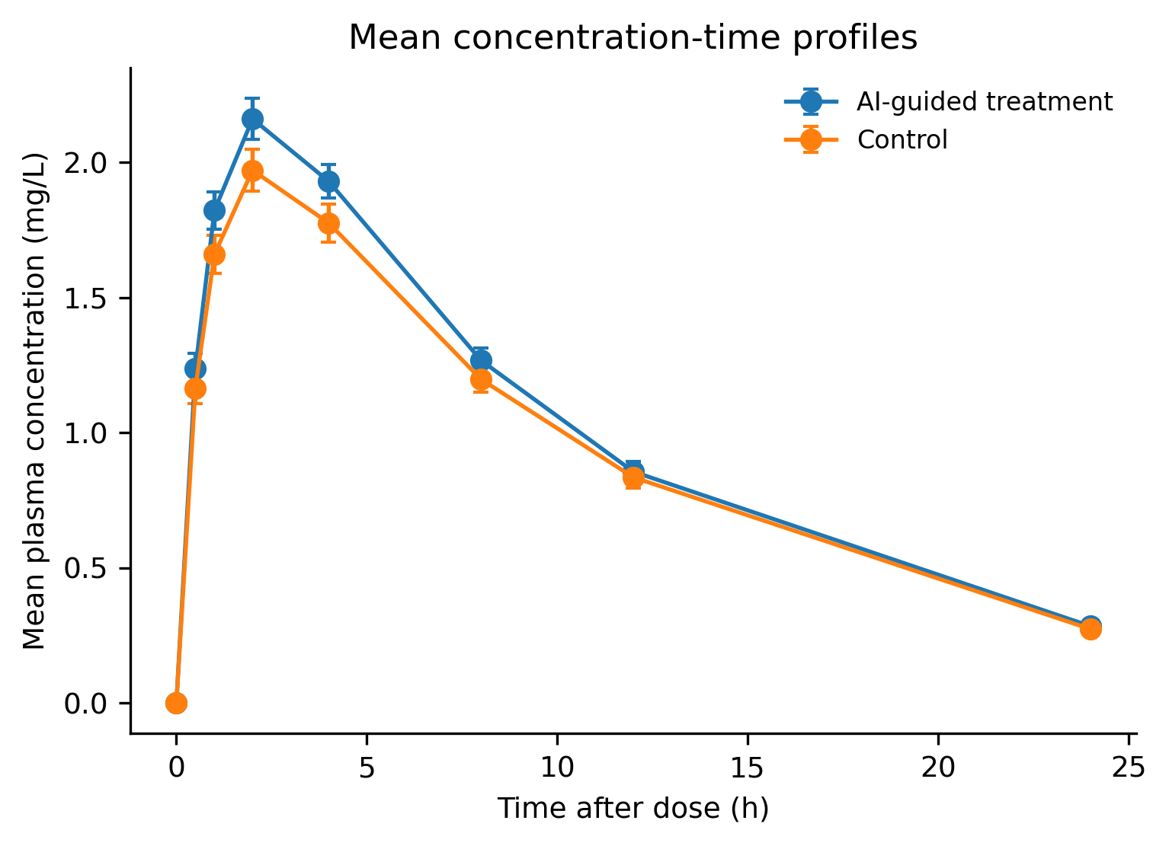
Figure 2. Simulated plasma concentration-time profiles. Mean Drug X concentrations and standard errors are shown for 36 pharmacokinetic participants per arm. The AI-guided strategy used a nominal 120-mg dose and control used 100 mg. Concentrations were generated using first-order absorption and elimination with inter-individual and residual variability.
At the molecular level, Cmax represents the highest systemic concentration available to drive target occupancy and concentration-dependent off-target interactions, whereas AUC represents the integrated exposure that can sustain pathway modulation over time. Half-life determines how quickly that molecular pressure dissipates. The present simulation produced exposure summaries but did not connect individual exposure to response or toxicity through a calibrated pharmacodynamic model; consequently, no exposure-response conclusion was drawn.

Safety signals were detectable with participant-level denominators
A total of 790 adverse-event records were generated. At least one Grade 3 or higher treatment-emergent event occurred in 88/188 (46.8%) AI-guided participants and 66/172 (38.4%) control participants. The corresponding relative risk was 1.22 (95% CI 0.96-1.56). Serious events occurred in 36 (19.1%) and 35 (20.3%) participants. Grade 3 or higher incidences by preferred term are shown in Figure 3 and Supplementary Table S4.
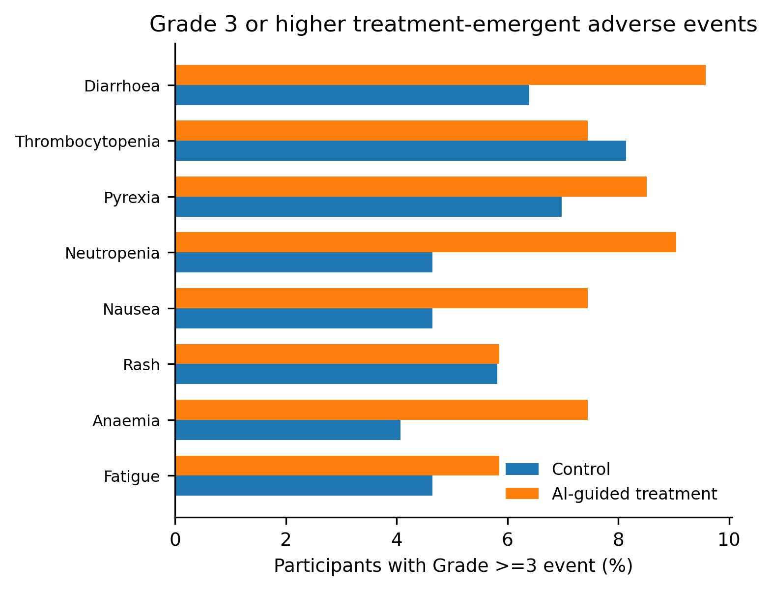
Figure 3. Grade 3 or higher treatment-emergent adverse events. Bars show the percentage of safety participants with at least one Grade 3 or higher event of each preferred term. Participants were counted once per preferred term, irrespective of repeated records.
The highest Grade 3 or higher incidences in the AI-guided arm were diarrhoea, neutropenia, and pyrexia, while thrombocytopenia and pyrexia were prominent in control. These patterns are stochastic consequences of the simulation and should not be assigned a drug-specific mechanism. In a real dataset, integrated review would connect neutropenia and thrombocytopenia to marrow lineage kinetics, diarrhoea to epithelial and inflammatory processes, pyrexia to cytokine or infectious pathways, and temporal relationships to dose and exposure.

Time-to-event analyses recovered the simulated treatment effect
There were 131 deaths in the AI-guided arm and 147 in control. Median overall survival was 214 versus 150 days. Kaplan-Meier curves separated over follow-up, and the log-rank statistic was 13.86 (p=0.0002; Figure 4). In the multivariable Cox model, the hazard ratio for AI-guided treatment versus control was 0.61 (95% CI 0.45-0.82; p=0.0010). Stage IV disease, age, and tumour burden were associated with higher hazard, whereas biomarker positivity was associated with lower hazard (Figure 5; Supplementary Table S5).
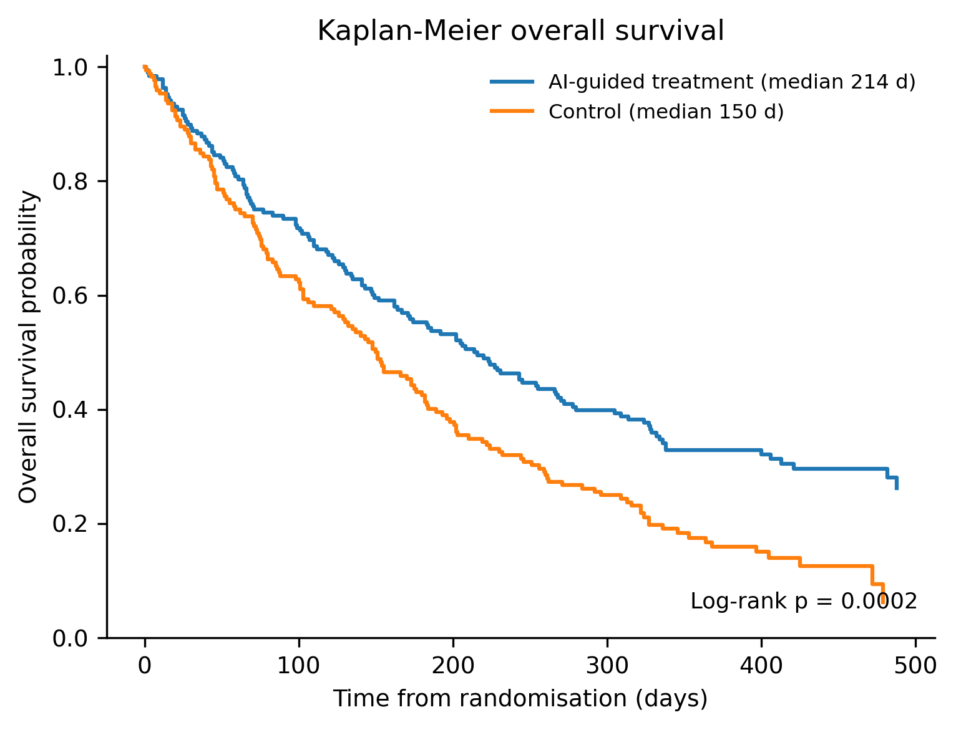
Figure 4. Kaplan-Meier estimates of overall survival. Overall survival is shown from randomisation for the simulated treatment strategies. Tick marks were not added because censoring times were densely distributed; medians and the two-sided log-rank p value are displayed in the panel.
The treatment-by-biomarker interaction hazard ratio was close to unity and not statistically significant, despite the biomarker being prognostic in the generated survival model. This result illustrates why treatment effects within subgroups and prognostic main effects are insufficient to establish predictive value. It also shows that a finite simulated sample can fail to recover a modest interaction even when one is included in the data-generating equation.
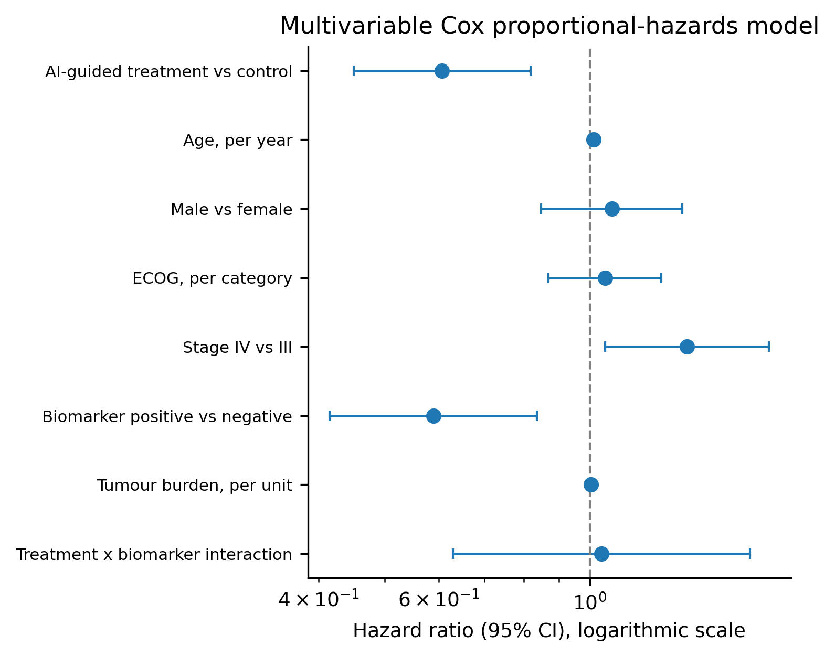
Figure 5. Multivariable Cox proportional-hazards model. Points are hazard ratios and horizontal lines are 95% confidence intervals. The dashed line denotes a hazard ratio of 1. The interaction estimate tests whether the treatment effect differs by biomarker positivity.

Response and biomarker analyses separated prognostic and predictive questions
Objective response occurred in 90/188 (47.9%) AI-guided participants and 51/172 (29.7%) control participants. The overall response risk difference was 18.2 percentage points (95% CI 8.3 to 28.1). Among biomarker-negative participants, response was 35.2% versus 25.9%, a risk difference of 9.3 points. Among biomarker-positive participants, response was 65.0% versus 35.9%, a risk difference of 29.1 points (Figure 6; Supplementary Table S6).
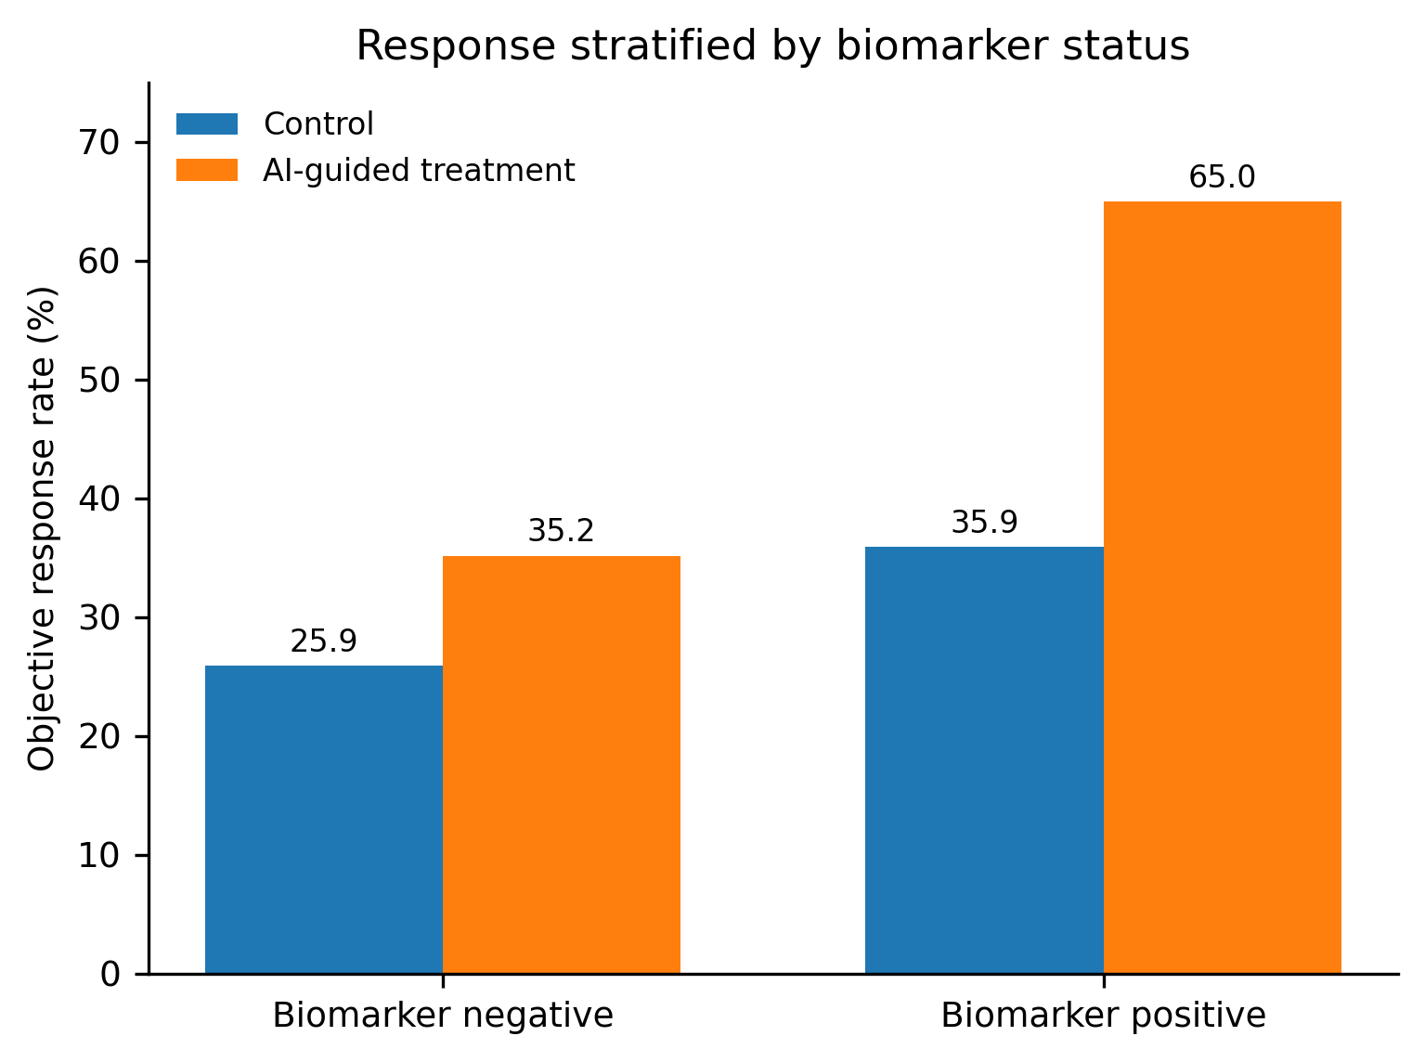
Figure 6. Objective response stratified by biomarker status. Bars show the simulated objective response rate by treatment strategy and biomarker group. The larger descriptive difference in biomarker-positive participants suggests effect heterogeneity in response, but predictive interpretation requires a prespecified treatment-by-biomarker interaction and independent validation.
The cross-validated logistic model achieved an AUROC of 0.645 and a Brier score of 0.221. The AUROC indicated modest discrimination rather than a clinically deployable model. The Brier score reflected the combined effects of discrimination and calibration at an observed response prevalence of 39.2%. This intentionally moderate performance is informative: a complete machine-learning workflow is not equivalent to a useful clinical model, and a model should not be promoted without external validation, calibration assessment, decision-curve analysis, robustness testing, and examination of subgroup performance.

Generative AI supported review without replacing deterministic analysis
The aggregate review object contained 360 participants, domain and analysis row counts, missingness, validation status, 154 participants with Grade 3 or higher events, 71 participants with serious events, 278 deaths, and 82 censored observations. Because no external language-model endpoint was configured, the notebook produced a deterministic narrative that reported these facts and explicitly required source-domain, denominator, censoring, analysis-flag, and statistical-analysis-plan verification.
This architecture separates three functions that are often conflated. Deterministic code defines the analysis and creates the numbers. A language model can assist with drafting, summarisation, or candidate checks. Human reviewers determine whether the analysis answers the clinical question and whether the generated language is scientifically and operationally acceptable. At a systems level, this separation reduces the risk that fluent text becomes an unaudited analytical result.

Discussion
This study demonstrates a reproducible clinical-development analytics framework spanning data standards, analysis derivation, quantitative pharmacology, safety, survival, biomarker science, predictive modelling, and constrained generative AI. The principal contribution is not a novel estimator or therapeutic claim. It is the integration of components that are commonly developed by different functions and later reconciled under time pressure. By using a single simulated participant spine and explicit identifiers, dates, populations, and derivations, the framework preserved lineage from randomisation through source domains, analysis datasets, outputs, and review summaries.
The molecular and systems levels are complementary. At the molecular level, dose determines the concentration-time profile; exposure governs the probability and duration of target occupancy; target engagement perturbs signalling, metabolism, DNA repair, transcription, cell-cycle control, apoptosis, or immune interactions; and normal-tissue engagement contributes to toxicity. Molecular heterogeneity, represented here by a synthetic biomarker, can alter each step. At the systems level, those processes are observed indirectly through concentration measurements, laboratory tests, adverse events, radiographic or response endpoints, and survival. Standards and analysis datasets do not create biological truth, but they determine whether the available evidence can be traced and interrogated.
The pharmacokinetic component illustrates this bridge. The 20% higher nominal dose produced modestly higher Cmax and AUC, but inter-individual variability prevented a fixed proportional difference. That behaviour resembles real pharmacokinetics, where absorption, plasma-protein binding, tissue distribution, hepatic metabolism, renal clearance, transporter activity, organ function, and drug interactions can produce substantial heterogeneity. A real model-informed development programme would connect these exposure distributions to pharmacodynamic biomarkers, tumour response, toxicity, and dose modification; quantify parameter uncertainty; and simulate alternative schedules (EFPIA MID3 Workgroup, 2016; Marshall et al., 2019). The present workflow stops before that causal PK/PD step, which is an important limitation rather than a cosmetic omission.
The adverse-event results demonstrate why safety must be analysed at participant and event levels. Event-record counts measure burden and recurrence, whereas participant incidence measures risk. Severity and seriousness are distinct: a Grade 3 event may be severe without meeting a seriousness criterion, and a serious event need not be the highest grade. Mechanistic review must then integrate timing, dose, concomitant therapy, laboratory trajectories, baseline disease, and biological plausibility. The framework preserved enough structure to support such extensions, but the generated event terms and risks were not derived from a real compound.
The survival analysis recovered the intended average treatment benefit and prognostic effects. Nevertheless, the hazard ratio should not be treated as a direct biological constant. It is a relative instantaneous-risk summary conditional on the model and can obscure changes in treatment effect over time. In a real trial, delayed immune effects, acquired resistance, informative treatment switching, non-random censoring, and competing causes of death can violate simple assumptions. Kaplan-Meier curves, absolute survival probabilities, milestone survival, restricted mean survival time, and sensitivity analyses can complement the Cox estimate (Clark et al., 2003; Royston & Parmar, 2013).
The biomarker results reinforce the distinction between association and treatment selection. Biomarker positivity was prognostic for survival, and biomarker-positive participants had a larger descriptive response difference. However, the survival interaction was imprecise and non-significant. A predictive biomarker must demonstrate reproducible treatment-effect modification, ideally in a design and analysis that protect against multiplicity, threshold optimisation, and selective reporting (Ballman, 2015; Sargent et al., 2005). Molecular plausibility strengthens a biomarker programme but does not replace statistical validation. Conversely, a statistically significant interaction without assay robustness or mechanistic coherence may be difficult to transport across populations and laboratories.
The prediction model's modest AUROC is also scientifically useful. It prevents the workflow from presenting an unrealistically perfect machine-learning result and highlights that calibration, prevalence, transportability, and clinical utility matter. Prediction tools should specify their intended user, decision, time horizon, outcome, and deployment setting. Data leakage, small effective sample size, unstable feature selection, unmeasured site effects, and changes in clinical practice can degrade performance. TRIPOD+AI and related guidance provide an appropriate framework for transparent reporting (Collins et al., 2024; Efthimiou et al., 2024).
Generative AI presents a different risk profile from a conventional prediction model. Its output is language rather than a single probability, and an error can be difficult to detect because the narrative may be internally coherent. The safest role in the present framework was assistive: operate on aggregate, de-identified summaries; generate candidate checks or draft explanations; log prompts and responses; and require verification against deterministic outputs. This design is consistent with calls for rigorous evaluation, human-AI interaction reporting, and error analysis in clinical AI (Kelly et al., 2019; Wiens et al., 2019; Liu et al., 2020; Cruz Rivera et al., 2020). It also recognises that encoded clinical knowledge in large language models does not guarantee faithful reasoning over a specific trial dataset (Singhal et al., 2023).
The framework is aligned with prior synthetic clinical-development and translational modelling work by the author. The medRxiv clinical-trial framework integrated response, circulating tumour DNA, safety, and survival; the ChemRxiv DMPK workflow connected ADME prediction, machine learning, and PK/PD prioritisation; and the bioRxiv membrane simulation examined how molecular membrane composition can propagate to ATP-output phenotypes (Petalcorin, 2026a, 2026b, 2026c). Together, these preprints support a broader strategy in which mechanistic and data-centric models are joined through explicit interfaces rather than presented as isolated applications. They remain preprints and should be evaluated accordingly.
Several limitations are fundamental. First, all data were simulated from simplified equations, and no conclusion applies to a real intervention or patient population. Second, the trial did not model longitudinal tumour measurements, progression, dose modification, competing risks, treatment switching, missing-not-at-random data, concomitant therapy, or site-level dependence. Third, the PK and endpoint simulations were not connected through an individual exposure-response model. Fourth, adverse events were generated from a small term set and lacked onset-relative-to-dose analyses, recurrent-event methods, and laboratory toxicity grading. Fifth, the Cox model was illustrative and not supported by a fully prespecified diagnostic and sensitivity-analysis package. Sixth, the prediction model was internally cross-validated only. Seventh, the generative-AI module was demonstrated as an architecture rather than prospectively evaluated with users or regulated-system controls.
Future development should add protocol-defined estimands, longitudinal tumour and circulating biomarker models, exposure-response and disease-progression models, recurrent-event and competing-risk analyses, multiple-imputation workflows, independent double programming, metadata-driven validation, and external datasets. The AI layer should be tested under prompt injection, data exfiltration, hallucination, model-version change, and adversarial error scenarios. Human-factors evaluation should determine whether generated assistance reduces review time without increasing automation bias. Most importantly, any transition from a synthetic demonstration to clinical use must be governed by protocol, statistical analysis plan, data-management plan, validation documentation, quality systems, privacy controls, and applicable regulatory requirements.

Conclusion
A coherent clinical-development technology strategy must connect molecular hypotheses to data standards, analysis-ready datasets, pharmacology, safety, efficacy, biomarkers, and auditable interpretation. The present synthetic workflow shows that these components can be implemented in one reproducible notebook and exported as traceable analytical products. It also defines a bounded role for generative AI that preserves deterministic programming and human accountability. The simulated treatment effects are demonstrations of analytical capability, not evidence of therapeutic benefit. The transferable result is the architecture: a standards-based, quantitatively informed, and governance-aware system for accelerating evidence generation while maintaining scientific traceability.

Data and code availability
The manuscript was generated from the executed Jupyter notebook and its synthetic CSV and JSON outputs. No real participant data were used. The notebook is suitable for adaptation into a public code repository after project-specific metadata, licensing, validation tests, and documentation are added.

Author contributions
M.I.R.P. conceived the framework, designed the synthetic study, implemented the notebook, performed the analyses, generated the figures, interpreted the results, and wrote the manuscript.

Funding
No external funding was received for this synthetic methodological study.

Competing interests
The author is Director and Founder of aAidea Ltd. No commercial product or real investigational intervention was evaluated.

References
Atkinson, T. M., Ryan, S. J., Bennett, A. V., Stover, A. M., Saracino, R. M., Rogak, L. J., Jewell, S. T., Matsoukas, K., Li, Y., & Basch, E. (2016). The association between clinician-based Common Terminology Criteria for Adverse Events and patient-reported outcomes: A systematic review. Supportive Care in Cancer, 24(8), 3669-3676. https://doi.org/10.1007/s00520-016-3297-9
Babre, D. K. (2013). Clinical Data Interchange Standards Consortium: A bridge to overcome data standardisation. Perspectives in Clinical Research, 4(2), 115-116. https://doi.org/10.4103/2229-3485.111779
Ballman, K. V. (2015). Biomarker: Predictive or prognostic? Journal of Clinical Oncology, 33(33), 3968-3971. https://doi.org/10.1200/JCO.2015.63.3651
Bonate, P. L. (2000). Clinical trial simulation in drug development. Pharmaceutical Research, 17(3), 252-256. https://doi.org/10.1023/A:1007548719885
Clark, T. G., Bradburn, M. J., Love, S. B., & Altman, D. G. (2003). Survival analysis part I: Basic concepts and first analyses. British Journal of Cancer, 89(2), 232-238. https://doi.org/10.1038/sj.bjc.6601118
Collins, G. S., Moons, K. G. M., Dhiman, P., Riley, R. D., Beam, A. L., Van Calster, B., Ghassemi, M., Liu, X., Reitsma, J. B., van Smeden, M., Boulesteix, A.-L., Camaradou, J. C., Celi, L. A., Denaxas, S., Denniston, A. K., Glocker, B., Golub, R. M., Harvey, H., Heinze, G., ... Logullo, P. (2024). TRIPOD+AI statement: Updated guidance for reporting clinical prediction models that use regression or machine learning methods. BMJ, 385, e078378. https://doi.org/10.1136/bmj-2023-078378
Cruz Rivera, S., Liu, X., Chan, A.-W., Denniston, A. K., Calvert, M. J., & SPIRIT-AI and CONSORT-AI Working Group. (2020). Guidelines for clinical trial protocols for interventions involving artificial intelligence: The SPIRIT-AI extension. BMJ, 370, m3210. https://doi.org/10.1136/bmj.m3210
EFPIA MID3 Workgroup. (2016). Good practices in model-informed drug discovery and development: Practice, application, and documentation. CPT: Pharmacometrics & Systems Pharmacology, 5(3), 93-122. https://doi.org/10.1002/psp4.12049
Efthimiou, O., Seo, M., Chalkou, K., Debray, T., Egger, M., & Salanti, G. (2024). Developing clinical prediction models: A step-by-step guide. BMJ, 386, e078276. https://doi.org/10.1136/bmj-2023-078276
Facile, R., Muhlbradt, E. E., Gong, M., Li, Q., Popat, V., Pétavy, F., Cornet, R., & Ruan, Y. (2022). Use of Clinical Data Interchange Standards Consortium standards for real-world data: Expert perspectives from a qualitative Delphi survey. JMIR Medical Informatics, 10(1), e30363. https://doi.org/10.2196/30363
Hume, S., Aerts, J., Sarnikar, S., & Huser, V. (2016). Current applications and future directions for the CDISC Operational Data Model standard: A methodological review. Journal of Biomedical Informatics, 60, 352-362. https://doi.org/10.1016/j.jbi.2016.02.016
Kahan, B. C., Morris, T. P., White, I. R., Carpenter, J. R., & Cro, S. (2024). The estimands framework: A primer on the ICH E9(R1) addendum. BMJ, 384, e076316. https://doi.org/10.1136/bmj-2023-076316
Kelly, C. J., Karthikesalingam, A., Suleyman, M., Corrado, G., & King, D. (2019). Key challenges for delivering clinical impact with artificial intelligence. BMC Medicine, 17, 195. https://doi.org/10.1186/s12916-019-1426-2
Liu, X., Cruz Rivera, S., Moher, D., Calvert, M. J., Denniston, A. K., & SPIRIT-AI and CONSORT-AI Working Group. (2020). Reporting guidelines for clinical trial reports for interventions involving artificial intelligence: The CONSORT-AI extension. Nature Medicine, 26(9), 1364-1374. https://doi.org/10.1038/s41591-020-1034-x
Marshall, S., Madabushi, R., Manolis, E., Krudys, K., Staab, A., Dykstra, K., & Visser, S. A. G. (2019). Model-informed drug discovery and development: Current industry good practice and regulatory expectations and future perspectives. CPT: Pharmacometrics & Systems Pharmacology, 8(2), 87-96. https://doi.org/10.1002/psp4.12372
Noe, D. A. (2020). Parameter estimation and reporting in noncompartmental analysis of clinical pharmacokinetic data. Clinical Pharmacology in Drug Development, 9(S1), S5-S35. https://doi.org/10.1002/cpdd.810
Petalcorin, M. I. R. (2026a). A simulated translational oncology DMPK workflow integrating ADME profiling, machine learning, and PK/PD-guided candidate prioritisation [Preprint]. ChemRxiv. https://doi.org/10.26434/chemrxiv.15002060/v1
Petalcorin, M. I. R. (2026b). An end-to-end synthetic oncology clinical trial framework integrating radiographic response, circulating tumor DNA, safety, and survival for decision-oriented clinical data science [Preprint]. medRxiv. https://doi.org/10.64898/2026.04.07.26350297
Petalcorin, M. I. R. (2026c). Computational synthetic inner membrane reveals cardiolipin-leak control of ATP output [Preprint]. bioRxiv. https://doi.org/10.64898/2026.02.25.708092
Phillips, R., Hazell, L., Sauzet, O., & Cornelius, V. (2019). Analysis and reporting of adverse events in randomised controlled trials: A review. BMJ Open, 9(2), e024537. https://doi.org/10.1136/bmjopen-2018-024537
Rajpurkar, P., Chen, E., Banerjee, O., & Topol, E. J. (2022). AI in health and medicine. Nature Medicine, 28(1), 31-38. https://doi.org/10.1038/s41591-021-01614-0
Royston, P., & Parmar, M. K. B. (2013). Restricted mean survival time: An alternative to the hazard ratio for the design and analysis of randomized trials with a time-to-event outcome. BMC Medical Research Methodology, 13, 152. https://doi.org/10.1186/1471-2288-13-152
Sargent, D. J., Conley, B. A., Allegra, C., & Collette, L. (2005). Clinical trial designs for predictive marker validation in cancer treatment trials. Journal of Clinical Oncology, 23(9), 2020-2027. https://doi.org/10.1200/JCO.2005.01.112
Schulz, K. F., Altman, D. G., & Moher, D. (2010). CONSORT 2010 statement: Updated guidelines for reporting parallel group randomised trials. Trials, 11, 32. https://doi.org/10.1186/1745-6215-11-32
Singhal, K., Azizi, S., Tu, T., Mahdavi, S. S., Wei, J., Chung, H. W., Scales, N., Tanwani, A., Cole-Lewis, H., Pfohl, S., Payne, P., Seneviratne, M., Gamble, P., Kelly, C., Babiker, A., Schärli, N., Chowdhery, A., Mansfield, P., Arcas, B. A. y, ... Natarajan, V. (2023). Large language models encode clinical knowledge. Nature, 620(7972), 172-180. https://doi.org/10.1038/s41586-023-06291-2
Trotti, A., Colevas, A. D., Setser, A., Rusch, V., Jaques, D., Budach, V., Langer, C., Murphy, B., Cumberlin, R., Coleman, C. N., & Rubin, P. (2003). CTCAE v3.0: Development of a comprehensive grading system for the adverse effects of cancer treatment. Seminars in Radiation Oncology, 13(3), 176-181. https://doi.org/10.1016/S1053-4296(03)00031-6
Wiens, J., Saria, S., Sendak, M., Ghassemi, M., Liu, V. X., Doshi-Velez, F., Jung, K., Heller, K., Kale, D., Saeed, M., Ossorio, P. N., Thadaney-Israni, S., & Goldenberg, A. (2019). Do no harm: A roadmap for responsible machine learning for health care. Nature Medicine, 25(9), 1337-1340. https://doi.org/10.1038/s41591-019-0548-6
Wilkinson, M. D., Dumontier, M., Aalbersberg, I. J., Appleton, G., Axton, M., Baak, A., Blomberg, N., Boiten, J.-W., da Silva Santos, L. B., Bourne, P. E., Bouwman, J., Brookes, A. J., Clark, T., Crosas, M., Dillo, I., Dumon, O., Edmunds, S., Evelo, C. T., Finkers, R., Gonzalez-Beltran, A., ... Mons, B. (2016). The FAIR Guiding Principles for scientific data management and stewardship. Scientific Data, 3, 160018. https://doi.org/10.1038/sdata.2016.18

Supplementary Material
All supplementary values derive from the same synthetic dataset used in the main analysis. Percentages use the treatment-specific denominator unless otherwise stated.

Supplementary Table S1. Baseline characteristics by treatment strategy
Characteristic | Control | AI-guided treatment
Participants, n | 172 | 188
Age, years, mean (SD) | 61.2 (9.8) | 61.0 (10.5)
Female, n (%) | 81 (47.1) | 87 (46.3)
ECOG performance status 2, n (%) | 32 (18.6) | 33 (17.6)
Stage IV disease, n (%) | 123 (71.5) | 139 (73.9)
Biomarker positive, n (%) | 64 (37.2) | 80 (42.6)
Tumour burden, mean (SD) | 81.0 (34.4) | 86.7 (40.0)
ECOG, Eastern Cooperative Oncology Group; SD, standard deviation.

Supplementary Table S2. Domain and analysis-dataset inventory
Dataset | Records | Primary purpose
DM | 360 | Demographics
EX | 1766 | Exposure
AE | 790 | Adverse events
LB | 4772 | Laboratory tests
PC | 576 | Pharmacokinetic concentrations
DS | 720 | Disposition
ADSL | 360 | Subject-level analysis
ADTTE | 360 | Overall-survival analysis
ADRESP | 360 | Objective-response analysis

Supplementary Table S3. Noncompartmental pharmacokinetic parameters
Strategy | n | Cmax GM, mg/L | Cmax CV, % | Tmax median, h | AUC0-24 GM | AUCinf GM | Half-life mean, h
Control | 36 | 1.981 | 23.1 | 2.0 | 21.798 | 24.671 | 7.406
AI-guided treatment | 36 | 2.152 | 20.7 | 2.0 | 23.279 | 26.226 | 7.250
AUC units are mg*h/L. CV, coefficient of variation; GM, geometric mean.

Supplementary Table S4. Treatment-emergent adverse events
Preferred term | Strategy | Any grade, n (%) | Grade >=3, n (%)
Anaemia | AI-guided treatment | 53 (28.2) | 14 (7.4)
Anaemia | Control | 28 (16.3) | 7 (4.1)
Diarrhoea | AI-guided treatment | 48 (25.5) | 18 (9.6)
Diarrhoea | Control | 45 (26.2) | 11 (6.4)
Fatigue | AI-guided treatment | 41 (21.8) | 11 (5.9)
Fatigue | Control | 34 (19.8) | 8 (4.7)
Nausea | AI-guided treatment | 42 (22.3) | 14 (7.4)
Nausea | Control | 36 (20.9) | 8 (4.7)
Neutropenia | AI-guided treatment | 53 (28.2) | 17 (9.0)
Neutropenia | Control | 44 (25.6) | 8 (4.7)
Pyrexia | AI-guided treatment | 50 (26.6) | 16 (8.5)
Pyrexia | Control | 37 (21.5) | 12 (7.0)
Rash | AI-guided treatment | 32 (17.0) | 11 (5.9)
Rash | Control | 36 (20.9) | 10 (5.8)
Thrombocytopenia | AI-guided treatment | 50 (26.6) | 14 (7.4)
Thrombocytopenia | Control | 43 (25.0) | 14 (8.1)

Supplementary Table S5. Cox proportional-hazards model for overall survival
Covariate | Hazard ratio | 95% CI | p value
AI-guided treatment vs control | 0.607 | 0.450-0.818 | 0.0010
Age, per year | 1.013 | 1.002-1.025 | 0.0230
Male vs female | 1.077 | 0.848-1.367 | 0.5442
ECOG, per category | 1.052 | 0.869-1.274 | 0.6003
Stage IV vs III | 1.389 | 1.052-1.832 | 0.0203
Biomarker positive vs negative | 0.589 | 0.415-0.836 | 0.0031
Tumour burden, per unit | 1.004 | 1.001-1.007 | 0.0032
Treatment x biomarker interaction | 1.039 | 0.629-1.717 | 0.8803
The model used Efron handling of tied event times. Results are illustrative and require proportional-hazards diagnostics in a confirmatory analysis.

Supplementary Table S6. Objective response and biomarker subgroup effects
Population | Control response, n/N (%) | AI-guided response, n/N (%) | Risk difference, percentage points (95% CI)
Overall | 51/172 (29.7) | 90/188 (47.9) | 18.2 (8.3 to 28.1)
Biomarker negative | 28/108 (25.9) | 38/108 (35.2) | 9.3 (-3.0 to 21.5)
Biomarker positive | 23/64 (35.9) | 52/80 (65.0) | 29.1 (13.3 to 44.8)

Supplementary Table S7. Programmed validation checks
Validation check | Status
ADSL has one record per participant | Passed
Intent-to-treat population equals randomised population | Passed
All safety participants have exposure | Passed
ADTTE analysis times are non-negative | Passed
ADTTE censoring indicator is binary | Passed
ADRESP response indicator is binary | Passed
Planned and actual treatment are populated | Passed
Selected DM, AE, and ADSL variables contain no missing values | Passed

