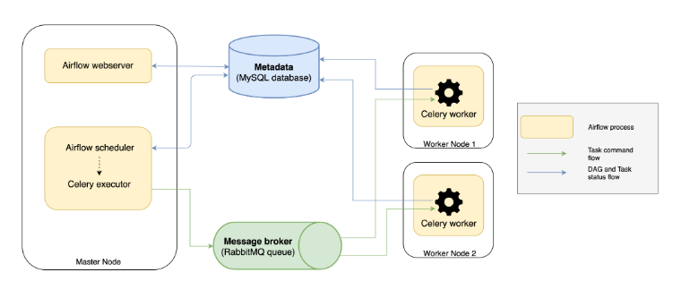

yum install python3-pip.noarch

yum install gcc.x86_64

yum install python3-devel

su – airflow

AIRFLOW_HOME=/home/airflow/airflow

pip3 install apache-airflow[postgres,celery,rabbitmq] –user

/home/airflow/airflow/airflow.cfg

AIRFLOW_HOME=/home/airflow/airflow

# Airflow

#systemctl start rabbitmq-server.service

#su - airflow -c "nohup airflow worker > /home/airflow/airflow/logs/worker.log 2>&1 &"

su - airflow -c "nohup airflow scheduler > /home/airflow/airflow/logs/scheduler.log 2>&1 &"

su - airflow -c "nohup airflow webserver -p 8080 > /home/airflow/airflow/logs/webserver.log 2>&1 &"

#su - airflow -c "nohup airflow flower > /home/airflow/airflow/logs/flower.log 2>&1 &"

airflow run example1 sleep30 2015-01-01

systemctl status rabbitmq-server

rabbitmqctl add_user mqadmin mqadminpassword

rabbitmqctl set_user_tags mqadmin administrator

rabbitmqctl set_permissions -p / mqadmin ".*" ".*" ".*"

rabbitmq-plugins enable rabbitmq_management

rabbitmqctl add_vhost rabbitrh602

rabbitmqctl set_permissions -p rabbitrh602 mqadmin ".*" ".*" ".*"

<http://rh602:5555/tasks>