**4. Conclusions**

Analysis and simulation have a big impact in the industry and the world. These let us save money when cases are complex by letting us how something is related to something else and predict how a process will behave. In this project, we had to analyze which component/components was/were influencing more in response time in the presented system so we could then bring a proposal of how improve it. In this case CPU and DB were the most influencing ones, therefore to achieve a lower response time we had to invest in CPU processors and DB disks. As previously mentioned, this make companies save money because once you know the root of the problem you don’t have to spend money in other components that won’t influence at all in the response time. Thus, the less electronic components we consume the less we damage the environment.

E-waste are the circuits and electronic components we no longer use so they end in the trash or being recycled. E-waste damages the environment and lately, researchers have not only liked it to environment damage but also linked it to adverse effects on human health.

Computers are the biggest e-waste source. They compound around the 74% of the number of electronics wasted. Mexico has a significant impact in the generation of e-waste in the world. As we can see they wasted 1.138 million of tons in the 2012, almost the same number as Russia.

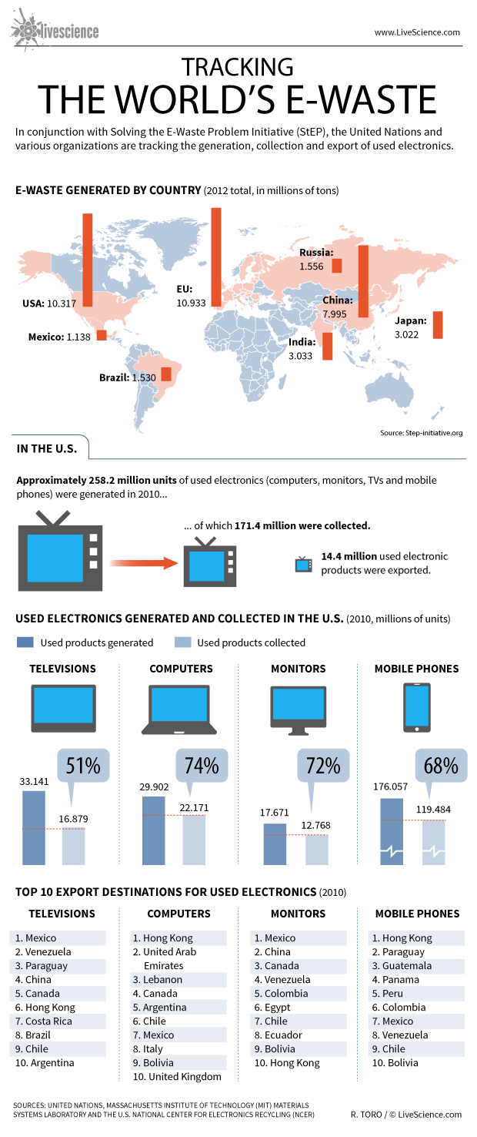

Nonetheless, with the pass of the time it is more often the practice of recycling in companies as the chart show below:

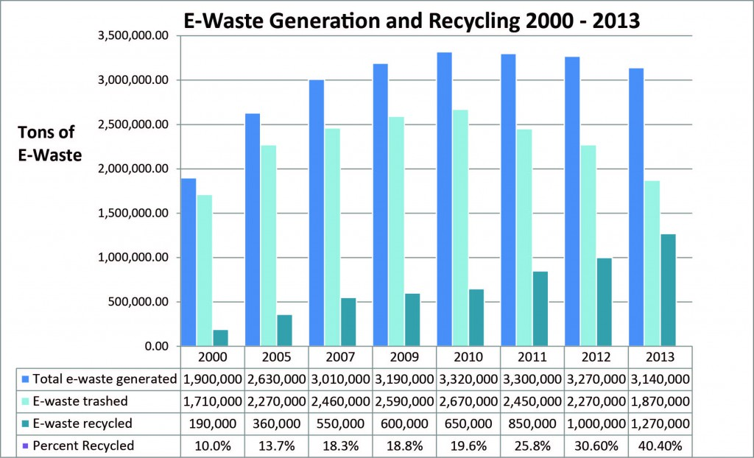

We as consumers must be careful with how much we consume. If we take care of the environment we implicitly act ethically and as a citizen. Currently we are university students but in some years, we will have our own family and it is almost certain that we all going to have kids. So, we have a responsibility to teach them what affect other humans and the world so they can think more ethically before act. By teaching them ethics and environmental cares we’re surely going to make a great impact in the future.

E-waste is a real thing, and we must be aware of it since now.

**References**

IOP (Institute of Physics). 2011. E-waste pollution’ threat to human health. http://www.iop.org/news/11/may/page_51103.html

Livescience. 2013. World's E-Waste to Grow 33% by 2017, Says Global Report. http://www.livescience.com/41967-world-e-waste-to-grow-33-percent-2017.html

Electronics TakeBack Coalition. E-Waste In Landfills. http://www.electronicstakeback.com/designed-for-the-dump/e-waste-in-landfills/